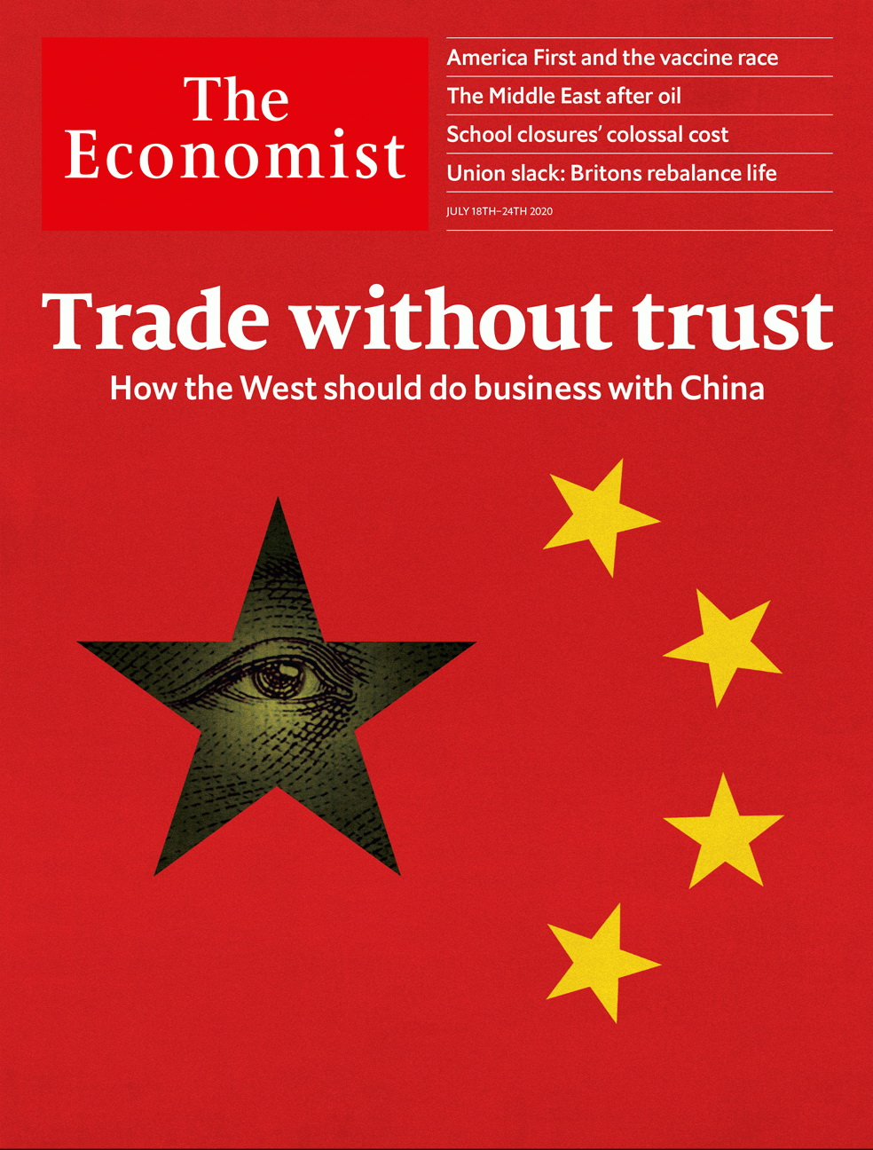

# Table of Contents

The world this week

Politics this week

Business this week

KAL’s cartoon

Leaders

Huawei and the world economy: Trade without trust

Covid-19 and schools: Let them learn

Poland’s presidential election: A narrow, nasty win

Oil and the Arab world: There will be pain

Banks and the economy: A window on America

Letters

Letters to the editor: On resilience, advertising, maritime quarantine, Joe Biden, zoonotics, covid-19, deforestation, Boris Johnson, bubbles, the Stone Roses

Briefing

Huawei and 5G: The European theatre

United States

Operation Warp Speed: America First-Aid

The virus: Here it goes again

Schools: Classroom cops

SCOTUS: The centre can hold

Nomenclature: Skin in the name

Lexington: A family separation

The Americas

Chile: Gimme shelter

Mexico: Banda does not play on

Asia

Drugs and vigilantes: Myanmar vice

Australia and the monarchy: Crown duels

Malaysian politics: A 70-minister mandate

Singapore’s election: Gluttons for punishment

Banyan: Shah of India

China

Hong Kong’s companies: The darkness behind

Satellite navigation: BeiDou begins

Floods: A deluge of doubts

Middle East & Africa

The Arab world: Twilight of the petrostates

South Africa: Measuring the poverty pandemic

Burkina Faso: Rhyme and punishment

Pineapples and prohibition: Dry, the beloved country

Europe

Germany’s China policy: Out of date

Protests in Russia’s Far East: An unlikely local hero

Poland’s election: Narrow minds, narrow win

France: Accent grave

Italy: Parting the waters

Charlemagne: How Ireland gets its way

Britain

Work-life balance: Union slack

Government help for startups: The joy of equity

Brexit: The nameless one approaches

Armed forces: Culture war

Government and covid-19: How the levers came off

Household finances: Run to the banks

Bagehot: Dance of the lemons

International

School closures: A class apart

Schools in poor countries: Won’t know much about history

Business

Unwanted fossil fuels: The bottom of the barrel

Entertainment (1): Ad nauseam

Entertainment (2): Off his rocker?

Sino-American tech mistrust: At the end of a rainbow

I’ll have semiconductors with that: Analog devices buys Maxim Integrated for $20bn

Cyber-security: The other virus threat

Bartleby: A question of judgment

Schumpeter: When bits bite

Finance & economics

Wall Street: A banking drama, in three acts

China’s economy: Low and mighty

The Big Mac index: Patty power

Corporate taxes: Digital divide

Insurance: A premium on change

Buttonwood: Lotus esprit

Free exchange: Housing was the business cycle

Science & technology

Chipmaking: The incredible shrinking machine

Environmental science: Pining for water

A new comet: Comet NEOWISE lights up northern skies

Navigation: Crystal clear

The socioeconomics of sewage: Class acts

The theory of relativity: Cycling tricks

Books & arts

The future of journalism: Invisible men

Craft and commerce: Shifting plates

Science and politics: Trial and error

Musical high jinks: Played for laughs

Economic & financial indicators

Economic data, commodities and markets

Graphic detail

Resource economics: Capital pains

Obituary

Ennio Morricone: Man on a mission



### Friday, July 17, 2020

|  |  |
| --- | --- |
| The world this week | 3 |
| Leaders | 5 |
| Letters | 1 |
| Briefing | 1 |
| United States | 6 |
| The Americas | 2 |
| Asia | 5 |
| China | 3 |
| Middle East & Africa | 4 |
| Europe | 6 |
| Britain | 7 |
| International | 2 |
| Business | 8 |
| Finance & economics | 7 |
| Science & technology | 6 |
| Books & arts | 4 |
| Economic & financial indicators | 1 |
| Graphic detail | 1 |
| Obituary | 1 |

|  |  |  |
| --- | --- | --- |
|  | Sections | Leaders |

The world this week

Politics this week

.

Business this week

.

KAL’s cartoon

.

|  |  |  |
| --- | --- | --- |
|  | Sections | Leaders |

|  |  |  |  |
| --- | --- | --- | --- |
|  | Articles | Sections | Next |

# Politics this week

Jul 18th 2020 |

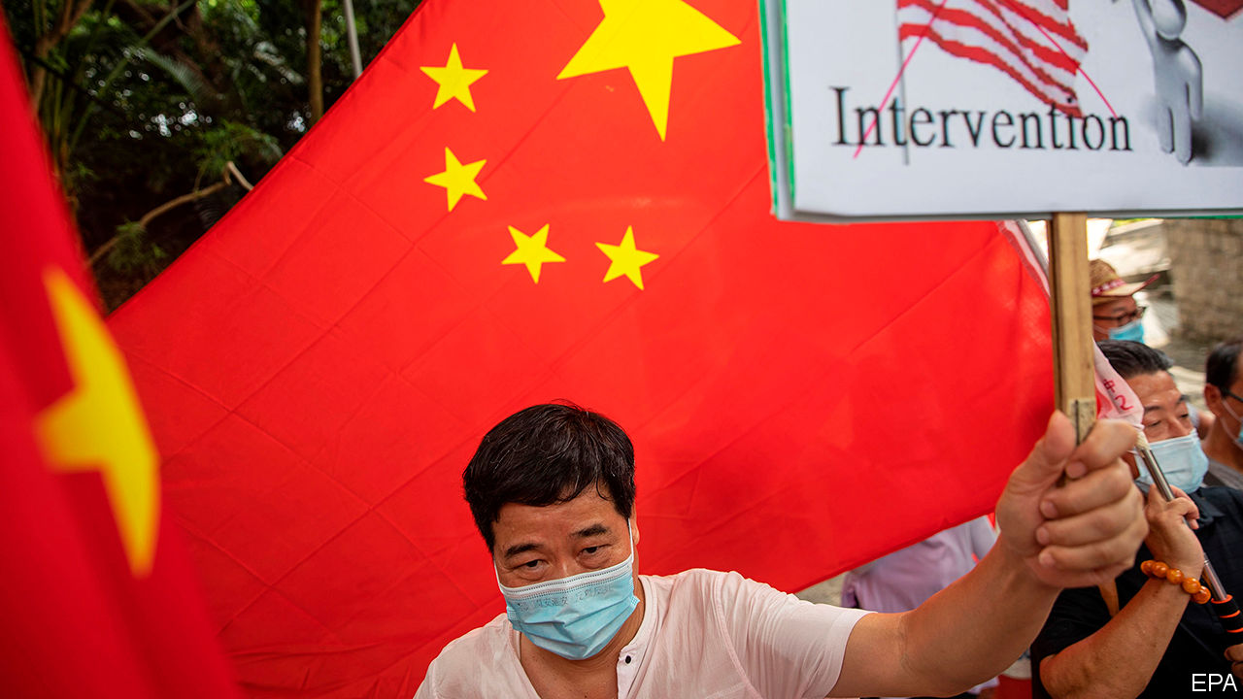

Donald Trump signed an executive order ending Hong Kong’s privileged trading status with America, in response to China’s imposition of a crushing national-security law. Under new legislation, banks aiding officials who implement the law may face sanctions, as may the officials. See article.

Separately, China announced sanctions against American officials, including Marco Rubio and Ted Cruz, two Republican senators. The move was in retaliation against American penalties on Chinese politicians for abusing the human rights of China’s Uighur citizens.

Jeff Sessions was clobbered in Alabama’s Republican Senate primary by Tommy Tuberville. Mr Sessions, a senator for 20 years until 2017, was an early supporter of Donald Trump, who made him attorney-general. His decision to recuse himself from investigations into Russian interference in the 2016 election made the president turn on him. See article.

Chinese officials accused pro-democracy politicians in Hong Kong of harbouring “evil intentions” by staging informal primary elections in preparation for Legislative Council polls in September. They said the democrats wanted to turn Hong Kong into a base for “subversion”—a crime under the new national-security law.

Floods continued to cause massive disruption across central and southern China. The deluges have killed more than 140 people, destroyed about 28,000 homes and caused more than $11bn-worth of damage. See article.

China accused America of stoking tensions in the South China Sea by declaring that China’s claims there are “completely unlawful”.

Brazil’s space agency, INPE, reported that 3,069 square kilometres (1,185 square miles) of the Amazon was cut or burned down from January to June, an increase of 25% from the same period last year. After the announcement, the head of the department responsible for monitoring deforestation was moved to another job. Last year the government sacked INPE’s chief after the agency reported an increase in deforestation.

Martín Vizcarra, Peru’s president, replaced more than half of his cabinet after his approval ratings fell. Pedro Cateriano, a previous prime minister, has taken the job again. The recession caused by the pandemic has led Mr Vizcarra’s popularity to drop from 87% in March to a still-impressive 65%.

Poland’s president, Andrzej Duda, was narrowly re-elected, surviving a fierce challenge from the mayor of Warsaw. Mr Duda’s campaign involved deriding gay people and Jews. See [article](https://www.economist.com/leaders/2020/07/18/polands-president-andrzej-duda-was-re-elected-after-a-nasty-divisive-campaign).

Protests erupted across Belarus after opposition candidates were barred from standing in next month’s presidential election. Meanwhile in Khabarovsk, in Russia’s Far East, crowds demonstrated after the local governor was arrested on a 15-year-old murder allegation. Protesters said his real crime was being more popular than the president, Vladimir Putin. See article.

Temperatures in the Siberian Arctic were up to 10°C hotter during January to June than the average between 1981 and 2010. Climate scientists say greenhouse gases made this 600 times more likely, making it one of only two extreme weather events to be firmly pinned on climate change. See [article](https://www.economist.com/science-and-technology/2020/07/15/siberias-heatwave-would-not-have-happened-without-climate-change).

Boris Johnson, Britain’s prime minister, pledged to hold an independent inquiry into the country’s handling of the coronavirus pandemic. He said the country needed to “learn the lessons” of the outbreak. See article.

The Philippine Congress decided not to renew the broadcasting franchise of ABS-CBN, the country’s biggest television network, in effect putting an end to its efforts to remain on air. The company says it is being persecuted for critical reporting on the government of President Rodrigo Duterte.

Park Won-soon, the mayor of Seoul, committed suicide after police began investigating allegations that he had sexually harassed a secretary.

The ruling People’s Action Party (PAP) won Singapore’s general election, as it has every election since independence in 1965. The opposition won ten out of 93 seats—its best showing ever. The PAP’s share of the vote fell from 70% to 61%. See article.

Libya’s eastern-based parliament said it would “welcome” Egyptian military intervention in the country’s civil war to counter Turkish support for the internationally recognised Government of National Accord (GNA), based in Tripoli. The assembly in the east is aligned with Khalifa Haftar, a general who is trying to overthrow the GNA.

At least seven boats caught fire at Iran’s Bushehr port, state media reported. It was the latest in a series of mysterious fires and explosions in the country, some at sensitive sites, leading to speculation about a campaign of sabotage.

Yemen’s Houthi rebels agreed to give a team of UN inspectors access to an abandoned oil tanker off the country’s Red Sea coast. The vessel, which is leaking, holds over 1m barrels of oil.

Talks between Ethiopia and Egypt over the filling of a controversial dam on the Nile river broke down. Ethiopia has begun filling the dam.

## Coronavirus briefs

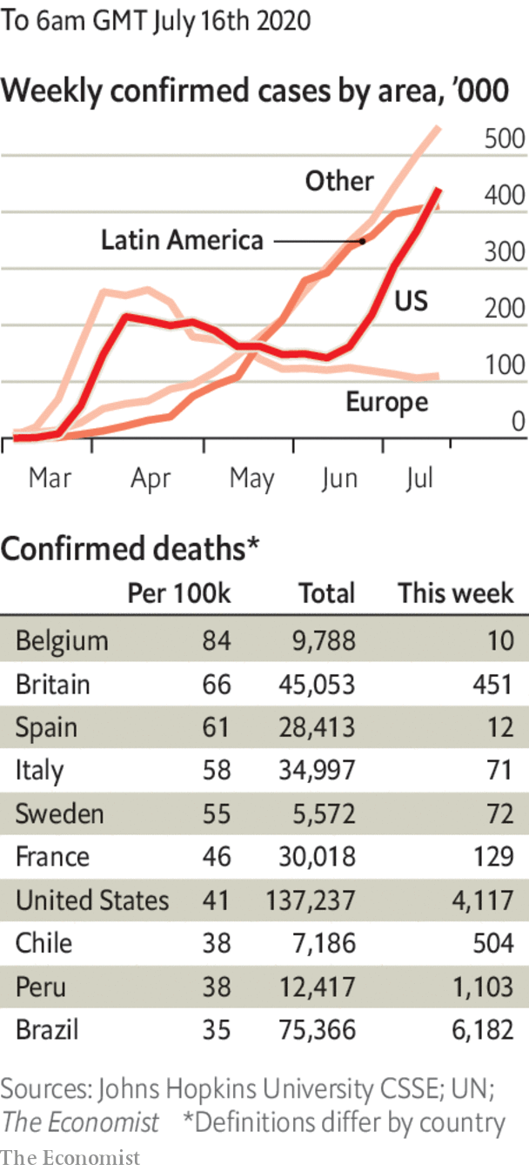

Infections continued to soar in America, to over 60,000 cases a day. Florida reported the largest daily increase of any state since the start of the pandemic. California reimposed many of the curbs it had only recently lifted. See article.

The death toll in Latin America surpassed 145,000, overtaking that in the United States. Only Europe has suffered more deaths—over 200,000.

The regional government in Catalonia put in place restrictions on areas where the disease has flared up again. A judge said only the Spanish government in Madrid could impose lockdowns.

Masks are to be compulsory in shops in England from July 24th. Boris Johnson wore a mask in public for the first time, as did Donald Trump.

South Africa banned sales of alcohol, to free up intensive-care beds for covid-19 patients. See article.

This article was downloaded by calibre from <https://www.economist.com/the-world-this-week/2020/07/18/politics-this-week>

|  |  |  |  |
| --- | --- | --- | --- |
|  | Articles | Sections | Next |

|  |  |  |  |
| --- | --- | --- | --- |
| Previous | Articles | Sections | Next |

# Business this week

Jul 18th 2020 |

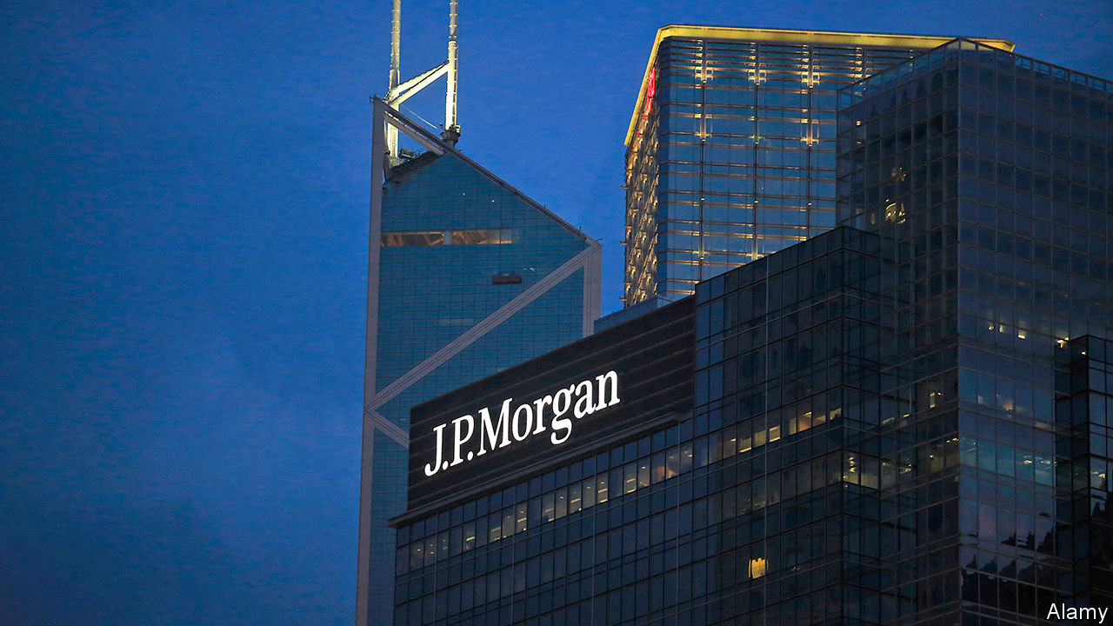

American banks had a mixed start to the second-quarter earnings season, as loan-loss provisions dented earnings. JPMorgan Chase reported net income of $4.7bn, around half what it made in the same period last year, but more than the $3.3bn analysts had forecast. Citigroup’s net income of $1.3bn also beat expectations, but was down by 73% year on year. Goldman Sachs reported net income of $2.4bn, unchanged from the same period a year ago. By contrast, Wells Fargo made a net loss of $2.4bn during the quarter. See [article](https://www.economist.com/node/21789779).

Singapore, which is among the first Asian economies to publish second-quarter GDP figures, announced that its economy had shrunk by a greaterthan-expected 41.2% quarter on quarter in the three months to the end of June. Meanwhile China’s GDP grew by 3.2% year on year in the three months to the end of June, beating forecasts. The figure followed a fall of 6.8% in the first quarter due to covid-19 outbreaks.

Britain said that Huawei’s equipment must be removed from the country’s 5G mobile networks by 2027. It also banned the Chinese company from providing new telecoms kit by the end of the year. The British government admitted that the decision, a U-turn from its previously less hostile position towards Huawei, will delay the country’s roll-out of 5G by up to three years. See article.

PepsiCo reported a fall in profits but still beat analysts’ expectations. The American maker of fizzy drinks and snacks made net revenues of $15.9bn in the three months to June 13th, 3.1% less than in the same period a year ago. Bumper sales of snacks such as Frito-Lay crisps to people stuck at home during lockdown were offset by the damaging impact of restaurant closures on sales of its drinks.

Delta reported a pre-tax loss of $7bn in the second quarter, the second largest in the American carrier’s history. Travel restrictions helped to reduce operating revenue by 88% year on year. The airline also announced plans to scale back its flying schedule for August and to shed at least 17,000 of its 91,000 employees through early retirement. The carrier said it hoped to lure back flyers with promises of extra aircraft cleaning, including “disinfectant electrostatic spraying”.

## Over the white cliffs of Dover

The British government announced plans to spend £705m ($888m) on extra border infrastructure, including the construction of a 27-acre (11-hectare) lorry park in Kent for cross-border checks to take place. Britain is preparing for the imposition of trade controls between it and the European Union after the Brexit transition ends on December 31st. Even if a UK-EU trade deal is reached, officials calculate that firms will need to fill in an extra 215m customs declarations each year at an annual cost of about £7bn. See [article](https://www.economist.com/node/21789792).

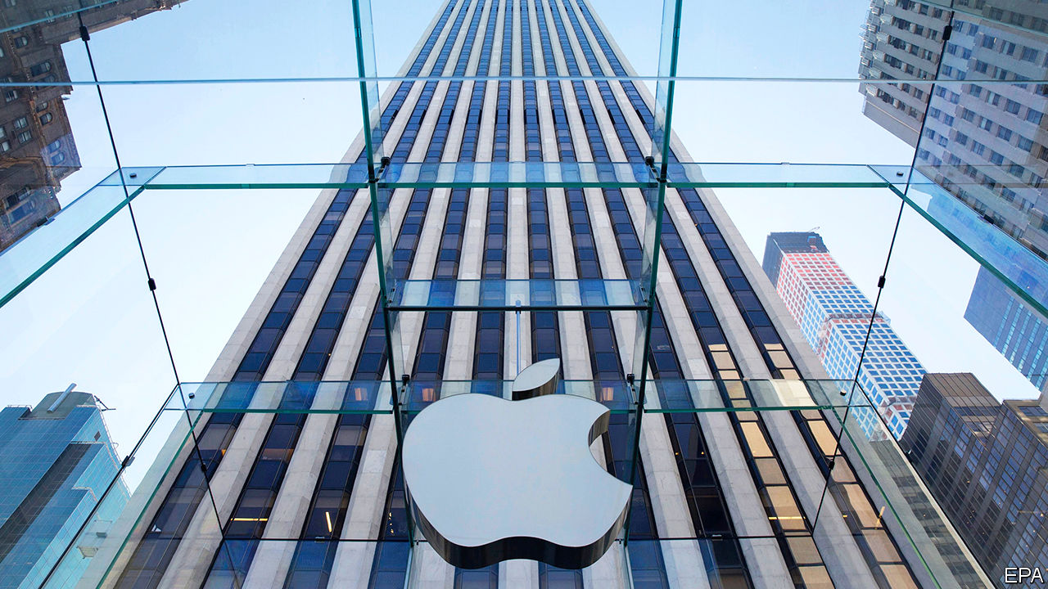

The European Union’s second-highest court dealt Apple a victory, declaring it will not have to pay a €13bn ($14.8bn) Irish tax bill. The ruling overturns a decision made in 2016 by the European Commission and presents its head of competition, Margrethe Vestager, with a challenge as she investigates national tax deals.

Seemingly unharmed by India’s severe lockdown, Infosys, an Indian IT giant, reported that second-quarter profits rose to 42.3bn rupees ($558m), up by 11.5% year on year.

Shares in Moderna, an American biotech firm, soared after it reported that an early trial of its covid-19 vaccine produced a “robust” antibody response in the 45 volunteers who took it. However, a much larger trial will be needed before regulators can approve it.

In a sign that Britain is not heading towards a “V-shaped” recovery, British GDP grew month-on-month by just 1.8% in May after a drop of 20.3% in April. Economists had expected growth of 5.5% in May.

Nissan unveiled its first major new car since Carlos Ghosn was dismissed as its chairman in November 2018. Shares in the Japanese carmaker jumped after it revealed the Ariya, its new all-electric sport utility vehicle, online.

The European Court of Justice struck down an agreement that allowed companies in the bloc to transfer EU residents’ personal data to America. The surprise decision is a win for privacy activists, but could be costly for tech firms.

## Hacked off

The Twitter accounts of several prominent American figures, including Barack Obama, Elon Musk and Bill Gates, were hacked by bitcoin scammers. In response Jack Dorsey, the firm’s chief executive, said “We all feel terrible this happened.”

This article was downloaded by calibre from <https://www.economist.com/the-world-this-week/2020/07/18/business-this-week>

|  |  |  |  |
| --- | --- | --- | --- |
| Previous | Articles | Sections | Next |

|  |  |  |  |
| --- | --- | --- | --- |
| Previous | Articles | Sections | Next |

# KAL’s cartoon

Jul 18th 2020 |

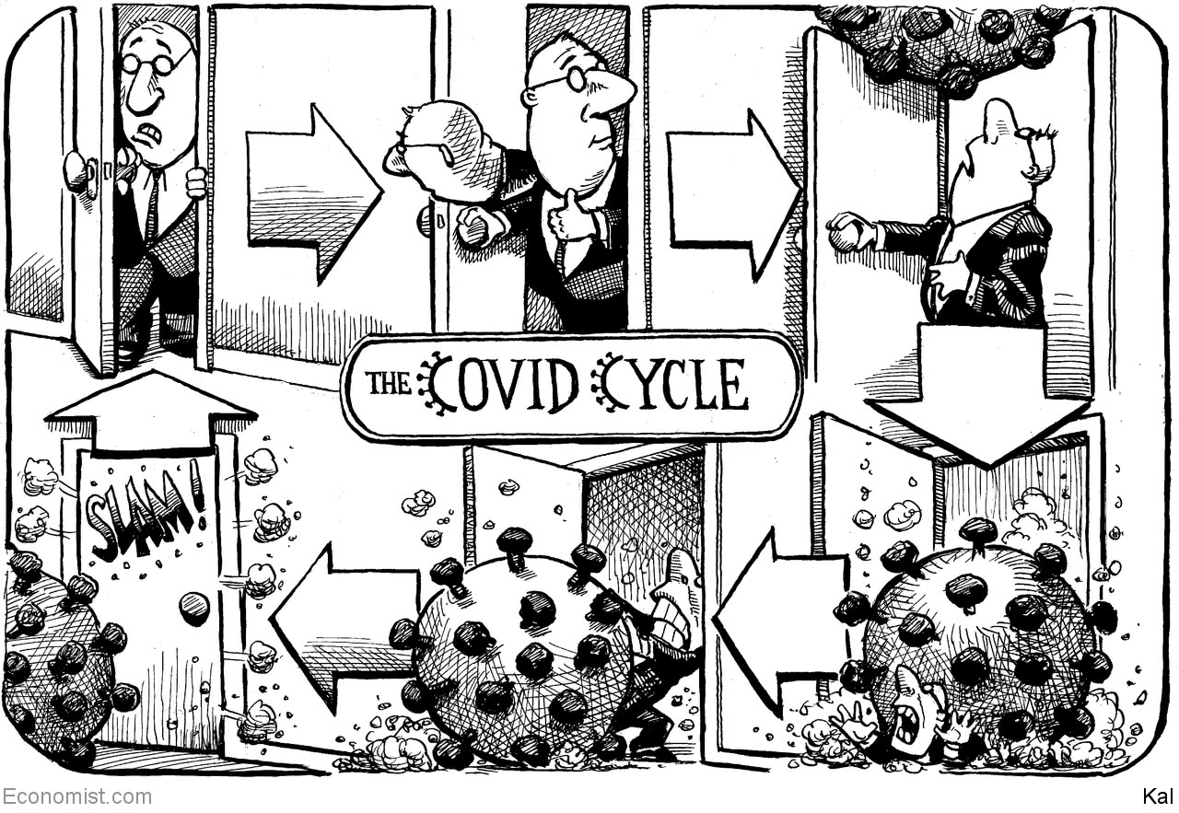

This article was downloaded by calibre from <https://www.economist.com/the-world-this-week/2020/07/18/kals-cartoon>

|  |  |  |  |
| --- | --- | --- | --- |
| Previous | Articles | Sections | Next |

|  |  |  |
| --- | --- | --- |
| The world this week | Sections | Letters |

Leaders

Huawei and the world economy: Trade without trust

.

Covid-19 and schools: Let them learn

.

Poland’s presidential election: A narrow, nasty win

.

Oil and the Arab world: There will be pain

.

Banks and the economy: A window on America

.

|  |  |  |
| --- | --- | --- |
| The world this week | Sections | Letters |

|  |  |  |  |
| --- | --- | --- | --- |
|  | Articles | Sections | Next |

#### Huawei and the tech cold war

# China v America

Doing business with China

Jul 18th 2020 |

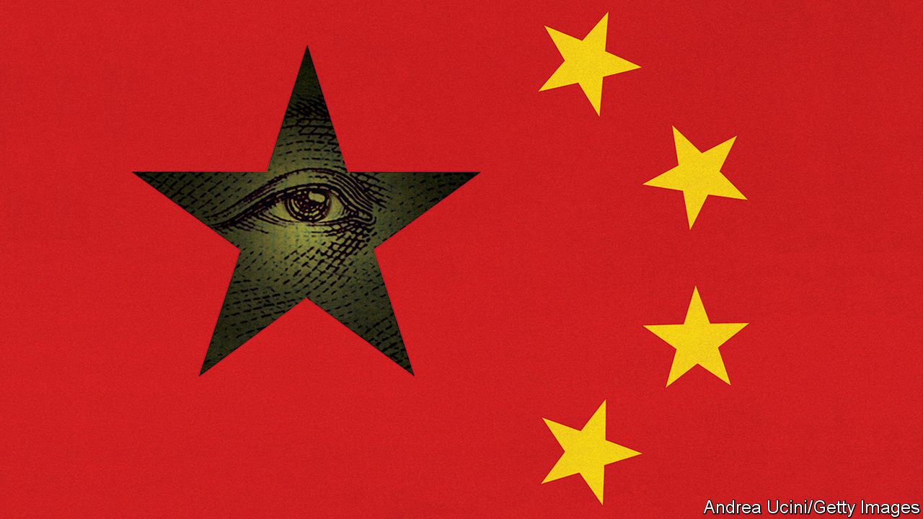

NINETEEN YEARS ago an unknown Chinese company set up its first European sales offices, in a suburb of Frankfurt and an English commuter town, and started bidding to build telecoms networks. Today Huawei symbolises the daunting rise of China Inc—and a global trading system in which trust has collapsed. With sales of $123bn, it is known for its razor-sharp prices and dedication to the industrial goals of China’s rulers. Since 2018 America has subjected it to a legal assault, making it a flashpoint in the trade war. Now Britain has said that it will block Huawei from its 5G networks (see article). Other European countries may follow. But far from showing the West’s resolve, the saga reveals its lack of a coherent strategy. If open societies and authoritarian China are to keep their economic links and avoid a descent into anarchy, a new trade architecture is needed.

America’s security chiefs have always worried that Huawei’s equipment was designed to aid spying and would make its customers dependent on subsidised Chinese technology. But over 170 other countries decided the risks were manageable. Britain, which works closely with America on intelligence, created a “cell” of cyber-experts to monitor Huawei’s gear in 2010 and, later, confined it to less sensitive parts of the network. Other countries mirrored this approach. It offered a middle way between a naive embrace of Chinese state capitalism and a cold war.

Such a finely balanced judgment has proved untenable. The Trump administration has urged the world to ditch Huawei and enforced a unilateral embargo on its suppliers, preventing sales of some components as well as chips made abroad using American tools. Forced to choose between an ally and a supplier, Britain was inevitably drawn to this week’s decision. It has become riskier for anyone to do business with a firm Uncle Sam wants to cripple. Huawei, for its part, has failed to reassure Britain’s cyber-experts, who have complained that its buggy software is getting harder to monitor, or to reform its opaque governance and ownership. Any remaining illusions that China’s leaders respect the rule of law when it really matters have been shattered by events in Hong Kong.

The direct cost of ripping Huawei out of European networks is tolerable—adding less than 1% to Europeans’ phone bills if amortised over 20 years. Ericsson and Nokia, two Western suppliers, can ramp up production and new competition may emerge as networks come to depend more on software and open standards.

The true burden has nothing to do with antennae but stems from the decay of the world’s trading system. Perhaps a dozen countries might end up banning Huawei—Germany is sitting on the fence (see article). But it will still be used in much of the emerging world, hastening the splintering of the tech industry. Trade relies on common rules but Britain’s decision has been made amid a swirl of lobbying and threats. It is hard to elicit a principle behind it that can be usefully applied more broadly. If the problem is gear made in China, then Ericsson and Nokia do that, too. If it is Chinese firms building systems which connect devices (in the case of 5G, robots and machines), then a similar logic could be applied across a digitising world economy. German cars and Apple phones sold in China are packed with software, data and sensors. Is China entitled to ban them, too?

This feeds a spiralling sense of lawlessness. The average tariff on Sino-American trade is 20%. Direct investment flows from China to Europe have dropped by 69% from the peak in 2016, according to Rhodium, a research firm. Other firms are caught in the crossfire. TikTok faces a ban in India and, perhaps, America. China plans to impose sanctions on Lockheed Martin for selling arms to Taiwan. Now that President Donald Trump has ended Hong Kong’s special status, HSBC, a bank with huge interests there, could be subject to punishment by both China and America. Some Chinese lenders may be banned from dealing in dollars.

The logic of the Huawei ban is one of disengagement and containment. But this will not work if it is applied across the entire economic relationship. The West’s last great authoritarian rival, the Soviet Union, was a trade minnow. China accounts for 13% of world exports and 18% of world market capitalisation, and is the dominant economic force in Asia.

Instead a new trade regime is needed that acknowledges China’s nature. That is not easy. The World Trade Organisation (WTO), which aims to set universal rules, has failed to evolve with the digital economy. Nor was it prepared for President Xi Jinping’s drive to increase state and Communist Party influence over private Chinese firms and those, like Huawei, which say they are mutually owned by workers. Disillusioned with the WTO, the Trump administration’s negotiators unilaterally tried to wrestle China into liberalising its economy and cutting subsidies, using the threat of tariffs and embargoes. That has been a fiasco.

So how should the trade architecture work in an age of mistrust? The goal should be to maximise trade consistent with both sides’ strategic security. That means fencing off flashpoints, such as tech, that generate lots of tension but a minority of trade: perhaps a third of Western firms’ sales to China based on our analysis of Morgan Stanley’s data, for example. These sectors will require scrutiny and international security certification of the kind Britain tried with Huawei. It may not work. But at least commerce in other areas can flourish.

Chinese firms should also be required to accept open governance of their big subsidiaries in the West, including local shareholders, foreign directors and managers with real autonomy, and disclosures that all help create a degree of independence from the state. This is not hard: multinationals such as Unilever have been doing it for decades. TikTok could be a pioneer.

## The ultimate network effect

Open societies are stronger when they act in unison. Europe may be tempted to go it alone, ending decades of transatlantic co-operation. Yet at some point, soon if Mr Trump fails to win a second term, America will reinvigorate its alliances because it has been less effective without them. The West cannot fundamentally change China or ignore it. But by acting together, it can find a way to do business with an authoritarian state it mistrusts. Huawei marked a failure to do this. Time to start again.■

This article was downloaded by calibre from <https://www.economist.com/leaders/2020/07/18/china-v-america>

|  |  |  |  |
| --- | --- | --- | --- |
|  | Articles | Sections | Next |

|  |  |  |  |
| --- | --- | --- | --- |
| Previous | Articles | Sections | Next |

#### Let them learn

# The risks of keeping schools closed far outweigh the benefits

Millions of young minds are going to waste

Jul 18th 2020 |

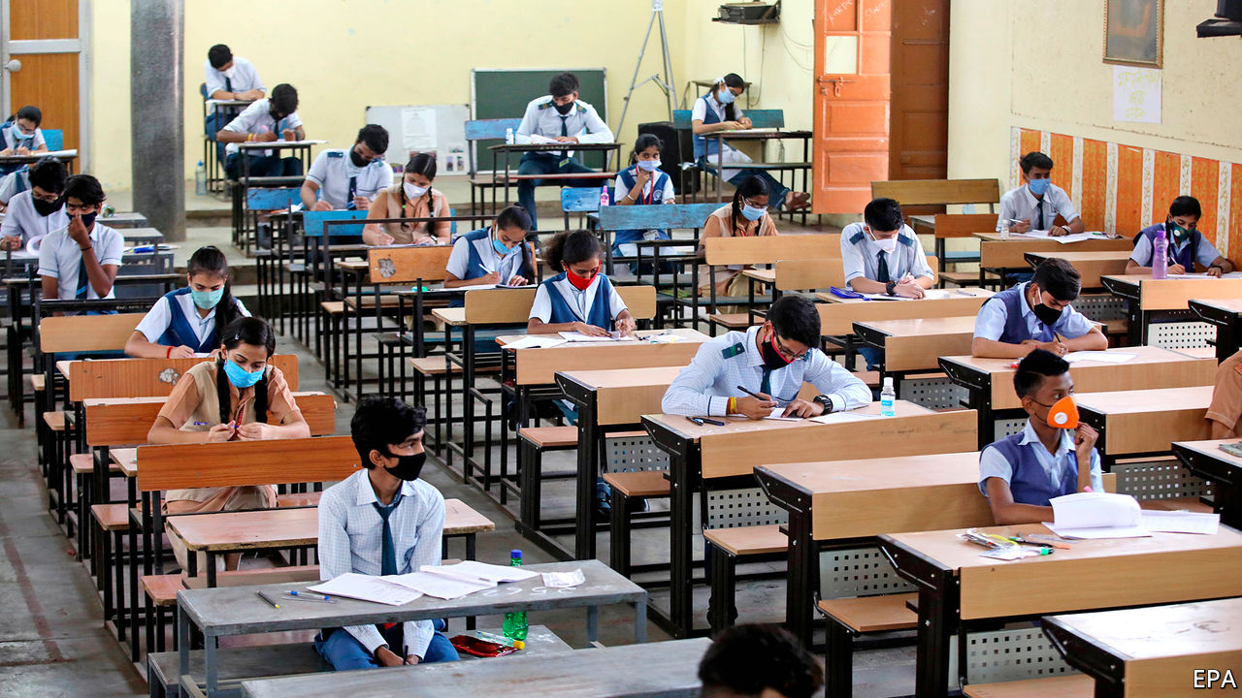

Editor’s note: Some of our covid-19 coverage is free for readers of The Economist Today, our daily [newsletter](https://my.economist.com/user#newsletter). For more stories and our pandemic tracker, see our [hub](https://www.economist.com/news/2020/03/11/the-economists-coverage-of-the-coronavirus)

ALL AROUND the world, children’s minds are going to waste. As covid-19 surged in early April, more than 90% of pupils were shut out of school. Since then the number has fallen by one-third, as many classrooms in Europe and East Asia have reopened. But elsewhere progress is slow. Some American school districts, including Los Angeles and San Diego, plan to offer only remote learning when their new school year begins. Kenya’s government has scrapped the whole year, leaving its children idle until January. In the Philippines President Rodrigo Duterte says he may not let any children return to the classroom until a vaccine is found. South Africa has reopened casinos, but only a fraction of classrooms.

Many parents are understandably scared. Covid-19 is new, and poorly understood. Schools are big and crowded. Small children will not observe social distancing. Caution is appropriate, especially when cases are rising. But as we have argued before, the benefits of reopening schools usually outweigh the costs.

The new coronavirus poses a low risk to children. Studies suggest that under-18s are a third to a half less likely to catch the disease. Those under ten, according to British figures, are a thousand times less likely to die than someone aged between 70 and 79. The evidence suggests they are not especially likely to infect others. In Sweden staff at nurseries and primary schools, which never closed, were no more likely to catch the virus than those in other jobs. A new study of 1,500 teenage pupils and 500 teachers who had gone back to school in Germany in May found that only 0.6% had antibodies to the virus, less than half the national rate found in other studies. Granted, an outbreak at a secondary school in Israel infected over 150 pupils and staff. But with precautions, the risk can be minimised.

However, the costs of missing school are huge. Children learn less, and lose the habit of learning. Zoom is a lousy substitute for classrooms. Poor children, who are less likely to have good Wi-Fi and educated parents, fall further behind their better-off peers. Parents who have nowhere to drop their children struggle to return to work. Mothers bear the heavier burden, and so suffer a bigger career setback. Children out of school are more likely to suffer abuse, malnutrition and poor mental health.

School closures are bad enough in rich countries. The harm they do in poor ones is much worse (see [article](https://www.economist.com/node/21789763)). Perhaps 465m children being offered online classes cannot easily make use of them because they lack an internet connection. In parts of Africa and South Asia, families are in such dire straits that many parents are urging their children to give up their studies and start work or get married. The longer school is shut, the more will make this woeful choice. Save the Children, a charity, guesses that nearly 10m could drop out. Most will be girls.

Education is the surest path out of poverty. Depriving children of it will doom them to poorer, shorter, less fulfilling lives. The World Bank estimates that five months of school closures would cut lifetime earnings for the children who are affected by $10trn in today’s money, equivalent to 7% of current annual GDP.

With such catastrophic potential losses, governments should be working out how to reopen schools as soon as it is safe. This should not be a partisan issue, as it has sadly become in America, where some people assume it is a bad idea simply because President Donald Trump proposes it. In some countries teachers’ unions have been obstructive, partly out of justified concern for public health as cases climb, but also because teachers’ interests are not the same as children’s—especially if they are being paid whether they work or not. The main union in Los Angeles urges that schools remain closed until a long wishlist of demands has been met, including the elusive dream of universal health care in America. Children cannot wait that long.

Places that have restarted schooling, such as France, Denmark, China and New Zealand, offer tips for minimising the risks. They let the most vulnerable teachers stay at home. They commonly reduced class sizes, even though that meant many children could spend only part of the week with their teachers. They staggered timetables to prevent crowding in corridors, at school gates and in dinner halls. They required or encouraged masks. They boosted school-based testing and tracing. The Centres for Disease Control and Prevention has used these to draw up sober guidelines, which include measures such as separating desks by six feet (though the vice-president this week said that schools should feel free to ignore them).

European countries waited on average about 30 days after infections had peaked before they resumed some presence at school. Having started this way, many have since relaxed the rules to let most pupils return to school at the same time. There is no known experience of schools reopening in places where the virus was as prevalent as it is now in Arizona, Florida or Texas. Such places will have to bring the virus under control before the new term begins. This probably means that not all children will be able to go back full-time even then. But a few days a week with a teacher are better than none. And, as in Europe, schools can open up more as covid-19 recedes.

The trade-offs in the global South are even harder. Only a quarter of schools in the poorest countries have soap and running water for handwashing. However, schools in such places are also where pupils are often fed and vaccinated. Closing them makes children more vulnerable to hunger and measles, and this risk almost certainly outweighs that of covid-19. The prudent course for poor-country governments is therefore to act boldly. Face down unions and reopen schools. Conduct loud re-enrolment campaigns, aimed especially at girls. Offer small cash transfers or gifts (such as masks or pens) to ease parents’ worries about the costs of getting their offspring back to class.

Reopening the world’s schools safely will not be cheap. Besides billions of bottles of hand sanitiser, it will require careful organisation, flexible schedules and assistance for those who have fallen behind to catch up. It will cost taxpayers money, but taxpayers are often parents, too. Rich countries should help poor ones with some of the costs. Steep as these will be, they are nothing like the costs of letting the largest generation in human history grow up in ignorance. ■

This article was downloaded by calibre from <https://www.economist.com/leaders/2020/07/18/the-risks-of-keeping-schools-closed-far-outweigh-the-benefits>

|  |  |  |  |
| --- | --- | --- | --- |
| Previous | Articles | Sections | Next |

|  |  |  |  |
| --- | --- | --- | --- |
| Previous | Articles | Sections | Next |

#### A win for intolerance

# A nasty election in Poland

The government should move to the centre

Jul 18th 2020 |

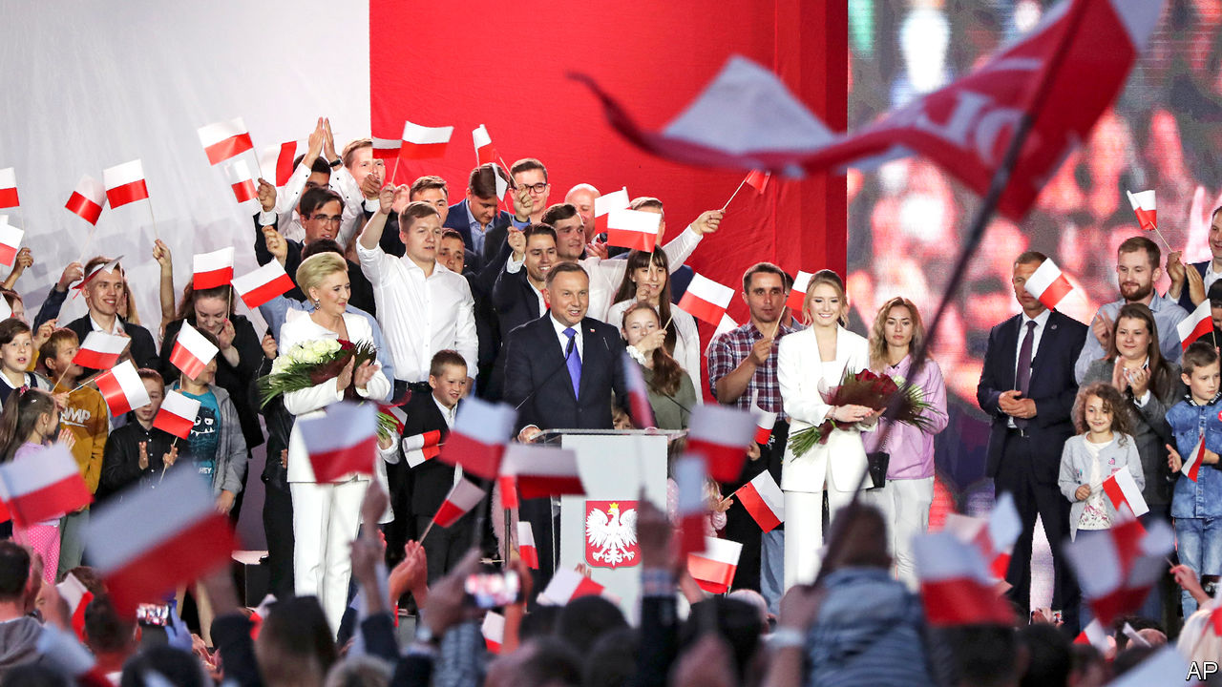

IT WAS A good week for eastern Europe’s populists. In Poland the nationalist Law and Justice party (PiS) fought off a determined challenge for the presidency from the moderate mayor of Warsaw. The ruling party’s favoured candidate clung on partly because Poland’s economy has continued to grow healthily under PiS, and because the government has lavished popular cash subsidies on families with children. But there was also a darker reason for President Andrzej Duda’s narrow victory: he stirred up hatred of gay people, Jews and the liberals who supposedly conspire with foreigners to undermine Polish traditions.

Meanwhile Viktor Orban, the populist prime minister of Hungary, looked set to get one over on the bien pensants of Brussels. They wanted to make the disbursement of a €750bn ($857bn) European Union recovery fund conditional on recipient countries abiding by the rule of law. Mr Orban did not like the sound of that, and threatened to veto the whole package. Other European leaders are likely to back down, since their voters care more about economic pain at home than court-nobbling in Hungary.

Mr Duda’s success leaves Poland divided (see article). He won solidly in the conservative, rural east of the country, and among older voters; he was trounced in the big cities, in the west of the country generally and in particular among the young. The result was 51% to 49% after a second round of voting that saw liberals rally around Rafal Trzaskowski, the mayor of the capital. That was a blow to liberal hopes, because the president, while having no executive power, can veto new laws. PiS, which last year lost control of Poland’s Senate, had already been weakened. A veto-wielding Mr Trzaskowski would have frustrated its attempts to steer a populist course.

Mr Trzaskowski was hardly someone to horrify elderly Catholics, much though PiS tried to portray him as such. Like Barack Obama before 2012, he declined to endorse gay marriage, while supporting civil partnerships. (His party, Civic Platform, is similarly reluctant to get too far ahead of public opinion.) Also like his party, he does not favour widening the availability of abortion, which is allowed only in cases of serious congenital defects, to protect the life of the mother or in cases of rape or incest. Still, he represents a different direction of travel from the one favoured by many PiS politicians and by Mr Duda, who talk of tightening the abortion rules still further. On the campaign trail, Mr Duda described gay and transgender rights as an ideology that is worse than communism. He also benefited from unremittingly positive coverage from the state broadcaster, which may have tipped a close contest. In parts of the country, people rely heavily on state television.

In the wake of Mr Duda’s victory, the ruling party must decide how to govern. Should it double down on a winning strategy, further limiting abortion for instance, and continuing its efforts to bend what is left of Poland’s independent judiciary to its will? Brussels will not stop it. If Europeans cannot summon the will to punish the blatant violations of democratic norms in Hungary, they are unlikely to punish Poland’s lesser sins.

The alternative is to tack to the centre. That would be the wiser course of action—for both Poland and PiS. Poland remains a conservative country, but it is steadily becoming less so. Economic growth is gradually transforming the countryside. Unlike Hungary, Poland is still a pluralist and vibrant place, with strong institutions and a fearless press, though PiS is trying to muzzle it. If it knows what is good for it, the ruling party will dial down the hate mongering, and shift to where more voters are, as some of its moderates want. The opposition, meanwhile, should keep trying to hold it to account, and prepare for the next election. ■

This article was downloaded by calibre from <https://www.economist.com/leaders/2020/07/18/a-nasty-election-in-poland>

|  |  |  |  |
| --- | --- | --- | --- |
| Previous | Articles | Sections | Next |

|  |  |  |  |
| --- | --- | --- | --- |
| Previous | Articles | Sections | Next |

#### There will be pain

# With oil cheap, Arab states cannot balance their books

The crisis is an opportunity to move beyond hydrocarbons

Jul 18th 2020 |

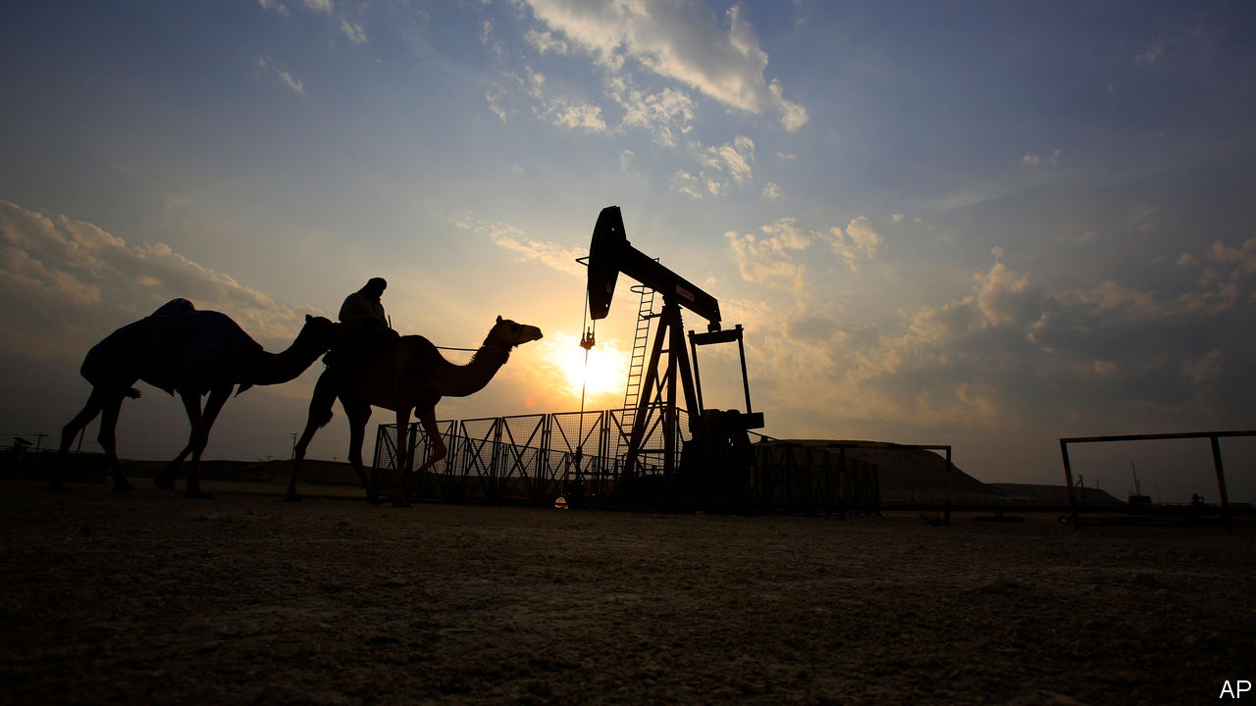

AMID WARLORDS and bandits, as smallpox spread around him, George Bernard Reynolds searched the sands of Persia (now Iran) for oil. The British geologist drilled for seven years—and found little. Finally his financiers said enough was enough: it was time to dismiss the staff, dismantle the equipment and come home. Instead Reynolds kept drilling. And in the early morning hours of May 26th 1908, he struck a gusher. It was the first big petroleum find in the Middle East, but certainly not the last. Oil would soon transform the region’s economies, enrich its ruling families and attract more foreign influence.

A century later another big change is coming, as countries around the world adopt cleaner sources of energy. Peak demand for oil may still be years away, but covid-19 has given the Middle East and north Africa a taste of the future. Prices of the black stuff plummeted as countries went into lockdown. The region’s energy exporters are expected to earn about half as much oil revenue this year as they did in 2019; the IMF reckons their economies will shrink by 7.3%. Even when the virus recedes, a glut of supply will probably keep prices down. Faced with budgets that no longer add up, Arab states must adapt.

The challenge they face is daunting (see [article](https://www.economist.com/node/21789797)). Take Algeria, which needs the price of oil to be over $100 a barrel for its government’s books to balance. The price of Brent crude, a benchmark, is just over $40. So in May the Algerian government said it would cut its budget by half. Things are no better in Iraq, a big oil exporter, which is nearly broke. Even stable producers such as Oman and Kuwait are living beyond their means. Saudi Arabia, the world’s biggest oil exporter, has been burning through its cash reserves for months. Money that was meant to smooth the kingdom’s transition to a less oily economy is now propping up the old petrostate.

The effects will be felt across the region. Egypt exports little oil, but over 2.5m of its citizens work in oil-rich countries. Remittances are worth 9% of its GDP. As oil revenues fall and some of those jobs disappear, Egypt will suffer, too. The same is true of Jordan, Lebanon and the Palestinian territories, which have long relied on the Gulf to absorb their jobless masses. These countries also count on oil producers as customers. Around a third of exports from Jordan and Lebanon go to oil-rich states, which send back wealthy tourists. Kuwaitis, Saudis and Emiratis account for about a third of tourist spending in Lebanon.

The good news is that many Arab countries have plans to wean their economies off oil. Reform programmes with fancy names like “Vision 2030” aim to unleash the private sector, employ more women, cut subsidies and invest in non-oil industries. The bad news is that these states are moving too slowly. Some have cut their bloated bureaucracies and pared back subsidies. Saudi Arabia recently tripled its value-added tax. But the public sector is still the region’s main employer. Despite talk of diversification, the Gulf’s economies continue to revolve around oil. Now Arab leaders speak of a wave of privatisations to bring in new revenue. What have they been waiting for?

Part of the answer is that these reforms will be painful and are harder in bad times. But today’s crisis also provides a chance to build vibrant, sustainable economies and representative governments. Rulers can no longer afford to buy loyalty with do-nothing public-sector jobs and free services. The plans put forward by leaders like Saudi Arabia’s Muhammad bin Salman are tearing up the social contract. Saudis wonder why he doesn’t sell his $550m yacht instead of raising taxes. Anger is growing across the region. For the past century Arabs have been ruled by abusive leaders who hoarded their country’s wealth. Now these leaders are asking their people to make sacrifices and giving them little say in the matter. That is a recipe for continuing unrest and brutal suppression. If Arab rulers want citizens to pay their way, they will need to start earning their consent. ■

This article was downloaded by calibre from <https://www.economist.com/leaders/2020/07/18/with-oil-cheap-arab-states-cannot-balance-their-books>

|  |  |  |  |
| --- | --- | --- | --- |
| Previous | Articles | Sections | Next |

|  |  |  |  |
| --- | --- | --- | --- |
| Previous | Articles | Sections | Next |

#### America’s economy and the banks

# Banks are a window into the economy

Wall Street banks book giant trading profits and giant bad-debt charges

Jul 18th 2020 |

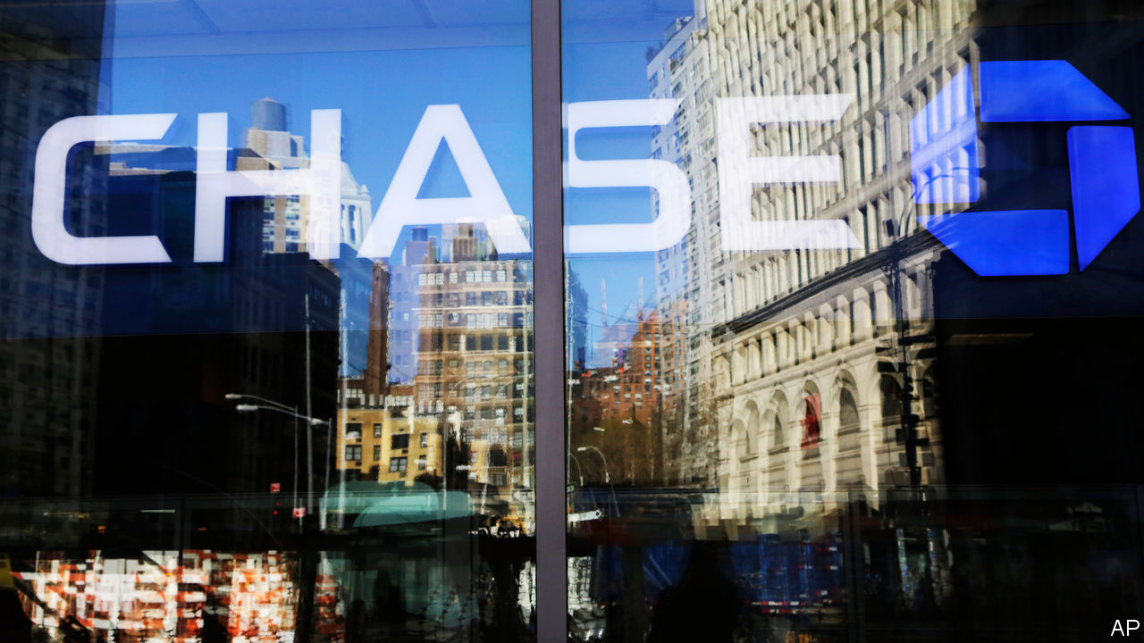

IF YOU WANT a sense of what is happening to America’s economy during one of the most unusual periods in its modern history, a decent place to start is its banks. Several of the very largest firms, including JPMorgan Chase, Citigroup, Wells Fargo and Goldman Sachs, have just updated investors. Together they have trillions of dollars of assets and dealings with many of the households and firms hit by the pandemic. The message is that Wall Street is booming even as Main Street is suffering.

When the pandemic struck, markets collapsed but the Federal Reserve started buying up government debt and promised to purchase all sorts of private assets, including corporate debt. Shares and bond prices soared and many companies, facing a shortfall in revenue because of the lockdowns, rushed to raise capital, mainly by issuing new bonds to investors but also by selling shares. In total some $5.4trn has been raised worldwide so far this year.

This has created a windfall on Wall Street (see [article](https://www.economist.com/node/21789787)). In the second quarter markets revenues at Citibank, Goldman Sachs and JPMorgan were higher than at any time since the global financial crisis, almost doubling over the same period in 2019. Goldman Sachs, one of the two remaining big stand-alone investment banks, saw revenues jump by 41%. True to form, it wasted no time in handing over more to its staff. Their 35% pay increase meant that its indulgent and long-suffering shareholders saw profits rise by only 2%.

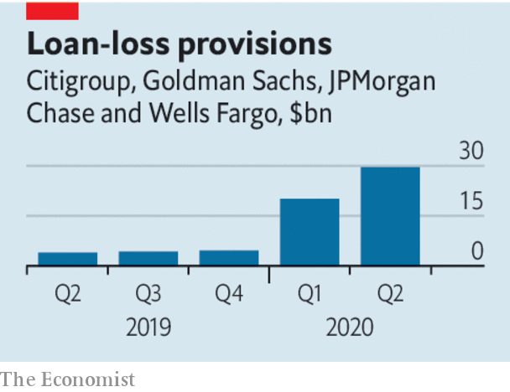

The real world is less reassuring. Under accounting and supervisory rules, bankers have to prepare for expected losses on loans that go sour, by making provisions now. The sums involved are staggering. The four big banks that have reported set aside $30bn, on top of the $20bn they earmarked in the first quarter. In total the bad-debt reserves they hold are equivalent to 2-4% of their consumer and corporate loan books. Provisions for bad loans now exceed those set aside at the height of the financial crisis. This dragged overall profits down by 50-70% year on year at the big banking conglomerates. Wells Fargo, which does not have a large Wall Street operation to offset charges for dud loans, recorded its first loss since 2008.

What about the outlook? Few investment-bank bosses expect Wall Street to see such stellar results in the second half of the year. Trading volumes have already fallen back and, now that big businesses have their war chest, they will not need to raise so much new money. But the most striking signal from the banks is just how much depends on whether the virus can be controlled—and what the government does. Asset prices have been lifted because of the extraordinary, and necessary, interventions made by the Fed to restart activity. Main Street is staying afloat thanks to generous government handouts. It is unprecedented that unemployment has jumped to post-war highs while income and savings are rising. Half of the consumers who requested deferrals for credit-card and mortgage payments from JPMorgan have kept paying their bills. Whether they will still do so when the government stimulus tapers is another matter. Ominously, Michael Corbat, the boss of Citigroup, admitted that “We are in a completely unpredictable environment.”

That the banks are not sharing the pain in a time of hardship may stick in the craw. But it is better than weak lenders dragging down the rest of the economy, as in the financial crisis. The idea of letting lenders run investment banks no longer looks as risky as it did, given that Wall Street revenues generate profits which can offset Main Street losses. And America’s banking system sits on a vast capital buffer worth a total of $1.2trn. The message from banks is not reassuring. The state of banks is more so.■

This article was downloaded by calibre from <https://www.economist.com/leaders/2020/07/18/banks-are-a-window-into-the-economy>

|  |  |  |  |
| --- | --- | --- | --- |
| Previous | Articles | Sections | Next |

|  |  |  |
| --- | --- | --- |
| Leaders | Sections | Briefing |

Letters

Letters to the editor: On resilience, advertising, maritime quarantine, Joe Biden, zoonotics, covid-19, deforestation, Boris Johnson, bubbles, the Stone Roses

.

|  |  |  |
| --- | --- | --- |
| Leaders | Sections | Briefing |

|  |  |  |  |
| --- | --- | --- | --- |
|  | Articles | Sections | Next |

#### On resilience, advertising, maritime quarantine, Joe Biden, zoonotics, covid-19, deforestation, Boris Johnson, bubbles, the Stone Roses

# Letters to the editor

A selection of correspondence

Jul 18th 2020 |

Letters are welcome via e-mail to letters@economist.com

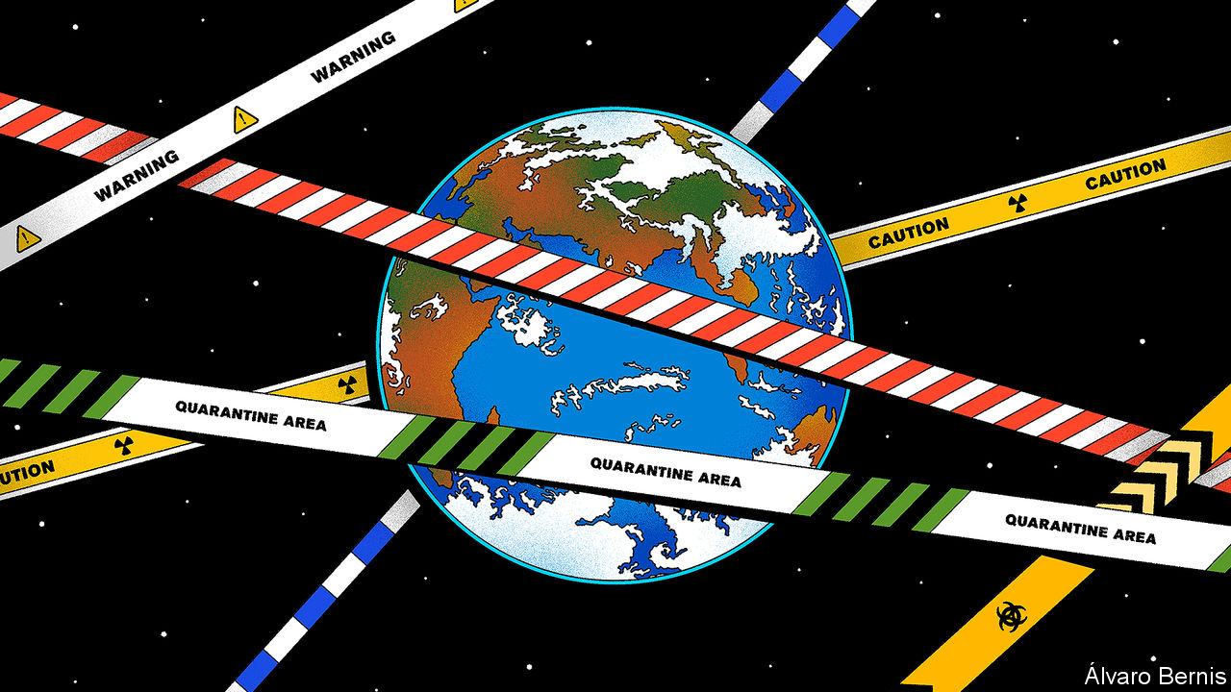

## Building resilience

Your briefing on catastrophic risks highlighted the necessary role of governments in preparing for low-probability, high-consequence events (“[What’s the worst that could happen?](https://www.economist.com/briefing/2020/06/25/the-world-should-think-better-about-catastrophic-and-existential-risks)”, June 27th). It summed up my personal experience with a software startup, based on an algorithm to detect infrequent, but potentially catastrophic power-plant failures. Our algorithm worked really well at detecting their precursors and successfully prevented them. We quickly learned, however, that it is tough to build a business model around resilience.

From a societal point of view, it makes good sense to invest in preventing low-probability, high-consequence events. But for a single asset owner, the low probability of occurrence simply didn’t pencil out. We learned that devising innovative products that could reduce near term costs or increase efficiency was a much better business, and adjusted accordingly. In other words, we got out of the business of selling resiliency products. Resilience is something that the market won’t support, but yet is clearly in society’s interest. Preparedness is something that governments are for.

TIM LIEUWEN  
Executive director  
Strategic Energy Institute  
Georgia Institute of Technology  
Atlanta

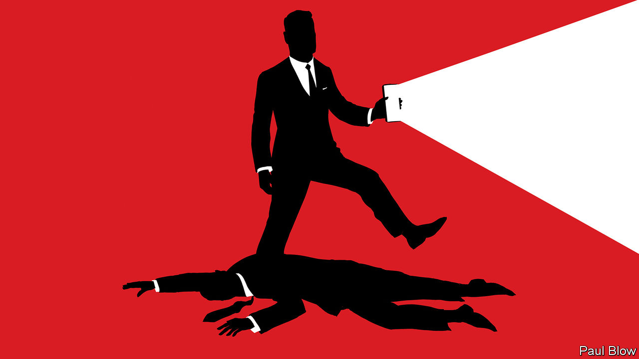

## Effective advertising

I would urge any chief marketing officer who has read “[The new admen](https://www.economist.com/business/2020/06/27/the-advertising-business-is-becoming-less-cyclical-and-more-concentrated)” (June 27th) to think twice about sacking their advertising agency. Digital advertising is alluring as it is cheap, shiny and easy to measure, and therefore easy to justify on a balance-sheet. However, it is substantially less effective than traditional advertising: TV campaigns have a considerably higher return on investment than online displays. It would seem that the case for good, old-fashioned creativity is not as outdated as one might think. Though the use of the term “admen” might be.

ALICE WALKER  
Strategist and adwoman  
BBH  
London

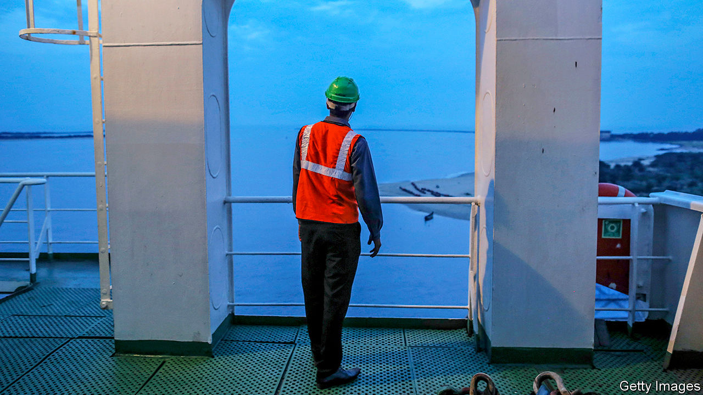

## Maritime quarantine

* Your recent article laments the plight of seafarers being stranded aboard ships during the covid-19 crisis (“[Invisible hands](https://www.economist.com/leaders/2020/06/20/cargo-ship-crews-are-stuck-at-sea)”, June 20th). As an international maritime centre, Hong Kong is always mindful of the need to support the global and local shipping community. We recognise the significance of cargo operations and have exempted crew members of vessels entering Hong Kong to load and unload goods from compulsory quarantine since the requirement was imposed in February. This was extended in June to cover all cargo vessels and passenger ships, including cruise ships, even when entering Hong Kong purely for crew change.  
  
The latest initiative further aids the shipping sector by allowing crew changes for more vessels, which provides relief for seafarers who have remained on board vessels for an excessively long time. These measures, which address industry requests, are the outcome of our close communication with the maritime industry. They also reflect Hong Kong’s prompt and positive response to calls from the International Maritime Organisation, International Chamber of Shipping, seafarers’ trade unions and other industry bodies. As a global shipping centre, Hong Kong will continue to explore and devise ways to facilitate maritime trade operations and assist seafarers not just for Hong Kong but for the whole of the shipping world.

FRANK CHAN  
Secretary for Transport and Housing  
Hong Kong Special Administrative Region Government

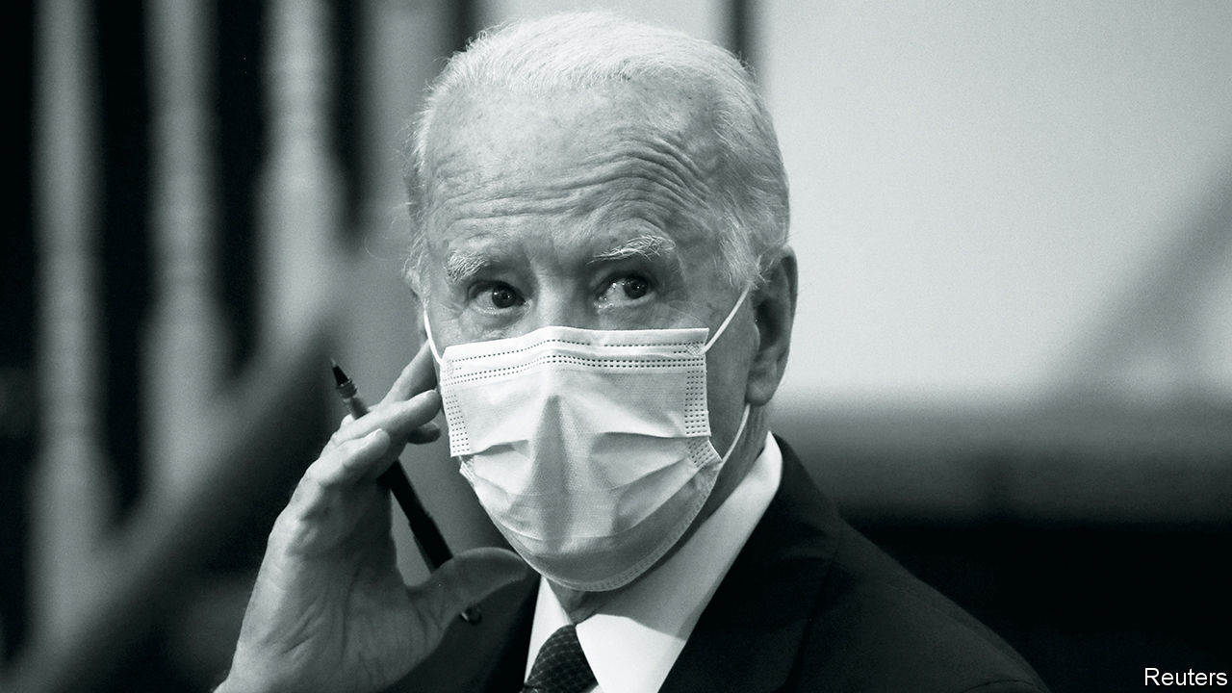

## The art of crafting bills

Assessing Joe Biden’s candidacy, you concluded that some consequential presidents have been accidental radicals, using the example of Lyndon Johnson and the passage of the Civil Rights Act in 1964 (“[Retro or radical?](https://www.economist.com/leaders/2020/07/02/why-joe-bidens-instinctive-caution-makes-real-change-possible)”, July 4th). Although Johnson strongly supported the civil-rights bill, had it not been for Hubert Humphrey, the Democratic whip in the Senate at the time, the obstacles to its passage would not have been overcome, including a 54-day filibuster. Bill Moyers, a political journalist, described Humphrey as a great orator, but also a great plumber, because he not only spoke eloquently as an indefatigable defender of human rights, he also worked assiduously on a bipartisan basis to draft and pass progressive legislation.

The skill of crafting legislative compromises must be recovered in Congress. Mr Biden will require similar talents in the Senate whether or not there is a Democratic majority come November if he wants his presidency to be transformative.

ED GIERA  
London

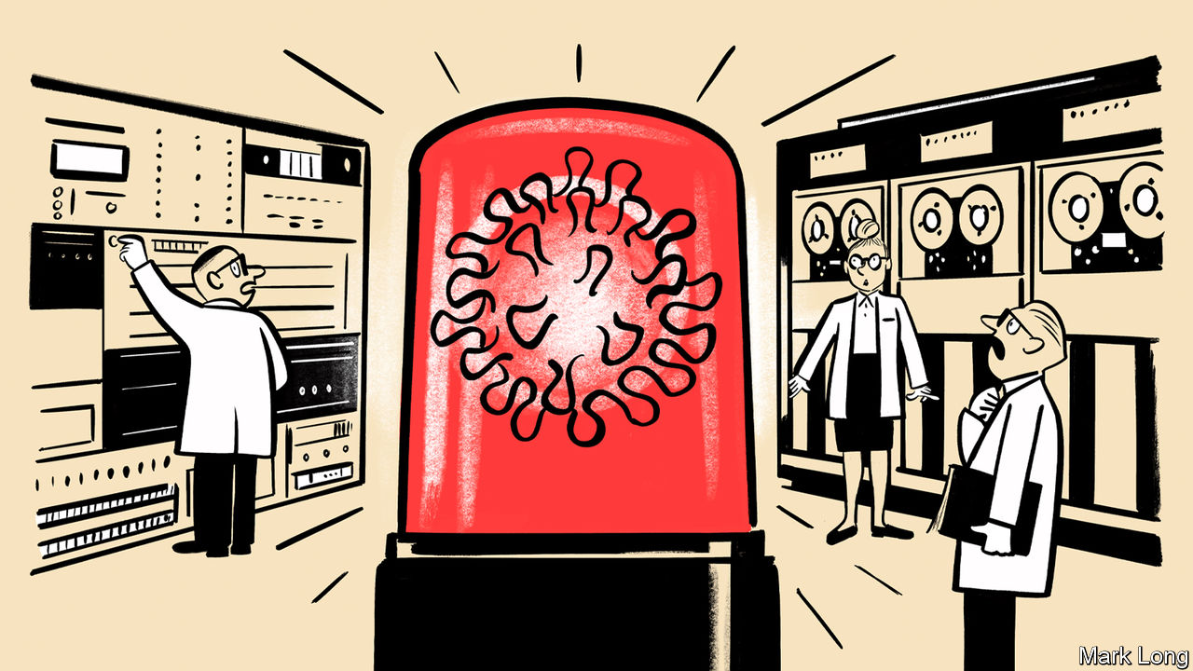

## From animals to humans

A greater understanding of the zoonotic-disease risk from wildlife is critical to mitigating future risks of a global disease outbreak (“[Pandemic-proofing the planet](https://www.economist.com/science-and-technology/2020/06/25/pandemic-proofing-the-planet)”, June 25th). Fieldwork by our staff and others has documented the threats from the increasing human interaction with wildlife, particularly mammals and birds, across the world. This has come about by the continued degradation of intact ecosystems and the increase in wild animals being removed from their natural habitats and transported for sale and consumption in urban centres.

The most simple, most cost-effective action governments can take with immediate effect is to ban the commercial trade of wild birds and mammals for consumption. This would significantly reduce the risk of future zoonotic transmission; safeguard resources for indigenous peoples and local communities who rely on the animals; and protect biodiversity. It would not cost billions of dollars. The Chinese and Vietnamese governments are currently leading the way in this direction, others should follow.

CHRIS WALZER  
JOE WALSTON  
Wildlife Conservation Society  
New York



## Must do better

“[Unhappy medium](https://www.economist.com/united-states/2020/06/27/decoding-the-confusing-messages-of-the-coronavirus-epidemic-in-america)” (June 27th) looked at the confusion in the American government’s communications on covid-19. America has a high level of preparedness for health hazards. The United States had the best overall score in the Global Health Security Index of 2019, which ranked 195 countries on disease prevention, detection, rapid response, health systems, compliance with norms and the risk environment. And yet infections are soaring. Despite the institutional strengths, the crisis was poorly managed from the top. The Trump administration has misled the public on the seriousness of the outbreak and given contradictory messages about wearing face masks and observing social distancing. The divergence between America’s strength on paper and its performance failure deserves to be quantified.

VINOD THOMAS  
Former senior vice-president for independent evaluation at the World Bank  
Singapore

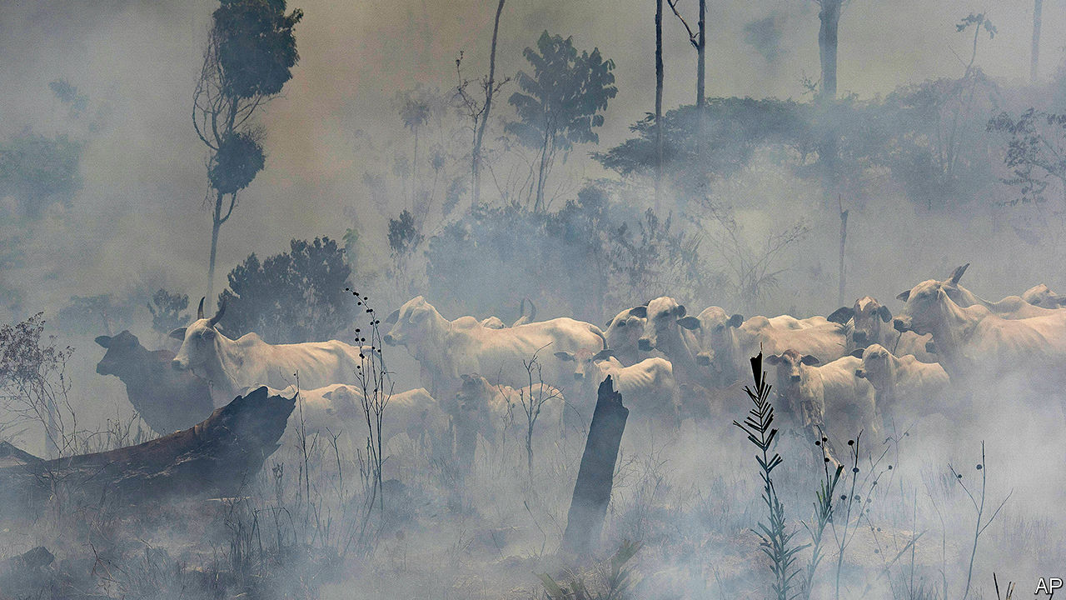

## Amazon deforestation

* I was encouraged to see your image of cattle on a burned forest rather than the customary photos of trucks loaded with logs and that your piece focused on land clearing for agriculture and cattle farming as main drivers of the Amazon's deforestation (“[Of chainsaws and supply chains](https://www.economist.com/the-americas/2020/06/11/how-big-beef-and-soya-firms-can-stop-deforestation)”, June 13th). Over the past few decades much has been learned about landscape approaches, land titling and how to use land taxes, economic incentives and sustainable certification schemes in production forestry worldwide. Where appropriate, production forestry should also be part of the solution so forested land becomes more valuable than cleared land. Given the global need to create rural incomes and jobs, relying on subsidies for rural landowners and land settlers to maintain forest cover will fail.  
  
The current backlash from nativist politicians, however misguided, should be seen as a call for rich countries and their global agencies to re-think their approaches to deal with deforestation and global warming through the lens of sustainable job creation and economic growth and where sustainable forestry and agriculture are parts of the solution.

VICENTE MOLINOS  
Kelso, Washington

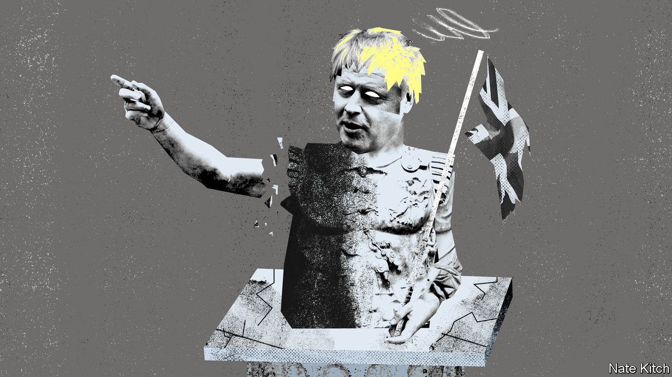

## His body torn, limb from limb

[Bagehot](https://www.economist.com/britain/2020/06/20/boris-johnson-loses-his-grip) missed a trick when likening Boris Johnson to a Roman emperor (June 20th). Who can forget the awful fate meted out by the mob to Sejanus, whose relationship to the Emperor Tiberius is not unlike that of Dominic Cummings to the prime minister?

MIKE LUNANThurso, Scottish Highlands

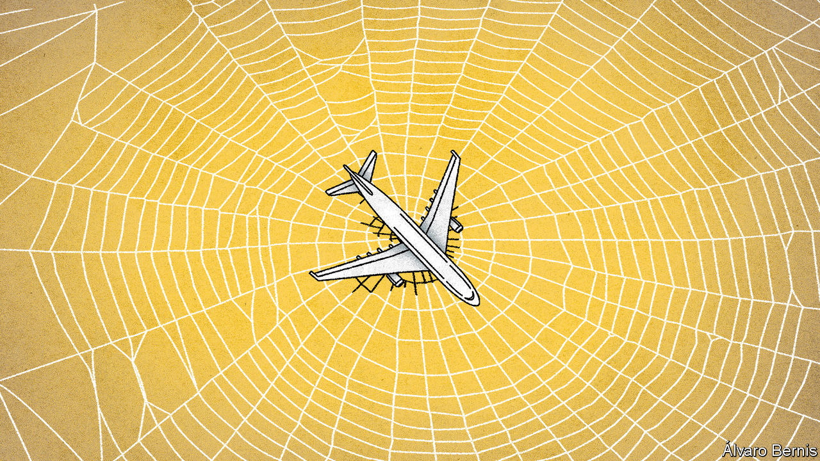

## Interconnecting

I wish everyone would stop calling the proposed plan to open borders between some countries a “travel bubble” (“[Peak plane](https://www.economist.com/the-world-if/2020/07/04/what-if-aviation-doesnt-recover-from-covid-19)”, The World If, July 4th). I am not sure who coined this (a verbal equivalent of a blank stare and surely no one employed at The Economist), but the imagery takes us to unintended places. For one, it provides a negative connotation to a perfectly workable arrangement. It also implies something unsubstantial, deceptive and ready to burst, though, hopefully, ever so fleeting and transient. I think “travel tunnel” would be more apt. Or maybe I just feel that way because of where I live.

ZUBIN AIBARA  
Bülach, Switzerland

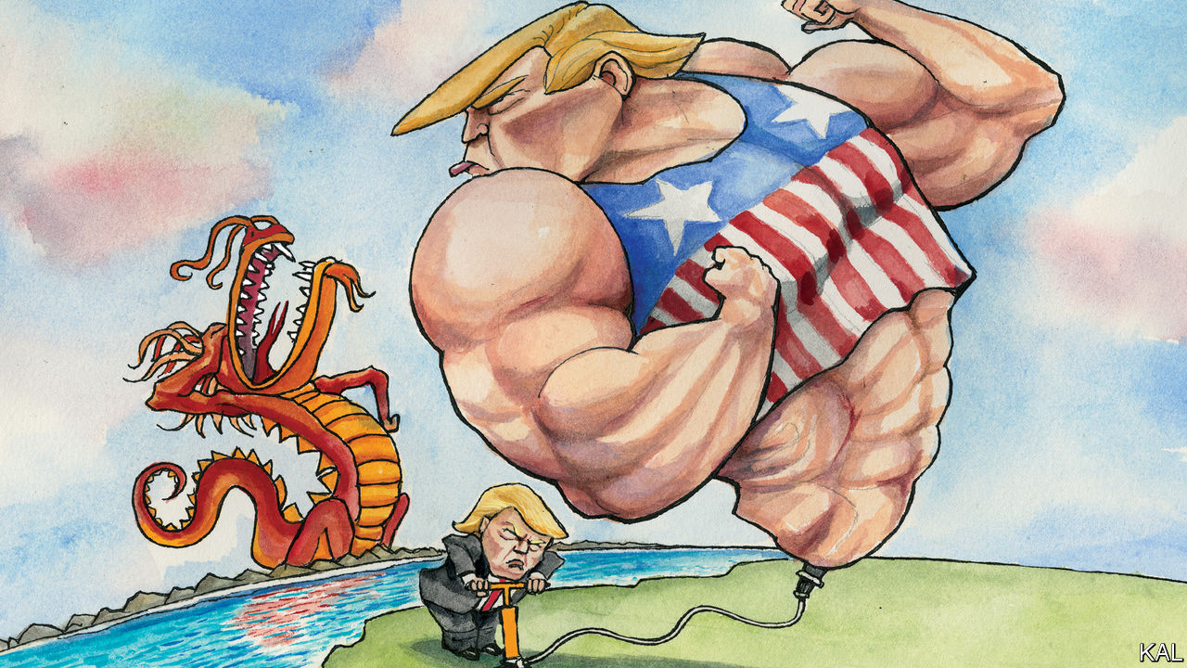

## She bangs the drums

I adored the subtle references to the Stone Roses in [Lexington’s](https://www.economist.com/united-states/2020/06/27/is-donald-trump-tough-on-china) recent column (June 27th). The ten-storey waterfall of allusions to Brownie and Co helped to put me in the picture and show me what you mean. Don’t stop.

PAUL PORTEROakland, California

Lexington’s look at John Bolton’s account of Donald Trump’s China policy snuck in a delicious reference or two to the Stone Roses. One wonders if those in the know were meant to hear faint echoes of the following lines from the same song: “The past was yours/But the future’s mine/You’re all out of time”?

JOHAN HUGO  
Leamington Spa, Warwickshire

* Letters appear online only

This article was downloaded by calibre from <https://www.economist.com/letters/2020/07/18/letters-to-the-editor>

|  |  |  |  |
| --- | --- | --- | --- |
|  | Articles | Sections | Next |

|  |  |  |
| --- | --- | --- |
| Letters | Sections | United States |

Briefing

Huawei and 5G: The European theatre

.

|  |  |  |
| --- | --- | --- |
| Letters | Sections | United States |

|  |  |  |  |
| --- | --- | --- | --- |
|  | Articles | Sections | Next |

#### The geopolitics of 5G

# America’s war on Huawei nears its endgame

In Europe, however, there exists a mixed response to the Chinese telecoms-equipment giant

Jul 16th 2020 |

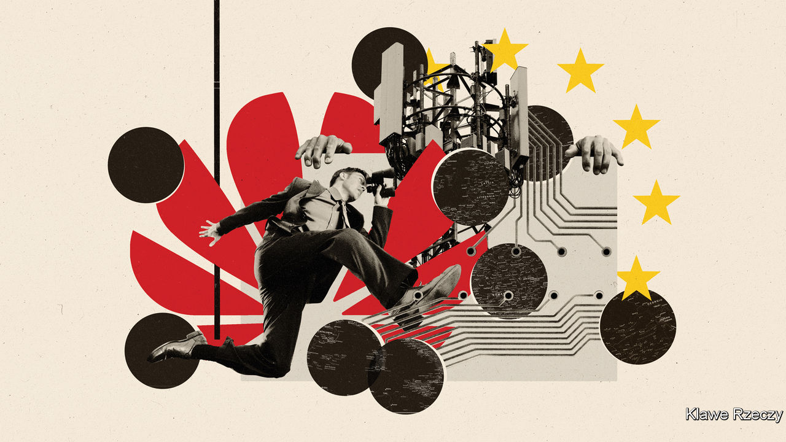

ON MAY 15TH the American government announced a startling escalation in its campaign against Huawei, a Chinese company which is the largest provider of telecoms equipment in the world. American politicians and officials have long expressed concerns that mobile networks which rely on Huawei could allow snooping and sabotage by China. In May 2019, citing alleged violations of sanctions against Iran—charges Huawei denies—America used powers designed to stop the transfer of military technology to bar the company from receiving American components vital to the systems it sells.

Those measures had loopholes: suppliers could keep on selling Huawei many components as long as they were made in facilities outside America. So this year America targeted the whole supply chain: as of September it will be seeking to stop companies around the world from using software or hardware that originally comes from America to manufacture components based on Huawei’s designs.

The move was a serious blow to the company. It may well have brought a sigh of relief in Britain. In January Boris Johnson, the British prime minister, had approved a substantial if clearly demarcated role for Huawei in Britain’s 5G telecoms infrastructure. Its promise of a faster, more commodious type of mobile broadband that allows completely new internet applications and might prove necessary for self-driving cars has made 5G a touchstone for seers scrying the next big thing and for politicians who pay heed to them. Infrastructure spending stamped with such a hallmark of futurity is right up Mr Johnson’s alley. If Britain’s existing procedures for overseeing Huawei’s role in telecoms infrastructure were applied, the government argued at the time, Huawei’s equipment could be used in “non core” parts of the network, and Britain could get its 5G systems up and running considerably sooner, and cheaper, than would otherwise be possible.

This decision was unpopular both with the White House and with a significant faction within Mr Johnson’s Conservative Party, with the opposition happily backing the rebels. Dismay over China’s imposition of new security laws on Hong Kong, in breach of the agreement under which the territory was handed back to it, heightened feelings further. America’s new salvo of sanctions provided a plausible reason for changing course. The inevitable dislocation to Huawei’s supply chains, the government said, would make relying on the company riskier. The new measures also meant that the vaunted system whereby British spooks vetted Huawei equipment would no longer be able to do its job: it would itself fall foul of the American sanctions.

On July 14th the government said it will ban mobile-network operators in Britain from buying Huawei equipment for their 5G networks, and told them to remove equipment already installed by 2027. Well before that—by the time of the next election, in 2024—the country would be on an “irreversible path” to expunging the Chinese firm from its networks, said Oliver Dowden, the culture secretary.

Mr Trump immediately took credit for having “convinced many countries” not to use Huawei. While some have been on board for a while—Australia banned Huawei 5G equipment in 2018—others have moved more recently. In June telecoms companies in Canada and Singapore announced plans for 5G networks built around equipment provided by Huawei’s main rivals, Ericsson, a Swedish firm, and Nokia, a Finnish one (see chart 1). In both cases Huawei had previously been a possible provider. On July 6th the head of the French cyber-security agency advised network operators which do not currently use Huawei not to plump for it in future.

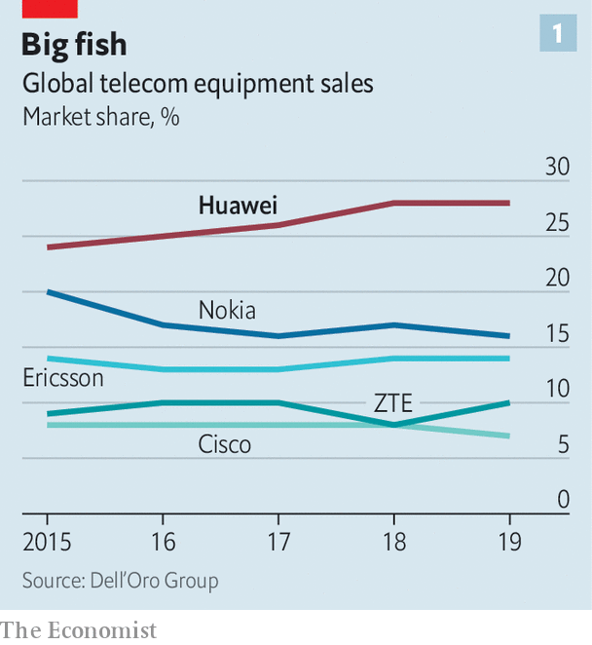

Now all eyes are on Germany, which has said it will decide on the matter in the autumn. If it follows America’s urging and Britain’s example then the rest of the EU will probably go the same way, and a significant corner will have been turned. Western communications systems will be a bit less insecure. America will have used its sovereign might to humble one of China’s national champions, and China will doubtless be responding. The technophilic imperative that has made 5G a totem of the fully networked future will have had its momentum checked, at least a little, by a mixture of countries not wanting to upset America and being willing to upset a China they find increasingly disturbing.

## The last domino

Perhaps most profoundly, such a change may leave behind it a world where governments are less willing to depend on companies from countries with divergent interests to supply capacities they deem strategic. “At the heart of this is a dilemma which the West has not faced before: how to cope with a technology superpower whose values are fundamentally opposed to our own,” in the words of Robert Hannigan, a former boss of GCHQ, the British signals-intelligence agency.

Germany’s decision is not a done deal. Deutsche Telekom (DT), a 32%-state-owned company, is the country’s largest mobile provider and already relies heavily on Huawei equipment. It has lobbied strongly against any action that would make it harder for it to roll out 5G. The Ministry of Economic Affairs, often eager to defend the interests of German industry, has backed the firm. Angela Merkel, the chancellor, has not wanted any trouble with China (see Europe section).

Yet, like the British Conservatives, Mrs Merkel’s Christian Democrats have split on the issue. As Norbert Röttgen, a conservative member of parliament and one of the leaders of the anti-Huawei faction, has put it, “We cannot trust the Chinese state and the Chinese Communist Party with our 5G network.” The Social Democrats, who are part of the governing grand coalition, and the opposition Greens are also opposed to letting Huawei play. “If there were a vote in parliament today, Huawei would lose,” says Thorsten Benner of Global Public Policy Institute, a think-tank based in Berlin.

Mrs Merkel, who will make the final decision, has so far been circumspect. She says she does not want to exclude a company on the basis of its nationality and that any firm that complies with certain security standards should be allowed to sell its wares in Germany. In late 2019 China’s ambassador in Berlin threatened retaliation against German companies should the government exclude Huawei from its 5G plans, and insiders say it is a threat the chancellor takes seriously. Meanwhile, DT is busily creating the aura of a done deal. It intends to provide basic 5G services to 40m Germans by the end of this month using equipment from both Huawei and Ericsson, though users will see little benefit at this stage. The company has also decided to intensify its co-operation with the Chinese firm in cloud computing and other areas.

There are many reasons for Europeans to be uncomfortable siding with America. Having missed the boat on the rise of consumer tech—Europe still bemoans the lack of the home-grown Google or Amazon—European politicians fear falling further behind if they delay 5G and the various wonders it is held to enable, such as an “internet of things”. Mobile-network operators play up these fears, with an eye to either keeping their ties to Huawei or receiving some form of compensation if it were to be proscribed. By combining direct costs with estimates of lost GDP they argue that ditching Huawei will cost the continent tens of billions of euros.

Regulators and independent observers are not convinced. Mr Dowden, admittedly an interested party, put the impact of Britain’s volte-face at two or three years’ delay and £2bn or so. A study by Strand Consult, a research outfit, thinks that the cost of eschewing Huawei would be quite modest for Europe as a whole, given that its ageing 4G kit would soon have to be replaced anyway. It estimates a total of around $3.5bn, no more than $7 per mobile customer.

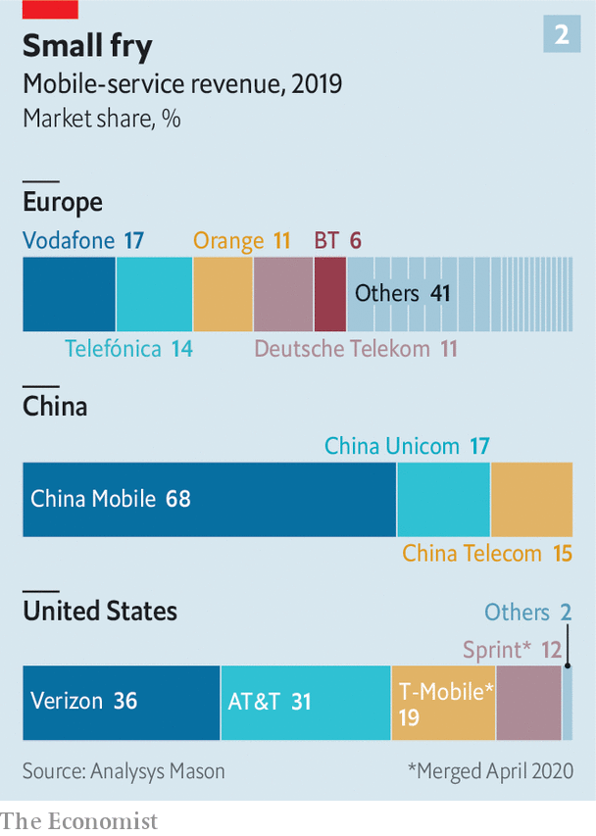

That said, not all European mobile-phone customers will get the same deal. The EU has failed to create a single digital market; an operator in Poland cannot sell services to a customer in Sweden in the same way New York-based Verizon sells to Californians. So where China and America have three network operators each, Europe has more than 100 (see chart 2). In some markets, such as Belgium, Germany and Poland, the local companies are highly reliant on Huawei; companies in Finland, Ireland and Spain would face much lower costs if forced to make the switch.

## Shrunken titans

The multiplicity of operators is a function of EU policy. Denied a continent-wide framework that would let them compete in far-off markets, telecoms companies are also kept from consolidating at home; the EU commission likes there to be four providers in each market. The resultant competition provides a stonking deal for customers. In Europe the average revenue per mobile-phone user is less than €15 ($17) a month. The average American user pays more than twice that. Rewheel, a data company, says that the cheapest unlimited-data plan in America costs €74 a month. In Germany the figure is €40, in Britain €22.

For network operators this fierce level of competition, coupled with the high costs of comparatively small, unconsolidated markets, constitutes a serious drag. Some carriers, including DT and Vodafone, a British operator, have returns on capital lower than their costs of capital: not the kind of business model that will find willing shareholders in the long term. Emmet Kelly of Morgan Stanley, a bank, points out that the market capitalisation of Europe’s major operators has shrunk from over €1trn in June 2000 to €258bn this June—a loss of 81% in real terms. Telefónica of Spain and Orange in France, once giants, are now not much more than minnows.

Mobile-network operators have long complained to the commission that the thin margins which scare away investors leave them unable to splash out on upgrades such as 5G, and that as a result Europe will fall behind its peers. China is investing massively in 5G and America is intent on keeping up; Mr Trump has called 5G “a race America must win”. The GSMA, which represents mobile-network operators, says that by 2025 half of all mobile users in America and the richer bits of Asia (including China) will be on 5G, compared with just one-third of Europeans.

In the past, Brussels has turned a deaf ear to such griping. The EU’s download speeds have remained comparable to those in America; the price of data services has fallen even faster than usage has grown: what’s the problem? But it is possible that a ban on Huawei could catalyse the “new deal” on regulation that the operators crave. Governments which realise that their actions are delaying 5G and driving up its costs might see their way to easing merger restrictions. The spectrum needed for mobile services, which in Europe is often sold through auctions designed to maximise revenue, might be given away instead, as happens in China and Japan. The lobbyists’ list is long. The industry takes courage from last year’s appointment of Thierry Breton, who was once boss of France Télécom (now Orange), as commissioner for the internal market.

Pending such a deal things might just slow down. There is already agreement among analysts that despite the hoopla 5G networks will be rolled out more slowly than the previous 4G ones were. This year’s 5G-spectrum auctions in France, Spain and Poland have been delayed by the covid-19 pandemic, which may quietly suit some operators. The equipment needed for 5G is only going to get cheaper and more reliable, as all chip-based kit does.

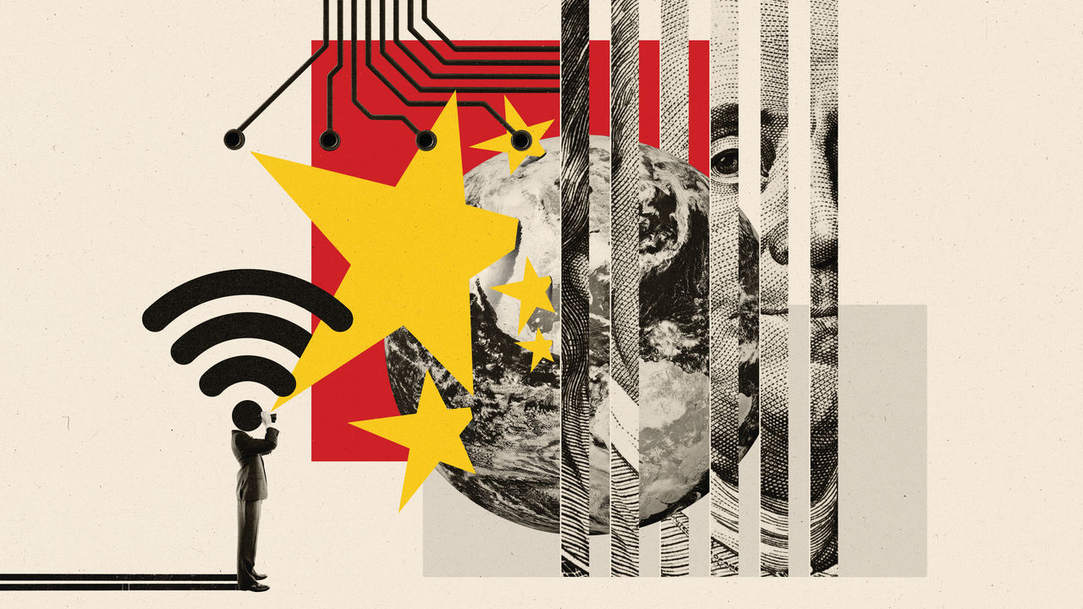

To the extent that there is indeed a race, it will not necessarily be won by those who get off to the fastest start. The services on offer so far are mostly just a faster version of 4G, and sometimes in practice the speed is not all that great. The most revolutionary aspect of 5G technology—the way in which it allows the workings of a network to be reconfigured through software and thus tailored to specific needs—will need years to come into its own. Profitable business models will take time to emerge.

## A continent of its own

A slower roll-out might also ease pressure on Ericsson and Nokia. The two Nordic companies will plainly benefit from countries turning away from Huawei, even if, as looks likely, they lose sales in China. They are precisely the kinds of industrial champion Europe is trying to promote these days, but there are worries about whether they can seize the moment. They now enjoy a duopoly in America (for a while there was talk of an American company taking a stake in one of them, but this idea seems to have been put aside). Some operators question whether, given those commitments, they can meet the needs of a Huawei-free full-speed-ahead Europe too. There is also the awkward fact that, supply chains for electronics being as they are, using European system integrators still means that much of the equipment comes from China.

The difficulties of having only a few suppliers will subside in time. Samsung of South Korea, a country very committed to 5G, is a growing presence. On July 15th Reliance Industries, an Indian conglomerate, announced that its Jio network, which uses a Samsung 4G network, will be building its own 5G infrastructure and selling it to others. Jio is likely to follow in the steps of some other carriers, most notably Rakuten Mobile in Japan, which are betting on networks based on advanced software, off-the-shelf hardware and open standards, thus side-stepping the need for systems integrators like Ericsson, Huawei or Nokia. Widespread implementations are still several years away, though.

Chinese reprisals against countries chucking out Huawei can be expected to come around a great deal sooner. China buys a lot from Europe, with Germany its largest trading partner in the bloc. It also invests quite heavily in the continent, having been courted by many of its leaders. Some of that may now be at risk. On the day of Britain’s U-turn the Chinese ambassador to London, Liu Xiaoming, tweeted that it was “disappointing and wrong”. China is painting the decision as a groundless capitulation to anti-Chinese pressure from America, and saying it calls into question the safety of Chinese investments in Britain, which are many and various.

But Europe does not see China exclusively through a commercial lens. Last year EU leaders designated it a “systemic rival”. The EU has since been working to limit Chinese state-backed groups’ operations in Europe. Its treatment of the Uighur minority, its reluctance to see word of covid-19 spread to the world and its move on Hong Kong have all raised hackles.

That does not mean Germany, or Europe as a whole, will necessarily ditch Huawei. Europe’s China links matter, and it does not like being pushed around by America. Policymakers on the continent have long fumed at the financial muscle that allows American administrations to punish European firms it sees as miscreants by squeezing the banks those firms deal with. But that does not mean it wants its internet infrastructure under the control of a third power that might, in time, aspire to use that control against it. A continental security official points out the underlying irony: “America wants to prevent China being able to do what America currently does to the rest of the world by controlling the financial system.”

The irony, though, does not invalidate the argument. Europe has sometimes acted to maintain its technological autonomy with respect to America in areas where national-security needs and civil infrastructure overlap, such as satellite launchers and navigation systems. In an interview with The Economist last November Emmanuel Macron, the French president, complained about European reliance on American tech platforms. At the same time he called development of 5G “a sovereign matter” and went on to say that “Some elements [of the 5G network] must only be European.” That did not in itself rule out any role for Huawei. But subsequent developments have pushed the continent further in that direction. American pressure may end up seeing Europe take a more assertive view of its “digital sovereignty”.■

This article was downloaded by calibre from <https://www.economist.com/briefing/2020/07/16/americas-war-on-huawei-nears-its-endgame>

|  |  |  |  |
| --- | --- | --- | --- |
|  | Articles | Sections | Next |

|  |  |  |
| --- | --- | --- |
| Briefing | Sections | The Americas |

United States

Operation Warp Speed: America First-Aid

.

The virus: Here it goes again

.

Schools: Classroom cops

.

SCOTUS: The centre can hold

.

Nomenclature: Skin in the name

.

Lexington: A family separation

.

|  |  |  |
| --- | --- | --- |
| Briefing | Sections | The Americas |

|  |  |  |  |
| --- | --- | --- | --- |
|  | Articles | Sections | Next |

#### Operation Warp Speed

# Donald Trump is hoping for a covid-19 treatment by November

He might get one

Jul 18th 2020 |



Editor’s note: Some of our covid-19 coverage is free for readers of The Economist Today, our daily [newsletter](https://my.economist.com/user#newsletter). For more stories and our pandemic tracker, see our [hub](https://www.economist.com/news/2020/03/11/the-economists-coverage-of-the-coronavirus)

IT IS EASY to smirk at the president. When it comes to the pandemic, he seems to be wrong about almost everything. He has promoted a dud malaria drug, said the virus would disappear, and even that 99% of cases of covid-19 are harmless. No wonder there is scepticism when Donald Trump says there will be a vaccine or a drug by the end of the year. But could he be right? After all, the government is spending more than $13bn on this goal and pursuing an aggressive strategy to achieve it.

The push to bankroll the rapid development of vaccines started in April. Operation Warp Speed (OWS) is a partnership between Health and Human Services, the Department of Defence and an alphabet soup of health-related agencies. The goal is to deliver 300m doses of a vaccine by January. OWS is also buying into medicines known as antibody therapies, and is part of a broader government strategy to accelerate the arrival of drugs and diagnostic tests. As part of this effort, the government triggered international outrage at the end of June when it bought up most of the supply of the drug remdesivir that the drug firm Gilead has for the next quarter.

Peter Bach, director of the Centre for Health Policy and Outcomes, an academic institute in New York, describes the effort as turning on the federal money hose. Already $3bn of federal cash has been spent on two vaccines in particular, one made by AstraZeneca, and another by Novavax. The biotech firm Moderna has been given $483m. The agreement with AstraZeneca includes the advance purchase of 300m doses of vaccine; the first doses could arrive as early as October this year. Novavax has agreed to deliver 100m doses of its vaccine by “late 2020”. The deal with Moderna allows for “large-scale” production in 2020. The money being directed at vaccine makers is also geared to helping firms scale up development and mass manufacturing.

In effect the government is subsidising the creation of a product that may not work. The strategy, which is also being employed by governments elsewhere, is necessary to help shave months off the development time for vaccines. Firms might otherwise be likely to wait for evidence of efficacy from trials before investing in manufacturing. OWS is investing in a wide range of vaccines because a number are likely to fail. The scale of the effort is so large that it has also been necessary to step up the national production of syringes.

Although OWS is described as a public-private partnership, the government is stumping up a lot of cash and shouldering a lot of risk. Matthew Kavanagh, a professor of global health at Georgetown University, worries that the government has too few levers to pull with the firms and that there is little transparency over how winners are being picked. Others worry about the affordability and cost of these eventual vaccines. American efforts to gain access to German and French vaccines have also sparked controversy in those countries.

Critics of the European Commission, including the boss of Sanofi, Paul Hudson, have accused it of dragging its feet in funding covid-19 research when compared with America. But the US government’s purchase of remdesivir caused alarm in many other rich countries, which fear that a drug that improves recovery time will be hard to obtain for their own patients. The move to corner the supply of this drug looked particularly bad abroad because the trials necessary to show that the drug worked involved patients in Germany, Greece, Japan, Korea, Spain and Britain.

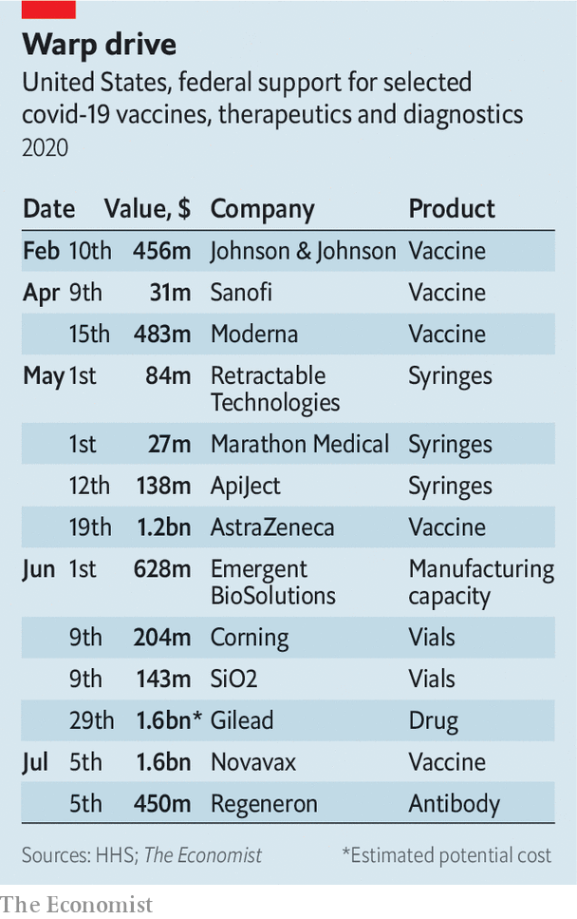

Less noticed, but potentially incendiary, was a similar American move on July 7th, when OWS signed a deal worth $450m with Regeneron. This acquired most of Regeneron’s supply of a promising experimental therapy, REG-COV2, for the next three months. If it turns out to work, most other countries will be unable to get hold of it. A spokesperson said the firm is working on plans to meet demand elsewhere.

The government’s money is not universally appealing to the pharma industry. The giant drug firm Pfizer has rejected cash from OWS. Its boss, Albert Bourla, says working with the government would slow the firm down. That fear seems to be justified. Work by Moderna, a biotech firm, appears to have been delayed amid reports of squabbles between the firm and the federal government over the design of trials.

Yet with the eagerness of the pharma sector to find treatments, along with the broad range of investments made by OWS (as well as other governments) there has been a lot of progress in the search for tests, drugs and vaccines. AstraZeneca has started late-stage trials, and Moderna and Pfizer are expected to do the same before the end of the summer. Even the master of caution on vaccines, Anthony Fauci, director of the National Institute of Allergy and Infectious Diseases, thinks a signal of vaccine efficacy might arrive in September. If data from trials emerges to suggest that a vaccine works, the Food and Drug Administration (FDA) will have to decide whether to grant an Emergency Use Authorisation (EUA).

Assuming these vaccines work, a best-case scenario could put an EUA for a vaccine well before the November election. A signal from the trials of the Regeneron drug is expected by the end of the summer. If it works, the federal government looks likely to be sitting on most of the world’s supply of the drug. All this means that Mr Trump has a reasonable chance at being right about there being a drug or vaccine by the end of the year. More significantly, analysts at Morgan Stanley think that the sort of early data that now looks possible in the coming months, would allow investors to “look through” any negative headlines in the economic recovery. This has the potential to help Mr Trump at the polls.

That would heighten concerns over how the government might apply pressure on the FDA to cut corners when approving a vaccine. Commissioner Stephen Hahn has said this will not happen. However his agency has been blasted for granting an EUA for the malaria drug hydroxychloroquine, an approval that seems mainly to have been designed to avoid embarrassing the president, who endorsed the drug as a treatment without any evidence.

Confidence in a covid-19 vaccine is essential. There are also concerns over the influence of anti-vaxxers in the uptake of any new vaccine. A poll in May found that half of Americans would take a vaccine, and one in five would refuse. Yet history shows that outbreaks of disease can be persuasive. The California Disneyland measles outbreak in 2014 gave a boost to childhood vaccination rates. The pandemic has even triggered a spike in demand for flu vaccine with one prescription drug firm, SingleCare, saying it saw a 500% increase in demand.

Even if a covid-19 vaccine is only 50% effective, and taken by less than half the population, experience with the flu jab suggests that it would be life-saving. A bigger concern, though, is whether a vaccine would get to those most at risk from covid-19. Persistent racial disparities already exist in flu-vaccination rates, with 9% and 12% lower coverage among black, non-Hispanics and Hispanic Americans, respectively, as compared with the vaccination rate of whites.

Successful therapies, particularly those supported by OWS, would give Mr Trump something to brag about on the campaign Zoom trail. Yet it seems unlikely to blunt much of the effect of the disastrous increase in cases of covid-19 (see article). The administration is keen to paint OWS in heroic terms, describing it as the “one of the greatest scientific and humanitarian accomplishments in history.” The reality is that even if international efforts help to create the knowledge to defeat covid-19, America looks unwilling to share the humanitarian gains outside its own borders.

The administration has shunned international efforts to co-operate on vaccines. On July 7th it said it would begin the process of withdrawing from the World Health Organisation, which plays a key role in organising the global distribution of vaccines, drugs and diagnostics. There is a strong argument that vaccines will be more efficiently deployed when delivered to the high-risk populations around the world rather than through near universal vaccination of a few rich countries such as America. That argument has not been very persuasive with this administration, but Mr Trump did promise America First. ■

This article was downloaded by calibre from <https://www.economist.com/united-states/2020/07/18/donald-trump-is-hoping-for-a-covid-19-treatment-by-november>

|  |  |  |  |
| --- | --- | --- | --- |
|  | Articles | Sections | Next |

|  |  |  |  |
| --- | --- | --- | --- |
| Previous | Articles | Sections | Next |

#### Covid deaths v cases

# America is in the midst of an extraordinary surge of covid-19

Will the gap between cases and deaths persist?

Jul 18th 2020 | WASHINGTON, DC

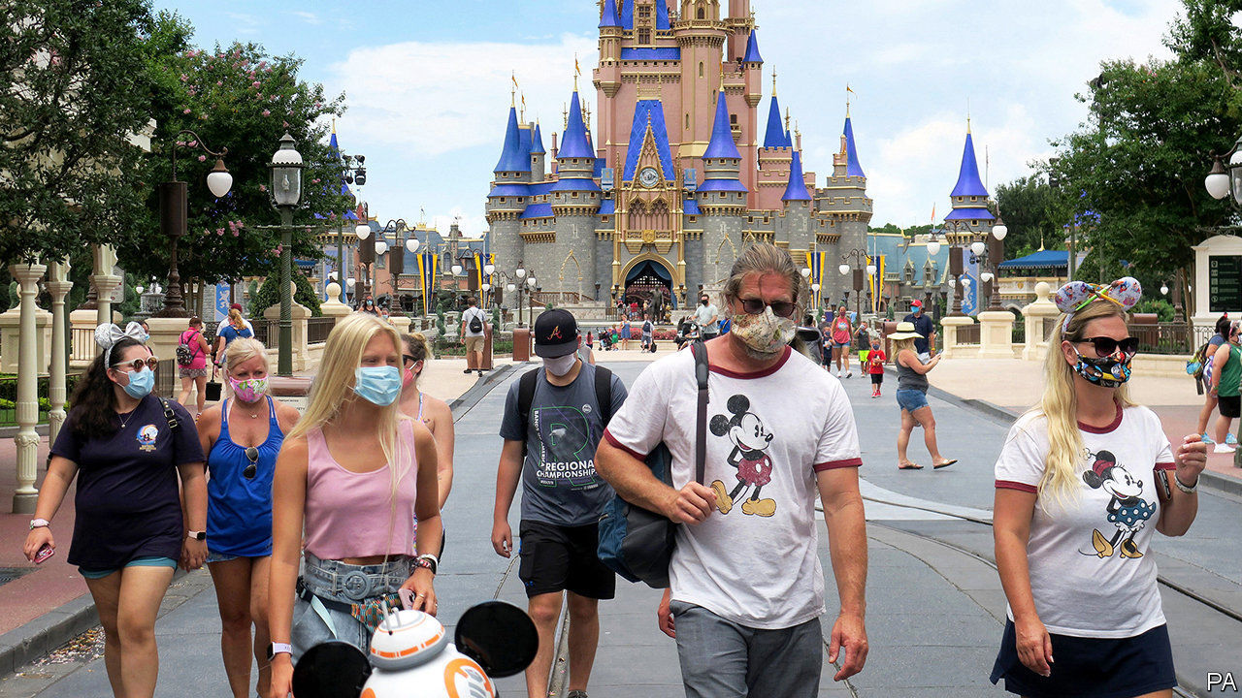

ON THE SAME weekend that Florida smashed the single-day state record for cases of covid-19—reporting over 15,000 in one day—Disney World, the gargantuan theme park in Orlando, opened its doors to masked revellers. At the start of June, when cases and deaths looked to be declining after reaching the terrible milestone of 100,000 dead, America appeared to have managed its epidemic as well as Europe—neither superbly nor awfully. Both began opening then at roughly the same time.

There was one difference, however. Some American states began reopening even as infection looked to be growing, as governors sought to cast off the shackles of locked-down life and a half-open economy. Bars crowded with thirsty patrons, restaurants reopened. There were some mass gatherings, whether to protest against racial injustice or to attend the president’s restarted rallies. Six weeks later, America is facing a secondary surge of cases quite unlike any other country. Having muddled along just about as well as other Western democracies, America now looks to be exceptional, in a disastrous way.

Some states, like California, which seemed to be early success stories in containing covid have also been beset by surges. On July 13th Gavin Newsom, the governor, announced that bars, indoor restaurants and cinemas would be closed to arrest the spread of the virus. On the same day schools in Los Angeles and San Diego announced that for 600,000 pupils the fall semester would begin online-only.

Predicting the course of the virus has proved remarkably difficult. When Ron DeSantis and Greg Abbott, the Republican governors of Florida and Texas, delayed stay-at-home orders in March they seemed to be inviting the virus to spread. That wave has now arrived as predicted, only three months late. Governors did not heed the warning signs—a rise in the share of tests coming back positive, reports of increased hospitalisations—until too late.

Doug Ducey, the Republican governor of Arizona, began reopening his state in early May, when there were around 400 new cases being detected a day. He began backtracking two months later, after caseloads had swollen tenfold, to around 4,000 a day, and 90% of the intensive-care beds in the state were occupied. Mr Ducey, like many Republican governors, had also barred cities in his state from imposing their own mask-wearing requirements, only reversing himself on June 17th.

Nor was there much desire for caution from the White House. Vice-President Mike Pence wrote an op-ed for the Wall Street Journal on June 16th with the headline “There Isn’t a Coronavirus ‘Second Wave’”, arguing that “the media has tried to scare the American people every step of the way, and these grim predictions of a second wave are no different.” A key argument of Mr Pence and President Donald Trump, even as case counts were rising through June, was that this was an artefact of increased testing and that the death rates continued to decline. Though the first contention was questionable (the rate of increase in cases exceeded the rate of increase in tests), the second was true.

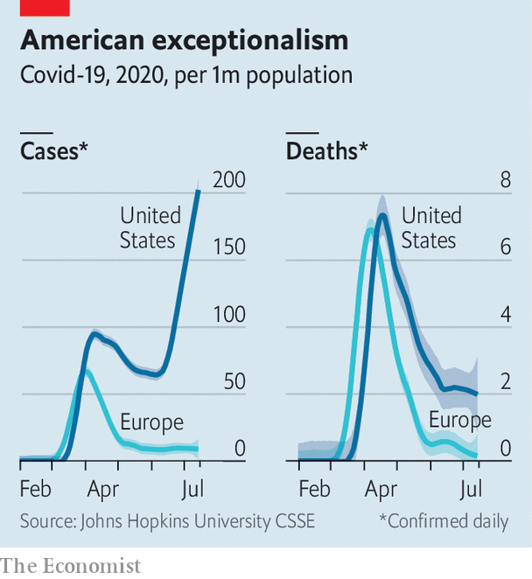

That puzzle—why deaths remain flat while cases have begun another exponential rise—can be explained by four factors. First, the substantial increase in testing means that more cases will be detected. Second, evidence suggests that younger adults are behind the latest surge in the virus. In Florida the median age of covid-19 patients has dropped from 65 to near 40. Third, there is usually a lag of several weeks between a patient contracting the illness and when the patient’s death is reported to state authorities. Fourth, doctors seem to have become better at treating severe cases of covid-19, reducing the death rate even for those who must be hospitalised.

Given the rise in cases, however, it seems unlikely that the death rate will remain stagnant for much longer. Deaths for patients infected weeks ago will probably start to pile up. Some morgues in Arizona and Texas are running out of capacity and are already seeking refrigerated trucks, just as those in New York City did months ago. Uncontrolled community transmission among young people is likely to result in a spread in nursing homes, where a large share of fatalities occurs among the more vulnerable elderly. Should hospital capacity become strained, as appears to be the case in Houston, the quality of care could deteriorate and result in increased deaths as well.

Denial has not proved to be a particularly effective virus-suppression strategy. When polled by YouGov last week, a third of Americans who had voted for Mr Trump said they thought covid-19 was either a minor problem nationwide or not a problem at all. A recent Gallup poll showed that 94% of Democrats say they always or very often wear a mask when outside their homes compared with 46% of Republicans (and 68% of independents). To many voters, worry about the virus transmuted into coded disapproval of the president; mask-wearing is seen as a talisman of deranged coastal liberalism.

Mr Abbott, who while running for governor bragged about how many times he had sued Barack Obama’s administration, is facing a mild insurrection in Texas from counties over his imposition of a mask requirement. Localised control, which once appeared to be a compensating feature of the American system, may now be working against containment. Confusing back-and-forths between Mr Newsom and counties in California have hindered timelier action there too. These are co-ordination problems that the federal government ought to solve. But throughout the crisis the White House has not seemed interested. Once again, states and cities will probably have to do the hard work alone.■

Editor’s note: Some of our covid-19 coverage is free for readers of The Economist Today, our daily [newsletter](https://my.economist.com/user#newsletter). For more stories and our pandemic tracker, see our [hub](https://www.economist.com/news/2020/03/11/the-economists-coverage-of-the-coronavirus)

This article was downloaded by calibre from <https://www.economist.com/united-states/2020/07/18/america-is-in-the-midst-of-an-extraordinary-surge-of-covid-19>

|  |  |  |  |
| --- | --- | --- | --- |
| Previous | Articles | Sections | Next |

|  |  |  |  |
| --- | --- | --- | --- |
| Previous | Articles | Sections | Next |

#### Classroom cops

# Do police officers in schools help or hinder teachers?

Surveys suggest teachers like “school resource officers”. But evidence for their efficacy is thin

Jul 18th 2020 | SAN FRANCISCO

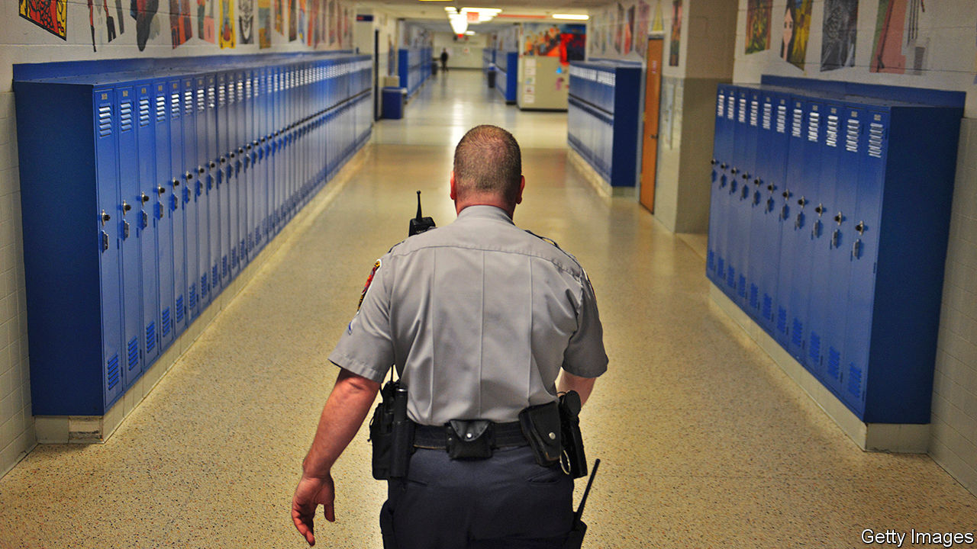

THE RE-EXAMINATION of policing in America that followed the killing of George Floyd has moved from the street into the classroom. In California two large school districts (San Francisco Unified and Oakland Unified) have severed relationships with police departments, while Los Angeles Unified cut the school police budget by $25m, a 35% reduction. Other school districts across the country have ended contracts with local police departments, including Minneapolis, Minnesota, Portland, Oregon, and Denver, Colorado. This movement is gaining momentum. But is it the right move for schools?

After originating in the 1950s in Flint, Michigan, school police officers proliferated in the 1990s in response to mass shootings. In 1994 the Community Oriented Policing Services (COPS) grant, a federal grant supporting the hiring of police officers, was established as part of a crime bill. The COPS grant funded “school resource officers” (SROs) in schools for three years, after which the money would need to come from a variety of state, county, local or private sources including school districts. In June William Barr, the attorney-general, announced that the Department of Justice would allocate $400m for the grant’s continuation, with the intention that some of the funds would support police in schools.

According to the Urban Institute, a think-tank, 67% of high-school students attend a school that has a police officer. The ACLU reports that, overall, 14m students are in schools with police but no counsellor, nurse, psychologist or social worker. In school districts where budgets are tight, funding a police presence often takes precedence over other personnel.

Whereas some schools are considering diminishing the role of police, others are continuing and even expanding their programmes. In June the Chicago Board of Education voted to keep their school police contract. New York’s mayor rejected calls to move the school-safety scheme from the NYPD to the Department of Education. Earlier this year the governor of Kentucky signed a bill requiring an armed police officer in every school.

Opponents of SROs argue that, among other things, school policing disproportionately targets non-white students. Blanca Hernandez, a high-school teacher in San Francisco, attended a rural California school district with an SRo programme. She recounted random drug searches where a drug-sniffing dog would be led into the classroom to check students’ backpacks. “It was a constant looming—you never knew when the dogs and the police were going to show up.”

## Police miss

According to a study by Jason Nance of the University of Florida Levin College of Law, black and Hispanic students are more likely than white students to attend schools with sworn police officers and other security measures, such as metal detectors and security cameras, even after controlling for school and neighbourhood characteristics such as how urban a school is, school size and reports of crime at school. This has led many activists, including the ACLU and Black Lives Matter, to advocate the elimination of such programmes and, with it, the “school-to-prison pipeline”.

Police officers were initially placed in schools with the purpose of improving school safety and academic results. However, with few exceptions, the evidence demonstrates that they miss the mark. Some research is supportive of SRO programmes, finding that they enhance school safety, help with drug-related arrests, and deter students from committing assaults and violent crime on campus. But more studies have found that SROs do not increase school safety. The Brookings Institution, a think-tank, determined that schools in North Carolina with SRO funding reported a similar amount of rule-breaking as schools without.

Police presence affects more than just arrests and discipline. It also has an impact on academic results. Emily Weisburst of the University of California, Los Angeles, found that Texas school districts with a COPS grant (to support the hiring of an SRO) experienced a 2.5% decrease in high-school graduation rates and a 4% decrease in college enrolment compared with years without the funding.

Proponents of SRO programmes worry that schools will be more violent if officers are removed. However, a case study in Canada suggests that these initiatives can be scrapped safely. Toronto’s school district recently removed its SRO programme after conducting a district-wide study on the impact of these schemes on students. Three years later, with cops replaced by unarmed school-safety monitors, Torontonians seem pleased with the outcome.

Despite this evidence, many teachers are calling for reform rather than removal. In a survey of 1,150 teachers, administrators and principals conducted by Education Week, only 23% of them favoured the removal of armed police officers from schools. Thirty percent of teachers responded that armed police were necessary on campus because students are “out of control”. Leton Hall, a teacher at a New York City Department of Education middle school, says that some incidents, such as large fights, require SRO presence. However, he encourages reformers to focus less on removing police officers, and more on why teachers and administrators call SROs into the classroom.

Mr Hall, an African-American raised in the Bronx, thinks that some teachers rely on police officers because they do not relate to the students. “I do think that there are some teachers who are more willing to work with and deal with certain behaviours and certain characteristics of students, and there are others who are not willing. I’ve had kids curse me out and say all types of stuff, and I’m like ‘OK, that’s nice. Now sit down and do your work. You’re not getting out of the class that easy.’ While other teachers, the second you do that, they are calling security. It depends on the tolerance level of the teacher, and how the students are viewed by the teacher.”

Mr Hall cites the racial make-up of the New York City teaching force as a problem: 80% of students are non-white, whereas 42% of teachers are. Still, rather than fully remove the programme, Mr Hall recommends that schools take a deeper look into how teachers use SROs within schools.

Others are also calling for reform rather than complete elimination. California’s superintendent of public instruction, Tony Thurmond, favours a redefinition of SRO roles, such as ending SRO involvement in student discipline. Philadelphia’s superintendent, William Hite junior, wants something similar. Yet with limited proof of their effectiveness and much evidence of their deleterious effects, SRO programmes are on shaky ground. ■

This article was downloaded by calibre from <https://www.economist.com/united-states/2020/07/18/do-police-officers-in-schools-help-or-hinder-teachers>

|  |  |  |  |
| --- | --- | --- | --- |
| Previous | Articles | Sections | Next |

|  |  |  |  |
| --- | --- | --- | --- |
| Previous | Articles | Sections | Next |

#### The centre holds

# An end-of-term report for SCOTUS

The 2019-20 Supreme Court term defied simple ideological division

Jul 18th 2020 | NEW YORK

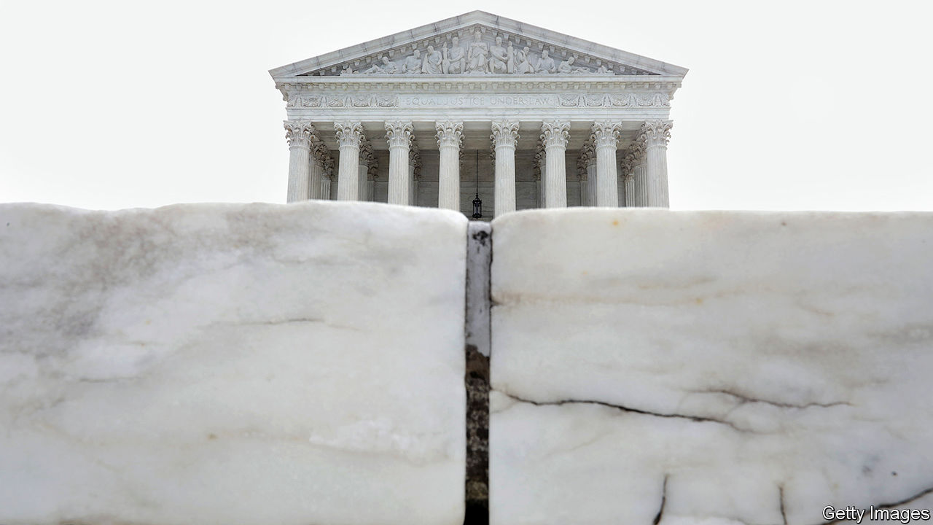

THE SUPREME COURTS first full term with Donald Trump’s two appointees in robes could have been a bloodbath. In the midst of a pandemic and the most fraught political landscape since the 1960s, though, the feast of cases did not bring total victory for the five-member conservative majority. Instead, John Roberts, in his 15th year as chief justice, presided over a court that broke left and right about equally in cases involving religion, abortion, civil rights and presidential power. He also managed to keep the proportion of 5-to-4 decisions down to around one-in-five—matching his tenure’s average.

The chief teamed up with the four more liberal justices to record three significant wins on the liberal side of the ledger. He wrote the decision rejecting Mr Trump’s attempt to rescind DACA, Barack Obama’s programme protecting young immigrants from deportation. He blocked a restrictive abortion law in Louisiana. And he signed a landmark ruling that extended protection against employment discrimination to gay, lesbian, bisexual and trans workers. Chief Justice Roberts also assembled wider 7-2 coalitions to reject Mr Trump’s claim to absolute immunity from criminal investigation while in office—opening the way for a New York grand jury to scrutinise his financial records—and to give House Democrats another chance to show why they, too, need to see Mr Trump’s finances.

These moves to the left are remarkable but come with caveats. Mr Trump could try to kill DACA again with a less obtuse justification. The abortion ruling may invite new regulations. LGBT workers might have little recourse against religiously inspired bias. And Mr Trump will probably stand for re-election before Americans get to see his finances (if they ever see them at all).

There were overt victories on the right, too. The chief justice joined his fellow conservatives in three cases expanding the law’s deference to religious folk and organisations while chipping away at the wall between church and state. He handed presidents the power to fire the head of the Consumer Financial Protection Bureau without cause. He said rogue border agents cannot be sued for shooting Mexican children standing on the other side of the US-Mexico line. His was the decisive vote to block Wisconsin and Alabama from facilitating absentee voting during the pandemic and to allow the federal death penalty to resume on July 14th.

The path towards the centre may have been forged by Chief Justice Roberts, but it would have met a dead end without the co-operation of colleagues. The farthest-right justices, Clarence Thomas and Samuel Alito, found themselves in the majority in only 72% and 73% of cases—in contrast to Mr Trump’s two nominees, Neil Gorsuch and Brett Kavanaugh, who were on the winning side 89% and 93% of the time. Those most recent additions to the court joined the chief and the liberals in rejecting their appointing president’s outlandish arguments against congressional and prosecutorial subpoenas of his personal information. Justice Gorsuch also joined the liberals in a 5-4 decision vindicating the territorial rights of the Creek Nation in Oklahoma, one of only two decisions from which the chief dissented this term. Among the unanimously decided cases (37% of the total) was a landmark decision averting possible chaos in November by allowing states to bind presidential electors to their pledged candidates.

A division in the four-member liberal minority became sharper this term. On most issues, Justices Stephen Breyer and Elena Kagan tack towards the centre while their colleagues, Ruth Bader Ginsburg and Sonia Sotomayor, lean farther left. Supreme Court justices are “the consummate repeat players”, Justice Kagan said to a Brooklyn audience in 2018. They are always thinking through how their votes today will affect “the next case and the next case and the next case”. In 2017, for example, Justices Breyer and Kagan joined the conservatives in siding with a church school that had been excluded from a playground-sprucing programme but seemed to be responsible for a footnote limiting the ruling to playgrounds. This year, both balked when the court used that precedent to require states, whenever they offer tuition support for secular private schools, to give money for religious schools as well.

This month the centre-left pair again crossed the aisle for relatively narrow 7-2 decisions insulating religious schools from some lawsuits brought by teachers, and permitting organisations with religious or moral objections to opt out of providing their workers with free contraceptive coverage under the Affordable Care Act. The rulings may have been more sweeping without the liberal justices’ influence, but such attempts to hold the line by joining and constraining conservative decisions may not ultimately “bear fruit down the road”, says Leah Litman, a law professor at the University of Michigan. For now, though, they are playing their part in the chief justice’s balancing act.■

This article was downloaded by calibre from <https://www.economist.com/united-states/2020/07/18/an-end-of-term-report-for-scotus>

|  |  |  |  |
| --- | --- | --- | --- |
| Previous | Articles | Sections | Next |

|  |  |  |  |
| --- | --- | --- | --- |
| Previous | Articles | Sections | Next |

#### Skin in the name

# Renaming the Washington Redskins

An American football team finally sheds its moniker

Jul 18th 2020 | WASHINGTON, DC



SINCE HE BOUGHT the Redskins in 1999, Daniel Snyder’s position on his team’s long-controversial name has been clear. “We’ll never change the name,” he told a reporter seven years ago. “It’s that simple. NEVER—you can use caps.” He and other defenders claimed the name honoured Native Americans—a view not shared by many Native Americans themselves.

Mr Snyder stuck to his guns through demonstrations outside his games, political pressure, even losing federal trademark protections because the team’s name and images were deemed “disparaging to Native Americans” (a ruling later reversed on First Amendment grounds). But on July 13th, after coming under pressure from sponsors including FedEx, which pays the team $8m per year for naming rights to its stadium, Mr Snyder announced the name and logo (a Native American in profile, with feathers in his hair) would be retired.

Its new name remains unclear, but the jokes all but wrote themselves: the Washington Pundits, Kickbacks, Internal Polls (which would, of course, always show them ahead). More serious possibilities include the dreary, hackneyed Warriors; the Redtails, honouring the black Tuskegee Airmen, who fought in the second world war; and the Red Wolves, which like the Redtails would let the team keep its burgundy-and-gold colours. Mr Snyder reportedly has chosen a name currently bogged down in a trademark fight—and indeed, an enterprising actuary from the Washington suburbs has registered trademarks for around a dozen possible team names.

The Redskins are not the only team wrestling with nomenclature. The Cleveland Indians and Atlanta Braves, both baseball teams, also face pressure to change their names, as have the Kansas City Chiefs, a football team. The Indians seem to be considering a change, but the Braves and Chiefs are so far holding firm.

The Indians retired Chief Wahoo, their grinning, hook-nosed Native American logo, two years ago. For a name that strikes fear into opponents’ hearts, the Indians probably do not want to look back; the team was formerly known as the Naps and the Spiders (though the Napping Spiders has outstanding logo possibilities).

Donald Trump mocked the Redskins and Indians for “changing their names in order to be politically correct”. After the Redskins’ announcement, Kayleigh McEnany, the White House press secretary, said he “believes that the Native American community would be very angry” at the change. Polling suggests that Native American elites do in fact dislike the name but that the majority are not overly bothered.

Mr Trump is also embroiled in a naming controversy of his own: he has vowed to veto the $740bn Defence Authorisation Bill, which funds the Department of Defence, if it includes an amendment to rename the ten military bases named after Confederate generals. Elizabeth Warren introduced the Senate’s amendment. Both the House and Senate versions of the bill have such language in them, and Republican senators believe they have enough votes to override a presidential veto.■

This article was downloaded by calibre from <https://www.economist.com/united-states/2020/07/18/renaming-the-washington-redskins>

|  |  |  |  |
| --- | --- | --- | --- |
| Previous | Articles | Sections | Next |

|  |  |  |  |
| --- | --- | --- | --- |
| Previous | Articles | Sections | Next |

#### Lexington

# Donald Trump ends the career of his former chief ideologue, Jeff Sessions

The president, a fan of Confederate monuments, topples one

Jul 18th 2020 |

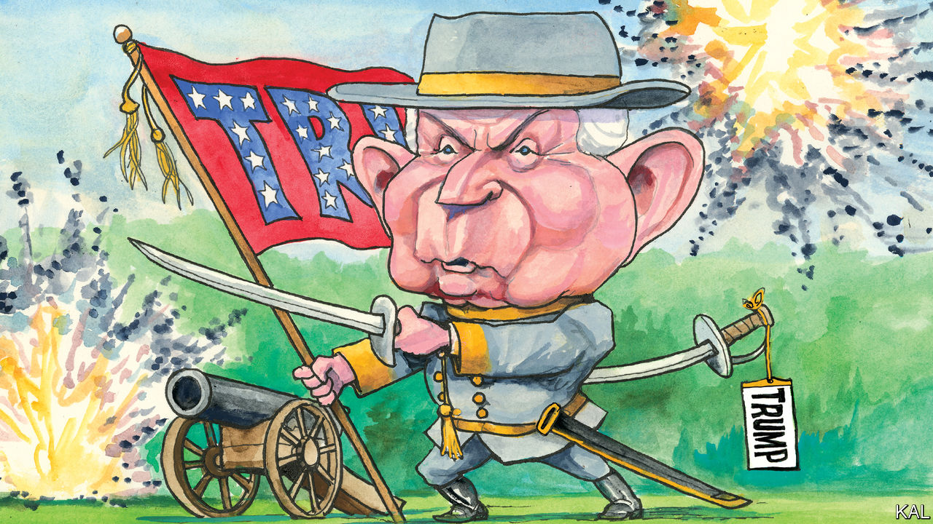

THOUGH A FAN of Confederate monuments, Donald Trump could not have taken down Jefferson Beauregard Sessions III, a living memorial to the rebel South and the president’s first attorney-general, more ruthlessly. This week the Republican veteran named after two Confederate heroes (Jefferson Davis and General P.G.T. Beauregard) suffered his first electoral defeat, in a primary for the Alabama Senate seat he occupied for 20 years. When he last defended it, in 2014, Mr Sessions won an uncontested race with 97% of the vote. But against a Trump-backed rival—a former college-football coach and political debutant, Tommy Tuberville, who seemed unsure of most issues—he was trounced.

Even after so many illustrations of the president’s grip on Republican voters, it was astonishing to see Mr Sessions’s career-long claim on Alabaman affections blown away in this fashion. It was equally remarkable, even after so many displays of Mr Trump’s vindictiveness, to see him end his former aide’s career so cruelly. No Republican played a bigger part in Mr Trump’s rise than Mr Sessions. No one did more to try to make Trumpism meaningful.

He was not only the first congressman to endorse Mr Trump (apart from two Republican House members, who have since been jailed for unrelated crimes). He was also the first to take him seriously—as he signalled by donning a “MAGA” cap and appearing with Mr Trump at a rally in Mobile in August 2015. Though Mr Trump had recently supplanted Jeb Bush to lead the primary field, most elected Republicans still considered his presidential bid absurd. Mr Sessions’s decision to stand with him, before 30,000 roaring Alabamans, and praise him “for the work you’ve put in on the immigration issue” was a striking corrective. No one could accuse Mr Sessions of being unconservative, the charge Mr Bush was levelling at Mr Trump. Indeed, his racially accented populism had latterly moved from the margins of his party to the mainstream.

He saw America not as an idea, as most Republican leaders professed to, but as a place of communities and traditions besieged by immigrants, criminals and a liberal elite unleashed by the first black president. He demanded tough border restrictions and policing, deregulation and religious-liberty guarantees. The Tea Party movement, a nativist campaign masquerading as an anti-government one, had embraced this agenda and Mr Sessions personally. A like-minded nationalist, Steve Bannon, even urged him to run for president—notwithstanding his low stature, thick accent and air of twinkling eccentricity. By identifying Mr Trump as a more charismatic populist, whose professed beliefs were close enough to his own, Mr Sessions made him seem not only more acceptable to his Republican colleagues, but comprehensible.

He played a similar role as attorney-general. In a cabinet of competent technocrats, such as John Kelly, and populist nincompoops like Ryan Zinke, Mr Sessions was a rare competent populist. Even more than Mr Bannon or Stephen Miller—who had gone from Mr Sessions’s office to the president’s—he drove the administration’s strict border policies. (On the trail in Alabama, he derisively mimicked those who had objected to his separating migrant children from their parents: “Noooo, this is a poor child!”) He also dismantled an effort to make the police more accountable. He launched a “religious liberty task force”. And as he did so the president tried to destroy him by a thousand cuts.

Mr Trump dealt the first (because he has no respect for eccentric ideologues) in Mobile, where he joshed that Mr Sessions was “like 20 years old”. But it was after Mr Sessions recused himself from his department’s investigation into Russia’s effort to get Mr Trump elected that he let loose. That was 22 days after Mr Sessions was confirmed by the Senate. For his remaining 20 months in the job, Mr Trump mocked and insulted him, on Twitter and in private, including allegedly as a “dumb southerner” and “mentally retarded”. No matter how often he was assured that Mr Sessions had had no choice but to recuse himself (because of his own Russia ties), Mr Trump considered his failure to fix the Russia investigation a sign of weakness and disloyalty. And the fact that Mr Sessions not only put up with this onslaught but continued beavering away at the president’s agenda only seemed to make him angrier. A similar dynamic was apparent in the closing stage of this week’s primary contest: the more Mr Sessions claimed to have delivered Trumpist policies, the more the president denounced him.

If Mr Sessions were a slightly more sympathetic figure, his downfall would be tragic. Instead it mainly points to Mr Trump’s abandonment of much of the populist platform he was ostensibly elected on. While he persists with protectionism—an important exception—he has not restored manufacturing jobs, built infrastructure including a border wall, or changed America’s immigration regime in any way that a Democratic administration could not change back. He has no heavy-hitters working on those issues. Mr Miller, a writer of dystopian speeches, is the last Bannonite standing. Mr Sessions’s latest successor, William Barr, though not opposed to tough policing and border policies, spends more of his time protecting the president and his criminal cronies, in precisely the way Mr Sessions refused to.

## No regard for Beauregard

A few prominent conservative populists are still struggling to make Trumpism mean something more than presidential whim—led by the Fox News presenter Tucker Carlson and a handful of senators, including Josh Hawley and Marco Rubio. But none, for obvious reasons, is eager to enter the administration, which makes them much less influential than Mr Sessions and Mr Bannon were. The result, less than four months from the election, is that Mr Trump appears to have no policy agenda of any kind for a second term. Trumpism, as Mr Sessions must now suspect, as he slopes back to his church and grandchildren, appears to mean little more than Mr Trump. Actually, he must have suspected that all along.■

Dig deeper:  
Sign up and listen to Checks and Balance, our [weekly newsletter](https://www.economist.com/checksandbalance/) and [podcast](https://www.economist.com/podcasts/2020/07/10/checks-and-balance-our-weekly-podcast-on-american-politics) on American politics, and explore our [presidential election forecast](https://projects.economist.com/us-2020-forecast/president)

This article was downloaded by calibre from <https://www.economist.com/united-states/2020/07/18/donald-trump-ends-the-career-of-his-former-chief-ideologue-jeff-sessions>

|  |  |  |  |
| --- | --- | --- | --- |
| Previous | Articles | Sections | Next |

|  |  |  |
| --- | --- | --- |
| United States | Sections | Asia |

The Americas

Chile: Gimme shelter

.

Mexico: Banda does not play on

.

|  |  |  |
| --- | --- | --- |
| United States | Sections | Asia |

|  |  |  |  |
| --- | --- | --- | --- |
|  | Articles | Sections | Next |

#### Gimme shelter

# Covid-19 hastens changes to Chile’s market-led economic model

Under the pressure of the health crisis, the country may become more social democratic

Jul 18th 2020 | SANTIAGO

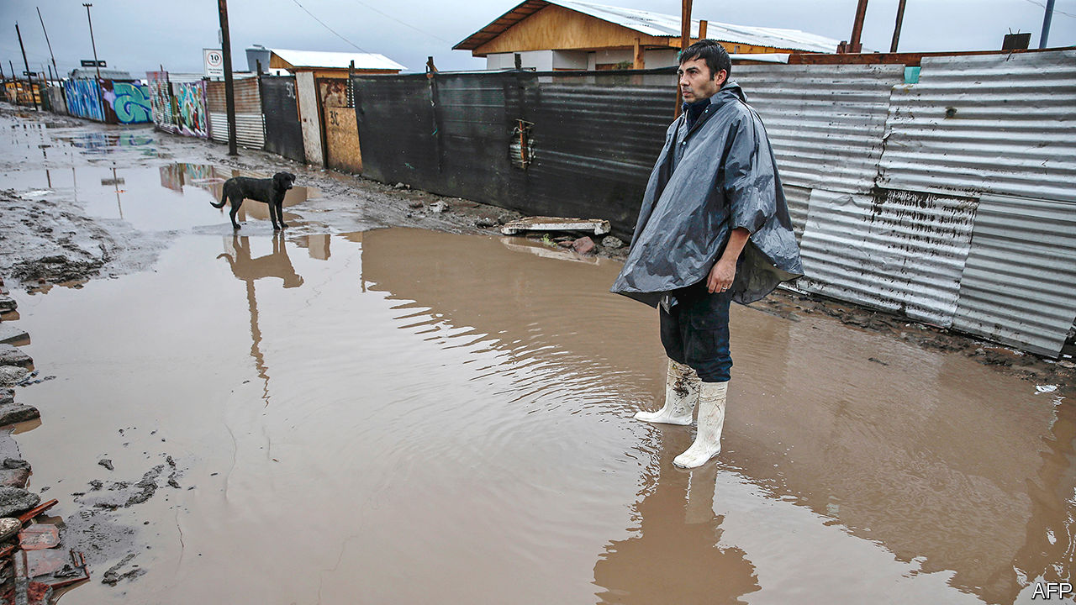

Editor’s note: Some of our covid-19 coverage is free for readers of The Economist Today, our daily [newsletter](https://my.economist.com/user#newsletter). For more stories and our pandemic tracker, see our [hub](https://www.economist.com/news/2020/03/11/the-economists-coverage-of-the-coronavirus)

ON A STREET corner in El Bosque, a poor district of Santiago, Dixa Contreras serves porotos con riendas (“beans with reins”: ie, bean-and-spaghetti soup) from a large pot. One lad takes enough for a family of four, sick at home with covid-19. Ms Contreras and six helpers provide 250 free meals a day, and fresh bread every second day for evening once (tea). Neighbours, shops, stands at the weekly produce market and EPES, a charity, provide the food.

Soup kitchens like this have appeared across Chile since the pandemic struck in March. They were last seen during a recession in the early 1980s, when Augusto Pinochet, a dictator, ruled the country. Helped by pro-market policies that Pinochet introduced, the economy grew rapidly in the years after his departure in 1990, though lately the pace has slowed. They gave the private sector a large role in providing pensions, education and health care. Chile’s poverty rate dropped from 45% in the mid-1980s to 8.6% in 2017, according to the government’s two-yearly socioeconomic survey. In the post-Pinochet years Chile won a reputation for sound economic management, relatively low levels of corruption and stable institutions.

Even before covid-19 its reputation took a knock. Pensions, which Chileans save up for themselves, were lower than many had expected when the scheme was introduced in 1980. Well-off Chileans got better health care and education than the poor. Massive and sometimes violent demonstrations against inequality began last October and dissipated only with the pandemic’s onset. They forced Sebastián Piñera, the centre-right president, to promise more social spending and a referendum, due to be held in October, on whether to rewrite the constitution, which is based on the one that Pinochet left the country. “There is consensus the state needs to give more and better-quality public services,” says Rodrigo Vergara, a former president of the Central Bank. The pandemic, and the government intervention it has provoked, may hasten an evolution towards social democracy that was already under way.

The government’s record in handling the pandemic has been mixed. As a share of its population, Chile’s 321,205 confirmed cases and 7,186 deaths are among the world’s highest. Rather than locking down the whole country, the government just sealed off covid-19 hotspots. It started talking of a return to a “new normal” in mid-April, before the disease had peaked. The government imposed a total lockdown of the capital, where a third of the population lives, only on May 15th. “It is a story of hubris,” says Eduardo Engel, a director of Espacio Público, a think-tank.

The government mitigated those failures by testing a lot (one reason its caseload looks so big). It has boosted the number of ventilators and intensive-care beds. The capital’s lockdown, followed by a tightening of restrictions in quarantined areas, have at last led to a decline in the number of new cases nationally.

The government expects GDP to contract by 6.5% this year. That is the biggest decline since the recession in 1982-83 (though it is smaller than the expected regional average). The average jobless rate from March to May hit 11.2%, its highest since the current way of reckoning began in 2010. The poverty rate is likely to reach 15% this year, says Dante Contreras, an economist at the University of Chile.

Dense neighbourhoods, cramped houses and the need to take public transport encourage covid-19’s spread among the poor. The health minister, Jaime Mañalich, admitted in May that he had not known how much poverty and overcrowding there is in parts of Santiago, making the government look clueless. He resigned.

The government has been as maladroit in shielding Chileans from covid-19’s economic ravages. It has acted slowly. Its measures, though large, have not met the need. Its under-reaction could cause a backlash that errs in the opposite direction.

The first package to protect employment, small businesses and poor households, introduced in March, is worth $17bn, nearly 7% of GDP. (Some is in the form of loans, and so is not counted as budgetary spending.) It includes a furlough scheme, which lets workers draw unemployment insurance while formally keeping their jobs, plus cash and food boxes for the poorest. But the support they provided families was less than the official poverty line. Protests broke out in poor neighbourhoods. Activists projected the word hambre (hunger) on the Telefónica tower in Santiago. Under pressure, the government reached agreement with opposition parties on June 14th to spend an extra $12bn over two years.

It followed up with a $1.5bn package for the middle class, which includes deferrals of mortgage payments and zero-interest loans. Middle-class Chileans were angry that much of the help took the form of loans. To assuage them, on July 14th the government again offered a belated booster: a one-off $632 handout to formal workers whose incomes have dropped.

Post-Pinochet governments have mostly kept budget deficits low. This year the government expects the deficit to reach 9.6% of GDP, the highest level in nearly 50 years. Its spending is to jump from 24% of GDP in 2019 to around 30% this year.

If Mr Piñera had his way, spending might recede. But his term is up in early 2022. The protests and the pandemic have weakened him. The government’s role will be determined by his successor and, if Chileans endorse it, by a constitutional assembly. It is likely to change. Calls for a more active state by the left are now echoed by politicians on the right, such as Joaquín Lavín, the mayor of a prosperous district of Santiago, who may become the next president. In their support for social benefits, like low-income housing, they sound more like European Christian Democrats than laissez-faire liberals.

There is broad agreement that tax revenue needs to rise from 20% of GDP. Already, in response to last year’s protests, the government raised the tax rate for the highest incomes. The new health minister, Enrique Paris, a technocrat, favours a cap on the profits of private health insurers, though this is not government policy.

Popular anger inspires more radical ideas. The rebellion against the first version of the middle-class aid package led to a proposal in Congress to allow Chileans to withdraw 10% of their pension savings to help them through the pandemic. That would reduce future benefits, which Chileans already deem too low, or, more likely, force the government to plug the hole, at a cost of at least $16.5bn. Either way, if passed the bill would weaken a central institution of the Chilean model. Some members of Mr Piñera’s coalition joined the opposition in backing it. The extra cash for formal workers was a way to win them back. So was Mr Piñera’s promise of “major surgery” for the pension system. It is not working. On July 15th Congress’s lower house passed the bill, sending it to the Senate.

Such radicalism poses a risk. Most Chileans agree that the state should act to reduce inequality and uplift the needy. But their anger could create support for populist policies that would make the country poorer. The success of Chile’s reinvention “will depend on whether the political system is capable of setting limits,” says Mr Vergara. The next lot of leaders will have to do better than the current ones.■

This article was downloaded by calibre from <https://www.economist.com/the-americas/2020/07/18/covid-19-hastens-changes-to-chiles-market-led-economic-model>

|  |  |  |  |
| --- | --- | --- | --- |
|  | Articles | Sections | Next |

|  |  |  |  |
| --- | --- | --- | --- |
| Previous | Articles | Sections | Next |

#### Banda does not play on

# Tough times for Mexico’s street musicians

To keep playing in a pandemic requires risk-taking and ingenuity

Jul 18th 2020 | MEXICO CITY

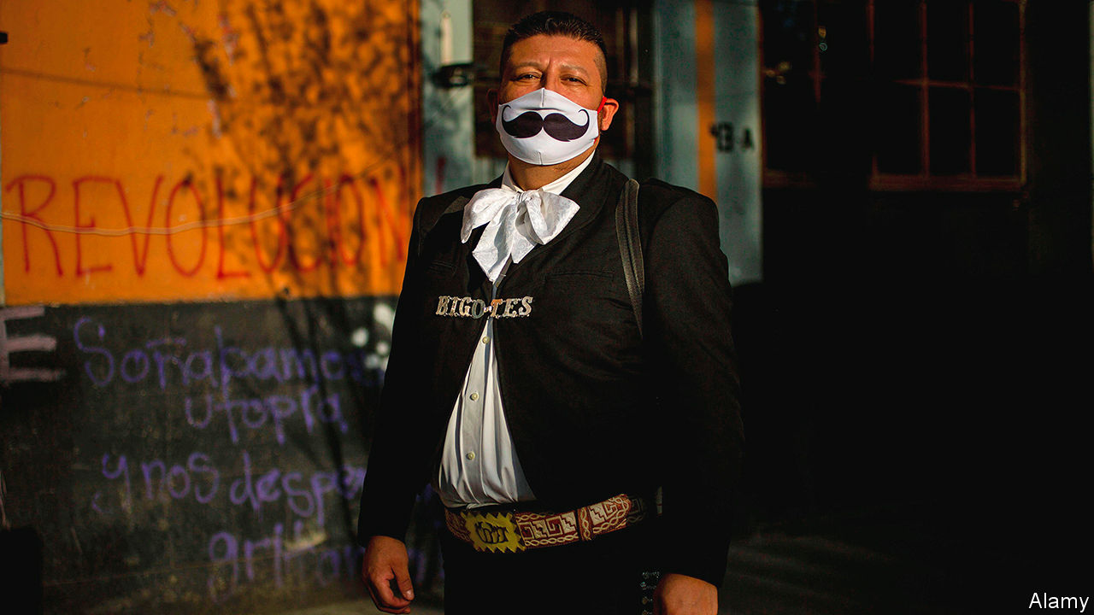

THE TUBA is the toughest of instruments to play, says Armando Ortiz, who has oompahed for half of his 30 years. It weighs 14kg (30 pounds), a lot to lug about if you’re a strolling street musician. Providers of rhythm, tuberos seldom rest mid-song. However, as the pandemic is teaching Mr Ortiz, whose parents sold a cow to buy his first instrument, not playing the tuba is even tougher.

Skilled performers of such Mexican genres as banda (Mr Ortiz’s speciality), mariachi and norteño can earn above-average incomes by playing at weddings, birthday parties, politicians’ events and on the streets. But when covid-19 arrived in March, bookings dried up. Restaurants and cafés closed, silencing buskers. Some regions banned street music because it attracts crowds and encourages non-distanced dancing. When police last month shut down an illegal party in Nuevo León, a state in the north, the musicians were among the 150 people they nabbed.

“We are dying of hunger,” says Luis Ramírez, a trumpeter for Banda La Crazy, only half-jokingly. He slaps the belly of a chunky clarinettist: “He was even fatter before the pandemic began.” The group, which is based in Jerez de García Salinas, in the central state of Zacatecas, has slimmed down from 15 members to seven, to give each one a bigger share of smaller takings.

In Mexico City musicians who have lost their audience play for apartment-dwellers, who throw money from their balconies. (Some shut their windows.) Mariachis serenade drivers stopped at traffic lights. Some musicians have moved to villages, where police do not break up clandestine performances.

Musicians were not at first eligible for the government’s modest aid offer to informal workers: a 25,000-peso ($1,100) loan, with a 90-day grace period. The government now says musicians will qualify. On July 10th they marched in Mexico City, demanding more.

But they now hope not to need it. An easing of lockdowns, despite rising numbers of new covid-19 cases, may bring back audiences. Mr Ortiz, who spent six weeks rising at 5.30 in the morning to make burritos with his wife for sale on the streets, reckons he is not cut out for such early shifts. He will not stop playing again, no matter how deep the slump, he says. “I will sell my car for money before I sell my tuba.”

Editor’s note: Some of our covid-19 coverage is free for readers of The Economist Today, our daily [newsletter](https://my.economist.com/user#newsletter). For more stories and our pandemic tracker, see our [hub](https://www.economist.com/news/2020/03/11/the-economists-coverage-of-the-coronavirus)

This article was downloaded by calibre from <https://www.economist.com/the-americas/2020/07/18/tough-times-for-mexicos-street-musicians>

|  |  |  |  |
| --- | --- | --- | --- |
| Previous | Articles | Sections | Next |

|  |  |  |
| --- | --- | --- |
| The Americas | Sections | China |

Asia

Drugs and vigilantes: Myanmar vice

.

Australia and the monarchy: Crown duels

.

Malaysian politics: A 70-minister mandate

.

Singapore’s election: Gluttons for punishment

.

Banyan: Shah of India

.

|  |  |  |
| --- | --- | --- |
| The Americas | Sections | China |

|  |  |  |  |
| --- | --- | --- | --- |
|  | Articles | Sections | Next |

#### Myanmar vice

# Illegal drugs have become deeply rooted in Burmese society

Vigilantes say they have no alternative but to take the matter into their own hands

Jul 18th 2020 |

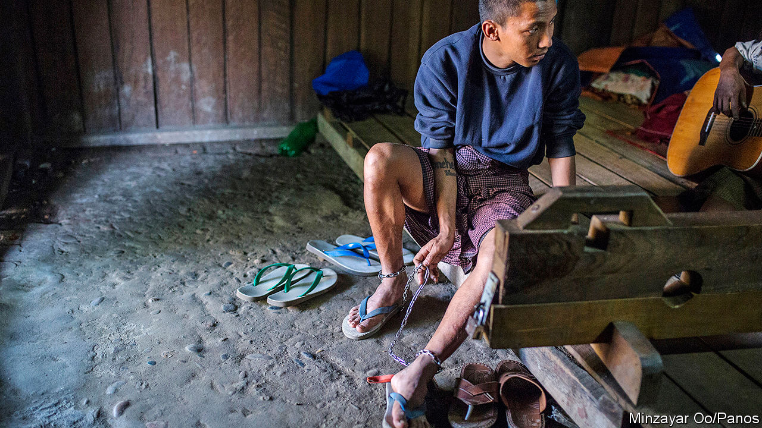

UNDER COVER of darkness, one night in 2017, Seng Naw and some 150 like-minded men revved up their trucks and drove a couple of miles from the town of Mohnyin in Kachin state, in remote northern Myanmar. Where the rice paddies give way to forest and mountains they found something that resembled a “festival”, according to Mr Seng Naw: scores of youths lolling about, high on heroin and methamphetamine sold to them by several dealers on the scene. It was 4am or thereabouts, by which time Mr Seng Naw knew the junkies would be too far gone to put up a fight, though some of his crew had brought clubs just in case. They rounded up the group—96 users and four dealers—packed them into the trucks and deposited them at the town’s police station.

That was Mr Seng Naw’s biggest haul. He is vice-president of the Mohnyin branch of Pat Jasan, a vigilante group trying to stamp out drugs. It was founded in 2014 by several prominent Kachins, a largely Christian ethnic group, who were dismayed by the havoc drugs had brought to their community. In Mohnyin, Mr Seng Naw says, people would regularly use drugs in public: on streets, in paddyfields, at university, even in a cemetery. As the number of addicts in Kachin state soared, so did violent crime, says Hpala Lum Hkao, a Baptist pastor and Pat Jasan’s secretary-general. The government could not, or would not, tackle the crisis. So they decided to pat jasan—“sweep and clean”.

There are no reliable data on the number of addicts in Myanmar, but the Transnational Institute, an international research outfit, believes the problem is severe. The official tally of “injecting drug users” has risen steadily over the past decade, to 93,000. But in the past five years methamphetamine, which is typically heated and the fumes inhaled, has supplanted heroin as a “drug of concern”, according to the government. It is cheap and readily available. Mai Kaung Saing, a journalist who reports on northern Shan state, which borders Kachin state (see map), estimates that 30% of the local population uses drugs, primarily heroin and meth. The problem is national. “Every family has been affected by drug-use issues,” says Tom Kramer of the Transnational Institute.

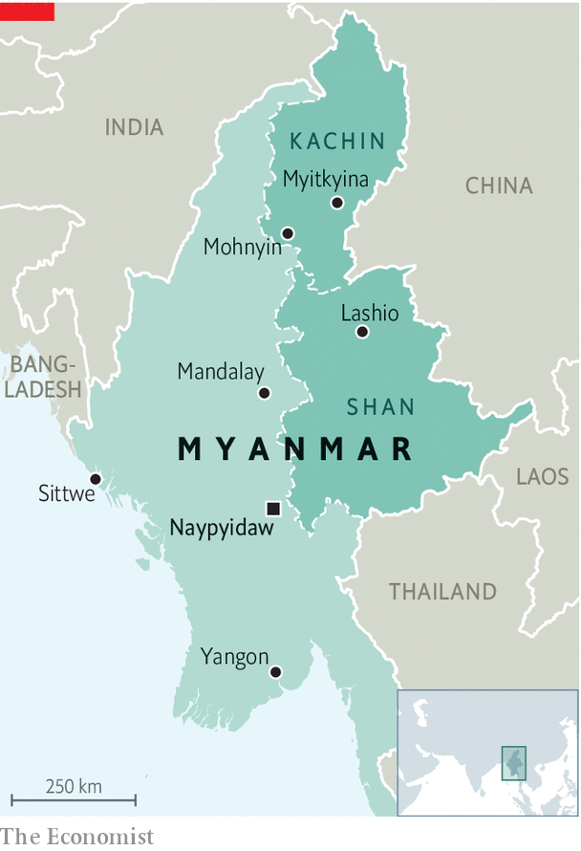

The surge in addiction is a symptom of the country’s central role in the drug trade. For decades assorted militias, some almost completely autonomous and others at war with the government, have controlled much of Myanmar’s border regions, especially in Shan and Kachin states. Many of the gunmen, and some of the soldiers sent to fight them, are involved in the drug trade. In the 1970s and 1980s Myanmar became the world’s biggest source of opium and heroin, and remains the second-biggest producer today. In 2018 sales of illegal opiates accounted for 1-2% of its GDP, according to the UN.

Since the 1990s Myanmar has also been producing meth which, like heroin, was initially intended for export. Gradually, however, as supply has increased and prices have declined, a domestic market has emerged. In Lashio, a city in northern Shan state, four yaba (meth) tablets can be bought for about $0.75. Many users find meth helps them work long hours or in arduous conditions, as truck drivers or miners; others are young and bored.

The International Crisis Group, an NGO based in Brussels, reckons the drug trade contributes more than any other industry to Shan state’s economy. In eastern and northern Shan state, “people get paid in yaba, they trade in yaba,” says David Mathieson, an analyst. So when vigilante groups like Pat Jasan cracked down in 2015 and 2016, it depressed the local economy.

The authorities have little incentive to tackle the trade. Police rarely pursue drug-traffickers. Sometimes they are users and dealers themselves: members of Pat Jasan have on several occasions inadvertently arrested officers, says Mr Hpala Lum Hkao. Sometimes they are simply too scared to arrest anyone but small-time dealers, says Mr Mai Kaung Saing. Some of the militias in drug-producing areas are even more deeply steeped in the trade, either providing protection to drug rings or running them themselves.

Kachins like Mr Seng Naw have refused to stand idle as their community becomes hooked. Pat Jasan, which claims to have 10,000 volunteers at its beck and call, is the biggest, most organised vigilante group in Myanmar, and has “a lot of energy”, according to Mr Kramer. It says it has destroyed 3,000-4,000 hectares of poppy fields, launched numerous campaigns to educate people about the harms of drugs, and arrested dealers and users, some of whom have ended up in their “rehabilitation” centres. Mr Hpala Lum Hkao says the group has opened 77 in total, though some have since closed down. Treatment consists of prayer, physical activity and the odd bath to dull the pain of withdrawal. Addicts there against their will are sometimes placed in stocks or shackled for the first few days, to ensure they do not escape.

This punitive approach to treating addiction is the norm in Myanmar, says Mr Kramer, even though it is highly ineffective: around 80% of those forced into treatment will relapse. Even Mr Hpala Lum Hkao concedes that once the inmates have been released from Pat Jasan’s centres, they frequently fall back into their old habits. Some officials are coming round to the idea that there are more humane and effective methods of treating addiction, says Mr Kramer. But curing addiction in Myanmar will take more than an evidence-based approach to treatment. It will involve ending the long civil war in Kachin and Shan states and stemming the flood of drugs. Until then, Messrs Hpala Lum Hkao and Seng Naw will remain on high alert. ■

This article was downloaded by calibre from <https://www.economist.com/asia/2020/07/18/illegal-drugs-have-become-deeply-rooted-in-burmese-society>

|  |  |  |  |
| --- | --- | --- | --- |
|  | Articles | Sections | Next |

|  |  |  |  |
| --- | --- | --- | --- |
| Previous | Articles | Sections | Next |

#### Crown duels

# Did Queen Elizabeth approve the toppling of Australia’s government?

No, but newly released papers from 1975 raise awkward questions

Jul 18th 2020 | SYDNEY

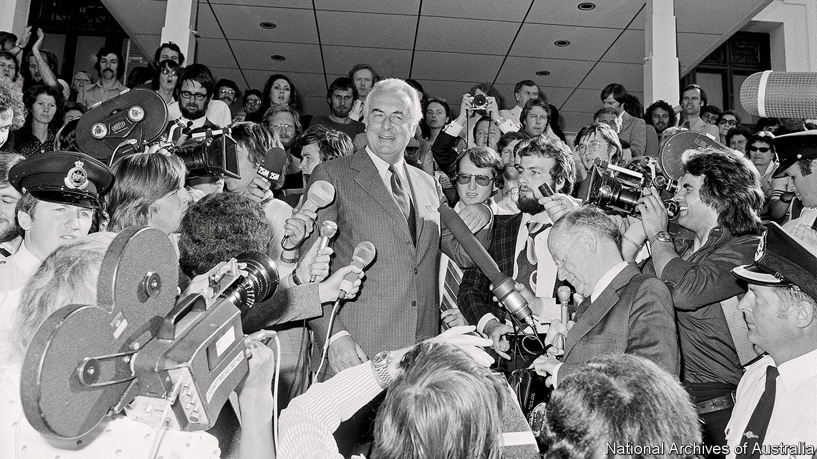

LIKE A TIME-BOMB, they have rested in Australia’s national archives for 42 years. On July 14th the “palace letters” were at last made public, revealing secrets about one of Australia’s most explosive days: November 11th 1975, when the prime minister of the day, Gough Whitlam, was dismissed by the governor-general, Sir John Kerr.

Kerr asserted the power to do so as the constitutional representative of Queen Elizabeth, who is the head of state of Australia and many other countries in the Commonwealth, as well as Britain. No one had expected the largely vestigial power to be exercised. Outraged Australians—especially those of a republican bent—wanted to know whether the queen had been warned of Kerr’s plans or had encouraged him. That mystery is now solved, but the broader question that the episode raised about Australia’s ties with its former colonial power remains as vexing as ever.

Kerr’s official secretary deposited his correspondence with Buckingham Palace in the Australian archives in 1978, calling it “personal and confidential”. The queen wanted it kept secret until 2037. Jenny Hocking, an Australian historian, embarked on a legal battle four years ago to have the letters made public. On May 29th the High Court agreed that they were public records and ordered their release.

It turns out that Kerr never informed the queen directly of his plan. But he did have extensive correspondence with Sir Martin Charteris, her private secretary at the time, who showed Kerr’s letters to the queen and replied on her behalf. The two men discussed “reserve powers”, an unwritten and disputed form of viceregal authority that Kerr used to sack Whitlam. A week before he did so, Charteris, who later admitted he was “not very well versed in the Australian constitution”, assured Kerr that such powers existed and could be used “at the very end when there is demonstrably no other course”. Buckingham Palace says the letters confirm that neither the queen nor the royal household “had any part to play in Kerr’s decision to dismiss Whitlam”. Ms Hocking disagrees. To her, they reveal “clearly and unavoidably” that the palace “did play a part”.

For almost 50 years, the dismissal has been a reference point for debate about the role of Britain and its monarchy in Australian affairs. Britain is still a big investor in Australia, but only the seventh-largest trading partner and currently the third-biggest source of immigrants after India and China. The monarchy is the last constitutional link between the countries.

John Howard, a conservative prime minister, called a referendum on becoming a republic 21 years ago and then helped to defeat it by campaigning for a No vote. Mr Howard succeeded in seeing off the republicans in part because they were divided about how a new head of state should be chosen, not because Australians had an ardent desire to retain the monarchy. Greg Barns, who headed the campaign for a republic, says the referendum is “unfinished business”. A poll two days before the letters’ release found that 62% of Australians would like an Australian head of state. The ambiguous letters will continue to provide ammunition for both sides of the debate. ■

This article was downloaded by calibre from <https://www.economist.com/asia/2020/07/18/did-queen-elizabeth-approve-the-toppling-of-australias-government>

|  |  |  |  |
| --- | --- | --- | --- |
| Previous | Articles | Sections | Next |

|  |  |  |  |
| --- | --- | --- | --- |
| Previous | Articles | Sections | Next |

#### A 70-minister mandate

# Malaysia’s government cobbles together a parliamentary majority

But it is unlikely to last

Jul 18th 2020 |

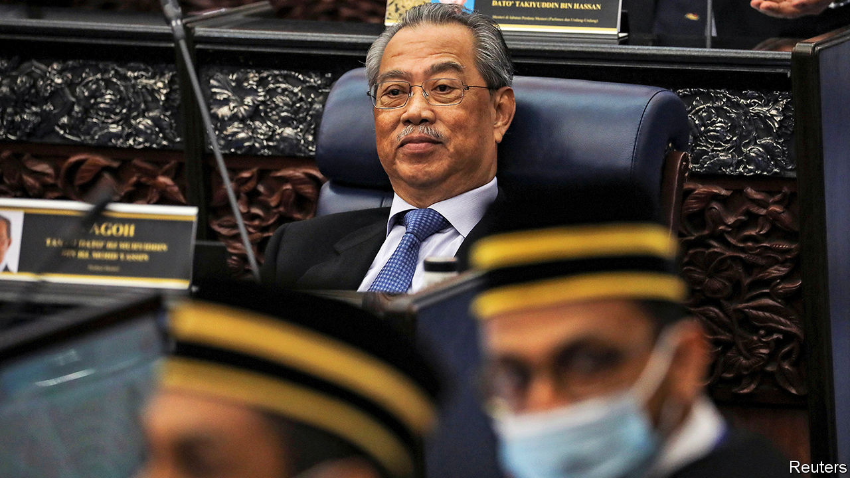

IT CAME DOWN to just two votes. On July 13th Malaysia’s prime minister, Muhyiddin Yassin, finally secured a parliamentary majority—more than four months after taking the top job. His coalition, Perikatan Nasional, plus an assortment of informal allies from the Malaysian part of Borneo, notched up 111 votes in favour of changing the speaker of the lower house; 109 opposed the move. Two more MPs on the government’s side couldn’t vote: one was absent and the other was presiding over the contest. The appointment of the new speaker means that a no-confidence motion, filed in May by the previous prime minister, Mahathir Mohamad, is unlikely to be debated.

Mr Muhyiddin’s reprieve is only likely to be temporary, however. He came to power by splitting Bersatu, the Malay nationalist party to which he and Dr Mahathir belong, as well as another party in Dr Mahathir’s coalition. The rebels joined forces with the United Malays National Organisation (UMNO), a much bigger Malay nationalist party booted from office after 61 years at the most recent election, in 2018. They also roped PAS, an Islamic outfit, into Perikatan Nasional. This messy process, and Mr Muhyiddin’s decision to keep parliament closed from March until now—save for a single day in May—cast a pall over the government’s legitimacy.

Mr Muhyiddin (pictured) used the period that Parliament was out of action to shore up his support within it. He created one of Malaysia’s largest-ever governments, with 70 ministers and deputy ministers. Other MPs snagged posts at government-linked companies.

Critics charge that Mr Muhyiddin’s government has also secured UMNO’s support by easing up on investigations of its leaders—a claim it denies. Musa Aman, a former chief minister of the state of Sabah, on Borneo, faced almost four dozen charges related to timber concessions, including corruption and money-laundering. Last month prosecutors withdrew all charges, citing a dearth of evidence. The prosecution of Najib Razak, a former UMNO prime minister and one of the government’s 111 votes, continues. Verdicts are expected soon on seven of the 40-odd charges against him, tied to a scandal at 1MDB, a state investment vehicle. America’s Department of Justice says some $4.5bn was siphoned out of the fund between 2009 and 2015.

“A narrow majority doesn’t give confidence that the government can stand for anyone, any side,” says Ibrahim Suffian, a pollster. Bersatu was founded as an alternative to UMNO for Malays, Malaysia’s biggest ethnic group. Now the two parties are aligned, Bersatu will struggle to differentiate itself from UMNO in voters’ eyes. UMNO, by contrast, is less afraid of an election, on the assumption that the bickering and back-stabbing of the past two years will have made at least some voters regret their decision to eject it from office. That gives it enormous leverage and makes the government inherently unstable. “If this situation persists,” says Mr Ibrahim, “then it makes an election more likely than not.” ■

This article was downloaded by calibre from <https://www.economist.com/asia/2020/07/18/malaysias-government-cobbles-together-a-parliamentary-majority>

|  |  |  |  |
| --- | --- | --- | --- |
| Previous | Articles | Sections | Next |

|  |  |  |  |
| --- | --- | --- | --- |
| Previous | Articles | Sections | Next |

#### Gluttons for punishment

# Why so many Singaporeans voted for the opposition

Though not enough to boot out the ruling party

Jul 18th 2020 | SINGAPORE

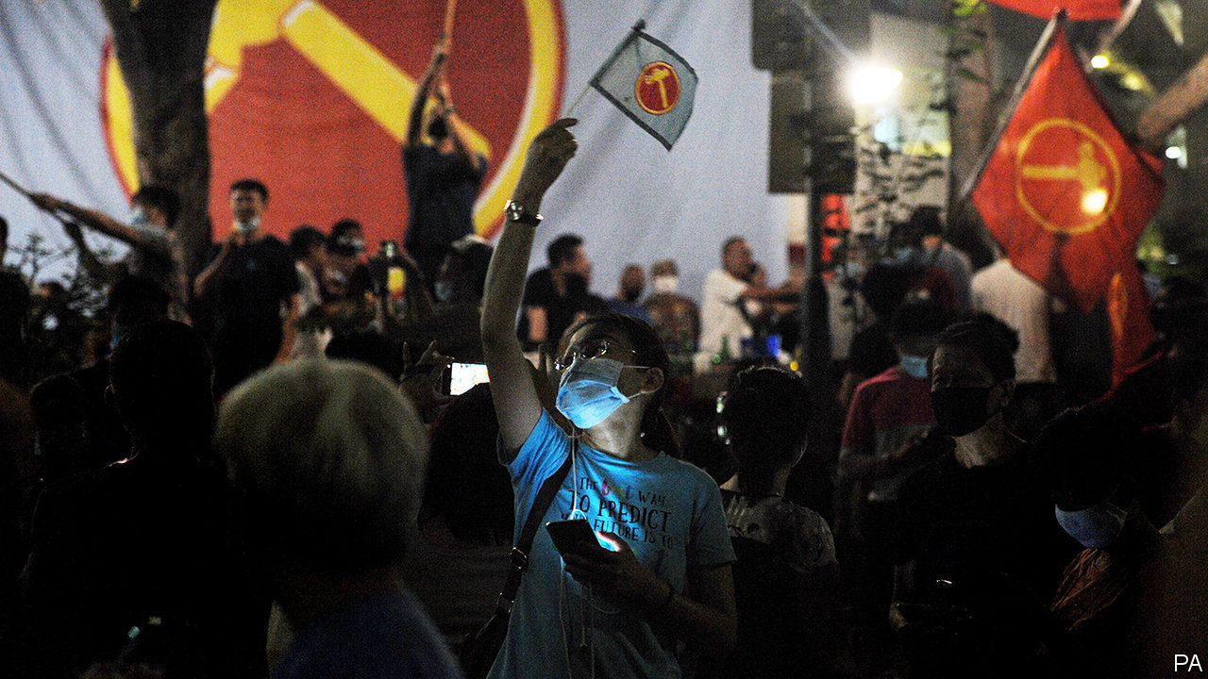

IN THE WEE hours after Singapore’s election on July 10th hundreds of supporters of the Workers’ Party (WP), the main opposition outfit, streamed onto the streets to celebrate, in defiance of the city-state’s strict social-distancing rules. One would have been forgiven for thinking that the WP had won the election. In fact it took a trifling ten seats out of 93. But in Singapore, which has been ruled by the People’s Action Party (PAP) since independence in 1965, this was the best performance by an opposition party ever in terms of seats won, and the worst by the PAP. The ruling party’s share of the vote sank from almost 70% at the previous election, in 2015, to 61%.

The greatest embarrassment of the night befell Heng Swee Keat, the anointed successor to the current prime minister, Lee Hsien Loong, who has said he will retire by his 70th birthday, in early 2022. The PAP slate headed by Mr Heng won its multi-member “group representation constituency” (GRC) with just 53% of the vote. Because he is the leader of the generation of PAP officials poised to take charge, who have been managing the response to covid-19, the result augurs badly for the party. Voters may have been expressing alarm at forecasts that the economy will shrink by 4-7% this year. At any rate, they did not appear grateful for stimulus packages worth almost 20% of GDP that Mr Heng, as finance minister, shepherded through Parliament.

Voters also seemed unmoved by the PAP’s system of carrots and sticks regarding public amenities. In 2006 Goh Chok Tong, a former prime minister, promised to spend S$100m ($63m at the time) sprucing up public housing in Hougang, in the north-east, if residents re-elected the PAP candidate. If they didn’t, he warned, their area would become a “slum”. By the same token, between 2009 and 2011, when the town council of a neighbourhood called Aljunied was in PAP hands, it got S$12m from CIPC, a government panel that hands out grants, says Pritam Singh, a WP MP. Between 2012 and 2018, when his party ran Aljunied, it received just S$680,000. This time would-be MPs promised to improve lifts in housing estates and to boost the internet—although the government also says it no longer favours PAP districts for housing upgrades.

In districts that spurn the PAP, the failed candidate nonetheless presides over naturalisation ceremonies, cuts the ribbon at new libraries and hosts “Meet the People” sessions, which in other constituencies would normally be a chance for residents to petition their MP for help. This is because in opposition districts the losing PAP candidate is invariably appointed a “grassroots adviser” by the People’s Association (PA), a body chaired by the prime minister. It is a position that comes with much responsibility; winning PAP candidates are appointed to it too. These advisers run residents’ committees, community clubs and, in opposition wards, decide whether MPs’ proposals for a new playground or jogging track merit consideration by the CIPC. Deen, a shopkeeper in Aljunied, likes Mr Singh, his MP, who often drops by for a chat. But for any sort of practical assistance, he says, “I go talk to the PAP.”

So why do Singaporeans bother to vote for the opposition? Although this week’s tally was especially high, about a third of the electorate has rejected the PAP at every election for decades. Most Singaporeans believe in checks and balances, says Eugene Tan, a law professor and former independent MP. Many voters view the PAP as arrogant and elitist, and complain about immigration, public housing and the cost of living, notes Netina Tan of McMaster University in Canada.

The WP, the ablest opposition outfit, has seized on such grievances. In 2011 it won Aljunied from the PAP—the first GRC ever to plump for the opposition. It was more than a protest vote. Residents felt that the incumbent PAP MPs “weren’t there for them,” says Chong Ja Ian of National University of Singapore. Low Thia Khiang, then the WP’s leader, put in the hours, attending funerals and weddings, and charming the area’s many ethnic Teochew Chinese by speaking to them in their native tongue. In 2015 the WP clung to the seat by a hair.

This time pundits thought that voters, worried by covid-19, might cleave more faithfully than normal to the devil they know. Aljunied’s fate was uncertain. Mr Low had retired. Mr Singh, his successor, although assiduous, does not speak Teochew. Yet the WP won Aljunied with 60% of the vote. It also held on to Hougang, a single-member seat and the WP’s first stronghold, with 61%. And it won a new GRC, Sengkang, with 52%.

The WP has managed to avoid the acrimonious in-fighting that has bedevilled other opposition parties undergoing a transition in leadership, notes Hoe Yeong Loke, author of “The First Wave”, a history of Singaporean opposition parties. The WP also proudly portrays its voters as “torchbearers of democracy in Singapore”, says Gillian Koh of the Institute of Policy Studies. The residents of Aljunied and Hougang wear their support for the WP as a “badge of honour”, says Eugene Tan. That kind of loyalty, he reckons, cannot be easily bought. ■

This article was downloaded by calibre from <https://www.economist.com/asia/2020/07/18/why-so-many-singaporeans-voted-for-the-opposition>

|  |  |  |  |
| --- | --- | --- | --- |
| Previous | Articles | Sections | Next |

|  |  |  |  |
| --- | --- | --- | --- |
| Previous | Articles | Sections | Next |

#### Banyan

# India’s home minister is an unlikely champion of police reform

Amit Shah seems more interested in keeping power than tempering it

Jul 18th 2020 |

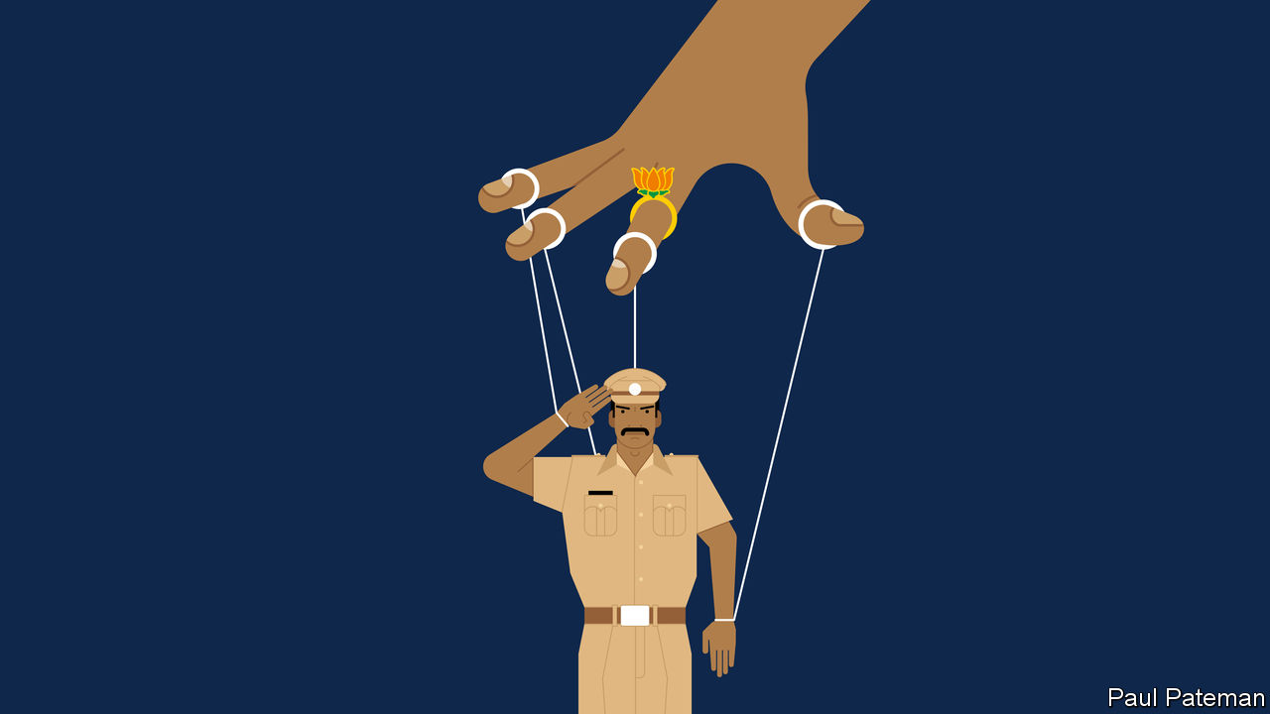

INDIA’S POLICE are generally better known for spit than polish. Yet even for a public inured to police violence, a slew of recent scandals has proved shocking. To punish a low-caste shopkeeper for staying open a few minutes after a local covid-19 curfew, for instance, officers in the southern state of Tamil Nadu spent a night torturing him and his son to death, in part by jamming nightsticks up the son’s anus. Far to the north in Uttar Pradesh a few days later, police “encountered” a local gang boss, which is to say, riddled him with bullets when he supposedly tried to escape from custody.

Such extra-judicial murders are common, and celebrated by some as rightful vengeance. This one stood out because the dead man’s gang had just killed eight cops on a bungled stake-out, following which five other members of his gang were “encountered” in rapid succession. But it also stood out for the sheer predictability of the gangster’s demise, mere hours after he had peacefully turned himself in, and for the brazen fakery of his “escape”.

In a Delhi courtroom, meanwhile, police have just as shamelessly been insisting they can find no proof that police or ruling-party politicians played any role in an ugly pogrom that shook the national capital in February. Disregarding copious video footage as well as the fact that most of the 53 who died were Muslim, investigators have instead invented a conspiracy by Muslim radicals and left-wing students.

In a tidier democracy, any one of these things might have cost the job not only of local police chiefs, but of their bosses’ bosses. Yet despite much talk about the need for a better police force, hardly a squeak has been uttered against the man who is ostensibly responsible for internal security, the home minister. This is not just because, though it exercises powerful influence, the central government does not control local forces in every state. The current minister, Amit Shah, also happens to be the closest and longest-standing lieutenant of Narendra Modi, the most powerful prime minister in a generation. Mr Shah is accomplished in his own right, too. As the top field commander of the Bharatiya Janata Party (BJP), he has won victory after victory in campaign after campaign. More than once he has even pulled victory from electoral defeat, luring opponents to defect just when rival parties thought they had won.

But if the silence surrounding Mr Shah reflects admiration, it also reflects fear. Before arriving in Delhi following the BJP’s triumph in national elections in 2014, Mr Shah had served, among other things, as Mr Modi’s home minister in BJP-ruled Gujarat. This was a time during which the state experienced bloody communal riots, as well as a rash of controversial police “encounters” of alleged Islamist terrorists. A number of officers who had saved Muslim lives during the worst violence in 2002 were transferred to lesser posts. Accused of complicity in one of the encounter killings, Mr Shah even spent a few months in prison himself before being (controversially) exonerated; several of the officers he commanded spent years behind bars and blamed him for hanging them out to dry.

That unpleasant experience seems to have strengthened the future minister’s resolve. Since arriving in Delhi, and particularly since his appointment as home minister last year, the tireless Mr Shah has been seen as the hidden hand turning virtually every agency of the state into a tool for keeping the government’s opponents in check. There is nothing new about the constitutionally questionable use of tax raids, or corruption probes, or claims of improper use of state property, or wielding of anti-terror laws, or myriad other pokes and prods of government authority for political ends. What is new is that it has become systematic and relentless. The police, it seems, are merely the most blunt of these instruments, and perhaps also the most malleable.

Whatever the need for police reform, then, it is unlikely to come from the home minister’s office. In a recent newspaper column Julio Ribeiro, former chief of police in both Gujarat and Mumbai, expressed dismay about the state of the force. “I know how dangerous it is for a straightforward police officer to oppose Shah’s diktats unless he is made of superior stuff, a rare occurrence today!” Or as a retired senior police officer recently lamented in a tweet, “It is so painful to see my service having become so subservient to vested, partisan interests that they are subverting the very foundations of our democracy.”

This article was downloaded by calibre from <https://www.economist.com/asia/2020/07/18/indias-home-minister-is-an-unlikely-champion-of-police-reform>

|  |  |  |  |
| --- | --- | --- | --- |
| Previous | Articles | Sections | Next |

|  |  |  |
| --- | --- | --- |
| Asia | Sections | Middle East & Africa |

China

Hong Kong’s companies: The darkness behind

.

Satellite navigation: BeiDou begins

.

Floods: A deluge of doubts

.

|  |  |  |
| --- | --- | --- |
| Asia | Sections | Middle East & Africa |

|  |  |  |  |
| --- | --- | --- | --- |
|  | Articles | Sections | Next |

#### The darkness behind

# Why business in Hong Kong should be worried

A new national-security law is not the only threat

Jul 18th 2020 | HONG KONG

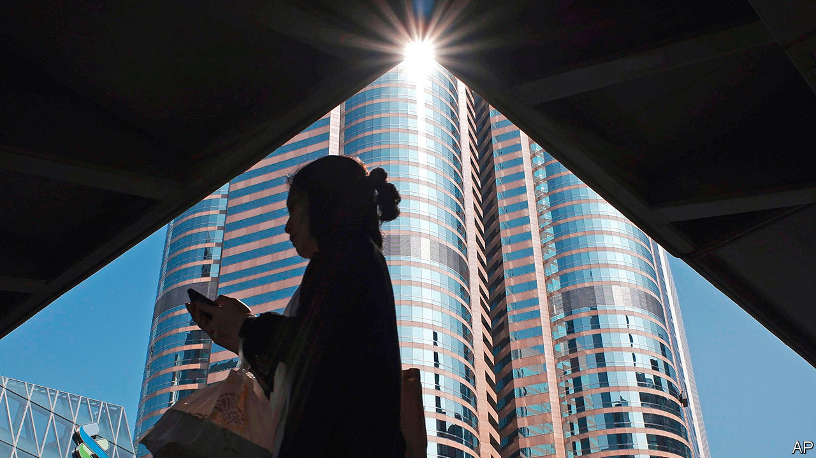

JUST OVER two weeks after its enactment, Hong Kong’s national-security law—a Leninist set of measures designed in Beijing and clamped on top of a legal system hitherto admired for its respect for individual rights—looms ever larger over the territory. In response, on July 14th, President Donald Trump signed the Hong Kong Autonomy Act. This authorises sanctions on those involved in “extinguishing Hong Kong’s freedom”, as well as on financial firms that knowingly do business with them. He also ruled that Hong Kong was no longer a separate economic entity justifying different treatment from the rest of China.

The act will sharpen differences between America and China, and give Hong Kong’s Communist Party overlords an excuse to divine foreign meddling in every corner of the territory’s life. They already spy enemies in many places. They have denounced the recent holding of informal primary elections, in which 610,000 Hong Kongers helped choose candidates fielded by anti-establishment parties for polls for the Legislative Council, or Legco, in September. They accused those who conducted the unprecedented exercise of harbouring “evil intentions”, including the use of Hong Kong as a base for “subversion” and foreign “infiltration”. These relate to crimes that, along with sedition and terrorism, are covered by the security law.

The mantra of establishment types is that this law is working to “stabilise” Hong Kong. They mean that, by constraining political and civil strife, the city is now reverting to its age-old role as a business hub. Officials point out how the Hang Seng index surged after the law’s promulgation on June 30th. Since then, they note, daily stockmarket turnover has been the highest in more than two years.

It is not surprising that they use such indicators. Business interests are deeply enmeshed in Hong Kong’s political structures—even more so now than in British colonial days. The Basic Law, the mini-constitution that Hong Kong adopted at the time of its handover to China in 1997, gives companies a big share of the vote in the 1,200-strong committee that chooses the chief executive. Nearly half of Legco’s seats are “functional” constituencies set aside for commercial and other special interests. The chief executive’s advisory body, the Executive Council, is stuffed with representatives from business and finance.

Since China took control of the city, businesspeople have had good reason to talk up its prospects. The territory has continued to be a vital intermediary between China and the world. In Hong Kong, mainland companies enjoy access to hard currency, free of the capital controls that shackle them at home. International investors have benefited from Hong Kong’s sound legal, monetary and regulatory systems. Hong Kong’s position as Asia’s pre-eminent international financial powerhouse has remained nearly unassailable. Its abundance of financial, legal, accounting and other professional expertise has encouraged more than 1,500 companies to put their regional headquarters in the city.

Strikingly, neither last year’s turmoil nor this year’s pandemic dented Hong Kong’s pre-eminence. In November Alibaba raised nearly $13bn in a secondary listing in Hong Kong. JD.com, another e-commerce giant, followed last month, raising $3.9bn. Officials and financial executives talk of a coming listings bonanza. Hong Kong is even a beneficiary in this regard of Sino-American tensions. Among other things, American moves to tighten auditing procedures make listings in New York harder for Chinese firms.

Yet business is also a source of social tension. Yes, finance and related services remain globally competitive, accounting for about a quarter of the economy. But finance employs relatively few people compared with less competitive services, and pushes up prices for everyone in the territory. In the absence of other vibrant sectors, property prices have grown out of kilter with most Hong Kongers’ incomes. Government efforts to foster high tech, the arts, medical tourism and even wine trading have produced little. In the time it took Alibaba, JD.com and a dozen other Chinese startups to emerge as giants, no new Hong Kong company has achieved the same.

This is a consequence of the government’s close ties with business. Nearly every major business sector is in the hands of one or another of the city’s handful of established property conglomerates. These stifle competition and keep the cost of property (the world’s most expensive) and other basic services prohibitively high.

The government should years ago have broken the dominance of such family-owned groups. And it should have done much more to build new public housing. Instead, writes Simon Cartledge for Gavekal Dragonomics, a consultancy, because these firms are over-represented in government, “Hong Kong’s single biggest disincentive to risk-taking and entrepreneurship—its high costs, especially for property—cannot be tackled.” That is why the back-to-business message is unlikely to resonate with ordinary Hong Kongers.

The security law, meanwhile, may generate problems for business. Admittedly, many executives say they are confident that street turmoil on last year’s scale is unlikely to erupt again, and that the stockmarket will keep booming. Many local firms say they support the new law. But some dare not voice their anxiety. A new survey of members of the American Chamber of Commerce is revealing: 76% of respondents said they were somewhat or extremely worried about the legislation.

In private, concerns are more fully aired. Hong Kong is a world leader in commercial arbitration, a niche the government has actively promoted. Yet leading experts in this field fear that clients with mainland counterparties will, however irrationally, think that the law undermines Hong Kong’s impartiality and will stipulate a seat for possible disputes other than Hong Kong. Singapore is vigorously recruiting Hong Kong arbitration lawyers.

Foreign media companies are also alarmed. The law requires tightened management of them and allows their communications to be seized or intercepted. This week the New York Times said it would move its digital operations, about a third of its Hong Kong staff, to South Korea.

Tech and social-media companies have the biggest worries. The law demands they take down material in breach of national security, or provide user information demanded by police investigating national-security cases. Alarm at having to do this has led Facebook, Twitter and others to pause all consideration of all requests from the government. Providers of cloud services, including Amazon, Google and Microsoft, are also under pressure to agree to demands from regulators for customers’ banking records. They too are stalling, but that can only be a stopgap. If executives are not to face fines or prison, firms must either comply or leave. The Hong Kong Autonomy Act only sharpens their dilemma. Helping America to enforce sanctions would violate the security law. Not doing so would incur American penalties.

Much as it would like to reassure firms, the government is failing to do so. The Economist asked the commerce secretary, Edward Yau, what measures would be taken against the media under the security law. He offered no details. Perhaps local officials are as much in the dark about the central government’s specific intentions as anyone. Asked whether the departure of Google, Facebook and Twitter would count as a bad day in the office for him, Mr Yau said that over time the picture would become clearer for tech companies when courts give rulings related to the security law. He added that it was not the job of a light-touch government to pick which business sectors should prosper and which should fail. Yet fostering tech is one of the government’s priorities, while the threat to the sector is the opposite of light-handed.

For the long term, the security law introduces a new and potentially ominous dimension into the business-political nexus. Under it, Luo Huining, the head of the central government’s liaison office in Hong Kong has been appointed as commissar to “advise” on national security. But he also oversees a secretive portfolio of investments in Hong Kong encompassing over 300 properties and the largest bookseller and publisher. If you think that Hong Kong’s anti-corruption body, which reports to the chief executive, would have no qualms about going hard after irregularities within that Communist Party-controlled empire, think again. Mr Luo is one of China’s most powerful men. Carrie Lam, the chief executive, is fast becoming just another small-town mayor. ■

This article was downloaded by calibre from <https://www.economist.com/china/2020/07/18/why-business-in-hong-kong-should-be-worried>

|  |  |  |  |
| --- | --- | --- | --- |
|  | Articles | Sections | Next |

|  |  |  |  |
| --- | --- | --- | --- |
| Previous | Articles | Sections | Next |

#### BeiDou begins

# China’s home-grown satnav system will soon be fully functional

Will the West shun a system so closely linked with China’s military power?

Jul 18th 2020 |

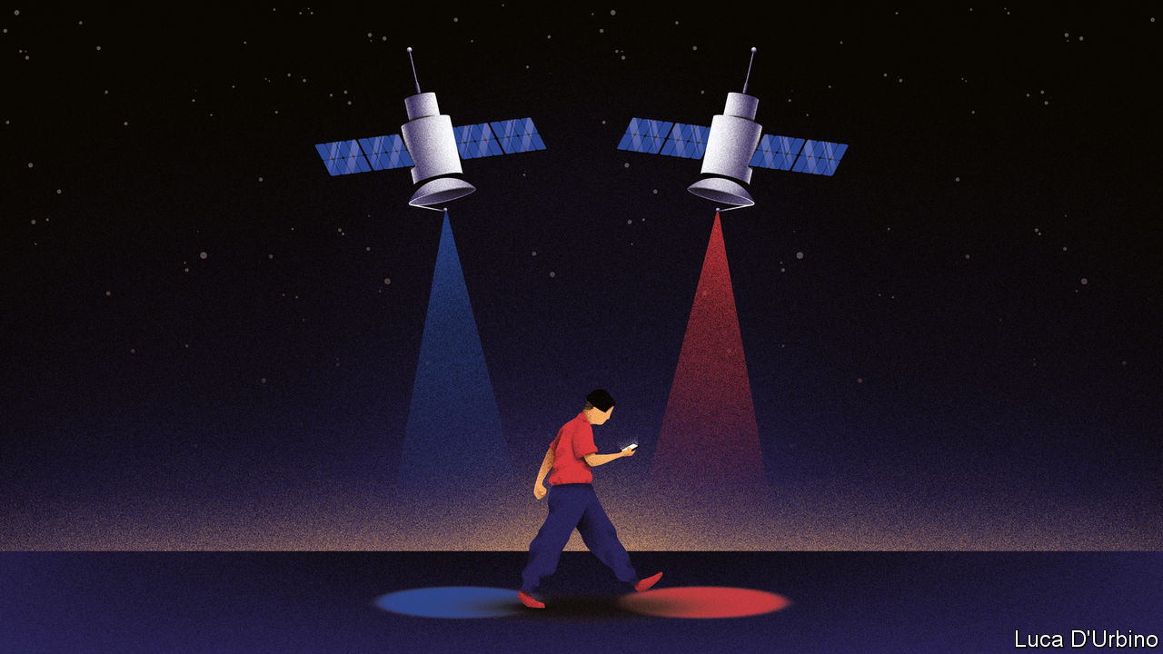

THIRTY-FIVE THOUSAND kilometres above the island of Borneo, the final piece of a Chinese infrastructure project is floating into place. The satellite is the last to join the BeiDou navigation system, which has taken nearly 30 years to develop and build. The state-owned firm that launched it from Sichuan province on June 23rd says the network of BeiDou satellites will function fully around the end of July. China sees this as a moment of triumph. It marks the end of the country’s dependence on America for provision of a vital service: location data.

Satellite-navigation systems work on a simple principle. Each spacecraft uses radio waves to beam the time and its position to Earth. Devices that receive simultaneous transmissions from three or more satellites can use tiny differences in these signals to work out where the user is. All location satellites broadcast timing data on the same frequencies, so that a location device could, in theory, lock on to whichever satellites provide the best signal, regardless of whether they belong to America’s Global Positioning System (GPS), Russia’s GLONASS, Europe’s Galileo or China’s BeiDou.

But depending on foreigners for a technology so critical to national security has long worried the Communist Party. Having to rely on America has caused particular anxiety. GPS was the earliest network to provide global coverage, so GPS-enabled devices became the norm for use by Chinese companies, citizens and soldiers. The system is owned by America’s government and operated by its air force, which means American officials could decide—say, in a conflict with China—to switch off or degrade the signals coming from GPS satellites. The main purpose of building BeiDou, which is operated by China’s space administration, is to give China full control over a navigation system it can rely on.

The placement of the final satellite (55 have been deployed, though some are no longer in use) is symbolic of a widening rift between China and the West in many technological domains. This trend was highlighted on July 14th by Britain’s decision to ban the use of products made by Huawei, a Chinese tech firm, in the country’s 5G telecommunications networks (see article).

Work on BeiDou began in 1993 and has involved three phases. The first two provided coverage in China and then across the rest of the Asia-Pacific region. As was the case with GPS, building it has focused on military applications. When the second phase was being tested in 2013, the Chinese navy relied on BeiDou data during exercises in the South China Sea, according to state media. The third phase provides global coverage. It also affords more accuracy, and allows users to send short text messages and distress signals.

China prefers to publicise BeiDou’s commercial applications. On the day of the final satellite’s launch, state television trumpeted an array of uses, from precision crop-planting and freight tracking to the guiding of autonomous taxis (when they eventually come into service). Since 2013 the government has required heavy goods vehicles and fishing ships to be equipped with BeiDou devices. Most smartphones sold in China, except Apple’s, can receive signals from BeiDou’s satellites.

The completion of BeiDou not only eliminates dependency on America. It also puts China ahead technologically. BeiDou’s satellites are more advanced than those of GPS. In the Asia-Pacific, BeiDou claims accuracy to 10cm, compared with 30cm offered by GPS. America began upgrading its system in 1997 with the deployment of a new generation of satellites known as GPS-3 in 1997. It may take another 15 years to complete this roll-out. China took just five years to finish installing its latest batch of 30 BeiDou satellites, which use technology as advanced as GPS-3.

China hopes to cash in on BeiDou globally. In December officials said China had exported BeiDou-enabled products to 120 countries and regions worldwide. Pakistan’s armed forces have started using the system. BeiDou receivers may eventually be installed in all phones, in addition to GPS. It would add little cost and give devices access to more satellites when pinpointing a location. Or perhaps Sino-American rivalry will make American and other Western manufacturers eschew the use of a system so closely linked with the military power of a potential enemy. BeiDou may yet struggle to find its place in the world. ■

This article was downloaded by calibre from <https://www.economist.com/china/2020/07/18/chinas-home-grown-satnav-system-will-soon-be-fully-functional>

|  |  |  |  |
| --- | --- | --- | --- |
| Previous | Articles | Sections | Next |

|  |  |  |  |
| --- | --- | --- | --- |
| Previous | Articles | Sections | Next |

#### A deluge of doubts

# Central and southern China are being ravaged by floods

The massive Three Gorges Dam is no cure for the woes of people further down the Yangzi

Jul 18th 2020 | KAISHA ISLAND, NANTONG

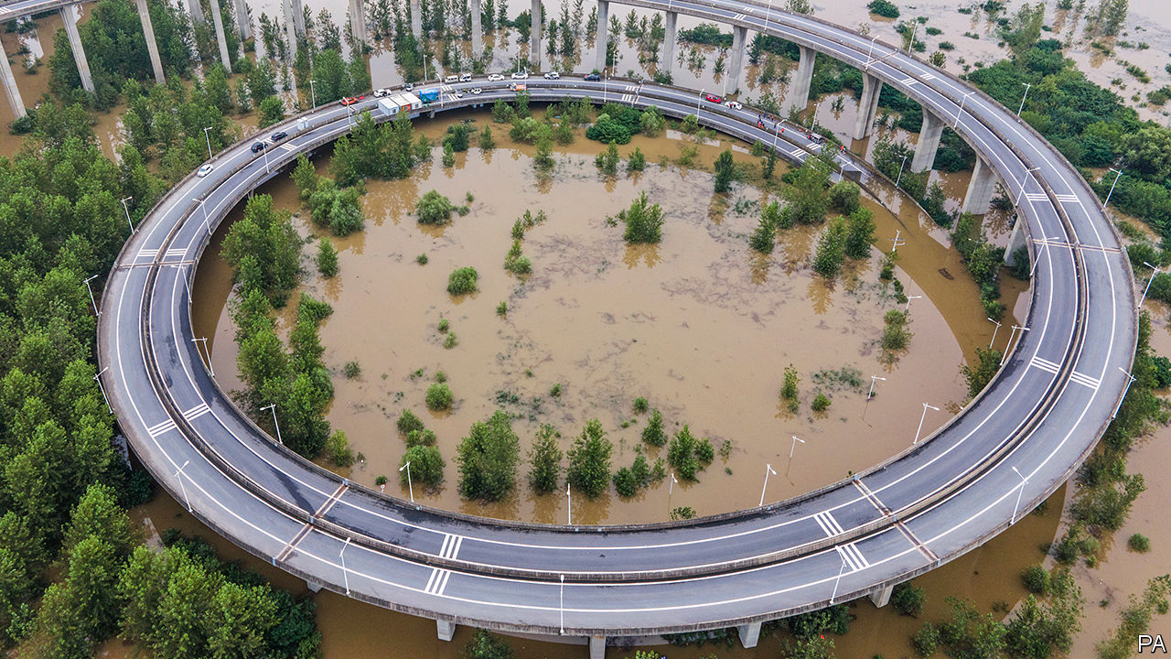

ON A RECENT rainy afternoon the owner of a small riverfront fish restaurant on sleepy Kaisha island, in the middle of the Yangzi river, was worried and bemused by the steadily rising waters. On a spit of land near the riverbank stood a cluster of trees, their trunks half-submerged. A wooden boardwalk leading out to a fishing pier remained only just above the murky water. “There is usually a metre of clearance under the walkway,” she said. “Yes, I have seen the water this high before, but never this early in the rainy season.”

Residents of the island, 160km upstream from Shanghai, where the river pours into the sea, worry about possible disaster. Upstream and along dozens of other river systems across central and southern China trouble has already come. In the face of the worst flooding in decades, China raised the national-emergency response to its second-highest level on July 12th. Two days it later issued an alert after forecasts of 200mm of rainfall a day (nearly eight inches) in many areas and, in some spots, as much as 60mm an hour.

Flooding in dozens of provinces has already caused the death or disappearance of 141 people, the displacement of millions, the loss of 28,000 homes and 82bn yuan ($11.7bn) in damage. Soldiers have been dispatched to help with relief. President Xi Jinping said China had entered “a crucial period of flood control”.

Kaisha island sits in the shadow of the Yangzi’s latest engineering marvel, a gleaming new rail-and-road suspension bridge linking the cities of Suzhou, Nantong and other parts of Greater Shanghai. There are no reports of risk to it, but six days after it came into service on July 1st, an ancient bridge 300km away was washed away by a roaring river flood. The seven-arched structure was a cherished landmark in the city of Huangshan.

But the fate of the nearly 500m people of the Yangzi basin ultimately depends on another engineering marvel far upstream, the massive Three Gorges Dam. Completed in 2006 at vast expense (and in the face of fervid opposition), it was touted as a multi-function boon. It would generate power, boost irrigation, improve river navigability and, perhaps most important, give China the upper hand in its millennia-old struggle against devastating floods. But its failure to do so this year is proof, say the dam’s critics, that its merits were oversold. Some even question the dam’s durability, and warn of a possible calamity—a risk that Chinese officials angrily dismiss.

Climate change may have caused extreme weather unusually early in the year, producing more rain than hydro-engineering can handle. Zhang Junjie of Duke Kunshan University says most Chinese experts agree that climate change is making the region’s weather more volatile and will reduce farming and industrial output. “In the past, China focused on the engineering approach, building more dams, more dykes and higher banks. But the government has realised this is like an arms race with nature that we can’t really win,” he says. In December, legislators began deliberating a new draft law on protecting the entire Yangzi river basin, including the restoration of riverside ecosystems that may help to reduce flooding. This, says Mr Zhang hopefully, is “giant progress”. ■

For more coverage of climate change, register for The Climate Issue, our fortnightly [newsletter](https://www.economist.com/theclimateissue/), or visit our [climate-change hub](https://www.economist.com/news/2020/04/24/the-economists-coverage-of-climate-change)

This article was downloaded by calibre from <https://www.economist.com/china/2020/07/18/central-and-southern-china-are-being-ravaged-by-floods>

|  |  |  |  |
| --- | --- | --- | --- |
| Previous | Articles | Sections | Next |

|  |  |  |
| --- | --- | --- |
| China | Sections | Europe |

Middle East & Africa

The Arab world: Twilight of the petrostates

.

South Africa: Measuring the poverty pandemic

.

Burkina Faso: Rhyme and punishment

.

Pineapples and prohibition: Dry, the beloved country

.

|  |  |  |
| --- | --- | --- |
| China | Sections | Europe |

|  |  |  |  |
| --- | --- | --- | --- |
|  | Articles | Sections | Next |

#### Twilight of an era

# The end of the Arab world’s oil age is nigh

Pain will be felt across the region

Jul 18th 2020 | BEIRUT

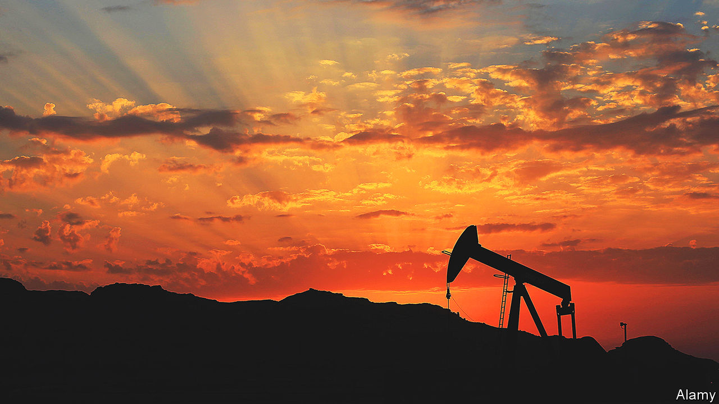

THEIR BUDGETS don’t add up anymore. Algeria needs the price of Brent crude, an international benchmark for oil, to rise to $157 dollars a barrel. Oman needs it to hit $87. No Arab oil producer, save tiny Qatar, can balance its books at the current price, around $40 (see chart).

So some are taking drastic steps. In May the Algerian government said it would slice spending in half. The new prime minister of Iraq, one of the world’s largest oil producers, wants to take an axe to government salaries. Oman is struggling to borrow after credit-rating agencies listed its debt as junk. Kuwait’s deficit could hit 40% of GDP, the highest level in the world.

Covid-19 sent the price of oil plummeting to all-time lows as people stopped moving around in order to limit the spread of the virus. With commerce resuming, the price has ticked back up, though a peak in demand may be years away.

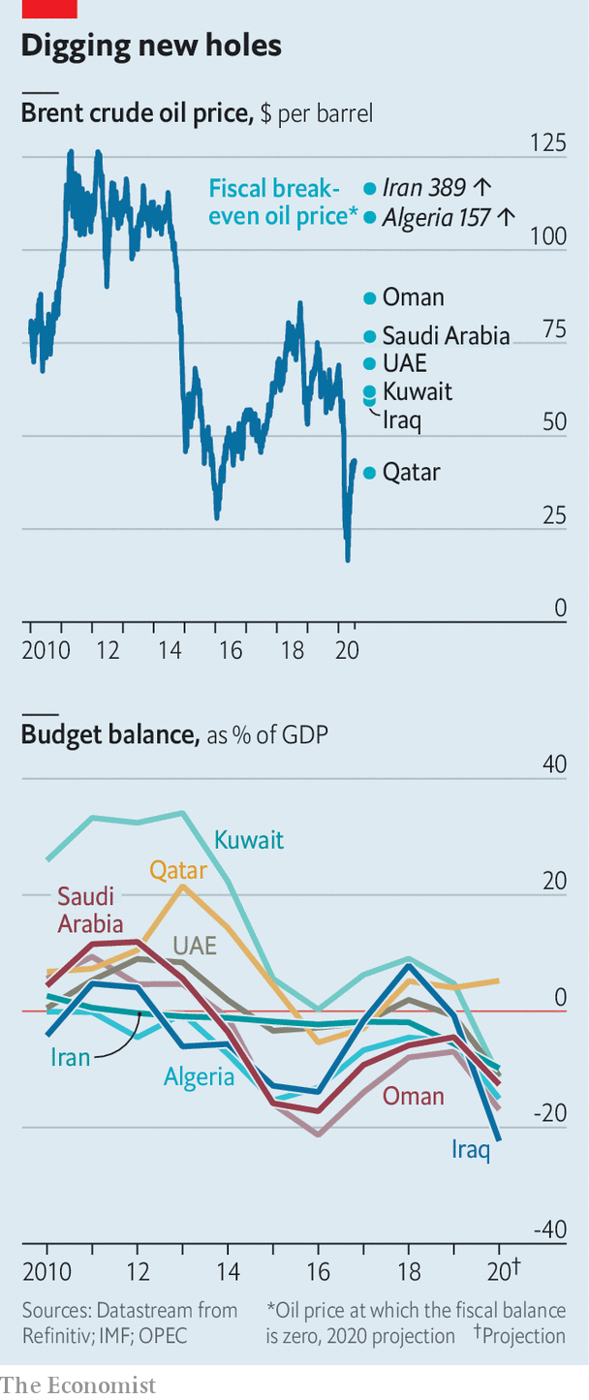

But don’t be fooled. The world’s economies are moving away from fossil fuels. Oversupply and the increasing competitiveness of cleaner energy sources mean that oil may stay cheap for the foreseeable future. The recent turmoil in oil markets is not an aberration; it is a glimpse of the future. The world has entered an era of low prices—and no region will be more affected than the Middle East and north Africa.

Arab leaders knew that sky-high oil prices would not last for ever. Four years ago Muhammad bin Salman, the de facto ruler of Saudi Arabia, produced a plan called “Vision 2030” that aimed to wean his economy off oil. Many of his neighbours have their own versions. But “2030 has become 2020,” says a consultant to Prince Muhammad. Oil revenues in the Middle East and north Africa, which produces more of the black stuff than any other region, fell from over $1trn in 2012 to $575bn in 2019, says the IMF. This year Arab countries are expected to earn about $300bn selling oil, not nearly enough to cover their spending. Since March they have cut, taxed and borrowed. Many are burning through cash reserves meant to fund reform.

Pain will be felt in non-oil producers, too. They have long relied on their oily neighbours to put their citizens to work. Remittances are worth over 10% of GDP in some countries. Trade, tourism and investment have spread the riches around to some degree. Still, compared with other regions, the Middle East has one of the highest proportions of unemployed young people in the world. Oil has bankrolled unproductive economies, propped up unsavoury regimes and invited unwelcome foreign interference. So the end of this era need not be disastrous if it prompts reforms that create more dynamic economies and representative governments.

There is sure to be resistance along the way. Start with the region’s wealthiest oil producers, which can cope with low prices in the short run. Qatar and the United Arab Emirates (UAE) have huge sovereign-wealth funds. Saudi Arabia, the region’s largest economy, has foreign reserves worth $444bn, enough to cover two years of spending at the current rate.

But they have all been hit hard by the pandemic, as well as low oil prices. And they have long overspent. In February, before the coronavirus broke out in the Gulf, the IMF predicted that the countries of the Gulf Co-operation Council (GCC)—Bahrain, Kuwait, Oman, Qatar, Saudi Arabia and the UAE—would exhaust their $2trn of reserves by 2034. Since then Saudi Arabia has spent at least $45bn of its cash. If it continues at that pace for another six months it would strain the Saudi rial’s peg to the dollar. Devaluation would hit real incomes hard in a country which imports almost everything. Officials are worried. “We are facing a crisis the world has never seen the likes of in modern history,” says Muhammad al-Jadaan, the finance minister.

In an attempt to balance the books, Saudi Arabia has suspended a cost-of-living allowance for state workers, raised petrol prices and tripled its sales tax. Even so, the budget deficit could exceed $110bn this year (16% of GDP). More taxes—perhaps on businesses, income and land—could follow. But raising taxes risks further depressing commerce, which has been hobbled in order to contain the coronavirus.

The kingdom had hoped an increase in religious and leisure tourism would at least partially compensate for the decline in oil revenue. That now seems a fantasy. The holy city of Mecca has been closed to foreigners since February. Last year the annual haj drew 2.6m pilgrims; this year it has been capped at around 1,000. “The kingdom is stuck in the oil dependency it needs to climb out of to survive,” says Farouk Soussa of Goldman Sachs, a bank.

Still, some see an upside to the upheaval in oil-producing states. The countries of the Gulf produce the world’s cheapest oil, so they stand to gain market share if prices remain low. As expats flee, locals could take their jobs. And the region’s struggles may convince some countries to speed up reforms. Credit-rating agencies praise Saudi Arabia’s tax rises as a step towards turning a rentier economy into a productive one. To drum up fresh revenue, Arab leaders speak of a wave of privatisations. The kingdom recently announced the sale of the world’s largest desalination plant at Ras al-Khair. But at the moment investors seem more inclined to pull their money out of the region altogether.

Meanwhile, public anger is growing. Saudis mutter about the new taxes, which fall most heavily on the poor. “Why is MBS not taxing the rich?” gripe the jobless on social media, referring to Prince Muhammad by his initials. “Why doesn’t he sell his yacht and live like us?” asks a mother of four from the north, where the prince is building more palaces. In Iraq officials enraged by pay cuts have thrown their support behind a protest movement that is seeking to topple the entire political system. In Algeria, where income per person has fallen from $5,600 in 2012 to under $4,000 today, protesters are drifting back to the streets. The region’s rulers can no longer afford to buy the public’s loyalty.

## Where the oil doesn’t flow

Protests have already resumed in Lebanon, where the pandemic temporarily halted months of demonstrations over corruption and a collapsing economy. Lebanon is not an oil producer (though it hopes to become one). Its crisis, which could see GDP shrink more than 13% this year, comes from the unravelling of a post-civil-war economic order too reliant on services and a bloated financial sector. But the slump in the Gulf has made it worse. A long-term drop in oil prices will bring more pain even for Arab countries that do not pump the stuff.

Remittances from energy-rich states are a lifeline for the entire region. More than 2.5m Egyptians, equal to almost 3% of that country’s population, work in Arab countries that export a lot of oil. Numbers are larger still for other countries: 5% from Lebanon and Jordan, 9% from the Palestinian territories. The money they send back makes up a sizeable chunk of the economies of their homelands. As oil revenue falls, so too will remittances. There will be fewer jobs for foreigners and smaller pay packets for those who do find work.

This will upend the social contract in states that have relied on emigration to soak up jobless citizens. About 35,000 Lebanese graduate from university each year; the Lebanese economy only employs 5,000 of them. Most look abroad for work. The exodus has speeded up the brain drain. Egypt used to supply unskilled labour to the Gulf. In the 1980s more than one-fifth of its migrants toiling in Saudi Arabia were illiterate. Today most have a secondary education; the share of university graduates has doubled. Egypt is now struggling with covid-19 in part because it lacks enough doctors: more than 10,000 have emigrated since 2016, many to the Gulf.

With fewer opportunities in the oil-producing states, many graduates may no longer emigrate. But their home countries cannot provide a good life. Doctors in Egypt earn as little as 3,000 pounds ($185) a month, a fraction of what they make in Saudi Arabia or Kuwait. A glut of unemployed graduates is a recipe for social unrest. Add to that, perhaps, an influx of compatriots forced to come home when their contracts run out. Many do not wish to, since emirates like Dubai and Qatar offer not just well-paying jobs but first-class services and relatively honest governance. A Gallup poll published in January found that just 10% of Egyptian migrants in the rich parts of the Gulf want to return.

Businesses will be hurt as well. Oil producers are big markets for other Arab countries. In 2018 they took 21% of exports from Egypt, 32% from Jordan and 38% from Lebanon. Firms can pursue other trading partners, of course. Egypt already exports more to both Italy and Turkey than it does to any Arab country. But the stuff it sells there—petroleum products, metals and chemicals—tends to create few jobs for Egyptians. Countries in the region buy more labour-intensive goods, such as crops, textiles and consumer products. More than half of the televisions exported from Egypt wind up in the GCC. Jordan’s pharmaceutical industry, which generates more than 10% of its total exports and supports tens of thousands of jobs, sends almost three-quarters of its exports to Arab oil producers. Smaller, poorer Gulf states will make for more impecunious customers.

They will also send out fewer wealthy tourists. In Lebanon visitors from just three countries—Kuwait, Saudi Arabia and the UAE—account for about one-third of total tourist spending. Most visitors to Egypt are from Europe, but Gulf tourists stay longer and spend more money at restaurants, cafés and malls. These countries can look elsewhere for revenue, but it will be hard to replace the wealthy tourists in their backyards. Saudis spend the summer in Cairo or Beirut because those cities are close, culturally familiar and speak the same language. Slovenians or Singaporeans are unlikely to do the same.

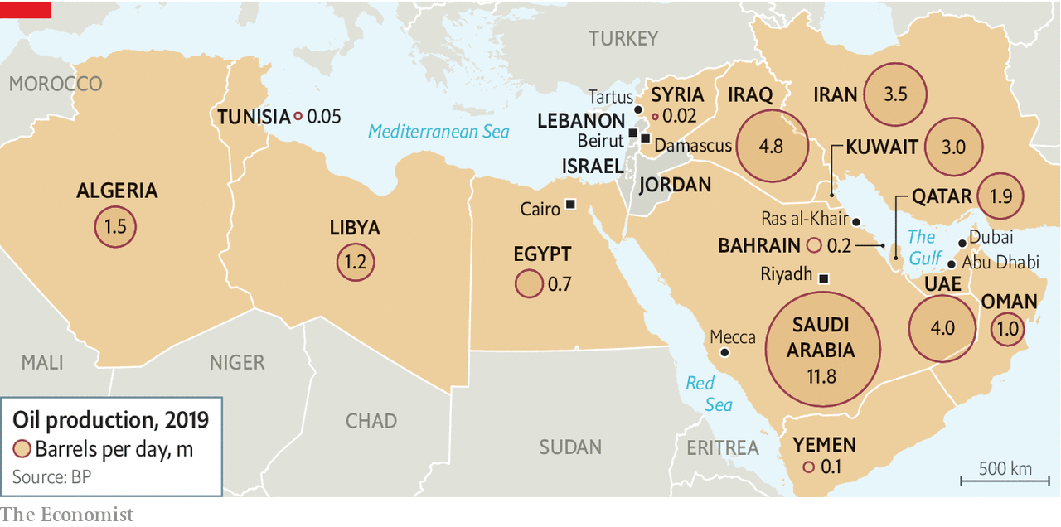

It is something of a historical accident that the Gulf states rose to become hubs of power and influence in the Middle East. For centuries they were backwaters sustained by pilgrimage and the pearl trade. The rulers of the region were in the great old Arab capitals: Cairo and Damascus fought wars against Israel and led the cry for Arab nationalism. Beirut was the financial and cultural hub.

These old powers, now well into decline, have an uneasy relationship with the newcomers. In a recording leaked in 2015 Abdel-Fattah al-Sisi, the Egyptian president, mocked the Gulf’s wealth. He told an adviser to ask the Saudis for $10bn in financial aid, a request that was met with laughter. “So what? They have money like rice,” Mr Sisi quipped in response.

They have been generous with it, if selectively so. Kuwait, Saudi Arabia and the UAE gave Egypt about $30bn in aid after 2013, when Mr Sisi overthrew an elected Islamist government. The Sunni leadership in Lebanon has long been a client of the Gulf states. Rafik Hariri, who led the country after its civil war, made his fortune as a contractor in Saudi Arabia. His son Saad, who also served as prime minister, holds Saudi citizenship. The GCC has bailed out Jordan twice in the past decade.

In recent years, though, funding has started to dry up. Partly this is due to political disputes. Seen from Riyadh or Abu Dhabi, many Arab states they once subsidised now look like bad investments. The Saudis are frustrated that Mr Sisi did not send troops to support their ill-fated invasion of Yemen, and that the younger Mr Hariri was too tolerant of Hizbullah, the Shia militia and political party backed by Iran. Their diminishing largesse also reflects their diminishing fortunes. Egypt has not received any money in years. No one from the Gulf looks willing to bail out Lebanon. Jordan had to plead to receive a five-year, $2.5bn aid package from the Gulf in 2018, half of what it got in 2011. None of this is necessarily bad: many Arabs would appreciate less foreign influence in their countries. But it will add to the financial pressure on their own indebted governments.

It may also presage a broader change in the region’s politics. For four decades America has followed the “Carter Doctrine”, which held that it would use military force to maintain the free flow of oil through the Persian Gulf. Under President Donald Trump, though, the doctrine has started to fray. When Iranian-made cruise missiles and drones slammed into Saudi oil facilities in September, America barely blinked. The Patriot missile-defence batteries it deployed to the kingdom weeks later have already been withdrawn. Outside the Gulf Mr Trump has been even less engaged, all but ignoring the chaos in Libya, where Russia, Turkey and the UAE (to name but a few) are vying for control.

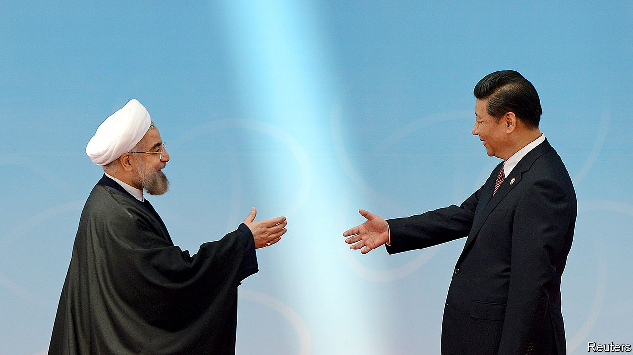

President Xi has a bridge to sell you

A Middle East less central to the world’s energy supplies will be a Middle East less important to America. Russia may fill the void in places, but its regional interests are narrow, such as its determination to preserve its Mediterranean port at Tartus in Syria. It does not wish to—and probably cannot—extend a security umbrella across the Arabian peninsula. China has tried to stay out of the region’s politics, pursuing only economic benefits: construction contracts in Algeria, port concessions in Egypt, a wide range of deals in the Gulf.

As Arab states become poorer, though, the nature of their relationship with China may change. This is already happening in Iran, where American sanctions have choked off oil revenue. Officials are discussing a long-term investment deal that could see Chinese firms develop everything from ports to telecoms. It is framed as a “strategic partnership”, but critics worry it could leave China in control of the infrastructure it builds, as it has in some indebted Asian and African countries. Falling oil revenue could force this model on Arab states—and perhaps complicate what remains of their relations with America.

## No way out

Ask young Arabs where they would like to live, and there is a good chance they will choose Dubai. A survey in 2019 found that 44% viewed the UAE as the ideal country to emigrate to. They often frame their admiration in contrast to their home countries. For all its faults, Dubai (and its neighbours) offers something unusual in the region: the police are honest, the roads well paved, the electricity uninterrupted.

As Lebanon’s economy crashes, everyone is talking of emigration. Yet there are few jobs in the Gulf. “Dubai was always the escape,” says one woman. “Now it’s like we’re trapped, with no backup plan.” Young people across the region have the same fears. Egypt can feel like a country crumbling under its own weight; Jordan is perennially in crisis. Almost ten years after a Tunisian fruit-seller lit the spark of the Arab spring, the frustrations that caused it persist. The end of the oil age could bring change. But it will bring pain first. ■

This article was downloaded by calibre from <https://www.economist.com/middle-east-and-africa/2020/07/18/the-end-of-the-arab-worlds-oil-age-is-nigh>

|  |  |  |  |
| --- | --- | --- | --- |
|  | Articles | Sections | Next |

|  |  |  |  |
| --- | --- | --- | --- |
| Previous | Articles | Sections | Next |

#### Measuring the poverty pandemic

# Covid-19 has throttled South Africa’s economy

A groundbreaking study reveals how many people have been tossed back into penury

Jul 18th 2020 | JOHANNESBURG

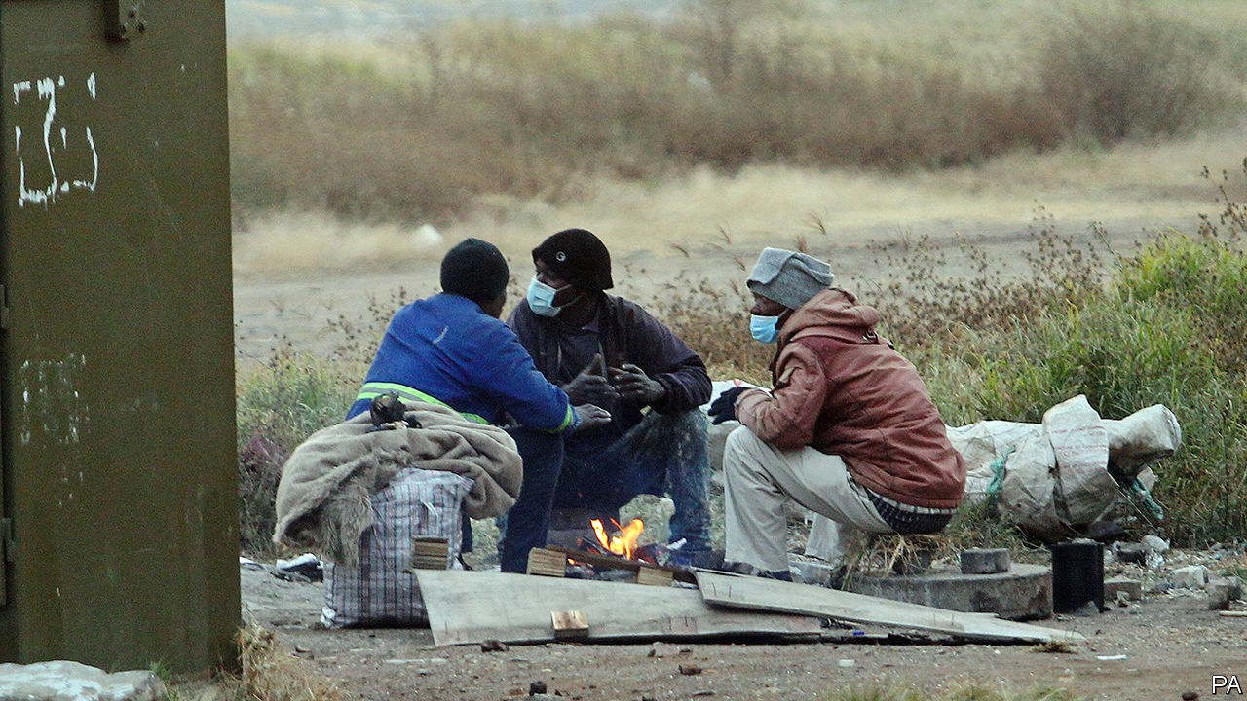

CHRISTINA MOTHIBA had always wanted to return home, but not like this. In 2006 she left Laaste Hoop, her village in Limpopo, South Africa’s most rural province, and moved in with her sister in Johannesburg, the country’s economic hub. It took four years but eventually she found a job, as a tea-lady in an office. In 2015 she was promoted to administrator. Her salary supported four others: a brother, her mother and two children. There was enough spare cash for a plot in Laaste Hoop. Ms Mothiba, who is 49, hoped to build a house on the land before she retired.

Then came covid-19. “With this pandemic life is not what it was before,” says Ms Mothiba. She was laid off shortly after South Africa’s lockdown began on March 27th. There were no prospects and rent was due, so she went back to her mother’s house in Laaste Hoop. She has shelved her retirement plans and is focused solely on ensuring her family eats. “You can’t understand how stressed I am right now.”

Before covid-19 South Africa was in its second recession in two years. That dire situation has turned into a disaster. A sense of the scale is given by groundbreaking research from an academic consortium, which used data from a mobile-phone survey to produce one of the first detailed analyses of the economic effects of covid-19 in a developing country. The reports, published on July 15th, show how the pandemic has impoverished South Africa—and made one of the world’s most unequal countries even more so.

According to the research, one in three people who earned an income in February did not do so in April. About half of the erstwhile earners were permanently laid off, rather than furloughed, suggesting that the effects of the pandemic will be long-lasting. South Africa’s eye-wateringly high unemployment rate—30% as of the first quarter of 2020—is set to rise further.

The studies show the uneven effects of economic restrictions (see chart). Researchers reckon that women account for 2m of the 3m net jobs lost. Manual workers were nearly three times as likely to have been laid off as professionals.

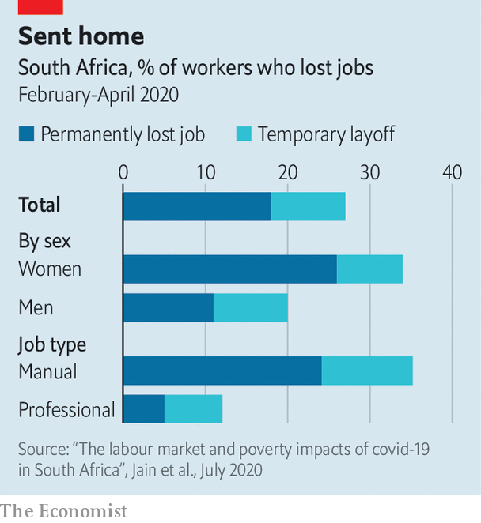

The lockdown also led to mass internal migration. Between late March and the end of May, 5m-6m people (15% of adults) changed their residence. Urbanisation has gone into reverse, as people like Ms Mothiba left townships and went back to their home villages to reunite with their families (in her case, her mother and 12-year-old daughter). So far the vast majority of movers have not gone back to cities.

Jobless returnees have put pressure on families. Of the households that received people in May, most reported that they ran out of money for food. Overall nearly half (47%) of respondents said they could not afford enough food in April—more than twice the share of households saying they could not do so at any point during 2017, according to a comparable survey.

South Africa’s social-security system should have cushioned the blow. But it has been woefully mismanaged. A dedicated grant meant for the unemployed who are ineligible for other support was supposed to help 15m people. By early June just 600,000 had been paid. The government has admitted that 60% of rejected applicants were in fact eligible.

President Cyril Ramaphosa hopes that the economy will soon recover. But there are ample reasons to worry. For a start the virus is surging; South Africa is the fourth-most affected country in the world, according to the five-day moving averages of case totals collated by Johns Hopkins University. Hospitals are increasingly overwhelmed. Epidemiological models used by the government suggest cases will peak between late this month and the end of September, depending on the province.

South Africa is trying to balance surging caseloads with rekindling economic activity (see article). It is a huge task. In June a benchmark measure of business confidence plunged to its lowest level since it began in 1975. The South African Chamber of Commerce and Industry worries that the unemployment rate could reach 50%. Eskom, the state-run power utility, has reintroduced rolling blackouts. The public finances, already damaged by years of corruption, wasteful spending and low growth, are perilous. The treasury’s forecast for the budget deficit for 2020/21 has been revised from 6.8% of GDP to 15.7%. More than a fifth of the budget will be spent on servicing debt.

Tito Mboweni, the finance minister, warns that more public spending is not the answer. On July 15th he argued that higher spending will only crowd out private investment and further raise the cost of borrowing. He reiterated his proposals for structural reform first published a year ago.

Mr Mboweni is, however, the lone reformist in the cabinet and the upper echelons of the African National Congress (ANC). There is seemingly no problem for which the ANC does not see the state as the solution. A paper by the party’s “economic transformation committee”, published this month, proposes, among other things, a state bank, a state pharmaceutical company and a national health-insurance scheme. Others in the ANC want a policy of “prescribed assets”, whereby the government dictates where pension funds and other investors put their money (a policy also used by the apartheid regime).

Mr Ramaphosa seems to be siding with the statists. This may be tactical: he needs to shore up his position within the party ahead of the ANC’s National General Council meeting, which has been postponed from June. But it is also because, unlike Mr Mboweni, he sees the state as a driver of—rather than a brake on—growth. In May he echoed the party’s left wing, saying that “radical economic transformation must underpin the economic future.”

Ms Mothiba has more prosaic concerns. She worries that there may be no point in trying her luck again in Johannesburg, even if the pandemic subsides. She is thinking of setting up a fruit and vegetable stand to make ends meet. It was not the return to the land she envisaged. “But I can’t just sit here and fold my arms.” ■

Editor’s note: Some of our covid-19 coverage is free for readers of The Economist Today, our daily [newsletter](https://my.economist.com/user#newsletter). For more stories and our pandemic tracker, see our [hub](https://www.economist.com/news/2020/03/11/the-economists-coverage-of-the-coronavirus)

This article was downloaded by calibre from <https://www.economist.com/middle-east-and-africa/2020/07/18/covid-19-has-throttled-south-africas-economy>

|  |  |  |  |
| --- | --- | --- | --- |
| Previous | Articles | Sections | Next |

|  |  |  |  |
| --- | --- | --- | --- |
| Previous | Articles | Sections | Next |

#### Rhyme and punishment

# A charity in Burkina Faso teaches criminals to sing

Finding rehabilitation, and stardom, behind bars

Jul 18th 2020 | OUAGADOUGOU

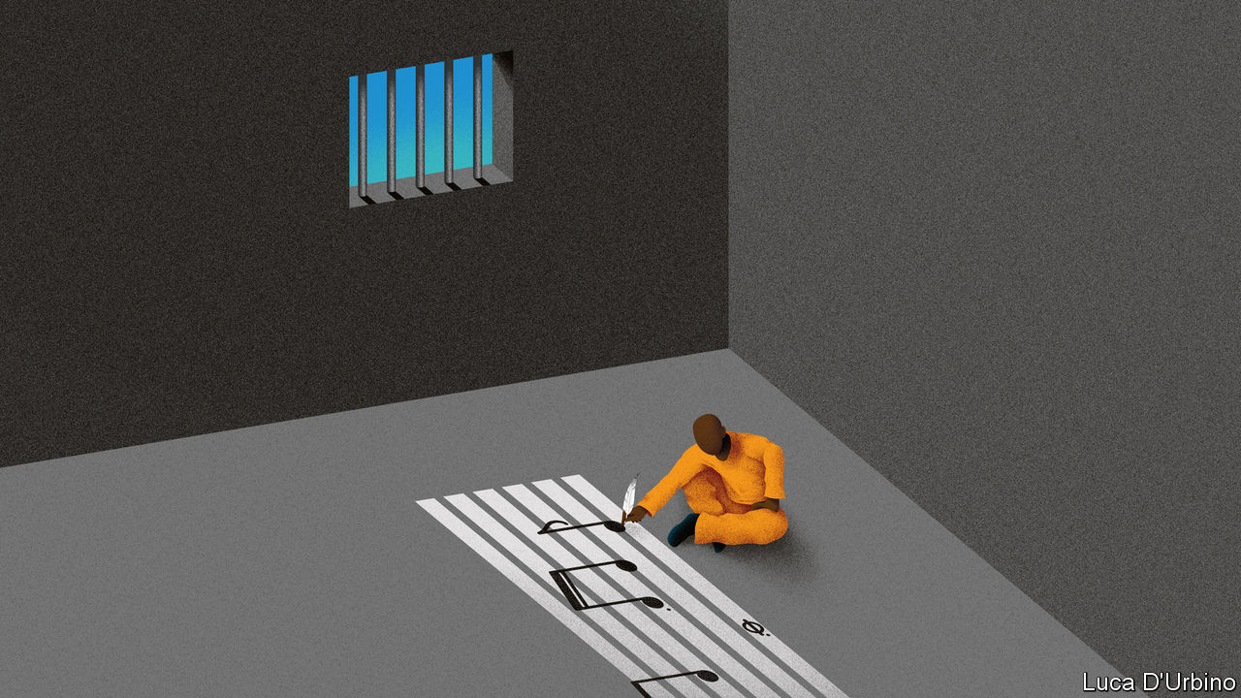

WHEN ROLAND TAPSOBA went to prison in 2015 he never dreamed he’d emerge a rock star. The 31-year-old former estate agent was convicted of fraud in Burkina Faso’s capital, Ouagadougou, and sentenced to five years behind bars.

He had sung hip-hop for fun in high school. In jail, music became his salvation. Mr Tapsoba learned to play the guitar, huddled with ten inmates over one instrument. His favourite song was “Wata Beogo” (“I’m coming tomorrow”, in Mossi, a local language). It made him think about seeing his family. “In jail you might feel hungry or have needs, but those are physical needs. In your mind the main priority is to get free, to go beyond the gates,” he says.

Almost three years into his sentence he entered a music competition run by African Culture, a local charity that tries to rehabilitate prisoners through the arts. Mr Tapsoba competed against six inmates and won an album deal and a music video, which he produced in jail. Since his release last year, fame has helped Mr Tapsoba (who now goes by the stage name Rolby) chart a new course in life. His lyrics thrum out over the airwaves and in concerts.

Even at the best of times Burkina Faso’s prisons are overcrowded and dangerous. Almost 8,000 inmates languish in them. Many have not been convicted of anything, since suspects can wait for more than a year before they are tried. And overcrowding is getting worse because the government is rounding up young men suspected of supporting jihadists. Human-rights groups say that some prisoners are tortured. Many are depressed or traumatised and get no treatment, either for their psychological problems or for HIV or TB.

Freeman Tapily, the founder of African Culture, has spent a decade trying to support prisoners through song and dance and to reduce the stigma they face when they are released. The group, which is funded by the French government, runs an annual music festival, during which it hosts concerts in prisons. This year inmates will have the opportunity to write a play, which they will perform in venues around the capital. The arts give “inmates the opportunity to express themselves, to help build resilience and trust,” says Melodie Safieddine, a psychologist who has worked in several conflict zones.

It is not just Mr Tapsoba’s ascent from cell to concert hall that offers hope, but his lyrics, too. One of his winning songs goes: “After effort there is comfort. After sweat there is happiness. If life doesn’t end, there is no despair. Take courage.”

This article was downloaded by calibre from <https://www.economist.com/middle-east-and-africa/2020/07/18/a-charity-in-burkina-faso-teaches-criminals-to-sing>

|  |  |  |  |
| --- | --- | --- | --- |
| Previous | Articles | Sections | Next |

|  |  |  |  |
| --- | --- | --- | --- |
| Previous | Articles | Sections | Next |

#### Dry, the beloved country

# South Africa bans alcohol sales

But it can’t stop the home-brewers

Jul 18th 2020 | JOHANNESBURG

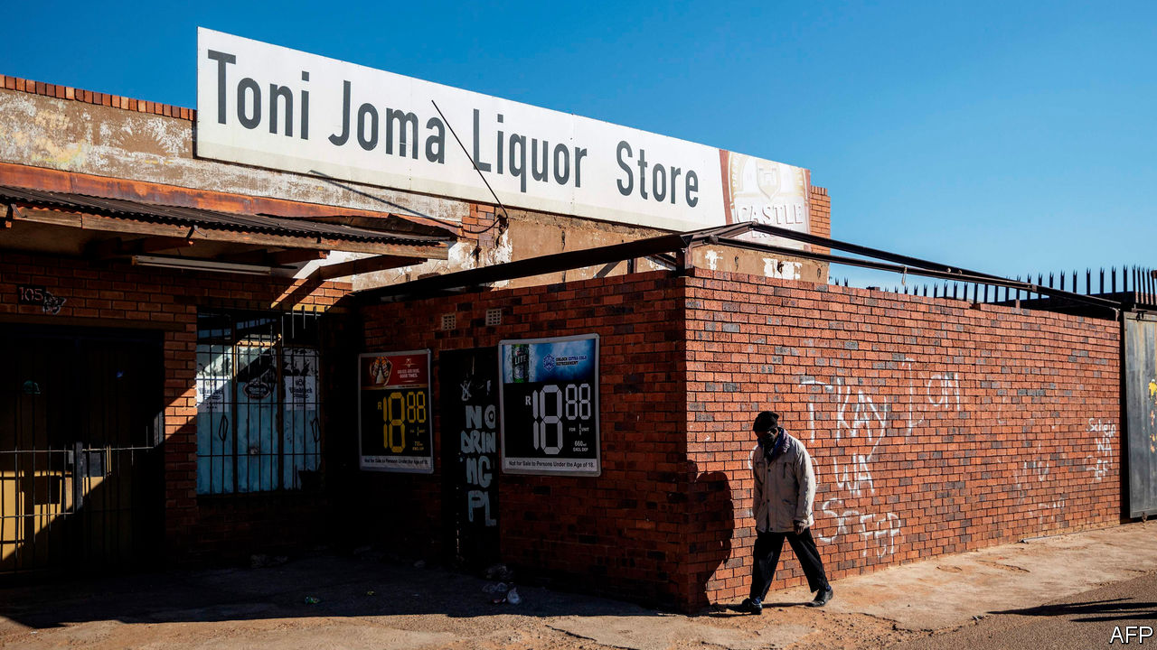

CHARLES DE BRUIN’S phone has barely stopped ringing since 9pm on July 12th, after Cyril Ramaphosa, South Africa’s president, announced an immediate ban on the sale of alcohol. The prohibition is a boon for pineapple growers such as Mr De Bruin. The fruit is good for home-brewing, he explains; pineapple beer requires little sugar or yeast and is ready quickly. “Prices have shot through the roof.”

The ban is the second of the year. Zweli Mkhize, the health minister, says that admissions to trauma wards fell by 60-70% in April and May, when alcohol was prohibited during an initial, stringent lockdown. When restrictions were eased in June, admissions rose. The Medical Research Council reckons that an eight-week ban could allow for nearly 13,000 covid-19 patients to be treated in intensive-care units.

These data reflect what Dr Mkhize calls South Africa’s “unhealthy relationship” with alcohol. Less than a third of South African adults drink the stuff, but those who do quaff about twice as much each as the average boozer elsewhere.

History partly explains these patterns. Under apartheid black miners and factory workers lived in single-sex hostels away from their families. Drinking passed the time. In the winelands mixed-race workers were given “dops” (alcohol) by farmers. Yet history also shows how illicit trades thrive under prohibition. Between 1928 and 1961 black people were not allowed to buy European wine or spirits. This, says Paul Nugent of the University of Edinburgh, encouraged the rise of home-brewing and shebeens, the drinking dens that thrive in townships.

The new ban has supporters. As in the 1920s these include women who fear drunken male violence. But it would be better received if the state were not so arbitrary. Cigarette sales are also illegal. Casinos are open but most schoolchildren are at home. South Africans cannot meet family members but they can attend church.

Hundreds of thousands of jobs depend on the alcohol supply chain. The first ban put 350 wine producers out of business. Tax collectors reckon they lost out on 1.3bn rand ($78m) in alcohol levies in April alone. Restricting sales takes away a source of pleasure, especially for those who cannot afford to bulk-buy pinotage. And though a short ban may help doctors for a time, history—and pineapple prices—suggest that in the long run prohibition fails. ■

This article was downloaded by calibre from <https://www.economist.com/middle-east-and-africa/2020/07/18/south-africa-bans-alcohol-sales>

|  |  |  |  |
| --- | --- | --- | --- |
| Previous | Articles | Sections | Next |

|  |  |  |
| --- | --- | --- |
| Middle East & Africa | Sections | Britain |

Europe

Germany’s China policy: Out of date

.

Protests in Russia’s Far East: An unlikely local hero

.

Poland’s election: Narrow minds, narrow win

.

France: Accent grave

.

Italy: Parting the waters

.

Charlemagne: How Ireland gets its way

.

|  |  |  |
| --- | --- | --- |
| Middle East & Africa | Sections | Britain |

|  |  |  |  |
| --- | --- | --- | --- |
|  | Articles | Sections | Next |

#### Mittelstand v Middle Kingdom

# Angela Merkel’s soft China stance is challenged at home

German businesses have had enough of being nice

Jul 16th 2020 | BERLIN

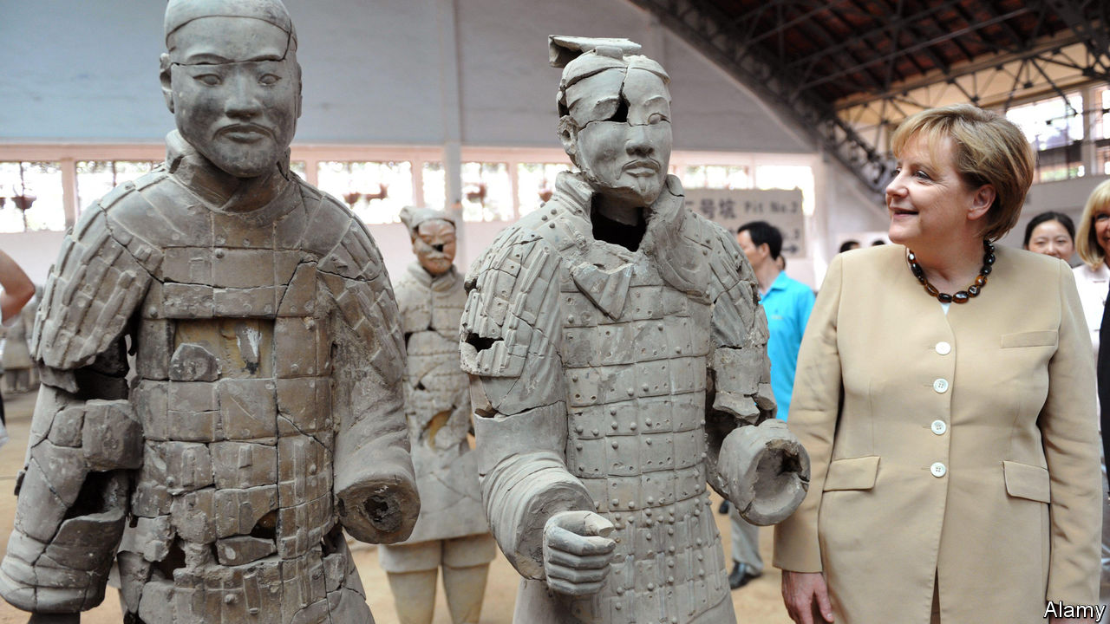

ANGELA MERKEL has always had Germany’s economic ties with China in mind while conducting bilateral diplomacy with the Asian giant. In the 15 years since she took over as chancellor in 2005, German exports to China have quintupled, to just under €100bn ($110bn), about 3% of GDP. Last year China was easily Germany’s largest trade partner, to the particular benefit of big firms such as Volkswagen, BMW and Siemens. To avoid antagonising China’s ruling Communist Party, Mrs Merkel was careful not to take the side of the hawks in the heated debate last year and this over whether to let Huawei, a Chinese telecoms giant, bid for contracts to build Germany’s 5G networks (see article).

Her caution goes wider. Mrs Merkel has also been circumspect in her comments on China’s recent clampdown in Hong Kong. She emphasised the need to “seek dialogue” with the Chinese government on the basis of a “relationship of trust”. But that means that she is increasingly out of step with the rest of Germany’s political establishment. Leading figures in her Christian Democratic Union (CDU) object to her refusal to criticise the Chinese government directly. Norbert Röttgen, head of the Bundestag’s foreign-affairs committee and a contender for the CDU leadership, condemned as “self-censorship” the German foreign office’s recent advice to be “particularly careful” about posting China-critical comments on social media. For Nils Schmid, foreign-policy spokesman for the Social Democrats, the CDU’s junior coalition partner, Germany’s China policy is “behind the times”.

Mr Schmid speaks not only for the political elite but also for many business leaders who used to be relentlessly gung-ho about China’s potential but have long since tempered their enthusiasm. Some 5,500 German companies with production sites in China face hurdles ranging from forced technology transfer to being required to set up joint ventures. Many have lost faith in the possibility of change. “I would now advise any Mittelstand company to stay away from China,” says Frank Klix, who used to represent the Panjin Economic Development Zone in Germany but became frustrated by the lack of a level playing-field.

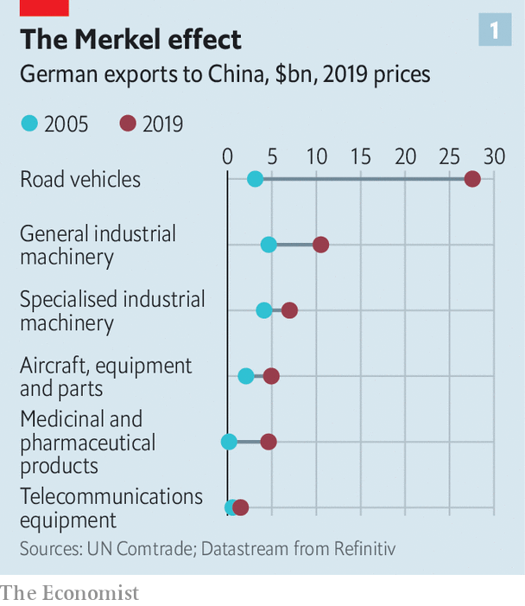

In early 2019 such concerns culminated in a head-turning paper issued by the Federation of German Industries (BDI), which declared that its hopes of convergence on the rules of doing business with China had faded. In January the VDMA, an association of German machinery manufacturers, said the “imbalance” in doing business with China had become unacceptable. Last year the German Chamber of Commerce in China found that nearly a quarter of German firms operating in China were planning to remove all or part of their businesses.

Challenges at home compound such difficulties abroad. When Midea, a Chinese appliance-maker, bought Kuka, a German robotics firm, in 2016, German industry and politicians realised that China had become a lot more than a loyal customer for its exports. Its “Made in China 2025” strategy represents a clear challenge to Germany’s high-value-added export model. China is now second only to Germany in global machinery exports.

Germany’s government is responding to this new rivalry by edging towards an industrial policy that looks more French. It has tightened its rules on foreign investment and flirted with the idea of protecting “strategic” companies by taking equity stakes. This shift has moved the European Union’s centre of gravity, too. The club, which now describes China as a “systemic rival”, is granting governments more power to screen foreign investments. Germany will push to tighten the EU’s state-aid regime under its presidency of the European Council, which started on July 1st.

In any event, the idea of German dependence on the Chinese market can be overdone. China overtook America as Germany’s single biggest trading partner in 2016, and it is true that Germany is more exposed to China than other large European economies. Yet Germany’s trade with China, at around €200bn last year, is just 8% of its total trade. It does more business with the four central European “Visegrad” countries alone. Barely 2% of German jobs depend directly or indirectly on Chinese exports, reckons Jürgen Matthes of the Institute of Economic Research in Cologne.

However, high-value-added products that Germany excels in, such as cars, machinery, electrical components and chemicals, account for 70% of German exports to China. Their makers include mid-size firms but also blue-chips that traditionally enjoy a hearing in Germany’s ministries. Take Volkswagen, which along with Daimler and BMW has a huge office in Beijing. VW entered China in 1985 through a joint venture, and now runs 33 factories in the country. Global carmakers cannot ignore the gargantuan Chinese market, says Stephan Wöllenstein, vw’s boss in China, which accounts for fully 40% of his firm’s sales. Other parts of German industry remain as keen as VW to tap Chinese growth.

This helps to explain Mrs Merkel’s apparent soft-pedalling on policy to China. Despite fierce pressure from America, government colleagues, intelligence agencies and from MPs across the spectrum, including her own CDU, she still refuses to bar Huawei from building Germany’s 5G network. She may fear that Chinese retribution exacted on German carmakers—a threat dangled by Beijing’s ambassador in Berlin—would be too much for a fragile economy crawling out of recession amid transatlantic trade tensions.

Mrs Merkel also carries a “political conviction” that trying to contain China carries more risks than rewards, argues Thorsten Benner at the Global Public Policy Institute in Berlin. How to accommodate China’s rise is a leitmotif of the speeches she made during her 12 trips to the country’s capital and hinterland in past years (see chart 2). She wants China to help shape rules on artificial intelligence and genetics to avoid cleaving the world into competing technological hemispheres.

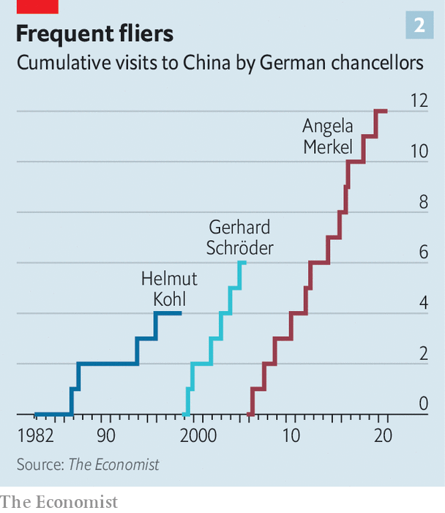

Echoing the EU’s new position, Mrs Merkel has largely ditched talk of China as a “strategic partner”, describing it as a “competitor” with which Germany has “profound differences”. But she still hoped to find areas of partnership, notably on climate change and development in Africa, at an EU-China summit in Leipzig in September to be attended by all 27 European heads of government. In June the summit was postponed, ostensibly due to the pandemic. Mrs Merkel hopes to revive it.

However, the chancellor’s hopes of docking China into the multilateral system have started to look a little forlorn. A new generation of analysts and politicians in Germany casts a more sceptical eye on China than its old-school sinologists. “The chancellor is brilliant, but perhaps still thinking in a pre-Xi world,” says Johannes Vogel, an MP for the liberal Free Democratic Party. Mrs Merkel will leave office next year.

None of this signals “decoupling” of the sort Mike Pompeo, America’s secretary of state, has urged on Europe. But Germany needs a “significant rebalancing”, says Mr Benner, who suggests it should nurture European capabilities in critical infrastructure like 5G, tell companies that have bet on China they will no longer enjoy political cover, and assemble alliances with like-minded countries at risk of Chinese economic coercion, such as Australia and South Korea. In German business and politics alike, the winds are changing. ■

This article was downloaded by calibre from <https://www.economist.com/europe/2020/07/16/angela-merkels-soft-china-stance-is-challenged-at-home>

|  |  |  |  |
| --- | --- | --- | --- |
|  | Articles | Sections | Next |

|  |  |  |  |
| --- | --- | --- | --- |
| Previous | Articles | Sections | Next |

#### A popular governor grabbed

# An unlikely local hero in Russia’s Far East

Mass protests in Khabarovsk may stir distant regions against Vladimir Putin

Jul 18th 2020 | KHABAROVSK

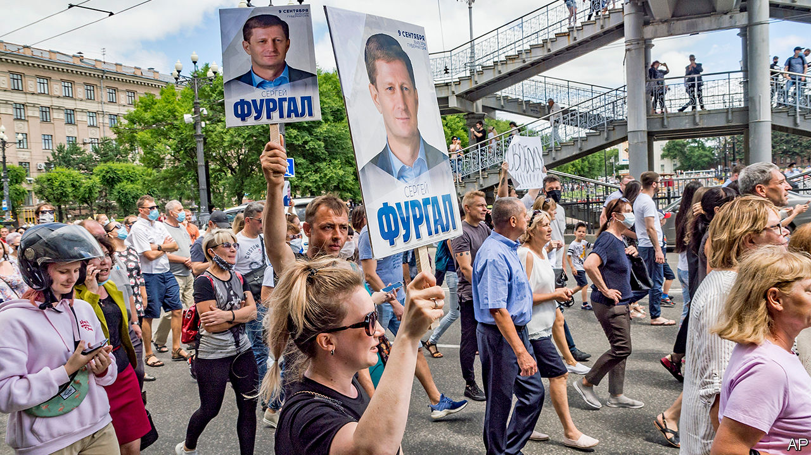

MOSCOW WAS fast asleep when, seven time zones to the east, tens of thousands of people took to the streets chanting “We are the authority here!” and “Moscow, listen to us!” Some 30,000 people marched through Khabarovsk, a city of 600,000 people, waving regional flags and cheering drivers who hooted their horns in solidarity. It was the largest protest the region has ever seen.

It broke out on July 11th, triggered by the arrest of a popular governor, Sergei Furgal, who was elected in 2018 on a wave of protest votes that swept through several regions against the Kremlin’s United Russia candidates. Grievances against Moscow have been building up for years. Russia’s Far East, a frontier land that borders China, has always displayed a sense of pride and self-reliance. This has been disrespected by President Vladimir Putin’s regime, which has rolled back federalism, depriving regions of control over their financial and natural resources, and curbing their power to take their own decisions.

The people of Khabarovsk were enraged by video images of camouflaged and masked security men from Moscow dragging their elected governor from the back seat of his black Lexus SUV, handcuffing him and packing him off to Moscow. Few believed Mr Furgal’s arrest was because of his alleged involvement in a murder 15 years ago when he traded in timber and scrap metal. True, links between crime and business in the 1990s were common, especially in the Far East. But why would the security service take 15 years to act on Mr Furgal’s alleged crime? And even if he were guilty, why should he not be tried in Khabarovsk? As far as people there are concerned, they elected him and only they are entitled to bring him to book.

Many suspect that the Kremlin was simply taking its revenge on the governor for his election victory and for becoming more popular, in the region, than Mr Putin is. An added irony is that Mr Furgal is not a rabble-rouser, nor an opposition activist, nor even a critic of the president.

As a member of the misnamed far-right Liberal Democratic Party, licensed by the Kremlin to play the role of tame opposition, Mr Furgal has served both in the local legislature and in the Duma, Russia’s parliament, since 2005. In the regional poll in 2018 he was meant to be a sparring partner for the Kremlin’s man. Mr Furgal barely campaigned. But local anger against Moscow’s colonial attitude swept him in.

A few simple populist steps, such as slimming down local government, cutting his own salary and putting up for sale a yacht used by his predecessors to entertain guests, quickly turned him into a local hero. A year later, in 2019, he refused to rig the elections to the local parliament. As a result, the Kremlin’s United Russia suffered a humiliating defeat, winning only two seats. Then, on July 1st, when Khabarovsk had one of the lowest turnouts in a farcical vote on constitutional changes that could make Mr Putin a supreme leader for life, the Kremlin snapped.

Mr Furgal is not the only recent target. On July 7th, in Moscow, plain-clothed officers of the FSB, the KGB’s successor, arrested Ivan Safronov, a former military journalist who had recently been a spokesman for Russia’s space agency, and charged him with espionage and treason. Dozens of prominent Russian journalists protested—and were also promptly detained. Russia’s elite has been warned, again.

The protests in Khabarovsk show that among many ordinary Russians Mr Putin arouses anger rather than admiration. They also show that feelings of regional identity can bring local bigwigs and the opposition together. One of the driving forces behind the protests in favour of the governor was the local branch of the movement led by Alexei Navalny, Russia’s national opposition leader. The event also exposes the limitations of the Kremlin’s security apparatus when dealing with mass protests. The police in Khabarovsk did nothing to stop the protest, lest it escalate and spread.

The Kremlin hopes that the protest, which has been ignored by national state television, will now fizzle out. Maybe so. But it will be harder to cover up the cracks in Mr Putin’s regime. ■

This article was downloaded by calibre from <https://www.economist.com/europe/2020/07/18/an-unlikely-local-hero-in-russias-far-east>

|  |  |  |  |
| --- | --- | --- | --- |
| Previous | Articles | Sections | Next |

|  |  |  |  |
| --- | --- | --- | --- |
| Previous | Articles | Sections | Next |

#### Narrow minds, narrow win

# Poland’s populist ruling party clings to the presidency

The campaign involved gay-bashing and anti-Semitism

Jul 16th 2020 | WARSAW

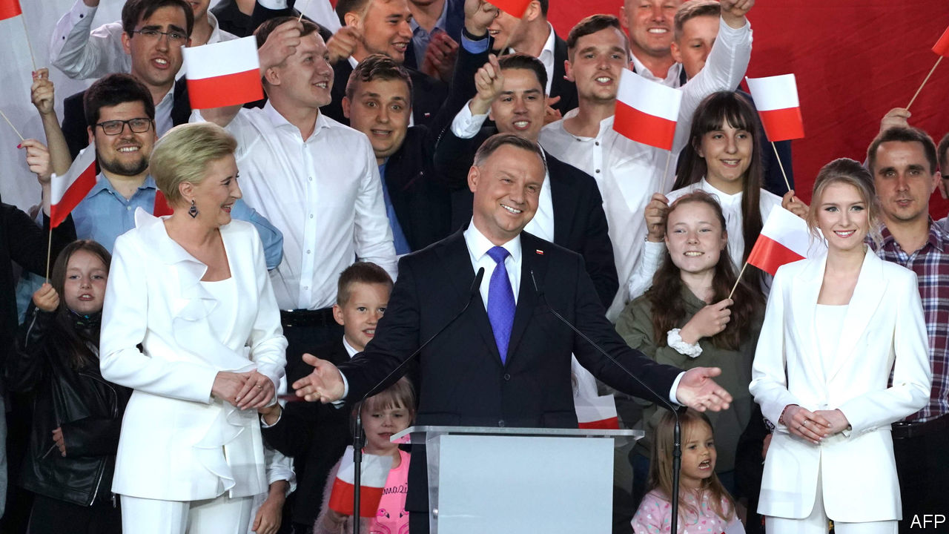

INCUMBENT PRESIDENTS will often go to great lengths to be re-elected. In the case of Andrzej Duda, Poland’s president, who hails from the ruling Law and Justice (PiS) party (though he formally left it after being elected president in 2015), this includes denouncing gay people, attacking the independent media and accusing Germany of meddling in the election.

It worked, but only just. He won the election run-off on July 12th, beating Rafal Trzaskowski, Warsaw’s liberal mayor, by 51% to 49%. The president has little executive power, but can veto laws, which would matter a lot if the opposition had won. Mr Duda’s win means further entrenching PiS’s brand of nationalist, socially conservative populism in Poland.

Mr Duda and Mr Trzaskowski are of the same generation. Both were born in 1972, both worked in academia and both served as members of the European Parliament. Yet their politics have placed them on opposite sides of the epic struggle between PiS and the centrist opposition led by the Civic Platform party, which has dominated Polish politics since the mid-2000s. Mr Trzaskowski joined the race at the last minute, after the election scheduled for May was postponed because of the coronavirus. The election went to a run-off after no candidate received over 50% of the vote in the first round on June 28th.

Mr Duda rallied socially conservative voters by championing the traditional family. LGBT (lesbian, gay, bisexual and transgender) rights are an “ideology” worse than communism, he told supporters on June 13th. This was a direct attack on Mr Trzaskowski, who as mayor signed a declaration in favour of those rights in Warsaw. However, in conservative Poland, he has been careful not to go too far; he said on the campaign that as president he would favour civil partnerships, but avoided making any commitment to legalising gay marriage, as is true of his party in general.

PIS took control of the public-television broadcaster, TVP, shortly after coming to power in 2015. It supported Mr Duda’s election campaign strongly, unfairly and with a dash of anti-Semitic conspiracy theory. “Trzaskowski will fulfil Jewish demands?” said the caption on its main evening news programme on July 9th. Mr Trzaskowski responded by putting openness right at the centre of his campaign, calling for a Poland in which “an open hand wins against a clenched fist”.

The turnout in the election was 68%, one of the highest in Poland since the fall of communism in 1989. Mr Trzaskowski came a strong first in the country’s western regions, which are the most closely integrated with other EU countries. Mr Duda won in the more rural, socially conservative east, which borders Ukraine and Belarus, and in the south. Mr Trzaskowski performed extremely well among the young, winning almost two-thirds of the under-30 vote, according to an exit poll published after voting closed. In the over-60 age group the proportions were reversed, with more than 60% backing Mr Duda.

The opposition is filing complaints about the election and encouraging citizens to do so, too. Many are likely to concern how the vote was conducted among Poles living abroad, among whom Mr Trzaskowski crushed Mr Duda, with 74% of the vote. Others may focus on the egregious bias of the state broadcaster. Yet Mr Duda’s victory seems unlikely to be overturned, or even vigorously contested.

With Mr Duda now re-elected, and no more elections scheduled until 2022, PiS can focus on its agenda to reshape the country. Recent comments by the party’s politicians indicate that the private media, including foreign-owned outlets (mostly in German hands), could be the next independent institution to feel the cosh. Some suggest that they should be “re-polonised”—a term used by the party in the past in relation to foreign-owned banks. “The media in Poland should be Polish,” said Jaroslaw Kaczynski, the party’s chairman, who is widely seen as steering politics from the back seat, in an interview with the Polish press agency published after the election. Liberals fear this could be a way to stifle criticism of the ruling party. Moderates in the party would favour concentrating on the economy.

In the opposition, eyes are on Mr Trzaskowski, who won over 10m votes. Some politicians in Civic Platform suggest that he could lead a new movement that could unite the fragmented opposition, which includes moderate conservatives, liberals, agrarians and the centre-left. In an interview with a privately owned television broadcaster on July 14th, he announced plans to “rebuild political parties” and use the “civic energy” of the election to build a modern, European Poland. He said he also intended to stay on as mayor of Warsaw. After years of a conspicuous lack of leadership and vision within the opposition, Mr Trzaskowski is offering his liberal compatriots a dash of that elusive quality: hope. ■

This article was downloaded by calibre from <https://www.economist.com/europe/2020/07/16/polands-populist-ruling-party-clings-to-the-presidency>

|  |  |  |  |
| --- | --- | --- | --- |
| Previous | Articles | Sections | Next |

|  |  |  |  |
| --- | --- | --- | --- |
| Previous | Articles | Sections | Next |

#### Accent grave

# Parisian snobbery towards regional French accents persists

But the new prime minister may challenge that

Jul 18th 2020 | PARIS

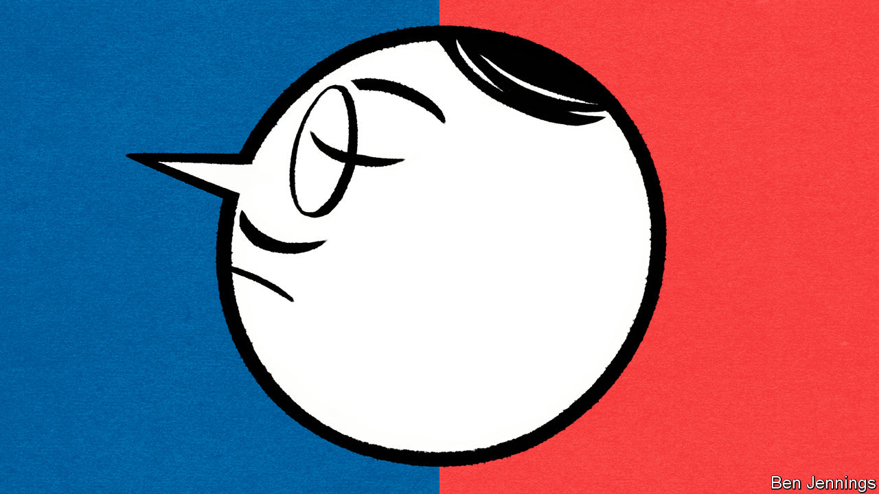

NO SOONER HAD Jean Castex been appointed than Parisians seized upon their new prime minister’s most distinctive feature: his regional accent. Born in the Gascon town of Vic-Fezensac, Mr Castex speaks with a south-western twang. Locals take pride in the “accent that sings”, which stems from Occitan, the local language. Yet Parisian mockery was thinly disguised. A Paris-Match journalist called it a “gravelly post-match rugby accent”. A broadcaster said that his accent was more commonly reserved for rugby commentators or weathermen.

Few members of the Parisian elite hang on to their regional accents, if they once had one. When Jules Ferry, a Third Republic education minister, imposed French as the sole language in schools in the 1880s, nursery teachers were told to “correct the flaws in pronunciation or local accent”. Dropping a northern ch’ti accent, or a southern drawl, is often a prerequisite for survival under Paris’s unforgiving social codes. French broadcasters, unlike those in Britain, still speak in identical metropolitan tones.

There are exceptions. Charles Pasqua, interior minister under President François Mitterrand, kept his Provençal accent. François Bayrou, a centrist politician from the south-west, occasionally lets his filter through. Jean-Michel Aphatie, a broadcaster originally from the Pyrenees, is well-known for retaining his. Given the backlash against the globalising elite, an accent can in fact hint at a precious link to le terrain, or local region, which may have helped Mr Castex—a high-flying technocrat—get the job.

Parisians may now have to overcome their glottophobie, or snobbery against regional accents. A law professor in Toulouse called the fuss about Mr Castex’s “irritating condescending Parisianism”. As for Mr Castex, when asked, as he inevitably was, he feigned surprise. “I’ve got an accent?” he asked, adding: “I’m proud of my accent, I am what I am.”

This article was downloaded by calibre from <https://www.economist.com/europe/2020/07/18/parisian-snobbery-towards-regional-french-accents-persists>

|  |  |  |  |
| --- | --- | --- | --- |
| Previous | Articles | Sections | Next |

|  |  |  |  |
| --- | --- | --- | --- |
| Previous | Articles | Sections | Next |

#### Parting the waters

# Venice tests its mighty flood defences

A success—up to a point

Jul 16th 2020 | VENICE

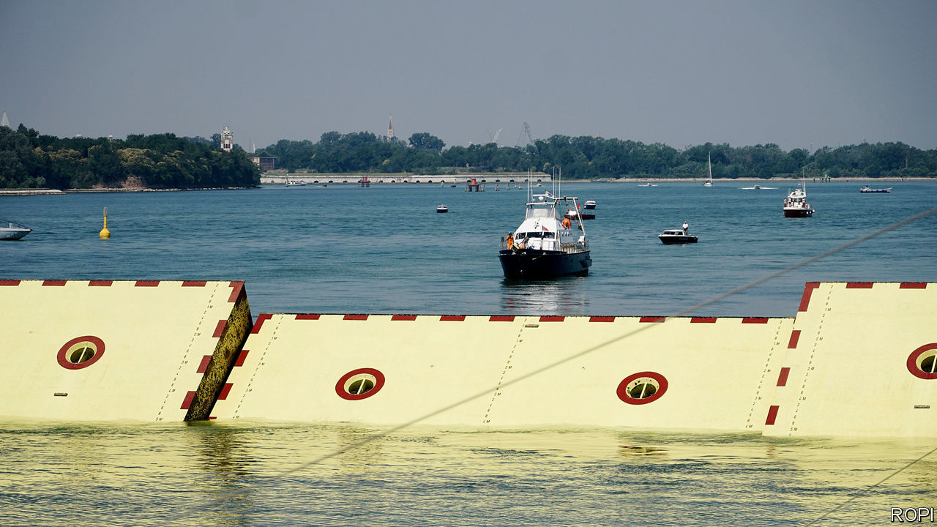

AT 12.25PM ON July 10th, something happened that had never happened before. Venice was cut off from the Adriatic Sea it dominated for centuries. Watched by Italy’s prime minister, Giuseppe Conte, and a bevy of ministers and officials, all 78 movable sluice gates of the MOSE sea barrier reared up, blocking the inlets to the lagoon that surrounds the city.

All present stressed that this was not an inauguration. MOSE, an acronym for Experimental Electromechanical Module, will not be fully functional until the end of 2021. But now that it has been operated in its entirety (only sections had been tested previously), there is a chance that the barrier could be used this winter if Venice were threatened by a sea surge like the one that swamped it in November 2019.

As an opening—or closing?—ceremony, this one was pretty bizarre. The mayor of Venice, Luigi Brugnaro, said MOSE was “not an example to be copied”. Indeed not: delays have put it nine years behind schedule and three times over its original budget. A bribes-for-contracts scandal in 2014 involved dozens of local politicians and executives of the consortium building it. Mr Conte was just as downbeat, saying, “Let’s all hope it works.”

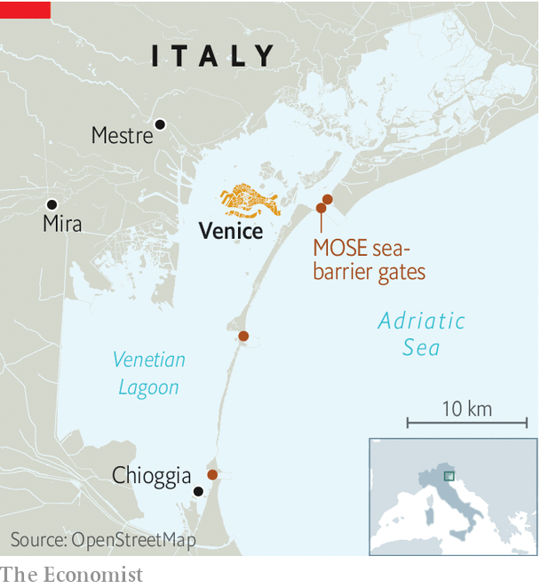

But then caution is advisable. Whether MOSE will be as efficient in parting the seas as its biblical namesake is unclear. The latest test was carried out in ideal conditions: a far cry indeed from the 100kph winds and three-metre waves (60mph and ten feet) that tore into the lagoon last November. And while its giant, box-shaped “gates” go up, not all can currently go back down again into their housings on the sea floor, thanks to sand in the works—a problem that is as tricky to solve as it was seemingly easy to predict.

The other doubt is whether Italy can afford MOSE’s astronomic running costs, estimated at around €100m ($110m) a year. Additional government borrowing to restart the economy after the covid-19 pandemic could easily push public debt above 160% of GDP, so money will be tight.

But even if this ill-starred scheme can be made to work, Venice will be far from safe. The sea surges and their effects are newsworthy, telegenic and easy to explain. Not so the other threat facing Venice: the inexorable rise in the everyday level of the water in the city, which is eating away at its fabric. The proof can be seen in strips of marine vegetation that run along the brickwork above the base of canal-side houses instead of attaching to the stone of the foundations as they once did. Few but the Venetians notice it, and those who do often see it as evidence that Venice is sinking. It no longer is; in fact, the causes are global warming and the loss of salt marshes that used to slow and partially absorb seawater.

What to do? Keeping big ships, including cruise liners, out of the lagoon would help. But Pietro Teatini, professor of hydrology at Padua university, has a more ambitious idea: lift up Venice. Raising the ground by just 20-30cm would make a huge difference. Mr Teatini thinks it can be done by pumping seawater into the already salty aquifers below the city. In 2008 it was estimated that a pilot scheme would cost €11.1m to launch and €1.4m a year to run; the full project around €80m and €10m a year. Compare that with the €6bn that MOSE has devoured. All the professor needs is a philanthropist who wants to be remembered as the saviour of St Mark’s Square. ■

This article was downloaded by calibre from <https://www.economist.com/europe/2020/07/16/venice-tests-its-mighty-flood-defences>

|  |  |  |  |
| --- | --- | --- | --- |
| Previous | Articles | Sections | Next |

|  |  |  |  |
| --- | --- | --- | --- |
| Previous | Articles | Sections | Next |

#### Charlemagne

# How Ireland gets its way

An unlikely diplomatic superpower

Jul 18th 2020 |

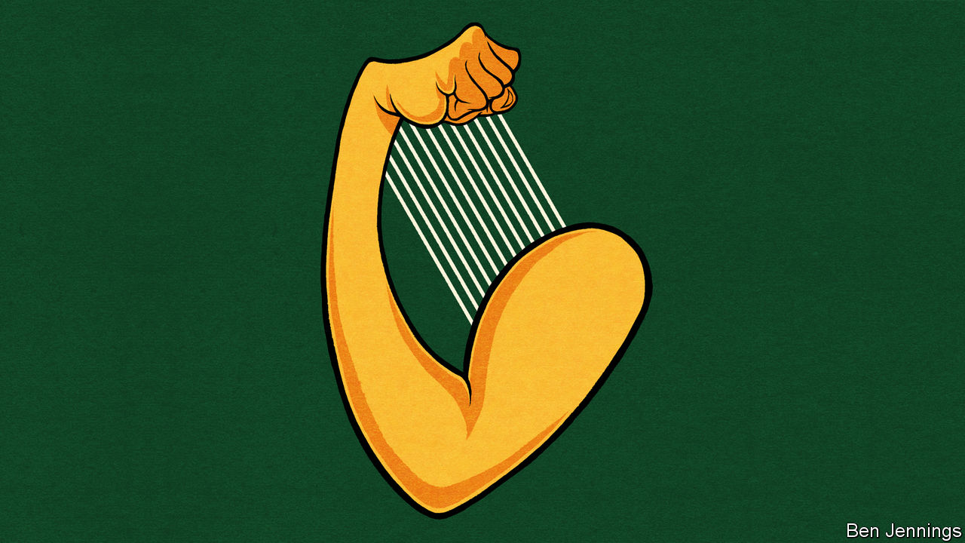

EVERY ST PATRICK’S DAY, Ireland’s ministers partake in a long-held Irish custom: they leave the country. Ministers are packed off to far-flung destinations to preach the virtues of the homeland. The prime minister always heads to America, but other bigwigs find themselves farther afield. In 2018 the housing minister was sent to South Korea, while the minister for higher education ended up in Oman. This year, as covid-19 raged through Europe and Irish politics stood still during coalition negotiations, things were scaled back. Only the trip to Washington went ahead. Ireland, a country of 5m people, had to settle for an audience with the president, a breakfast with the vice-president and a lunch with practically every senior member of Congress.

On a per-head basis, Ireland has a good claim to be the world’s most diplomatically powerful country. Its finance minister, Paschal Donohoe, last week won the race to become president of the Eurogroup, the influential club of euro-zone finance ministers, despite the French and German governments backing another candidate. In June Ireland won a seat on the UN Security Council, fending off Canada, another country often flattered by comparison with a bigger, sometimes boorish, neighbour. Barely a decade after a financial crisis saw Ireland bailed out, Philip Lane, the former head of Ireland’s central bank, is the main thinker at the European Central Bank. In Brussels, Ireland’s commissioner Philip Hogan is in charge of trade, one of the few briefs where the European Commission, rather than EU governments, is supreme. And the EU’s position on Brexit was shaped by Irish diplomats.

Ireland has some natural advantages. A history of emigration blessed it with a huge diaspora in America, which unlike say the German diaspora, is vocal about its heritage. That ensures an audience in the White House and sway on Capitol Hill. It is a small, English-speaking country with diplomats able to focus on a few clear aims. A policy of neutrality helps it avoid unpopular military entanglement. Unlike most rich European countries, it carries no imperial baggage. Indeed, Ireland’s history as a victim of colonialism still provides a useful icebreaker with countries once coloured pink on Victorian maps. Nor is Ireland shy about using its cultural clout. Alongside more subtle overtures, the push for the Security Council seat involved free tickets to Riverdance and a U2 gig. The best that Canada could muster was Celine Dion.

It is in the EU where Ireland shows true diplomatic dexterity. It avoids easy classification. Ireland shares a lust for balanced budgets with frugal northern states, yet it endured a banking crash and the ignominy of a bail-out programme like Spain and Portugal. Though it is now among the richest countries in the bloc, it started life as the poorest, relying on EU funding to spur growth—a similar path to the one countries in Europe’s east hope to take. It is a member of the New Hanseatic League, a club of northern, liberal countries, yet it was among the first to back a demand from southern Europe for common debt to be issued by the EU and granted to struggling governments. Ireland can fairly be labelled as a northern, southern, eastern or western European country.

Ireland’s membership of a more informal, yet powerful, grouping is also key. Of the EU’s 27 members, only five have populations of more than 20m. The small countries have different agendas, but they share a similar goal: not being trampled by bigger neighbours. These relationships are cherished by Ireland, which has an embassy in every EU country—a rarity for a country of its size. For big countries used to having their own way through history, the EU is a way of maintaining power even as they shrink as individual actors on the world stage. For smaller countries, however, the EU magnifies their power beyond their wildest dreams. During last year’s Brexit negotiations, Irish diplomats were well aware of this fact, which took longer to be appreciated in London. The EU was never likely to side against a current member in favour of a departing one. However, it was thanks to Dublin’s patient, energetic lobbying that the border on the island of Ireland became the defining issue during talks.

## Letting other people have your way

Ireland was not always so influential. At the start of the decade, the country’s reputation was shot. A banking crisis led to an embarrassing €85bn bail-out. Rebuilding that reputation has been a decade-long task. Among the bail-out countries, Ireland became a star pupil, enacting reforms with almost masochistic relish, while other countries in a similar position complained. For a country whose prosperity is based on economic openness, foreign policy starts with economic policy.

There are still plenty of reasons for Ireland to be disliked. It hosts the European operations of many of the world’s largest tech companies, and its data-protection regime is lenient. For a while, the likes of Google and Facebook were watched over by a regulator whose office was above a convenience store in a small town 50 miles (80km) from Dublin. Although now a more professional operation, it is still seen as weak. When it comes to tax, kind words about the Irish disappear. At 12.5%, its corporation tax is the second-lowest in the EU. Often companies do not pay even that. In 2016 the European Commission demanded that the Irish government collect €13bn in back-taxes from Apple. On July 15th the European Court of Justice annulled the decision. Ireland’s tax policy was legally vindicated (although its coffers were less full).

A crackdown on Ireland and her fellow low-tax states is still brewing. But here Ireland has real power: each EU country wields a veto on the topic. There is less need for crafty diplomacy if Dublin has as much power to block as Paris. Now plans are afoot to clamp down on unpopular tax policies using methods that would bypass this veto. The only way of stopping such proposals would be via an alliance of countries able to amass a blocking minority. It is lucky Ireland has skilled diplomats. It will need them. ■

This article was downloaded by calibre from <https://www.economist.com/europe/2020/07/18/how-ireland-gets-its-way>

|  |  |  |  |
| --- | --- | --- | --- |
| Previous | Articles | Sections | Next |

|  |  |  |
| --- | --- | --- |
| Europe | Sections | International |

Britain

Work-life balance: Union slack

.

Government help for startups: The joy of equity

.

Brexit: The nameless one approaches

.

Armed forces: Culture war

.

Government and covid-19: How the levers came off

.

Household finances: Run to the banks

.

Bagehot: Dance of the lemons

.

|  |  |  |
| --- | --- | --- |
| Europe | Sections | International |

|  |  |  |  |
| --- | --- | --- | --- |
|  | Articles | Sections | Next |

#### Office culture

# Britons tip the work-life balance

Working Britons have less time for leisure than other Europeans. Covid-19 is changing that

Jul 18th 2020 |

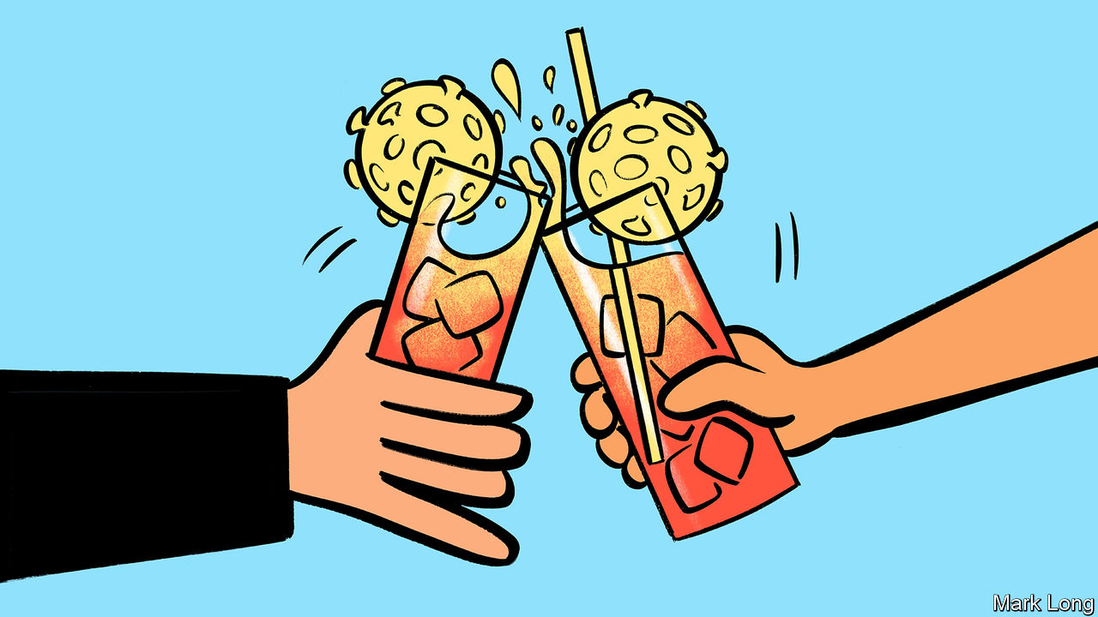

FOR 23 YEARS, Richard Ramsey’s working life had the same essential rhythm, one that will be familiar to office workers everywhere. The hours changed, the pay changed, sometimes the job changed. But he always got into a car in the morning, spent 30-40 minutes crawling the four miles into the office, in central Belfast, and came back the same way each evening, ready to sleep and repeat. His colleagues at Ulster Bank had started to work more flexibly in recent years. But, as its chief economist, he assumed that the office was the only place he could work: he needed to be close to his beloved Bloomberg terminal.

It turns out he was wrong. In March, when covid-19 began to spread rapidly in Britain, everyone at the bank’s headquarters, like millions of other British office workers, was ordered home. Mr Ramsey experienced “teething problems” for a week, but he soon replicated his office set-up. When the office reopens, he will mostly stay at home, perhaps going in once or twice a week for meetings. He misses the camaraderie of the office, but that is outweighed by the time he saves on commuting and the flexibility to walk the dog at lunchtime. “It’s not going to go back to the way it was,” he says.

Workers everywhere find it tricky to juggle the competing demands of work, family and social life. But evidence suggests Britons find it trickier than most of their European counterparts (see chart). According to an index produced by the OECD, a typical Briton spends roughly an hour a day less sleeping or at leisure than workers in comparable European countries. And 12% of them work more than 50 hours a week—a larger proportion than in America and nearly three times as many as in Germany. Despite all this toil, Britain’s productivity lags behind its competitors.

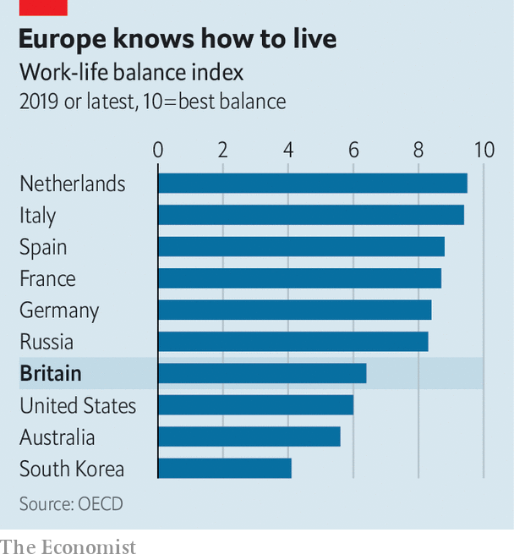

The pandemic has upended these norms. Millions of staff have been furloughed; thousands of redundancies are being announced each week. But even the majority who have kept their jobs are doing them in different places and in different ways. On July 10th Boris Johnson began encouraging workers to return to their offices, in part to revive plummeting demand for firms that depend on old working habits, such as sandwich shops. That will be hard going since, on the whole, employees are keen on working from home. According to a YouGov poll published in May by Skillcast, a compliance-training firm, two-thirds of Britons would like to continue doing so, at least some of the time.

Until now, employers were the biggest obstacles to such flexibility. Research by the European Commission in 2018 found that while Britain has among the highest share in Europe of workers who want to work flexible hours or at home, a fifth of workers who had this option had never taken it up. Roughly a third of workers said doing so was discouraged by managers or would be viewed negatively by colleagues. In many cases they were right. “We did try to be flexible,” says Mark Read, chief executive of WPP, an advertising giant. “But there was a large feeling by senior executives that people weren’t really working when they were working from home.”

Lockdown quickly changed that. The majority of office workers have spent the past four months exclusively at home and, according to the YouGov poll, more than two-thirds of them think they can be at least as productive as in the office. Like many bosses, Mr Read eventually wants to introduce a hybrid model, with most staff working some days in the office for collaboration and camaraderie and some at home. But, he says, “the number one question I’m asked in all our town halls is can we work remotely or from home more in future. The answer is going to be ‘yes’.” That is partly to help retain and attract employees and partly because it could save the firm some of the £650m ($818m) or so it spends each year on office space.

If such a mixed model is widely adopted, workers will spend a lot less time in traffic jams or on crowded buses and trains. Britons spend longer commuting than people in any other European country. Londoners have it worst—on average they spend an hour and 20 minutes a day getting to and from work, eight minutes more than the average New Yorker. If they worked from home instead, they would save 297 hours a year, according to an analysis of official statistics by the Trades Union Congress, a labour-rights umbrella group. If they sleep for eight hours a day, that’s 19 days, or three and a half working weeks.

Whatever model emerges, it will not be a Utopia. Indeed, 38% of Britons reckon it is harder to strike a work-life balance when working remotely. Things will probably improve as children return to school, but a significant minority of workers are likely to struggle, especially graduates who want to learn on the job, those whose homes are not big enough to make work pleasant and people who live on their own. A 47-year-old market researcher, who lives alone, says he is “bored stupid” at home. He is desperate to go back to work for a “change of scenery”. A gender divide is emerging. Whereas 22% of British men find working from home difficult, according to official statistics, only 13% of women do so.

But workers are already voting with their feet. A recent survey by Unilever, an Anglo-Dutch consumer-goods group, found that half of staff in countries where offices were reopening did not yet want to return. Only 8% wanted to go back to the office full-time; the rest said they would like to come in for one or two days a week. “In five years’ time, if you’re an employer that tries to implement a strict office-based culture, you’re going to really struggle for talent,” predicts a work-policy wonk. Now they have tried flexible working, Britons seem unlikely to surrender it easily. ■

Editor’s note: Some of our covid-19 coverage is free for readers of The Economist Today, our daily [newsletter](https://my.economist.com/user#newsletter). For more stories and our pandemic tracker, see our [hub](https://www.economist.com/news/2020/03/11/the-economists-coverage-of-the-coronavirus)

This article was downloaded by calibre from <https://www.economist.com/britain/2020/07/18/britons-tip-the-work-life-balance>

|  |  |  |  |
| --- | --- | --- | --- |
|  | Articles | Sections | Next |

|  |  |  |  |
| --- | --- | --- | --- |
| Previous | Articles | Sections | Next |

#### Loans for firms

# How the government may end up with a stake in a sex-party company

The Future Fund may provide taxpayers with an eclectic portfolio

Jul 18th 2020 |

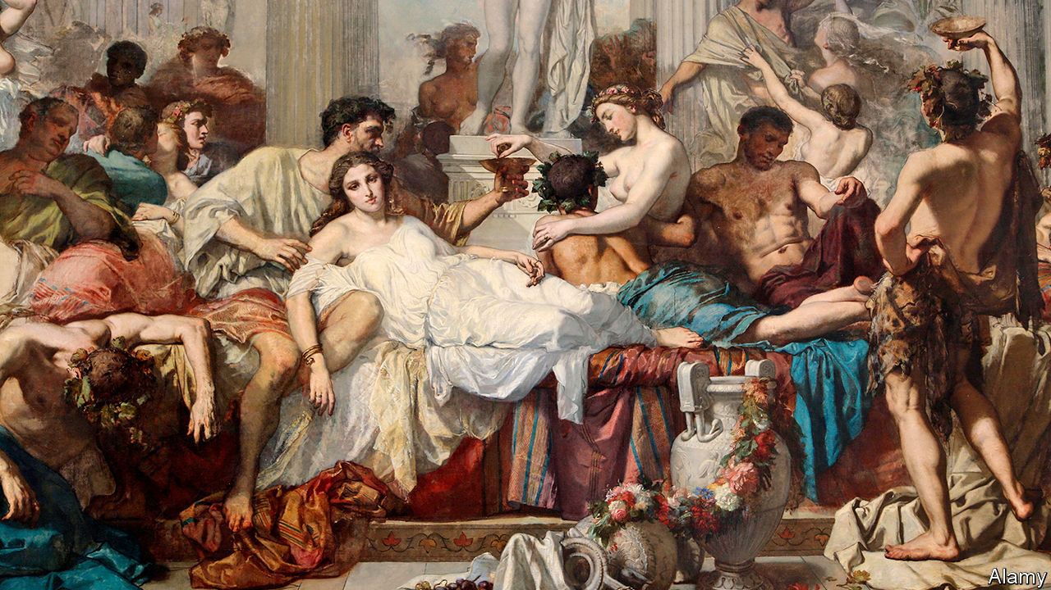

IN THE BALLROOM of a Georgian house in central London, five mattresses have been pushed together, and a pile of people are having sex on them. The orgy has been organised by Killing Kittens, a company that claims to throw “the world’s most exclusive, decadent and hedonistic parties”, and which has been offered a £170,000 ($213,000) loan from the government’s new Future Fund scheme. Unless paid off, the loan will convert into equity, giving the government a 1.47% stake. Emma Sayle, Killing Kittens’ chief executive, is careful to point out that taxpayers’ money will be spent not on orgies but on an app and a social network.

The prospect of the government owning a slice of an organiser of upmarket sex parties is one of the more surprising side-effects of the covid-19 pandemic. Rishi Sunak, the chancellor of the exchequer, launched the Future Fund in April to tackle a gap in previous offerings of financial help to firms. Since March around £45bn of government-backed loans—2% of GDP—have been extended to the private sector but the initial package was ill-suited to firms that are, in the jargon of venture capital, “pre-profit” or even “pre-revenue”. The Future Fund offers up to £5m in convertible loans for firms that meet its criteria if they raise the same amount of third-party cash. The need for matching funding ensures that decisions are still, ultimately, being made by investors rather than by civil servants. So far 429 companies have received a total of £420m.

The Treasury has declined to publish a full list of the recipients. But several of the firms that have raised capital through funding websites, such as Seedrs, a startup platform, have publicised their Future Fund loans. The names do not occupy the commanding heights of the economy to which politicians used to aspire. Aside from Killing Kittens they include Stem + Glory, a vegan restaurant, and Save Your Wardrobe, an app that allows users to digitise their closet.

Not everyone is happy. Darren Jones, the chair of the House of Commons Business Select Committee, has called for details of the firms the Treasury is backing. “We need to understand how the government is managing risk and be assured that money is being spent well,” he says. Ms Sayle criticises the targeting of firms that already have significant venture-capital funding. “It was made by VCs for only VCs to benefit, not startups or small investors.”

Jeff Lynn, the founder of Seedrs, warns that failures are an intrinsic part of startup culture and worries about bad headlines when investments go wrong, but he supports the government’s approach. “I would expect two or three in ten of any portfolio of startup investments to perform really well and the rest, less so.”

Whereas most of the government’s financial-support packages will cost taxpayers money, VCs expect the Future Fund to turn a profit as well as helping sustain the startup sector—a relatively bright spot in the British economy pre-crisis. But taxpayers may be surprised by some of their new relationships, and they are not the only ones. “I never envisaged Boris as a sleeping partner,” says Ms Sayle.■

This article was downloaded by calibre from <https://www.economist.com/britain/2020/07/18/how-the-government-may-end-up-with-a-stake-in-a-sex-party-company>

|  |  |  |  |
| --- | --- | --- | --- |
| Previous | Articles | Sections | Next |

|  |  |  |  |
| --- | --- | --- | --- |
| Previous | Articles | Sections | Next |

#### Leaving the EU

# The Brexit poster campaign

And why it can’t say the dreadful word

Jul 18th 2020 |

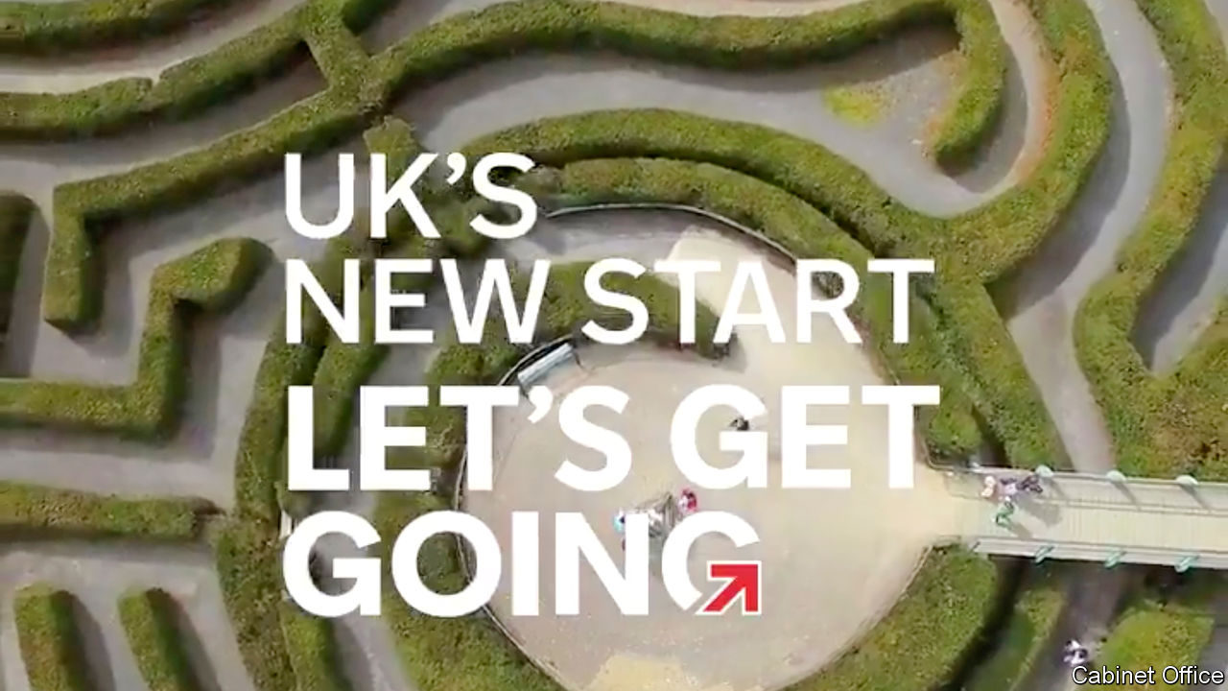

BORIS JOHNSON’S government excels at punchy slogans: “Get Brexit Done”, “Stay Home” and “Build Build Build”. Its latest offering is uncharacteristically ambiguous. “UK’s new start: let’s get going,” runs the slogan in a big poster campaign unveiled on July 13th, with the strapline: “Check, change, go.”

But where? The answer, revealed via the advertised web address (gov.uk/transition) is: out of the European Union’s single market and customs union on December 31st. For holidaymakers, the changes will mean buying travel insurance, checking whether they will be stung for mobile-phone roaming bills, and possibly leaving the family dog at home. For companies, they will mean reams of new forms, hiring customs agents and possibly a major restructuring of their business. Michael Gove, the Cabinet Office minister who has taken charge of Brexit preparations, published plans for the processing of freight travelling between Britain and continental Europe. The government will spend £705m ($890m) on new inspection sites, IT systems and customs officers.

One of the government’s biggest worries is that traders crossing the English Channel, especially small businesses, won’t be ready. If lorry drivers fail to produce the correct paperwork they will swiftly clog up the ports, bring ferry traffic to a halt and create miles-long tailbacks on the motorways. Officials anticipated hauliers dumping their cargos of gone-off food around Kent. Industry groups complain they still don’t know what rules to prepare for, and say covid-19 has squeezed the money and attention they need to get ready.

But getting the public’s attention may be tricky. The government ran two major Brexit readiness campaigns last year, but both scheduled exits were aborted after MPs forced extensions to the negotiating timetable. (The National Audit Office, the spending watchdog, wasn’t convinced the public paid much attention anyway.) Knowing the public’s weariness, Mr Johnson declared Brexit was “done” on January 31st when Britain formally left the bloc and entered a transition period. The government’s campaign video strenuously avoids the B-word, like a big-budget round of Articulate, a synonym-based board game. Evidence from focus groups suggests that many voters think that issue has been indeed dealt with, says Will Jennings, a political scientist at Southampton university. The trade negotiations rumble on but barely feature on the television news. Mr Gove must now convince voters that a major dislocation is back on, and can’t be moved.

Mr Johnson has succeeded in cooling the political strife, but this political landscape carries risks. Some disruption is likely, whatever deal he secures and regardless of how well firms prepare. Sir Keir Starmer, the Labour leader, who favoured a second referendum, once presented Brexit as an ideological question but now frames it purely as a test of Mr Johnson’s grip and ability to deliver. The prime minister is vulnerable, as coronavirus has battered his standing, with some polls suggesting voters think him less competent than Sir Keir. Queues of trucks at the border would never be good for a prime minister, but last October voters might have accepted them as a side-effect of Mr Johnson’s inflexibility towards Brussels. He will suffer if they become a symbol of his ineptitude.■

This article was downloaded by calibre from <https://www.economist.com/britain/2020/07/18/the-brexit-poster-campaign>

|  |  |  |  |
| --- | --- | --- | --- |
| Previous | Articles | Sections | Next |

|  |  |  |  |
| --- | --- | --- | --- |
| Previous | Articles | Sections | Next |

#### The armed forces

# Black Lives Matter and the British army’s culture war

Officers and squaddies march to a different tune

Jul 18th 2020 |



“I ALWAYS GET asked to be a suicide bomber” in training exercises, reveals a British soldier of North African descent. The role has its perks: spending an afternoon far away from barked orders, waiting to ambush a passing patrol. But with his fellow troops eagerly wrapping a rag around his head, he found it hard to ignore the profiling. “I wouldn’t term it abuse, I would term it racial ignorance on a staggering scale. It’s a group of people who are naturally attracted to a particular political ideology, and don’t want to engage with political correctness.”

The army’s job is to fight the queen’s enemies, and the fact that they have often been of a different colour to her is embedded in its culture. A non-white reservist says friends ask him why he “wants to fight a white man’s war”. Once a year his regiment sits down to watch “Zulu”, a film about a bloody battle between British soldiers and African tribesmen. He says that the atmosphere isn’t racist, but “you can see how there might be some negative connotations amongst the junior ranks.”

Nicola Williams, the Service Complaints Ombudsman, said in December 2019 that “incidents of racism are occurring with increasing and depressing frequency.” The army is trying to change this, and says of instances of racism The Economist put to it, such as the one above, “There is no place for racism in the military and anyone behaving in this way can expect to be disciplined or dismissed.” Last month, General Sir Nick Carter, the head of the armed forces, wrote to every soldier to say that the army supports Black Lives Matter (BLM). A few weeks later, central command waived the usual rule that politics is off-limits by letting troops attend BLM protests.

Senior staff hope that supporting BLM will send a positive signal. The young cohort from which the army recruits is more ethnically diverse than the population as a whole. Black and minority ethnic (BME) troops make up 8.8% of the 145,000-strong armed forces, which is in line with the population, but that includes 3,760 Gurkhas, around 1,300 Fijians and other non-white troops recruited from Britain’s former colonies. So it needs to improve its image among BME people to keep its numbers up.

This new approach also reflects the increasingly liberal views of senior staff in the armed forces. A growing professionalism has raised entry and training standards while making promotion more meritocratic. Once a cadet at Sandhurst, Britain’s officer-training academy, was a bit like Prince Harry: an Old Etonian, with deep family ties to the army, who was rather dim and prone to using racial slurs (as the young prince did as a Sandhurst cadet in 2009). Nowadays cadets are more likely to share the prince’s current views on race. The public-school contingent has been reduced to under half of Sandhurst’s intake. Socially mobile graduates now dominate.

Private soldiers still tend to come from low-income families in white working-class towns where social attitudes are more conservative. A BME soldier describes fellow squaddies as having a “hillbillies in the Deep South who voted for Donald Trump mentality”. A lance corporal was jailed in 2018 for joining National Action, a fascist group. Later that year a group of soldiers caused outrage after posing for photographs with Tommy Robinson, a far-right activist. Some of the counter-protests to BLM were organised by veterans who claimed to be guarding war memorials from potential vandalism. A black reservist says, “I’ve been surprised with the amount of people who have come out with the ‘All Lives Matter’ mantra, and then actually having to sit down with NCOs [non-commissioned officers] and explain the whole situation to them.”

The shared conservatism which once helped officers and troops to overcome class distinctions has now gone. There is a growing division in attitudes between commissioned officers, who see liberal reforms as necessary, and squaddies, who think political correctness is destroying the army’s esprit de corps and undermining its professionalism. “I’ve had officers try and tell me about white privilege,” sighs one soldier. “That doesn’t go down well with a bunch of blokes from the north.”

Not all officers have moved in line with senior staff. Some allowed troops to attend counter-protests. But under new regulations officers who aren’t seen to encourage diversity will not be promoted. Anthony King, chair of war studies at Warwick university, thinks that in their drive to support diversity officers might sometimes be seen to promote women and ethnic minorities who had failed to meet the army’s own rigorous standards. “Independently of any committed racism or sexism on the part of the soldiers, this is bound to generate a reaction,” he cautions. A former squaddie says he left the army last year when a female officer was promoted despite failing fitness tests. According to a spokesman, “All fitness courses require the same challenges for both men and women—all staff being promoted are expected to pass the relevant tests.” The squaddie is unimpressed. “The army is just for shit cunts and liberals now,” he says. ■

This article was downloaded by calibre from <https://www.economist.com/britain/2020/07/18/black-lives-matter-and-the-british-armys-culture-war>

|  |  |  |  |
| --- | --- | --- | --- |
| Previous | Articles | Sections | Next |

|  |  |  |  |
| --- | --- | --- | --- |
| Previous | Articles | Sections | Next |

#### How the levers came off

# How centralisation impeded Britain’s covid-19 response

British politicians hoarded power, unlike their counterparts in Germany

Jul 18th 2020 |

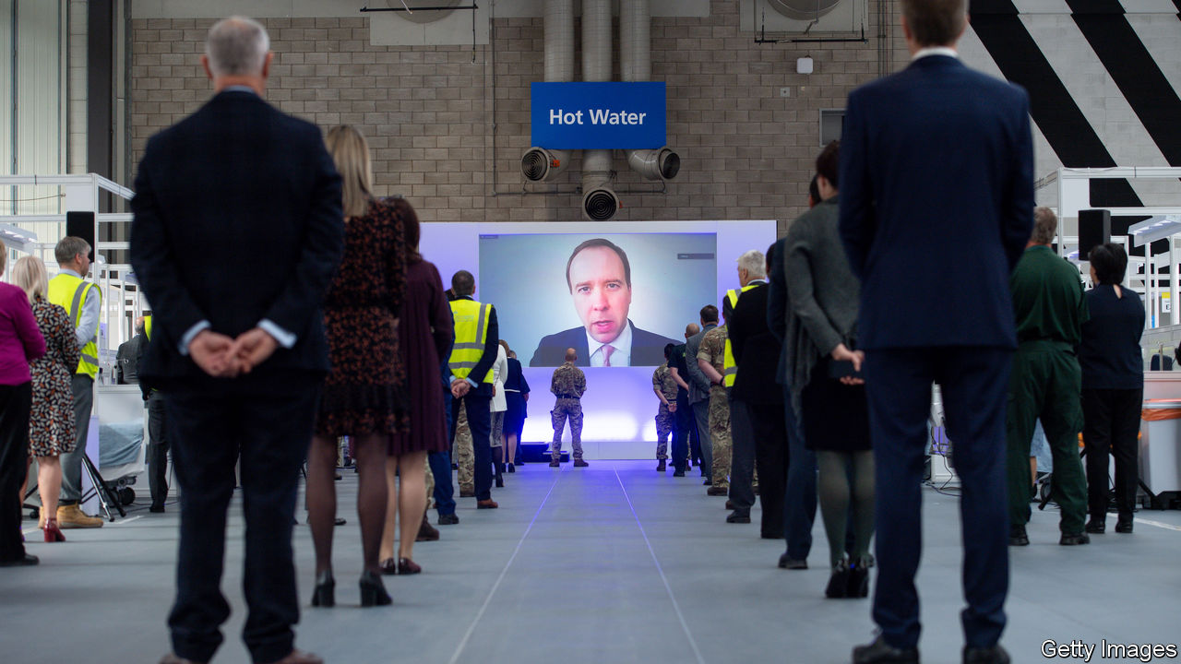

“I DO NOT WANT to be sitting and talking about this in the aftermath of something that goes wrong,” Gabriel Scally, now president of the epidemiology and public health section of the Royal Society of Medicine, told a House of Commons committee in 2012. Working for the World Health Organisation at the time, he was worried that the big planned reform of the National Health Service (NHS) would impede the response to emergencies. “I have seen enough major incidents in my time to think that this is worrying.”

Dr Scally now finds himself in the position that he dreaded. He is one of the many public-health experts who believe that the failures in Britain’s response to the covid-19 pandemic have been the result not just of slow political decision-making, but also of the highly centralised nature of the British state.

Germany and South Korea, two of the countries that responded most successfully, both have public-health systems embedded in local government. In Germany, the federal government provided extra resources, but the response was run by 375 local authorities. In South Korea, the decision-making was mostly done by central government, but the implementation was local. In Britain, the response has been run and implemented from the centre.

Public health was a local matter in Britain for over a century. After a water pump in London’s Soho district was identified as the source of a cholera outbreak in 1854, councils began to build up the capacity to keep their communities clear of infectious diseases. But the centralised design of the NHS—“The sound of a dropped bedpan in Tredegar Hospital,” said its founder, Nye Bevan, “should reverberate in the Palace of Westminster”—shaped the way health provision developed.

In 1974, public health was detached from its local roots, as directors of public health (DPH) were taken out of local government and placed within the NHS. In 2013 a restructuring of the health service (see chart) under Andrew Lansley, the health secretary—the change that concerned Dr Scally—replaced a simple structure with a complex one. It split responsibility for public health between a national agency, Public Health England (PHE), which has responsibility for infectious diseases, and local authorities.

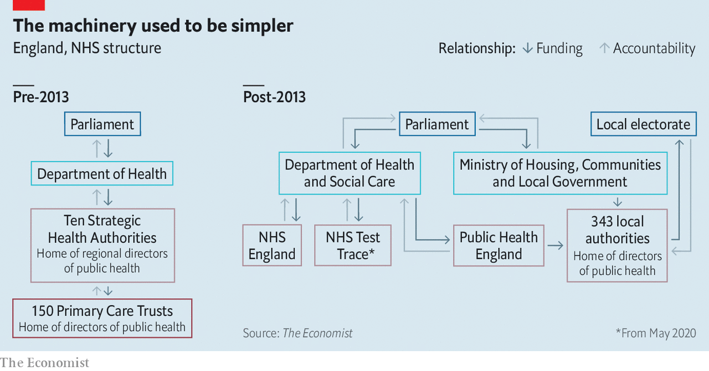

The reorganisation moved DPHs back into local authorities, but with fewer resources and less power. The timing—in the wake of the financial crisis—was bad, too. “We landed in local government just when it took a massive hit,” says a DPH in a London borough. According to the Health Foundation, a think-tank, the government grant to local authorities for public health fell by a fifth in real terms in the five years after 2014. A DPH in a county council says he has lost 30 of about 100 staff.

When covid-19 broke out, PHE was responsible for tracking the course of the epidemic, but had only 290 people nationally to do the job. By early March, it had been overwhelmed.

In Germany at that point, local authorities reallocated resources from functions that had been put on hold during lockdown—such as libraries or sexual health—and were given money by the federal government to hire medical students to help. Claudia Kaufhold of Germany’s Public Health Academy says that in the Charlottenburg-Wilmersdorf district of Berlin, where she used to be director of public health, the number of staff dedicated to track and trace rose from about 10 to roughly 130 at the beginning of March, for a population of 326,000. In Britain, the government instead created NHS Test and Trace, a national system directly answerable to Whitehall.

Andy Burnham, mayor of Greater Manchester, was arguing for a German-style response. “We would have had no problem scaling up,” he says. Local-area knowledge is essential to tracing infections, according to a director of public health. “Particularly with the vulnerability of ethnic minority people, it’s essential to know communities. You know where BME people are concentrated, you know community leaders.”

David Buck, of the King’s Fund, a think-tank, is sympathetic but points to the urgency and the scale required. “At that stage you probably needed a national response to ramp it up so quickly. But a lot of time had been wasted in not involving local government sooner.” He attributes that to policymakers’ centralising instinct. “The NHS is a command-and-control system. Local government is not a command-and-control system, so it feels distant to policymakers in Whitehall. When you have to do something quickly, you reach for the levers closest to you, and that you understand.”

Politicians have indeed struggled with the machinery of government. According to Bernard Jenkin, chair of the House of Commons Liaison Committee, there has been a constant refrain from Number 10 during the crisis that “the levers of power just came off”. That may be the result, in part, of the Lansley reforms: they replaced a clear chain of command with a fragmented system, which seems insufficiently joined-up. An email in mid-May from the office of the minister of state for care—who shares responsibility with local authorities for the care homes in which around half of British victims died—shows that her senior private secretary did not have an email distribution list for DPHs.

The instinct to centralise also frustrated the development of a contact-tracing app. At the beginning of the crisis, various apps on which people could log their symptoms were launched. Nearly a million people downloaded one created by Tim Spector of King’s College London and ZOE, a health startup, within 24 hours; it has now had 4m downloads. Soon after launch in March, the team asked for support from the government, NHS and charities, but was rejected on the grounds that the government was developing its own.

That effort, in the event, was also sunk by a desire to retain control. Faced with a choice between an app based on Google’s and Apple’s protocols under which data were decentralised, and one in which they were held by the NHS, the government went for the latter—and fell on its face, when the technology defeated the health service. The government is now going with the Google/Apple system, but has not said when the app will be ready.

To make matters worse, the development of testing capacity has also suffered from the urge to centralise. Christopher Stanley of MicrosensDx, a clinical-diagnostics company, had a covid-19 test ready in mid-March. He approached various parts of the government, to no avail. The testing regime was run by PHE, which was relying on its own capacity. Large-scale testing got off the ground only at the end of May, when the government started sourcing kits from companies like his.

Complaints about centralisation persist. Local authorities are struggling to get data from NHS Test and Trace. According to Leicester’s mayor, Sir Peter Soulsby, the city’s recent outbreak was exacerbated by poor-quality data and delays before they were provided. They are, he says, still too slow to arrive—the last batch came on July 4th—and they identify cases only at a postcode level, without addresses or workplaces, and with ethnicity for only a minority of cases.

Mr Burnham, in Manchester, concurs. “It’s like a local detective being asked to solve a crime without the names and addresses of witnesses or suspects,” he says. When he asked why more granular data were not provided, data-protection concerns were offered as the explanation. “It’s about as useful as a chocolate teapot,” says a DPH in southern England of the data—which is also a reasonable description of how parts of the machinery of government performed when the heat was on.■

Editor’s note: Some of our covid-19 coverage is free for readers of The Economist Today, our daily [newsletter](https://my.economist.com/user#newsletter). For more stories and our pandemic tracker, see our [hub](https://www.economist.com/news/2020/03/11/the-economists-coverage-of-the-coronavirus)

This article was downloaded by calibre from <https://www.economist.com/britain/2020/07/18/how-centralisation-impeded-britains-covid-19-response>

|  |  |  |  |
| --- | --- | --- | --- |
| Previous | Articles | Sections | Next |

|  |  |  |  |
| --- | --- | --- | --- |
| Previous | Articles | Sections | Next |

#### The economy

# Household savings are up in Britain

That’s bad for the economy

Jul 18th 2020 |

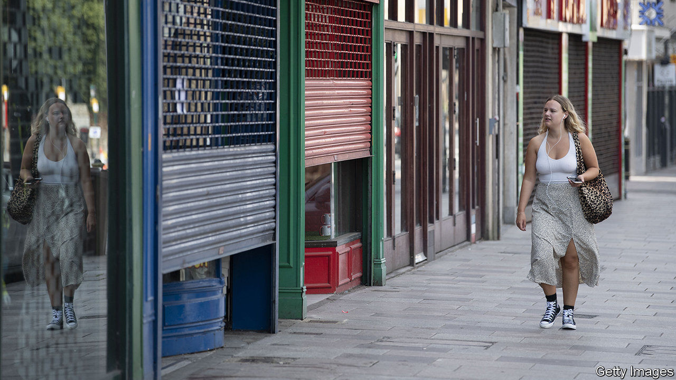

ECONOMIC CRISES often involve runs on banks. This one is causing the opposite. The enforced shutdown of many shops, less commuting and a reluctance to return to pubs and restaurants, have left households, in aggregate, awash with cash. Household holdings of money, mainly in the form of bank deposits, rose by a record-breaking £25.6bn ($32bn) in May following sharp rises in March and April (see chart). This run to the banks has pushed household cash balances up by around £55bn, some 2.7% of pre-crisis GDP, in three months.

Alongside rising bank balances, net lending to consumers contracted by £15.8bn in the three months to the end of May. The Office for Budget Responsibility (OBR), the government’s fiscal watchdog, now thinks that the household savings ratio, the percentage of their income that households put aside rather than consume, jumped from about 5% in February to close to 30% at the height of the lockdown.

This big shift is the result not only of the closure of much of the economy by government fiat, but also the government’s initial response to the crisis. Despite a collapse in GDP, unemployment remains relatively low and household incomes have fallen only modestly. That’s because the government is taking a much bigger hit than is normal in recessions. Through the furlough scheme and support for the self-employed it is bankrolling more than 12m workers. Universal credit, the main out-of-work benefit, was increased by £20 a week at the budget in March. The OBR estimates that government borrowing will hit 16.4% of GDP this financial year, a peacetime record.

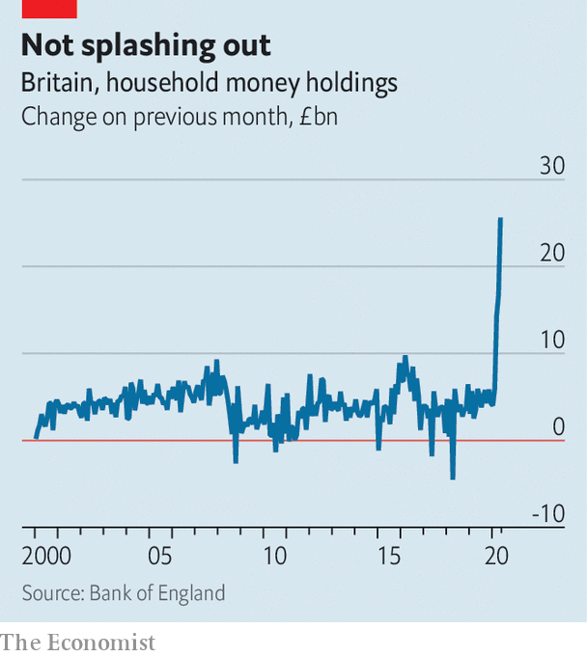

Not everybody is seeing their piggy-banks fatten. Analysis by the Resolution Foundation, a think-tank, points to a reasonably consistent fall in incomes across the earnings distribution for working age households but vastly different changes in spending. Households that had little discretionary spending in the first place have seen much more modest drops in expenditure, or even rises, as having the children out of school for weeks has increased their shopping bills. Prosperous commuters, by contrast, are saving a small fortune on train fares, coffees and lunches. Pensioners’ incomes have fallen by less, but their spending by more. Despite three months of falling consumer credit, gross repayments are actually down on pre-pandemic levels, but new gross lending is down by a lot more.

How households will react to the reopening of the economy is “one of the big questions that will determine the shape of the recovery”, says Paul Dales of Capital Economics, a consultancy. It seems likely that workers’ worries about rising unemployment will keep precautionary saving high. The OBR’s central scenario predicts that the household savings ratio will remain above 10% in the next few years. That’s bad news for the economic outlook.

This article was downloaded by calibre from <https://www.economist.com/britain/2020/07/18/household-savings-are-up-in-britain>

|  |  |  |  |
| --- | --- | --- | --- |
| Previous | Articles | Sections | Next |

|  |  |  |  |
| --- | --- | --- | --- |
| Previous | Articles | Sections | Next |

#### Bagehot

# The talent dearth in Britain’s government

Dance of the lemons

Jul 18th 2020 |

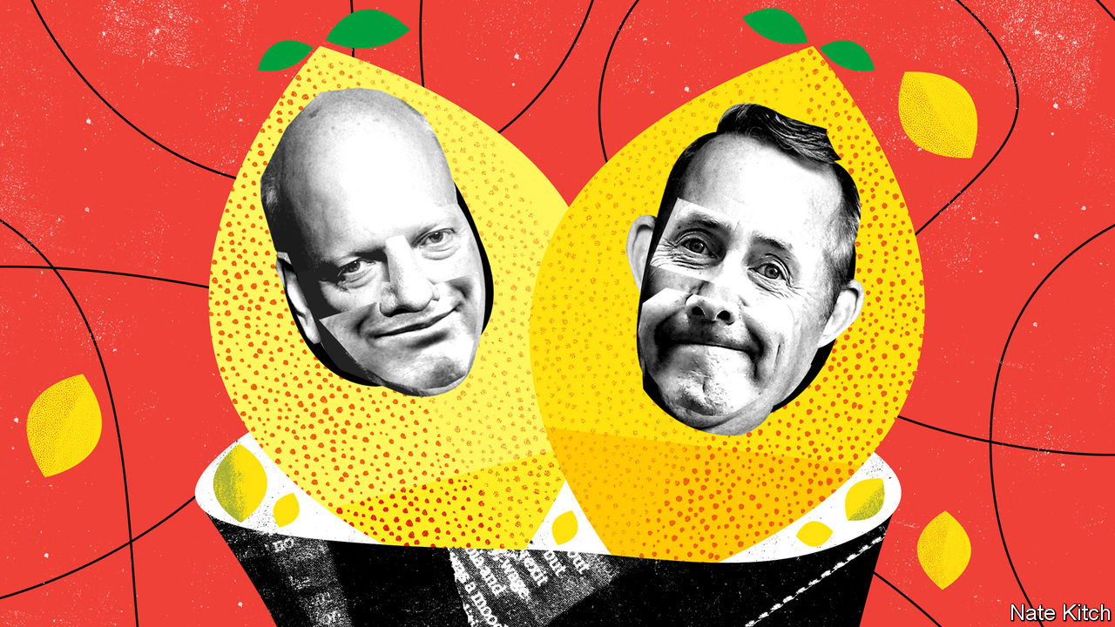

AMERICA’S PUBLIC education system has given the world two pungent mismanagement phrases: the “dance of the lemons” and the “rubber room”. The power of teachers’ unions makes their members hard to sack, so school districts either shuffle bad teachers from one school to another (“the dance of the lemons”) or put them in a downtown office (“the rubber room”) where they twiddle their thumbs and draw their salaries.

The case of the four biggest lemons in British politics suggests that the government has adopted this approach. Priti Patel and Gavin Williamson were both sacked by Theresa May for bad behaviour. Chris Grayling failed so spectacularly in every job he undertook that the Labour Party calculated he had cost taxpayers £2.7bn. Liam Fox lost not one but two cabinet positions—first the secretaryship of defence in 2011 because he had allowed a friend to accompany him on official trips and then the job of trade secretary in 2019 because Boris Johnson no longer required his services.

All have spent time in the rubber room only to bounce back into front-line politics. Ms Patel and Mr Williamson are home secretary and education secretary respectively. Ms Patel has proved so inarticulate that she is rarely allowed on the media; Mr Williamson has become a patsy of teachers’ unions that seem determined to keep children out of classrooms. Mr Johnson recently nominated Mr Fox to run the World Trade Organisation (WTO) and Mr Grayling to chair the House of Commons Intelligence and Security Committee (ISC). Mr Fox’s nomination is dead on arrival: nobody (other than him) regards him as a serious candidate and his application consists mainly of quotations from his own speeches. “Failing Grayling” lived up to his nickname by getting pipped at the post for the committee chairmanship by his fellow Conservative MP, Julian Lewis. “Only Grayling could lose a rigged election,” sighed the pro-Brexit Guido Fawkes website.

Britain’s political system puts artificial constraints on the supply of talent. In many countries you can become a minister without being an MP. In Britain you have to get into Parliament. That means living in one of the world’s most expensive cities on a modest salary and putting up with being treated as a liar by regular voters and subjected to abuse by an ever larger unhinged fringe.

The government has exacerbated the problem by imposing a Brexit purity test on recruits, thereby turning Brexiteers into the country’s mightiest-ever trade union. There are certainly a few competent Brexiteers, most obviously the chancellor, Rishi Sunak. But the supply is necessarily limited. Lord Mandelson, who was rejected as Britain’s candidate for the WTO despite being far better qualified than Mr Fox, argues that the “the Brexit gene pool” is not big enough to “produce all the people we need to work in public life”. The British establishment (including a majority of Tory MPs in 2016) was against leaving the EU. This was particularly true of people with expertise in Brexit-related areas such as trade policy.

When Mr Johnson opted for a hard line on Brexit, the Tory Party lost first-class people such as David Gauke and Rory Stewart. By requiring cabinet ministers to support a “do or die” Brexit, the prime minister denied himself the service of able pragmatists who opposed Brexit but accepted the result of the referendum, such as Jeremy Hunt and Tom Tugendhat. True believers, meanwhile, are getting preferment, irrespective of their abilities or qualifications: Mr Fox is a long-standing booster of the Anglosphere while the hapless Mr Grayling was one of the first six cabinet ministers to announce that they intended to campaign to leave the EU.

This talent shortage is proving more damaging by the day. The entire Brexit project increasingly rests on the shoulders of just three people, Mr Johnson, Michael Gove, the Cabinet Office minister, and Dominic Cummings, the prime minister’s chief adviser—“two journalists and a maniac” in the words of a former MP—who have to deal with covid-19 as well as forging a new relationship with Europe. Britain has long prided itself on its ability to punch above its weight in international institutions. Mr Fox’s WTO application was treated with incredulity in the organisation’s Geneva headquarters, and alarm in Britain’s foreign-policy establishment, which worries that the government is either indifferent or blind to global opinion. “What’s next?”, asks a mandarin, “IDS (Iain Duncan Smith) for the IMF or JRM (Jacob Rees-Mogg) for the UN?”

The ISC debacle shows how counterproductive Mr Johnson’s personnel-management can be. The committee’s job is to bring democratic oversight to the secret world—or not. It has been sitting for months on a report on Russian interference in British politics that may prove inconvenient to the government. It is widely assumed that Mr Grayling was chosen for the job because he would be pliant. The day after the committee got its new chairman—who was instantly thrown out of the Tory party for conspiring with Labour MPs to get the job—it announced that it would publish the report before July 29th, when Parliament packs up for summer. Westminster waits with bated breath, and the prime minister finds himself undermined by his lemon-promotion.

Populist revolutions are always in danger of falling into a familiar trap. Their leaders mobilise outsiders against insiders and neophytes against old hands. But those who win find themselves running the country, which requires the services of clever, competent types. Recruiting and retaining such people does not come naturally to populists. Donald Trump has included a former contestant on his game show (Omarosa Manigault Newman), a far-right activist (Steve Bannon) and law-breakers (Michael Flynn and Roger Stone) in his entourage, while sneering at those who know their stuff, such as Dr Anthony Fauci, his covid-19 adviser.

Mr Johnson has shown that he’s wilier than Mr Trump by listening to scientists during this crisis. He still has a chance to redeem his premiership by restocking his government with talent from across the party. But his enthusiasm for rubber-room residents such as Messrs Fox and Grayling does not bode well. ■

This article was downloaded by calibre from <https://www.economist.com/britain/2020/07/18/the-talent-dearth-in-britains-government>

|  |  |  |  |
| --- | --- | --- | --- |
| Previous | Articles | Sections | Next |

|  |  |  |
| --- | --- | --- |
| Britain | Sections | Business |

International

School closures: A class apart

.

Schools in poor countries: Won’t know much about history

.

|  |  |  |
| --- | --- | --- |
| Britain | Sections | Business |

|  |  |  |  |
| --- | --- | --- | --- |
|  | Articles | Sections | Next |

#### A class apart

# As schools reopen, how can pupils make up for lost time?

The hard-up find it hardest

Jul 18th 2020 |

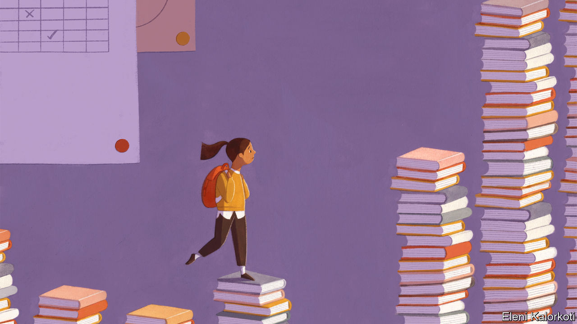

Editor’s note: Some of our covid-19 coverage is free for readers of The Economist Today, our daily [newsletter](https://my.economist.com/user#newsletter). For more stories and our pandemic tracker, see our [hub](https://www.economist.com/news/2020/03/11/the-economists-coverage-of-the-coronavirus)

LAST YEAR Kiana Jones took a summer job at a trampoline park, supervising birthday parties and keeping an eye out for overzealous bouncers. This season Ms Jones, an undergraduate in Tennessee, is spending seven weeks in a community centre drilling children in reading and maths. She is one of around 600 locals swiftly assembled by the Tennessee Tutoring Corps, a charity set up in May by a former state governor to help children who have missed months of school. It will pay each tutor $1,000, more than many had expected to make during a summer overshadowed by the pandemic.

The efforts of those such as Ms Jones are a rare bright spot in America’s scholastic landscape. The government has largely failed to control the pandemic. Schools have largely stayed closed. President Donald Trump and Betsy DeVos, the education secretary, have threatened to defund schools that refuse to reopen. Those that do welcome back children in the autumn may have to rely on rota systems that allow pupils to attend in person only part-time.

In other parts of the rich world, however, children are already coming back. In countries such as France, Denmark and New Zealand social-distancing rules have been relaxed to allow most children to return to classes every day. Schoolchildren in England will return full-time from September, the British government says. But getting children back into classrooms is only the first step in repairing the damage the pandemic has done to their learning. Educators must now work out how to make up for lost time.

The challenge is huge. Lessons from the year now ending remain untaught. When children spend any significant time out of school (including normal summer holidays), they tend to forget some of what they have already learnt. Analysts at NWEA, an American test-provider, reckon that by autumn some children will be a year behind in maths.

Poor children will suffer most. Many were some way behind their peers before the pandemic. Some American classrooms included pupils whose true learning levels spanned seven grades, according to NWEA. This gap has only widened as children have missed months of school, making teachers’ jobs even harder.

Guidance produced by UNESCO and McKinsey, a consultancy, identifies three types of catch-up strategies. Schools can give children more time. They can adjust their curriculums. Or they can try to improve the quality of their instruction. The greatest success will probably come from a combination of all three.

Some countries have already tinkered with timetables. Singapore pulled forward its month-long annual recess—usually in June—to May, when the country’s lockdown was already keeping schools shut. In some parts of Vietnam schools have crunched the usual three-month break down to a few weeks.

Others are expanding existing summer programmes. New York City is requiring about 100,000 students to enroll in online summer schools, twice as many as last year. The difficulty is that children often fail to turn up to real summer schools frequently enough to benefit from them. It is even harder to ensure they attend lessons conducted online.

Squeezing curriculums to create more time for the most important subjects is less painful than it sounds. Andreas Schleicher of the OECD, a club of mostly rich countries, says that politicians have long found it easy to add fashionable new topics but more difficult to take things away. As a result, he continues, syllabuses have become “a mile wide but only an inch deep”. David Steiner of Johns Hopkins University says much of American pupils’ time is wasted on material that is less challenging than it should be.

Experts are most enthusiastic about using tutors to help children catch up. The British government has put aside £350m ($439m) to launch a national tutoring programme in September. Schools can use existing organisations or hire graduates who would work full time. They can top this up with money from another pot of £650m that schools can use for any remediation strategies they deem helpful. The Dutch government has earmarked €244m ($277m) for a similar programme. It plans to enlist trainee teachers to help bring struggling learners up to scratch.

Robert Slavin, director of the Centre for Research and Reform in Education at Johns Hopkins University, would like America to mount a federally funded tutoring programme. Trained graduates could be deployed in teams to each American school, beginning with those whose students have been worst affected by the closures. They could teach pupils one-to-one or in small groups. A few American politicians like the idea but the government has shown no interest in doing anything on this scale. Tutoring jobs would be welcomed by graduates entering a terrible market, reckons Matthew Kraft of Brown University. Getting large numbers of graduates to work as tutors might help to reduce teacher shortages by encouraging more youngsters to consider teaching as a career.

Schools will have to work hard to ensure that everyone gets the help they need. A survey carried out in early May by the Institute for Fiscal Studies, a British think-tank, found that poorer parents were less inclined than rich ones to send their children back to school as soon as it is allowed. An American poll found that black and Hispanic parents are much less likely than white ones to consider classrooms safe.

Ultimately no child will learn anything “unless they feel psychologically and emotionally safe”, says Pasi Sahlberg of the University of New South Wales in Australia. When schools reopen, he reckons, they will need to provide children with counselling and time to play as they adjust to their return. Tute Porter-Samuels, a primary-school teacher in New Zealand, says that when her school in Wellington reopened it devoted two weeks to music and art.

Still, there are grounds for optimism. Home schooling has introduced parents to the horrors of trying to educate their children while holding down a job. But it has also made parents more sympathetic to teachers, says Odile Cordelier, a teacher in the French city of Dijon.

Distance-learning, despite its glitches, has made teachers more familiar with technology. Recessions may force governments to trim school budgets but they may also get some new blood into the teaching profession. In Britain applications to teacher-training programmes surged in May and June. A recent study found that teachers in Florida who started their careers in downturns were better at raising test scores than those who did not. Schools will need all the help they can get. ■

This article was downloaded by calibre from <https://www.economist.com/international/2020/07/18/as-schools-reopen-how-can-pupils-make-up-for-lost-time>

|  |  |  |  |
| --- | --- | --- | --- |
|  | Articles | Sections | Next |

|  |  |  |  |
| --- | --- | --- | --- |
| Previous | Articles | Sections | Next |

#### Learn today, earn tomorrow

# School closures in poor countries could be devastating

And governments are bungling their response

Jul 18th 2020 | JOHANNESBURG, PARIS AND SÃO PAULO

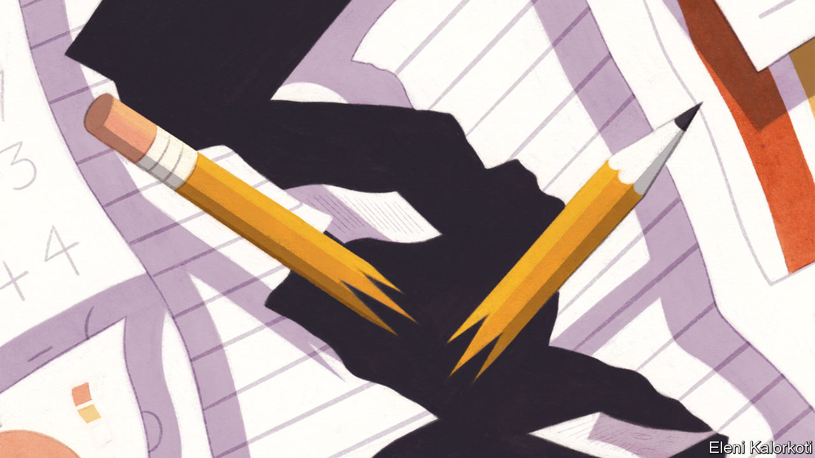

Editor’s note: Some of our covid-19 coverage is free for readers of The Economist Today, our daily [newsletter](https://my.economist.com/user#newsletter). For more stories and our pandemic tracker, see our [hub](https://www.economist.com/news/2020/03/11/the-economists-coverage-of-the-coronavirus)

SUHANI, WHO is nine years old, wakes each day before dawn. She collects flowers to weave into necklaces which she flogs to drivers stuck in Dhaka’s endless traffic jams. Until recently Suhani and her sister spent their days in a crowded classroom in Nimtoli, a slum in Bangladesh’s capital. When the country locked down to stop the spread of covid-19 their mother, a single parent, lost her job as a maid. She has been out of work since. Schools remain closed. Even if they were open, Suhani could not go. She is the breadwinner now.

Of the 1.5bn children forced out of school by lockdowns around the globe, 700m are in developing countries. Like pupils in rich countries, their education is suffering. But the consequences in poor places will be far worse. Before the pandemic, more children were in school than ever before, according to Robert Jenkins, head of education at of Unicef, the United Nations’ children’s fund. In its aftermath nearly 10m children in 40 countries might never return to formal education, estimates Save the Children, a charity.

The economic impact of the pandemic has forced many to abandon their studies in favour of work. Between 2000 and 2020 the number of children in work around the world fell by 40%, mostly because more were going to school. Covid-19 is undoing that progress. In the Democratic Republic of Congo growing numbers are helping their parents in mines, says Stephanie Shumsky of Pact, an aid group. Others are being recruited into militias. In Jordan young Syrian refugees are toiling on farms.

Experts are most worried about the effect on girls. In the handful of places that have reopened schools, such as Vietnam and the Ivory Coast, teachers say girls are notably absent. Some are getting married—or being married off. Snehalaya, an Indian NGO, says its emergency hotline has been inundated with reports of this since schools closed in March. Handing a daughter over to a new husband means one fewer mouth to feed. With schools closed, idle daughters may strike up a romance or fall prey to sexual assault. Working parents forced to leave their daughters at home all day alone would rather marry them off than risk the shame of premarital sex, says Girish Kulkarni, Snehalaya’s founder.

Others are falling pregnant, some after being raped by relatives or neighbours while quarantined at home, says Alice Albright of the Global Partnership for Education, an umbrella group based in Washington, DC. While schools are closed girls are no longer in touch with teachers who might help them in such circumstances. During the Ebola crisis in Sierra Leone in 2014, when schools were also closed, teenage pregnancies rose by between 11% and 65%, according to a variety of studies. Extrapolating from these data, researchers at Save the Children think they could rise by 25% as a result of covid-19.

The economic damage from children dropping out of school will be vast. The World Bank estimates that, if schools remain closed for five months, pupils will forgo $10trn of future earnings in today’s money. That could rise if covid-19 is not curbed and schools stay closed for longer.

Many governments are finding it hard to get children learning again. Poorer countries face obvious disadvantages in teaching lessons remotely. In some places access to the internet is patchy. In the Indonesian capital, Jakarta, 87% of children can get online, says Nadia Fairuza of the Centre for Indonesian Policy Studies, a think-tank, but in Papua, Indonesia’s biggest province, the figure is less than 30%.

Thus the pandemic is widening the pre-existing gap between how much rich and poor children learn. A survey last month by Datafolha, a pollster, revealed that while 74% of pupils in Brazil are participating in some kind of distance learning, often over WhatsApp, that drops to just 52% in the poor Amazonian north. There is a similar disparity between the (poor) north and (richer) south in Nigeria, says Emeka Nwajiuba, the country’s education minister. Families sometimes respond to scarcity in ways that disadvantage girls. Parents often give the family’s only phone to their son, not their daughter, he points out.

Many parents and students are being asked to do the impossible. Francis Aruo, a 32-year-old father of five from Rumuruti, a small town in central Kenya, was told to buy a computer by his children’s headmaster. It would cost more than three times his savings. Even if he could afford the computer, a reliable internet connection is not readily accessible in Rumuruti. Mr Aruo can just about afford enough data to run WhatsApp on his phone; he cannot afford enough to download lessons. Femi Odunsi, a secondary-school teacher in Lagos, Nigeria’s largest city, was trained by the state government to teach online. But few of his students have computers and those who have smartphones cannot afford data. In Bangladesh the main remote learning is through programmes broadcast on state-run television. But only 44% of children have access to a television, according to BRAC, a big charity.

Some governments have failed even to try to help children learn from home (see map). Others have been slow to get going. Ghana’s government only launched its distance learning radio programme on June 15th, three months after schools closed.

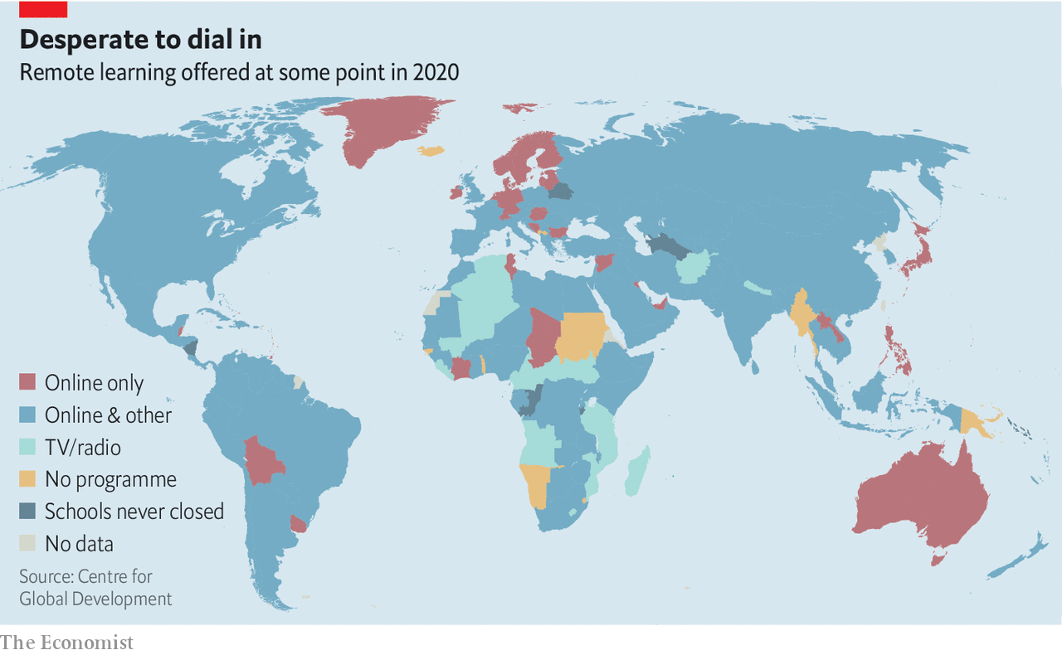

Reopening schools is hard, too. In June only about half of poor countries said they had a plan for doing so, according to a survey by the UN and World Bank. Social distancing is tricky where 50 or 60 pupils are often packed into a single classroom. In sub-Saharan Africa less than 30% of schools have handwashing facilities.

Governments are opening many other things before schools. In Kenya revellers can hit the pub for a beer and some nyama choma (grilled meat), but the government says schools will stay closed until 2021. In Pakistan the government has allowed madrassas, run by powerful religious groups, to open, but not mainstream institutions. Garment factories opened in Bangladesh more than two months ago, but schools remain closed. Schoolchildren and their parents lack the political clout of factory owners—or indeed, teachers’ unions, which typically resist a return to work. They cite the health risks, which are real. Since South Africa’s schools opened partially on June 8th, nearly 800 schools have had cases of covid-19. But teachers’ unions have also made unreasonable demands. SADTU, the biggest, opposes some provinces opening schools before others: ie, it wants all to hang back with the slowest.

Getting schools up and running will require money, which is tight. Just 8% of the poorest countries report that they are recruiting new teachers to help with reopening, compared with almost 40% of rich ones, according to the same survey by the UN and World Bank. Cash-strapped governments are more worried about boosting their already overstretched health systems. In Bangladesh’s new budget, announced last month, the amount allocated to education was unchanged as a share of GDP.

Still, some governments are making progress. Education ministries in Dominica, Grenada, St Lucia and St Vincent and Grenadines in the eastern Caribbean are working with private telecoms providers to roll out free internet for students and distribute mobile devices to the poorest. Rwanda hopes that an offer of free lunches will get children back to school. Mozambique is giving girls sanitary products. Even handing out snacks or pencils can make a difference.

## Old-school learning

Experience helps. Sierra Leone used radio programming during the country’s Ebola outbreak in 2014. It was easy to reboot it, says David Moinina Sengeh, the country’s education minister. Preparation for schools to reopen started before they even shut. Mr Sengeh enlisted an army of bus drivers to ferry children, whose families had moved during lockdown, back to the villages and towns their schools were in.

He also rushed to overturn a law banning pregnant girls from going to school, offering incentives to teenage mothers to return to their studies and adding sex education classes to lessons broadcast by radio to reduce the likelihood of girls getting pregnant. Mr Sengeh sees the pandemic as an opportunity to ensure that everyone, everywhere, gets a good education. Covid-19 has given the government the “oomph” it needs to make it happen, he says. Others could learn from him. ■

This article was downloaded by calibre from <https://www.economist.com/international/2020/07/18/school-closures-in-poor-countries-could-be-devastating>

|  |  |  |  |
| --- | --- | --- | --- |
| Previous | Articles | Sections | Next |

|  |  |  |
| --- | --- | --- |
| International | Sections | Finance & economics |

Business

Unwanted fossil fuels: The bottom of the barrel

.

Entertainment (1): Ad nauseam

.

Entertainment (2): Off his rocker?

.

Sino-American tech mistrust: At the end of a rainbow

.

I’ll have semiconductors with that: Analog devices buys Maxim Integrated for $20bn

.

Cyber-security: The other virus threat

.

Bartleby: A question of judgment

.

Schumpeter: When bits bite

.

|  |  |  |
| --- | --- | --- |
| International | Sections | Finance & economics |

|  |  |  |  |
| --- | --- | --- | --- |
|  | Articles | Sections | Next |

#### The bottom of the barrel

# Oil giants want to own only the cheapest, cleanest hydrocarbons

What to do with the cruddiest crude

Jul 18th 2020 | NEW YORK

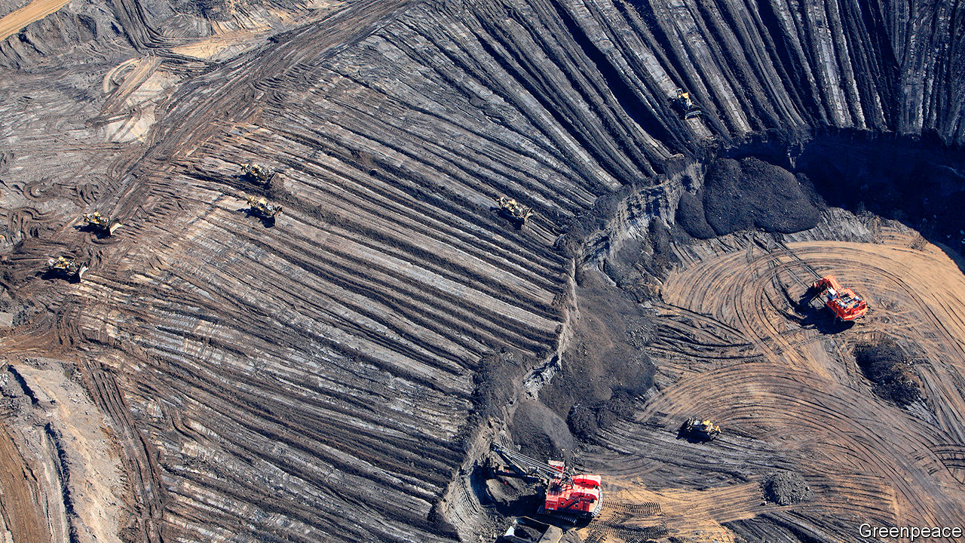

LONG BEFORE oilmen fracked the Permian basin, they came to Prudhoe Bay. Spanning more than 800 square kilometres of Alaska’s North Slope—an area the size of New York City—it remains one of the most productive oilfields in American history. In 1977 BP began pumping the black stuff from Prudhoe Bay, whence a new pipeline transported it over 1,300km of frigid wilderness to the port of Valdez. The project was a triumph of engineering and a testament to BP’s ambition. This month the British giant achieved a different feat: it sold its stake in Prudhoe Bay and other Alaskan oilfields to Hilcorp, a smaller firm. When, in April, it looked as if the $5.6bn sale might be at risk, BP said it would extend a loan to Hilcorp to help close the deal.

BP’s eagerness to sell its Alaskan business reflects a broader shift. Oil and gas firms, which report second-quarter earnings in the coming weeks, are cutting investment and trying to sell billions of dollars’ worth of resources. Even before covid-19 lockdowns hit energy demand and oil firms’ profits, investors were wary of big projects. Now the risk of costly stranded assets has grown more obvious. Last month BP and Royal Dutch Shell, an Anglo-Dutch rival, said they would take write-downs of up to $17.5bn and $22bn, respectively, on assets. The oil majors are ever keener to own only the cheapest, cleanest reserves. Getting there will be tough.

The oil industry faces a basic problem. If the price of Brent crude, the global benchmark, surpassed $100 a barrel, about 90% of the world’s oil could be extracted with a return on capital of at least 10%, according to Rystad Energy, an energy-research firm. Today Brent fetches just over $40 a barrel, making about half the world’s oil reserves too costly to produce (see chart 1). Oil prices are expected to rebound as post-pandemic demand picks up, but by how much is fiercely debated.

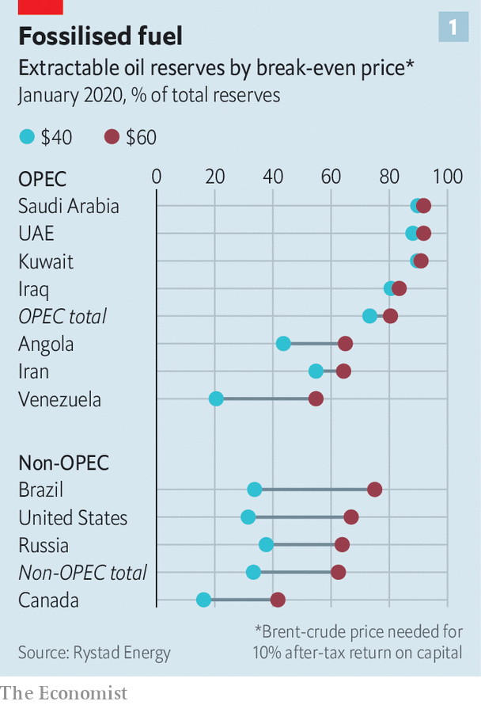

ExxonMobil, an American behemoth that remains bullish on future fossil-fuel demand, has declined to write down its shale assets. The impairments announced by BP and Shell last month accompanied revisions to their forecasts for the price of Brent. Shell now expects a barrel to cost $40 in 2021 and $50 in 2022, down from the $60 it assumed in its most recent annual report. BP forecasts that Brent will average $55 from 2021 until 2050. Just a few months ago its central assumption for prices over the next 20 years was $70. BP’s outlook for gas prices at Henry Hub, a benchmark for that commodity, has darkened, too, from a long-term average of $4 to $2.90 per million British thermal units.

For some petrostate-owned oil firms, current prices are high enough to keep drilling profitably but too low to balance national budgets (see article). Elsewhere high costs mean oil may simply remain below ground. In Canada only 42% of reserves can be produced with Brent at $60 a barrel, a share that falls to 16% at $40. The energy needed to extract and refine Canada’s thick bitumen makes its oil sands even less appealing. Angola in recent years passed tax incentives to promote offshore drilling, but Rystad now estimates that low prices and Angola’s relatively high costs will deter investment.

The supermajors understandably desire resources that are resilient to price swings and to climate regulations being considered in many countries to discourage the use of the dirtiest fuels. They have worked to cut costs. Last year the average oil price needed to cover capital spending and dividends for the five biggest—ExxonMobil, Shell, Total, Chevron and BP—was less than half what it was in 2013, according to Goldman Sachs, a bank (see chart 2). The pandemic hit to demand has prompted further cuts to capital budgets. For some giants this coincides with a slow shift to cleaner energy. “We’re not about volume,” Bernard Looney, BP’s chief executive declared recently. “We’re about value.”

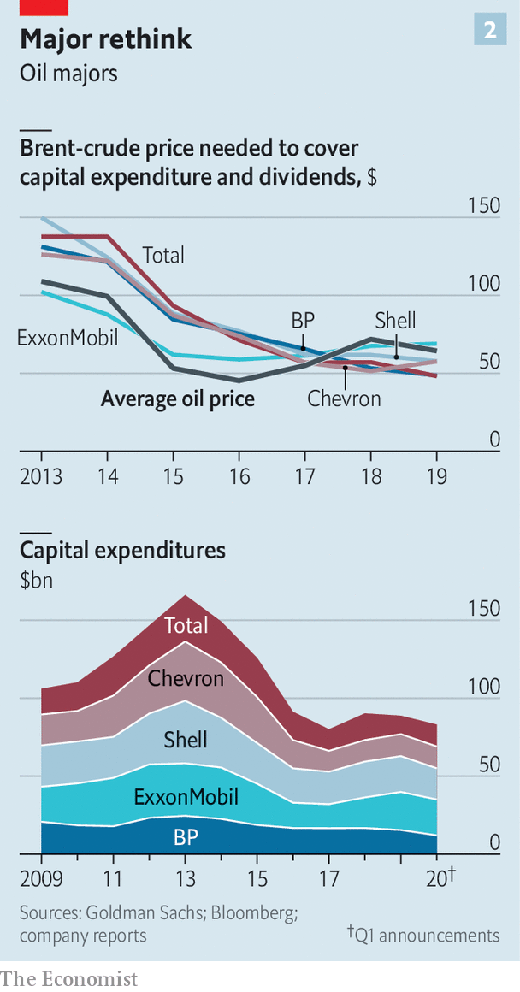

Still, the switch to top-quality assets will be messy. Projects that seem safe one minute can look imperilled the next. In April Shell said it would postpone a final investment decision on its Whale oilfield in the Gulf of Mexico, considered one of its most promising finds of the past decade. Even American shale, where big oil poured money, lured by its flexibility, falling costs and low geopolitical risk, is looking riskier. Last year shale gas was a big reason why Chevron wrote down $10.4bn. Some frackers fear potential environmental restrictions from Joe Biden, were the presumptive Democratic nominee to become president, and the courts. This month a federal judge ordered a pipeline from North Dakota to be emptied of oil by August 5th.

As firms seek winning projects, many are struggling to offload mediocre ones. BP is the sole supermajor to meet its divestment target, of $15bn—in part thanks to the decision in June to sell its petrochemicals unit, a business that rivals view as having brighter prospects than drilling. Rystad reckons reserves equivalent to 12.5bn barrels of oil were for sale in June, excluding shale and oil sands. Of that, the majors accounted for over two-thirds of liquids like oil and propane, and half the gas.

In the past finding a buyer for an oil- or gasfield was not that difficult. Greig Aitken of Wood Mackenzie, an energy consultancy, recalls “a widespread view that prices would get up to $80 or $100” after the price crash of 2014. Even before covid-19, however, buyers were turning more cautious.

In China a crackdown on corruption has made state-owned oil companies less acquisitive amid closer scrutiny of foreign deals. Companies which focus on exploration and production have faced their own pressure to boost profits now rather than growth later, given uncertainty over future demand. Private-equity (PE) firms no longer have an easy exit strategy for energy investments because uncertain regulation and demand make it hard to envision a successful listing or sale to an oil major in a few years’ time. One PE investor in Houston says it has become increasingly difficult to estimate shale companies’ long-term value, making financiers more reticent to back them in the first place.

As a result willing buyers are getting ever harder to find. Chevron is trying to sell its stake in offshore blocks in Nigeria, which it first attempted to sell five years ago. Sellers are sweetening deals. In May Total announced a loan similar to the one BP extended to Hilcorp, to help close the sale of its North Sea fields to a PE-backed company called NEO Energy. In May Shell said it would sell its gas assets and pipelines in Pennsylvania to National Fuel Gas Company, a regional business. Wood Mackenzie reckons that the $541m transaction implied a fair value for Shell’s producing gasfields but valued the company’s undeveloped gas acreage at close to nothing.

Some acquirers will emerge for the same reasons others stay away: the transition to cleaner energy is uncertain and markets will remain volatile for a while. Opportunistic buyers may purchase resources as they would an option, which could pay out if demand picks up and prices rise. It is a credible strategy, but a risky one. In recent months Saudi Arabia has shown it can unleash millions of barrels of crude to win market share. “Companies will be able to find buyers for difficult resources,” says Per Magnus Nysveen of Rystad. “It’s all a question of the price.” Right now, buyers drive a hard bargain. ■

For more coverage of climate change, register for The Climate Issue, our fortnightly [newsletter](https://www.economist.com/theclimateissue/), or visit our [climate-change hub](https://www.economist.com/news/2020/04/24/the-economists-coverage-of-climate-change)

This article was downloaded by calibre from <https://www.economist.com/business/2020/07/18/oil-giants-want-to-own-only-the-cheapest-cleanest-hydrocarbons>

|  |  |  |  |
| --- | --- | --- | --- |
|  | Articles | Sections | Next |

|  |  |  |  |
| --- | --- | --- | --- |
| Previous | Articles | Sections | Next |

#### Now a message from our sponsors

# NBC turns to ads to fund its streaming wars

As the cost of content rises, more video companies consider running commercials

Jul 18th 2020 |

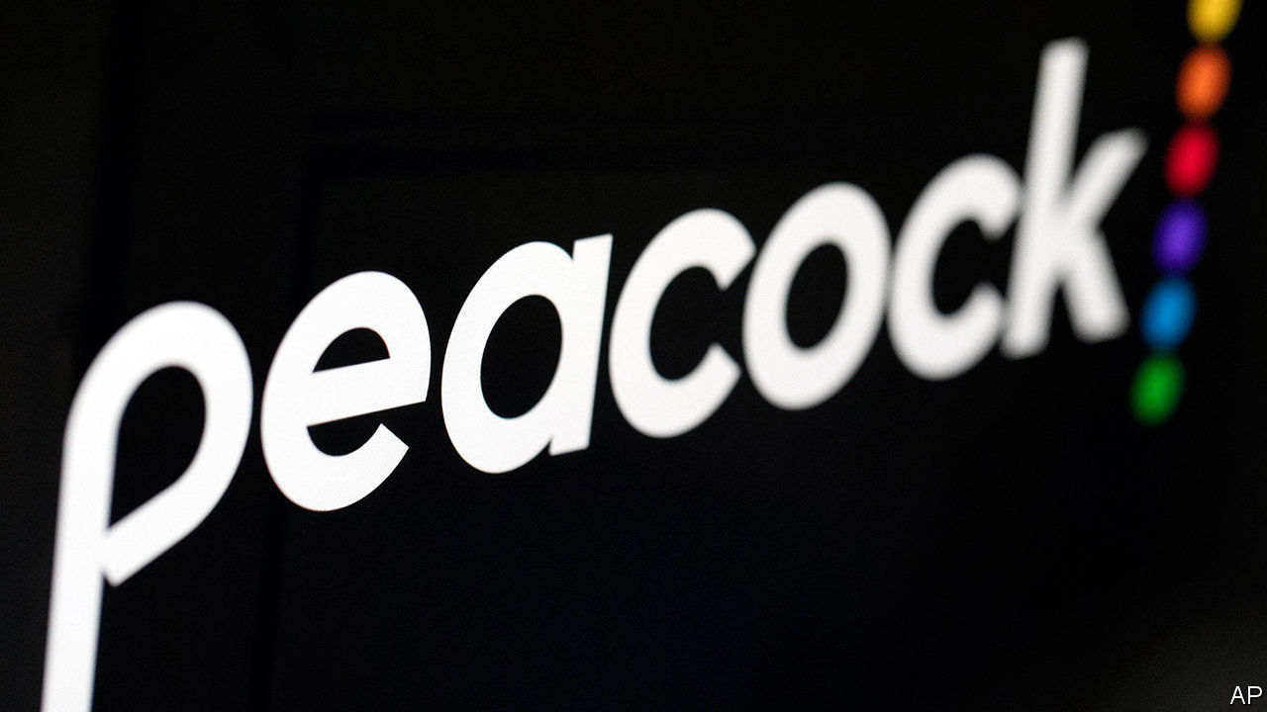

EVEN AS LOCKDOWNS confine Americans to their homes, no one is in danger of running out of things to watch on television. Netflix, the leading video-streamer, offers more than 36,000 hours of programming. If that is not enough, viewers can tune in to new offerings from tech firms, such as Amazon and Apple, and old media companies, from Disney+ to HBO Max, owned by AT&T. So viewers may barely blink their square eyes at the news that yet another streamer, Peacock, hatched on July 15th. And unlike its rivals, this bird is free.

It needs to be, for it is late to the party. The average American household paid for three streaming services last year and has taken on a fourth since the pandemic hit, reckons Deloitte, a consultancy. In a recession few want a fifth. So Peacock, launched by NBCUniversal, part of Comcast, a cable provider, is letting them pay not with money but with their time, by watching ads.

NBCUniversal’s back-catalogue is certainly deep—13,000 hours of TV and film, from “Psycho” to “30 Rock”, or 20,000 on a paid, “premium” plan. But, says Peter Supino of Bernstein, a research firm, it is designed for the old days of linear television and the cinema. Online, with near-infinite choice and personalised recommendations, niche is king. Comcast is not putting much money into Peacock originals: the service currently has nine shows (covid-19 delayed a few others) to Netflix’s 1,600.

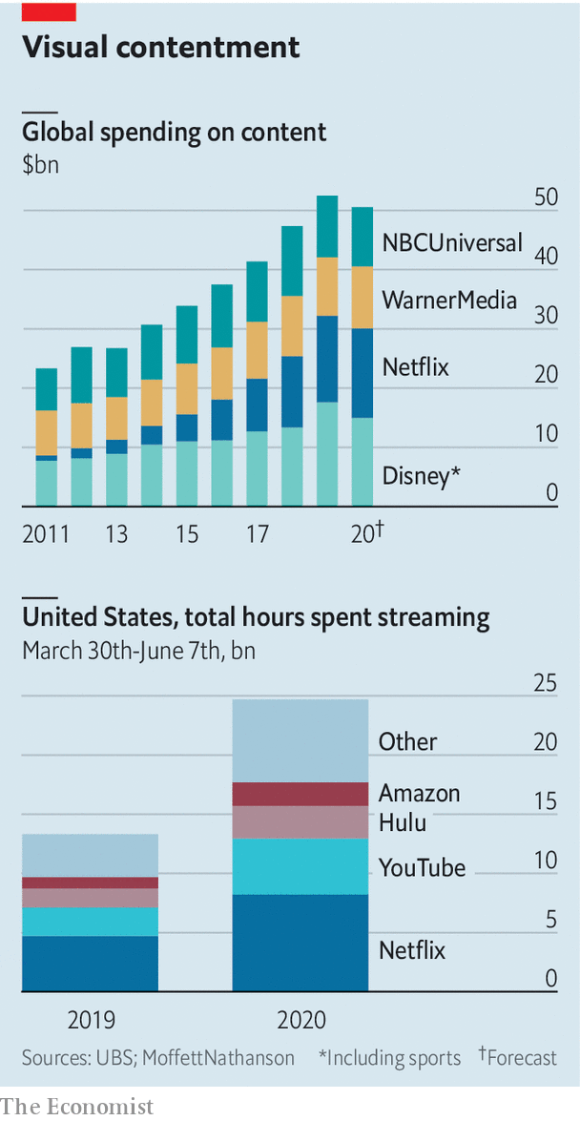

Yet advertising-supported streaming may be worth pursuing. Two-thirds of Americans say they would prefer a wholly or partly ad-supported service to a subscription one, finds Deloitte. Seven out of ten customers of Hulu, owned by Disney, opt for its cheaper, ad-supported plan. Advertisers are also keen, as cable TV bleeds viewers, and appearing next to user-generated content on sites like YouTube poses a reputational risk. Peacock promises no more than five minutes of commercials per hour, against the American-TV standard of 18. In future it hopes to target these ads, using Comcast’s data on subscribers.

Ad-supported video is already the main model in Asia. Disney’s Hotstar has more than 300m monthly users in India. In China services owned by tech giants—Baidu’s iQiyi, Alibaba’s Youku and Tencent Video—all carry ads, and have around half a billion users each. As the cost of content rises, American firms’ interest is growing. Comcast bought Xumo, a free streamer, earlier this year and is in the process of buying Vudu, another ad-supported service, from Walmart. ViacomCBS and Fox Corporation have also acquired ad-carrying streamers. AT&T plans an ad-supported tier of HBO Max next year. And Amazon may one day use detailed data on its online shoppers to run targeted ads on its Prime Video service. American viewers, spoilt for choice about what to watch, will increasingly be able to choose if and how they pay for it. ■

This article was downloaded by calibre from <https://www.economist.com/business/2020/07/18/nbc-turns-to-ads-to-fund-its-streaming-wars>

|  |  |  |  |
| --- | --- | --- | --- |
| Previous | Articles | Sections | Next |

|  |  |  |  |
| --- | --- | --- | --- |
| Previous | Articles | Sections | Next |

#### Off his rocker?

# CTS Eventim is plotting a post-pandemic comeback tour

Europe’s live-music giant is unfazed by the coronavirus slump

Jul 18th 2020 | BERLIN

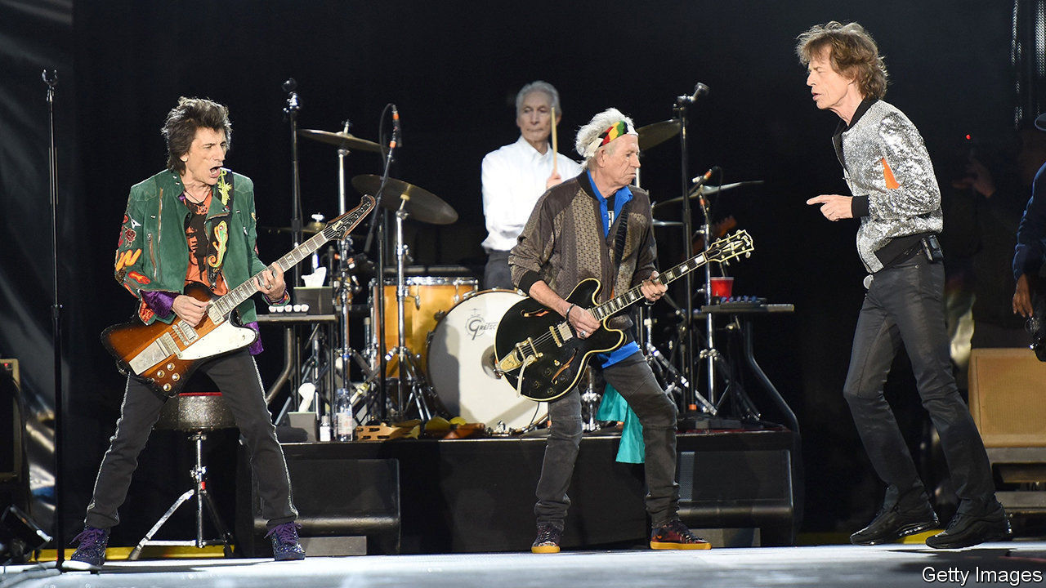

“WE WERE MEDIOCRE,” confesses Klaus-Peter Schulenberg about Free, the rock band he played guitar for in his youth. He was, though, excellent at landing attractive gigs. So much so that other bands asked him to help them do the same. It became his job in 1971, before he was old enough to sign a contract to manage Bernd Clüver, who went on to become a chart-topping pop star (Mr Schulenberg’s father did so on his behalf). Today he is the billionaire boss of CTS Eventim, Europe’s biggest organiser of live entertainment.

Mr Schulenberg developed Computer Ticket Service, a struggling ticket-seller he bought in 1996, into one of the world’s biggest events groups. It has had ups and downs, but social-distancing measures imposed by governments to contain the covid-19 pandemic are by far the biggest challenge in the 69-year-old’s career. Live shows stopped cold in March across most of Europe. Sales of tickets—his firm shifts 250m in a normal year—collapsed by 90%. Only a vaccine against covid-19 would enable the return of perennial crowd-pleasers like the Rolling Stones, who rocked an audience of 85,000 in Hamburg in 2017.

The slump comes after a year of record earnings for CTS Eventim, which enjoys a near-monopoly in Germany and controls big chunks of the market in Austria, Switzerland and Italy. The global live-music boom pushed its revenue up by 16% year on year, to €1.4bn ($1.6bn). It expanded further in Austria and Switzerland, bought a 48% stake in France Billet, France’s top ticketing firm, and set up a partnership with Michael Cohl, a Canadian concert promoter and erstwhile chairman of Live Nation, a bigger American rival. CTS Eventim’s share price rose by 72% in the course of 2019.

Now the shares are back down where they were 18 months ago. But Mr Schulenberg is unfazed. Kurzarbeit, a scheme under which the state pays most of the wages of workers whose hours have been cut, helps contain costs. He hopes to start staging smaller events in September, for instance at the Waldbühne, an open-air amphitheatre in Berlin (where gatherings of more than 5,000 are banned until October 24th). And he has successfully lobbied the federal government to pass a new law that lets organisers offer concert-goers vouchers in exchange for tickets bought before March 8th rather than their money back (vouchers unused by the end of 2021 would be refunded). Without the law, Mr Schulenberg says, two-thirds of smaller impresarios would have been out of business by the autumn.

Now some of them may instead be swallowed by CTS Eventim, which has a history of aggressive takeovers. In 2015 Germany’s competition watchdog investigated it after a series of acquisitions. The firm was cleared, but two years later regulators blocked its purchase of Four Artists, a Berlin-based concert promoter. Today trustbusters may be more lenient if a takeover is seen as a way for smaller fry to survive the corona-crisis. CTS Eventim has tolerable debt and enough cash to withstand two years of current lockdown restrictions. In the meantime, lenders would probably help bankroll acquisitions by a firm that analysts describe as, ehem, “rock solid”. ■

To keep up with our coverage of the pandemic, visit our coronavirus [hub](https://www.economist.com/news/2020/03/11/the-economists-coverage-of-the-coronavirus). Some of our covid-19 coverage is free for readers of The Economist Today, our daily [newsletter](https://my.economist.com/user#newsletter).

This article was downloaded by calibre from <https://www.economist.com/business/2020/07/18/cts-eventim-is-plotting-a-post-pandemic-comeback-tour>

|  |  |  |  |
| --- | --- | --- | --- |
| Previous | Articles | Sections | Next |

|  |  |  |  |
| --- | --- | --- | --- |
| Previous | Articles | Sections | Next |

#### At the end of a rainbow

# The varying American fortunes of Grindr and Blued

America’s government viewed one gay-dating app with Chinese ties as a national-security concern. Can another that has just listed in New York expect similar treatment?

Jul 18th 2020 |



“I USED TO think that I was the only person in the world attracted to people of the same gender.” So begins Ma Baoli’s letter to investors. The 43-year-old Mr Ma spent nearly two decades as a closeted policeman in small-town China before founding a gay-dating app called Blued. Today it is China’s most popular social network for homosexual men. On July 8th its parent company, BlueCity, listed on New York’s Nasdaq exchange, at a market value of over $600m.

Blued launched in China in 2012, 11 years after homosexuality was removed from the country’s list of mental disorders and as social attitudes towards same-sex relations were liberalising (though too many government officials and businesses still harbour hidebound views). An international edition of the app was released in 2015. Just over half of Blued’s 6m active monthly users are in China. The rest are mainly in other parts of Asia. It is the market leader in India, South Korea, Thailand and Vietnam.

Growth has been brisk. BlueCity’s revenues reached 207m yuan ($30m) in the first quarter, up by 43% year on year. These come mainly from sales of in-app virtual gifts, advertising and membership fees (which let users skip ads, for example). Blued is still loss-making. But that is not holding back ambitions. Mr Ma vows in his shareholder letter to “continue expanding our brand globally” and build “a beautiful rainbow over the capital markets”. America, where gay dating is more mainstream than in most of Asia, is the big pot of gold.

Is it attainable? Blued has so far avoided the sort of scrutiny from American regulators that befell another gay-dating app with Chinese ties: Grindr. Until last month Grindr was owned by Beijing Kunlun, a private Chinese gaming firm which acquired the American app in two separate deals between 2016 and 2018 for a total of $245m. Beijing Kunlun was ultimately forced to divest itself of Grindr on the orders of the Committee on Foreign Investment in the United States (CFIUS), a federal body which reviews deals for national-security concerns.

CFIUS did not disclose the reason for its decision. One obvious worry relates to the potential for blackmail. Reports surfaced last year that some of Beijing Kunlun’s engineers in China had access to the personal data of Grindr’s millions of American users. The fear is that the private messages of certain users, such as closeted politicians, could be turned over to China’s government. (No evidence of foul play was ever made public by CFIUS.)

Unlike Grindr, which was popular in America before Kunlun bought it, Blued is a minnow outside Asia. Its relative obscurity may shield it from examination for a while. If it starts to gain a foothold in America, which is tussling with China over technology and trade, regulators are likely to take a closer look. Anticipating this, Blued insisted in its prospectus that “data related to users in and outside of China are strictly stored on servers in and outside of China, respectively.” Investors seemed reassured at first; BlueCity’s share price soared by 63% on the first two days of trading. That it has since lost a chunk of those gains suggests that Mr Ma has his work cut out. ■

This article was downloaded by calibre from <https://www.economist.com/business/2020/07/18/the-varying-american-fortunes-of-grindr-and-blued>

|  |  |  |  |
| --- | --- | --- | --- |
| Previous | Articles | Sections | Next |

|  |  |  |  |
| --- | --- | --- | --- |
| Previous | Articles | Sections | Next |

#### I’ll have semiconductors with that

# Analog devices buys Maxim Integrated for $20bn

Appetite for chips—and chipmakers—is strong

Jul 18th 2020 |



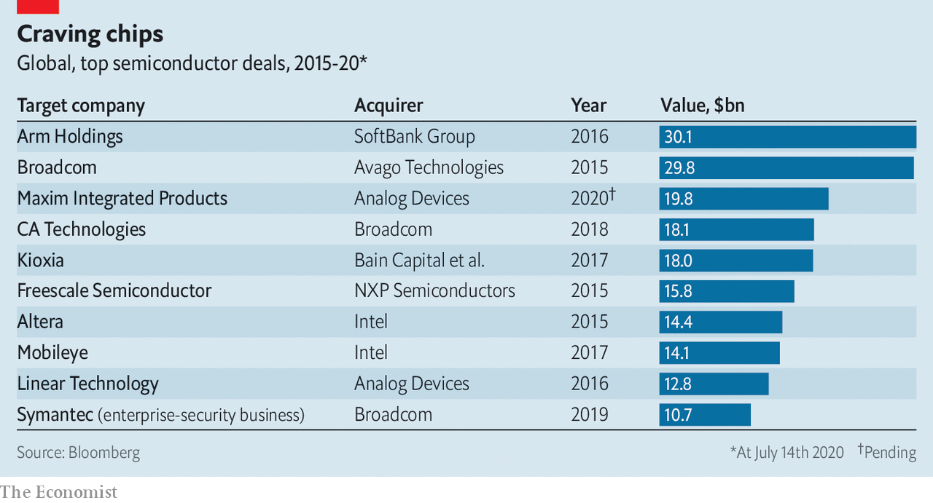

SOFTBANK IS reportedly mulling the sale or flotation of Arm, a chip designer it bought for $30bn in 2016. Luckily for the tech group, appetite for chips—and chipmakers—remains strong. On July 13th Analog Devices bid $20bn for Maxim Integrated, an American rival.

This article was downloaded by calibre from <https://www.economist.com/business/2020/07/18/analog-devices-buys-maxim-integrated-for-20bn>

|  |  |  |  |
| --- | --- | --- | --- |
| Previous | Articles | Sections | Next |

|  |  |  |  |
| --- | --- | --- | --- |
| Previous | Articles | Sections | Next |

#### The other virus threat

# Japan Inc’s IT needs a security patch

Japanese firms are more vulnerable to cyber-attacks than Western peers

Jul 18th 2020 | TOKYO

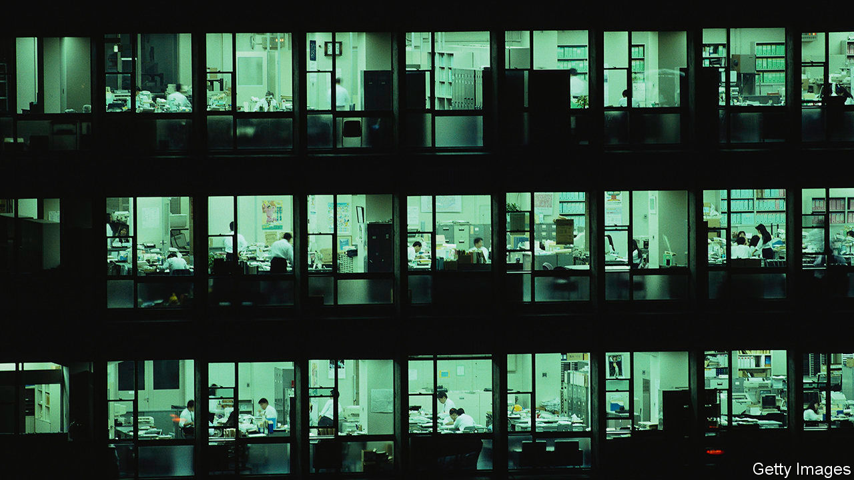

JAPAN HAS a reputation for technophilia. Robots have even been enlisted to cheer players at professional baseball games while covid-19 keeps fans away from stadiums. Yet when it comes to more humdrum information technology (IT), the country lags behind other advanced economies—nowhere more so than in cyber-security. Nearly 14m people were still using Windows 7 when Microsoft stopped providing security patches in January, including 7.5m at work. This, the American software giant warned, could make Japan “susceptible to cyber-attacks”.

In January Mitsubishi Electric and NEC, two electronics giants, admitted to data breaches. Last month a virus infiltrated Honda’s internal servers and disrupted the carmaker’s factories in several countries. With more employees teleworking on unsecured devices and networks during the pandemic, cyber-security experts have noticed a spike in cyber-attacks since March.

Businesses everywhere contend with cyber-criminals. On July 15th scammers hacked the Twitter accounts of public figures including Joe Biden and Elon Musk. Many big Japanese firms, including Mitsubishi, NEC and Honda, are bolstering their defences. But many small and medium-sized ones, which make up 99% of Japanese companies, have little or no security systems in place. Hackers can use such weak links in the supply chain to infiltrate larger corporate targets.

In 2017 only 55% of firms of all sizes conducted cyber-security risk assessments, compared with 81% in America and 66% in Europe, according to a government agency tasked with promoting IT. Another study last year revealed that whereas nearly 90% of American and Singaporean firms appoint a chief information-security officer, barely half of Japanese ones do.

An executive of a big shipping company acknowledges the need for better cyber-protection but grumbles that “it is a cost”. That echoes the sentiment of 64% of companies, big and small, surveyed in 2017 that viewed cyber-security as an expense, not an investment. Japanese firms spend 2.4% of their revenues on IT, a third less than in America. A smaller share of the lower spending goes to cyber-defences: whereas 85% of American firms devote at least a tenth of their IT budgets to security, in Japan 62% spend less than a tenth. And, as with Windows 7, a portion of that goes on preserving outdated technology.

“Executives must stop thinking of network security as an IT problem and start seeing it as a business challenge,” says Kajiura Toshinori of the Japan Cyber-security Innovation Committee, a think-tank, who advises Keidanren, Japan’s main business lobby. That is easier said than done. Nine in ten firms say they have trouble recruiting cyber-security personnel—another sharp contrast with America, where fewer than one in five report such problems. Japan’s shrinking labour force doesn’t help, especially outside big cities. Even in Tokyo many IT analysts lament low pay and a lack of career paths. Plenty leave the profession entirely. Unlike baseball fans, there are no robots to make up the shortfall.■

This article was downloaded by calibre from <https://www.economist.com/business/2020/07/18/japan-incs-it-needs-a-security-patch>

|  |  |  |  |
| --- | --- | --- | --- |
| Previous | Articles | Sections | Next |

|  |  |  |  |
| --- | --- | --- | --- |
| Previous | Articles | Sections | Next |

#### Bartleby

# A question of judgment

A managerial quality that is hard to define but important to possess

Jul 18th 2020 |

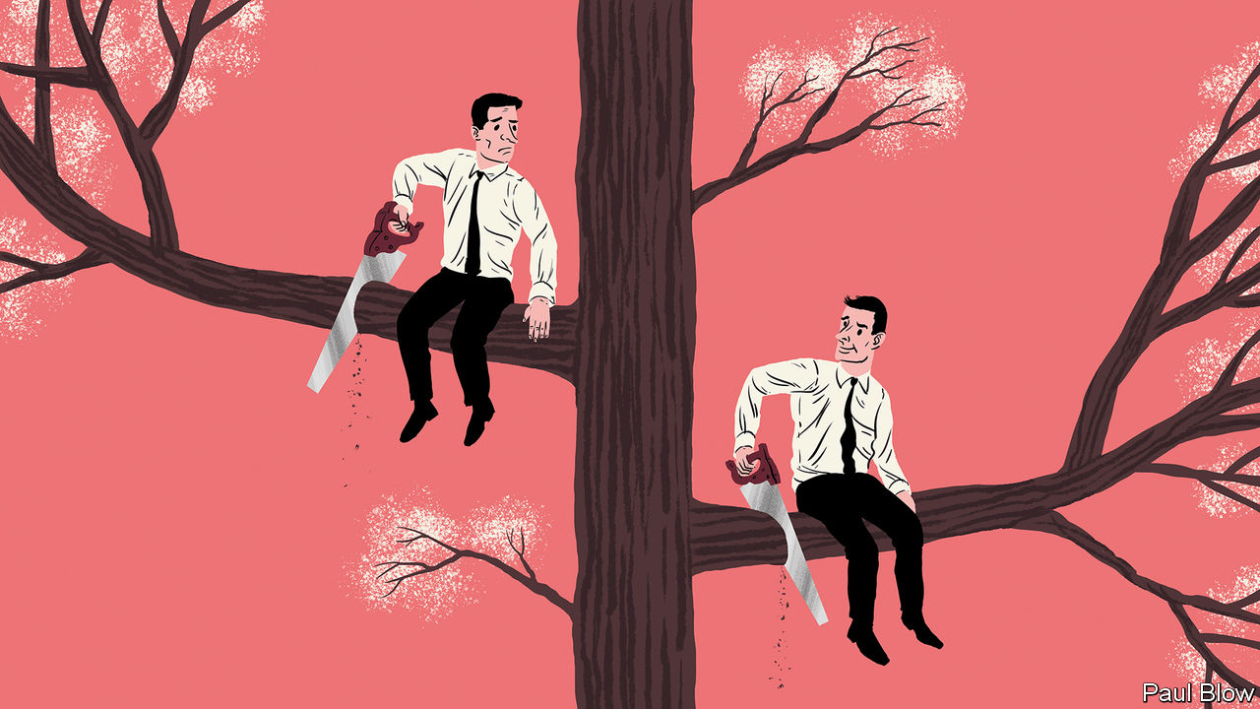

THE PANDEMIC has required many people to make difficult judgments. Politicians have had to decide which restrictions to impose on citizens’ behaviour and individuals were forced to assess how much personal risk to take. Managers, faced with tough calls like which parts of their operations to close, have not been spared.

Good judgment is a quality everyone would like to have. But it is remarkably difficult to define precisely, and many people are not sure whether they personally possess it. Sir Andrew Likierman of the London Business School has spent a long time talking to leaders in a wide range of fields, from business and the army to the law and medicine, in an effort to create a framework for understanding judgment.

First he had to define the word. He suggests that judgment is “the combination of personal qualities with relevant knowledge and experience to form opinions and take decisions”. And he argues that, thus defined, judgment involves a process—taking in information, deciding whom and what to trust, summarising one’s personal knowledge, checking any prior beliefs or feelings, summarising the available choices and then making the decision. At each stage, decision-makers must ask themselves questions, such as whether they have the relevant experience and expertise to make their choice, and whether the option they favour is practical.

Expertise can be useful in making judgments. But it is not the same thing. “Academics have expertise,” Sir Andrew observes. “They don’t necessarily have judgment.” People with judgment know when they are out of their depth in making a decision and typically then seek the advice of someone who has the right background and knowledge.

It is, of course, possible to follow all these steps and still make the wrong choice. But Sir Andrew argues that a sensible process improves the chance of getting it right. The temptation is to look at people’s track records when assessing when they have good judgment, but luck may have played a huge part. “While good judgment is important to success,” Sir Andrew cautions, “success is not a signal that there has been good judgment.”

The degree of judgment required tends to increase as people take on more responsibility. Those with routine tasks generally have limited scope for judgment. Line supervisors have some discretion. For a chief executive, the proportion of decisions involving judgment is high. Deciding not to take action is also a judgment with potentially serious consequences (for example, “I won’t get vaccinated” or “I won’t pay my bills”). The world is full of people whose lack of judgment brought their careers or personal life crashing down. Many made the common mistake of assuming everything was fine.

Some people think that good judgment is innate. Sir Andrew accepts that some individuals are born with the ability to listen, be self-aware and better understand other people: all qualities that make good judgment easier. People with good judgment tend to have a breadth of experiences and relationships that enables them to recognise parallels or analogies that others miss. The ability to be detached, both intellectually and emotionally, is also a vital component.

Others may have the wrong sort of characteristics; a tendency to ignore others, stick to rules irrespective of context, rush into action without reflection and struggle to make up their minds. Many leaders make bad judgments because they unconsciously filter the information they receive or are not sufficiently critical of what they hear or read. The danger is that people ignore insights that they don’t want to hear, a tendency that can increase with age.

As artificial intelligence gets used for more and more routine tasks in the service sector, exercising judgment may be one area where humans retain an edge over machines. This is far from certain, however. What people perceive as good judgment may stem from the ability to spot certain cues in the environment. This ability may be unconscious, just as a dog can catch a Frisbee in mid-air without knowing how to calculate wind speed and air resistance.

With enough practice, machines may be able to recognise these implicit cues and thus display the equivalent of good judgment. But then, perhaps humans can be taught, too. In the long run one of the trickiest aspects of human judgment may be knowing precisely when to let machines take decisions and when to leave it to people.

This article was downloaded by calibre from <https://www.economist.com/business/2020/07/18/a-question-of-judgment>

|  |  |  |  |
| --- | --- | --- | --- |
| Previous | Articles | Sections | Next |

|  |  |  |  |
| --- | --- | --- | --- |
| Previous | Articles | Sections | Next |

#### Schumpeter

# Why companies struggle with recalcitrant IT

As software eats the world, more firms are being nibbled at by their computer systems

Jul 18th 2020 |

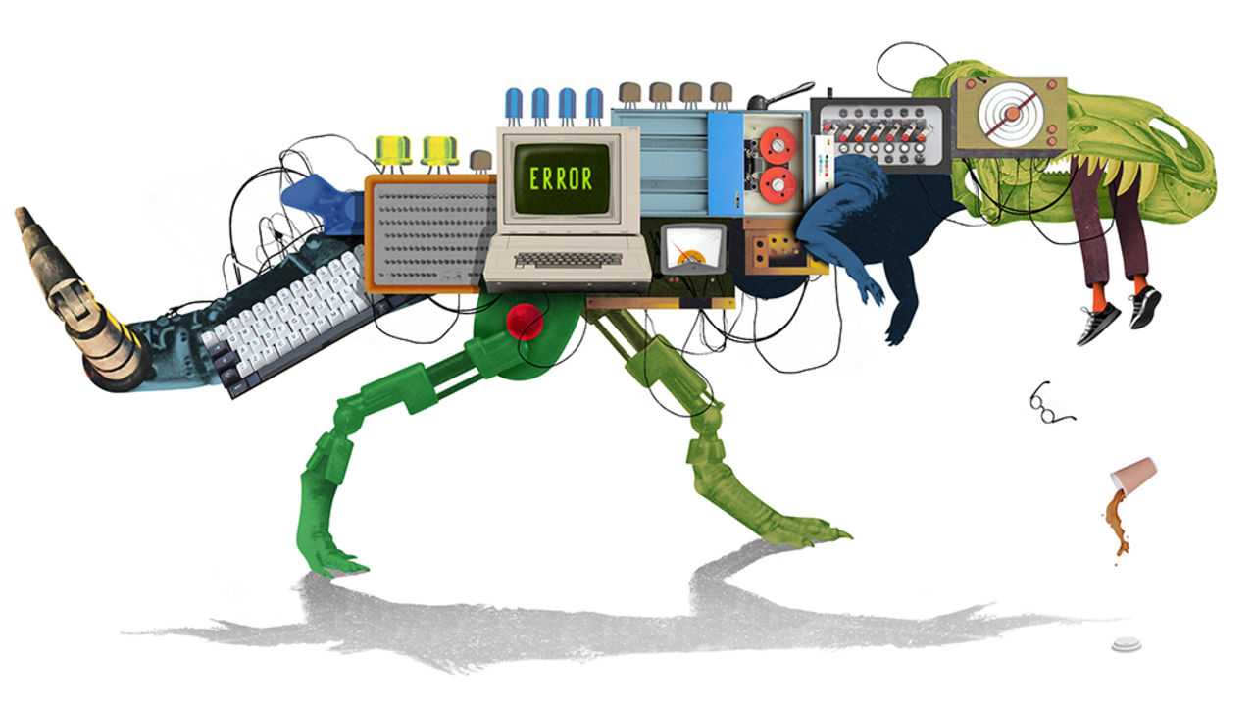

IT IS SUPPOSED to be the “Tesla killer”. Volkswagen’s new ID.3 is the firm’s first mass-produced all-electric car—and the first step in the German carmaker’s attempts to reinvent itself for an electrified world. That makes it perhaps the most important model since the original Golf, launched in 1976. The ID.3 is also late. Mechanically, the car is hunky-dory. But some software widgets that are a big selling point these days—rumoured to include smartphone connectivity and augmented-reality parking assistance—may be missing at first, only to be added later. Originally set for this summer, the launch has been pushed back until at least September.

VW is not the only big company struggling to make its computers work. Last year British banks were hauled over the coals by regulators for online outages and botched IT upgrades that left millions of customers unable to make or receive payments. Some problems are much more serious. Boeing’s 737 MAX aircraft were grounded in 2019 after two fatal crashes caused partly by a software flaw. Investigators have since found lesser bugs. Airlines are, for instance, now advised to turn the plane off and on again every 51 days, to stop its computers displaying false data in mid-flight. A similar problem found in 2017 in some aeroplanes made by Airbus, Boeing’s European rival, prompted the European Union Aviation Safety Agency to require that such aircraft be rebooted at least every 149 hours.

Blame for companies’ IT woes often ends up in the boardroom. Sometimes that is fair; Dennis Muilenberg was rightly forced to resign as Boeing’s CEO after the tragic 737 max disasters. But not always. For software is hard—and hard to keep up with. And the employees expected to produce it are often the products of a discipline that is in many ways oddly premodern. When software is “eating the world”—Silicon Valley speak for a situation where most firms are to a greater or lesser extent software companies—that matters.

Start with the computer code itself. Programming requires a mix of hyper-literalness and creativity. Tiny errors, like a misplaced punctuation mark, can completely change how a system behaves. An industry rule of thumb is that, depending on how carefully they work, programmers make between 0.5 and 50 errors in every 1,000 lines of code they write. Because cars and aircraft contain tens of millions of lines, the chances of an error-free system are in effect zero. Even when bugs do not lead to catastrophe, they put a constant drag on a firm’s productivity. A survey commissioned by Stripe, a digital-payments processor, suggested the average developer spends 21 hours a week fixing old or bad code.

The inherent difficulty of programming is made worse by the shortcomings of software engineering as a profession. These are laid out in a book, “The Problem With Software: Why Smart Engineers Write Bad Code”. The author, Adam Barr, spent 20 years as a developer for Microsoft, a software giant. Many coders, he notes, are at least partly self-taught. That leads to bad habits, which software-engineering courses fail to correct. There is too little communication between academia and industry, and no real agreement on what to teach or what habits to instil. The result, argues Mr Barr, is a field in which folklore and fads too often take the place of professional standards.

To illustrate the field’s shaky foundations, Mr Barr points to the practice, popular with technology firms like Google or Apple, of giving job candidates a programming problem to solve on a whiteboard. Few other fields behave that way, because they assume that, by dint of having graduated, applicants have already achieved a basic level of competence. Doctors do not expect anatomy quizzes before being hired. Mechanical engineers are not required to jot down Newton’s laws of motion to prove their bona fides.

All those problems are compounded by software engineering’s breathless rate of change. Even when a system works, it rapidly becomes obsolete. The woes of British banks are largely the result of trying to maintain such “legacy” systems, written by long-departed programmers (often outsourced) in half-forgotten computer languages to satisfy criteria no one can quite remember. Coders under pressure to add nifty new features often cut corners, storing up problems for the (ever less distant) future.

The result, says one expert with decades of experience, is that shiny new IT systems can rapidly devolve into rickety, half-understood contraptions held together with gaffer tape and a prayer. Eventually the costs become too great to ignore, and companies must upgrade their systems. But that is the moment of maximum danger, for the new software must do everything that the half-understood old one does, and more. It is, to repeat a common but apposite analogy, like rebuilding an aircraft in flight.

## A bug’s life

VW is doing its best to iron out the kinks with the ID.3’s snazzy features. The firm wants to bring most software development back in-house, and has spent €7bn ($8bn) on a shiny new “digital unit”. That is probably a good idea. However, as Mr Barr argues, the structural problems with writing software mean that spending money on it does not, by itself, guarantee success. One great advantage possessed by startups like Tesla or Monzo, a newish online bank in Britain, is that their programmers are handed a blank sheet of paper. With no legacy systems to maintain, and fewer old bugs to root out, their software is more robust and developers can spend more time on features that customers want.

If that is cold comfort for older companies that have no easy way of starting afresh, computing greybeards offer reassurance—after a fashion. The startups’ advantages will, they predict, prove temporary. Bugs will creep in. Bodge jobs will go unfixed. Developers will leave, taking knowledge with them. Today’s feisty usurpers will become tomorrow’s clumsy incumbents, held back by their antiquated, unreliable IT—and ripe for disruption in turn. ■

This article was downloaded by calibre from <https://www.economist.com/business/2020/07/18/why-companies-struggle-with-recalcitrant-it>

|  |  |  |  |
| --- | --- | --- | --- |
| Previous | Articles | Sections | Next |

|  |  |  |
| --- | --- | --- |
| Business | Sections | Science & ... |

Finance & economics

Wall Street: A banking drama, in three acts

.

China’s economy: Low and mighty

.

The Big Mac index: Patty power

.

Corporate taxes: Digital divide

.

Insurance: A premium on change

.

Buttonwood: Lotus esprit

.

Free exchange: Housing was the business cycle

.

|  |  |  |
| --- | --- | --- |
| Business | Sections | Science & ... |

|  |  |  |  |
| --- | --- | --- | --- |
|  | Articles | Sections | Next |

#### A banking drama, in three acts

# What Wall Street’s results tell you about America’s economy

The panic has been calmed, and the economic pain deferred. But uncertainty still abounds

Jul 18th 2020 | NEW YORK

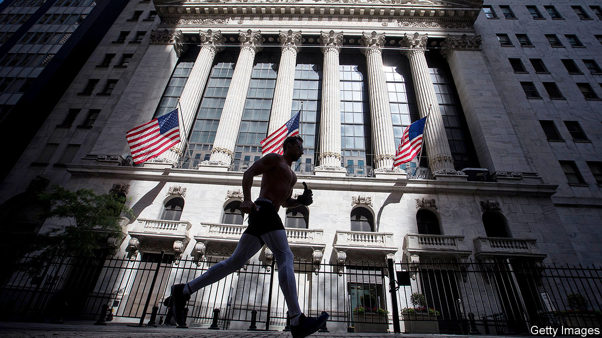

THE FIRST act of the impact of the coronavirus on America’s financial markets and banking system was characterised by panic. As firms scrambled to amass the cash they needed to survive shutdowns, they rushed to sell their holdings of securities and draw down their revolving credit lines. Traders attempting to make markets from their sofas were overwhelmed with record volumes. Banks’ loan books and deposit accounts swelled. Risk managers frantically tried to compute potential loan losses. All this was reflected in the big banks’ first-quarter earnings, reported in the middle of April. Trading profits were sky high, lifting investment-banking revenues. But bottom lines suffered as commercial banks set aside reserves to prepare for likely credit losses (see chart).

The second act was less turbulent, as government support quelled the panic. Legislation passed in March bolstered unemployment benefits, set up a lending scheme for small businesses and provided a backstop for the Federal Reserve to buy up corporate debt. This seems to have insulated firms and households from much of the damage, and has restored order to financial markets. But unease about the future remains. These dynamics were evident in the second-quarter earnings put out by Citigroup, Goldman Sachs, JPMorgan Chase and Wells Fargo, four of America’s largest banks, on July 14th and 15th. (Bank of America and Morgan Stanley, America’s other big lenders, were due to report on July 16th, as The Economist went to press.)

As bond markets began to function again, firms rushed to sell securities. In America companies have issued more than $2trn in equity and debt, equivalent to 5% of the entire value of outstanding corporate bonds and public equity, and an increase of almost 50% on the year. Accordingly, primary-issuance revenues at the four big banks rose by 56%, year over year, to $7.8bn. Traders stayed busy: trading revenues rose by 70% on the year to an all-time high of $26.9bn. That reflected stronger client activity, as well as wider trading spreads, said Stephen Scherr, the chief financial officer of Goldman Sachs.

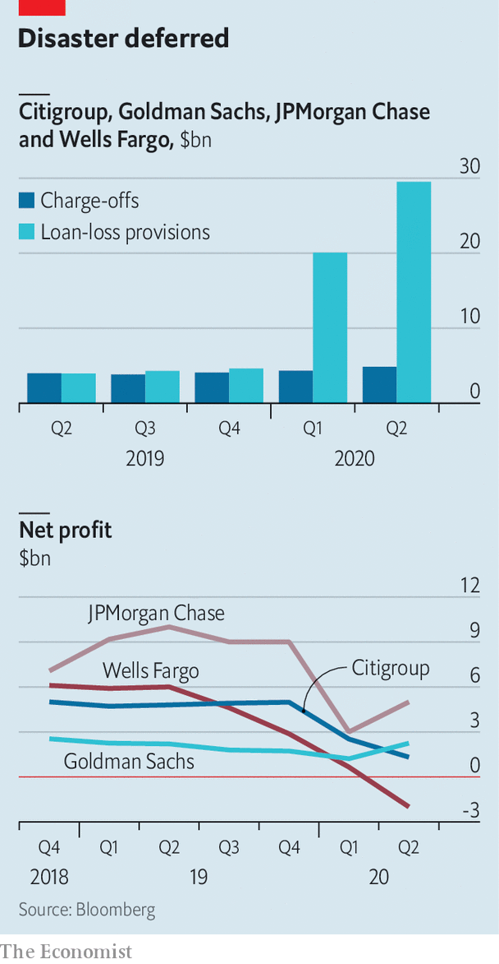

More company bosses are now telling investors that they hold enough cash to cover two or three years’ worth of outgoings. Newly recapitalised companies are paying back revolving loans. Of the $55bn drawn down from JPMorgan in March $39bn has since been repaid.

Commercial banks are bracing for the impact of the crisis, but it has yet to come. Although 17.8m Americans were unemployed at the end of June, few have defaulted so far, thanks to stimulus cheques and meaty unemployment benefits, and banks’ willingness to defer mortgage and credit-card payments. The four banks’ charge-offs—ie, their write-offs for loans in default—rose by just 22% to $4.9bn in the second quarter, up from $3.9bn during the same period in 2019. By contrast, $29.5bn was set aside for provisions for expected losses, compared with just $3.9bn in the same quarter in 2019. This stockpile comes on top of the $20bn the lenders set aside in the first quarter. The way to think about these provisions, said Jennifer Piepszak, JPMorgan’s chief financial officer, is that “it is all in the outlook, because we are not seeing it today”.

Will the third act of the crisis see banks making big losses? A simple way of thinking about what will happen next is to split the institutions into three parts: the investment bank, which has performed exceptionally well so far; loan provisions, which have been exceptionally costly; and “everything else”, which includes wealth and asset management. The residual bit of large banks’ business has, overall, been remarkably steady. If provisions for loan losses and revenues from investment banking had both been flat on the year, net income would have fallen by an average of just 1% across Citi, JPMorgan and Wells.

The fate of banks’ profitability seems likely therefore to depend on the fate of the investment-banking business, and of provisions for loan losses. Investment-banking revenues seem set to slow, if they have not already done so. Trading volumes have eased in June and early July from their highs in March and April. Jamie Dimon, JPMorgan’s chief executive, reckoned that trading revenues would “normalise” or even drop below normal later in the year.

Whether provisions prove sufficient or not is far from clear. They are based on a number of assumptions that are layered on top of each other. One is about the path the virus takes. Another is how that evolution affects unemployment and economic growth. Yet another concerns the size of any further fiscal stimulus, and how consumers and firms respond to it.

Banks’ base case seems to be broadly in line with that of the Federal Reserve. The economy is expected to be smaller by the end of 2021 than it was at the end of 2019. The unemployment rate is expected to remain in double digits until the end of this year, before falling gradually. But bank bosses emphasised the fog of uncertainty shrouding it all. “We are in a completely unpredictable environment,” said Michael Corbat, Citi’s chief executive. “In a normal recession unemployment goes up, delinquencies go up, charge-offs go up, home prices go down, incomes go down, savings go down,” said Mr Dimon. This time the usual relationships do not hold. Even as unemployment has jumped, for instance, incomes have risen.

If investment-banking revenues subside and banks keep having to add to provisions, losses may be on the cards in the third quarter. Wells Fargo was the only bank to make a loss in the second. That reflects its relatively small investment bank, as well as its special situation—it still operates under an asset cap imposed by regulators that has constrained its growth, even as other lenders have ballooned. But another, rosier scenario is possible: that government stimulus continues to keep delinquencies down, and banks end up with mountains of spare capital. That would be welcome news for shareholders. Even as the s&P 500 benchmark index has recovered, bank shares are a third lower than at the start of the year. But the happy scenario also relies on the third act being the final one. With covid-19 cases rising, that is looking increasingly unlikely. ■

This article was downloaded by calibre from <https://www.economist.com/finance-and-economics/2020/07/18/what-wall-streets-results-tell-you-about-americas-economy>

|  |  |  |  |
| --- | --- | --- | --- |
|  | Articles | Sections | Next |

|  |  |  |  |
| --- | --- | --- | --- |
| Previous | Articles | Sections | Next |

#### Low and mighty

# China’s world-beating growth rate of...3.2%

Its economic rebound is impressive but uneven

Jul 18th 2020 | SHANGHAI

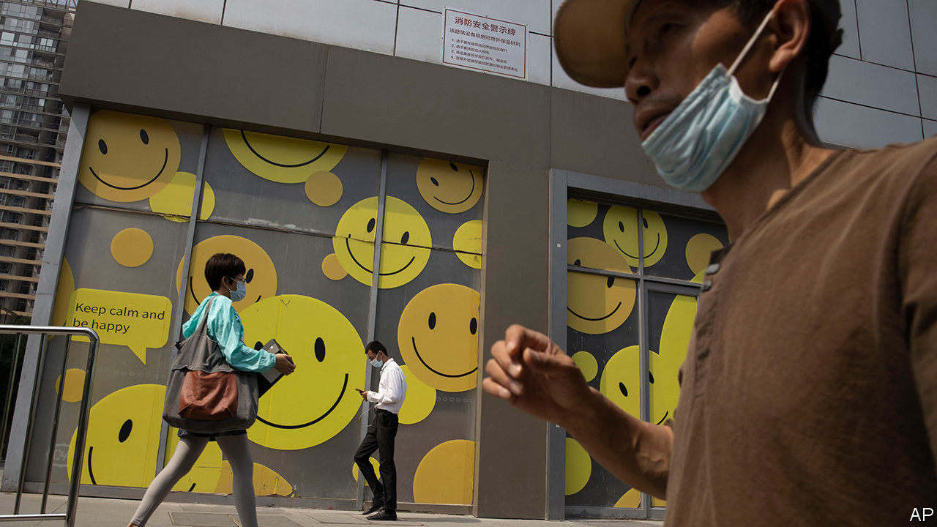

AT THE START of the year no one would have predicted that China would crow about such slow growth by its lofty standards. Yet on July 16th it proudly reported that GDP grew by 3.2% in the second quarter compared with a year ago, rebounding from its coronavirus lockdown (see chart 1). This makes it, by far, the best-performing big economy.

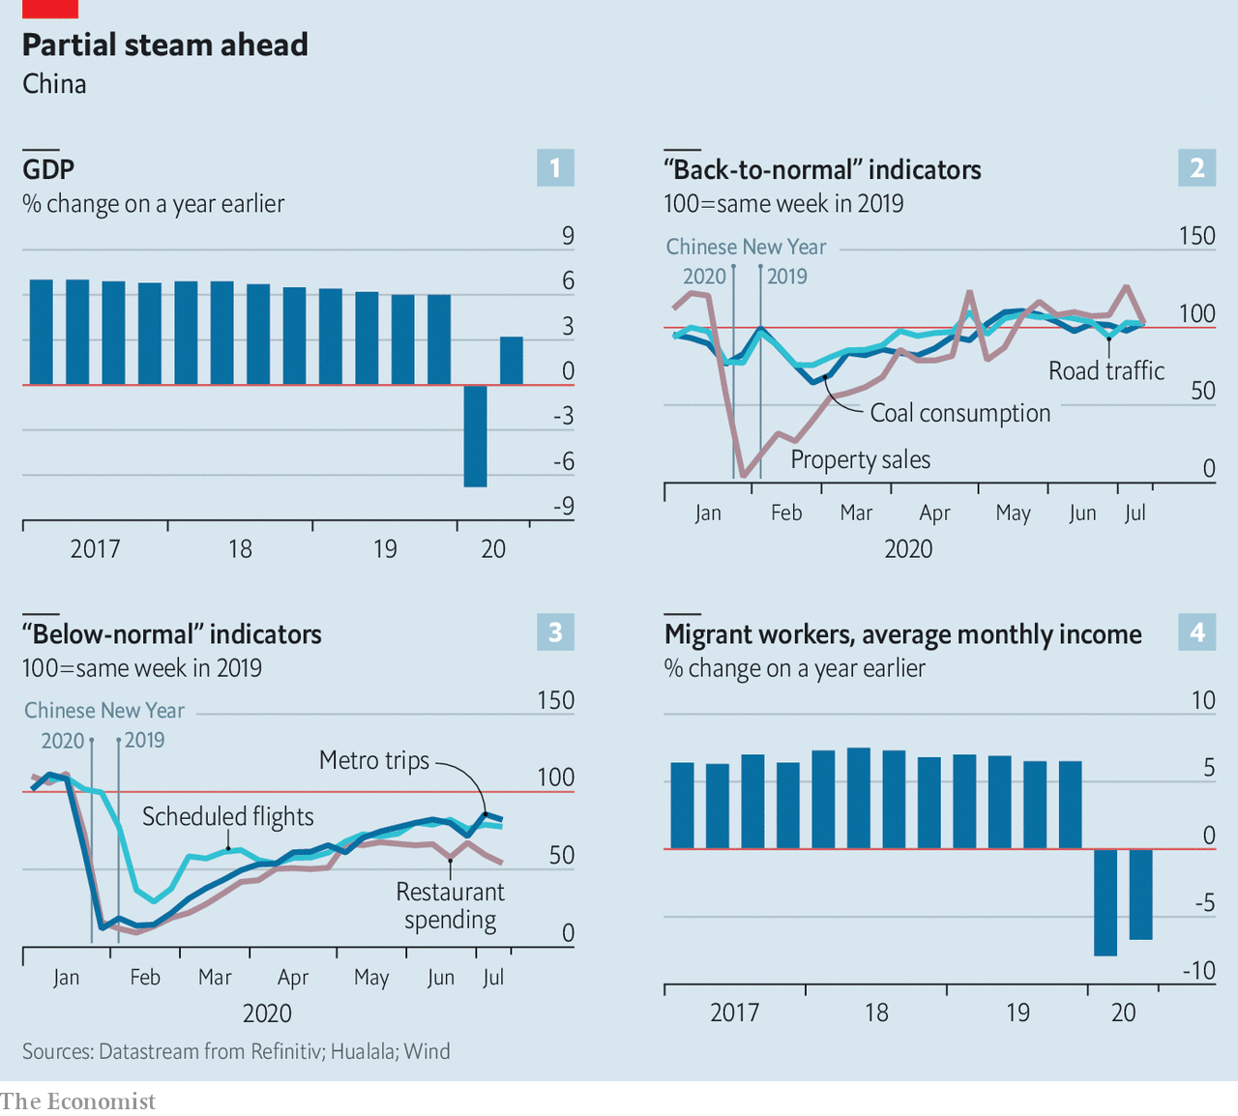

Sceptics question the data. But alternative indicators confirm that the recovery is real, albeit highly uneven. During February the government prioritised the reopening of factories, as shown by coal consumption (see chart 2). Traffic congestion returned as people went back to work, partly because, wary of public transport, more commuted by car. Banks ramped up their lending to keep businesses afloat. Some credit flowed into the property market.

Yet flights are still down as few people go on trips. They also avoid crowds, taking the subway less often (see chart 3). Spending on restaurants, including takeaways, is weak, which in turn points to the soft labour market (see chart 4). That is all to say: China’s rebound from the coronavirus crisis is impressive, but it is not yet back to normal.

This article was downloaded by calibre from <https://www.economist.com/finance-and-economics/2020/07/18/chinas-world-beating-growth-rate-of32>

|  |  |  |  |
| --- | --- | --- | --- |
| Previous | Articles | Sections | Next |

|  |  |  |  |
| --- | --- | --- | --- |
| Previous | Articles | Sections | Next |

#### Patty power

# How big is China’s economy? Let the Big Mac decide

Our index reckons China’s GDP is bigger than the World Bank thinks

Jul 18th 2020 |

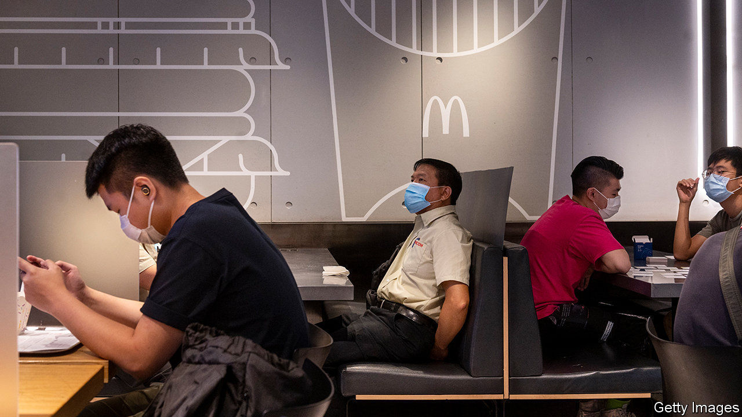

AMERICA’S ECONOMY did not exceed China’s in size until the 1880s, according to the Maddison Project at the University of Groningen. The two now rival each other again. Because China’s workers are 4.7 times as numerous as America’s, they need be only a fraction as productive to surpass America’s output. No fewer than 53 countries would already have a bigger GDP than America if they were as populous as China.

In 2019 China’s workers produced over 99trn yuan-worth of goods and services. America’s produced $21.4trn-worth. Since it took about 6.9 yuan to buy a dollar last year, China’s GDP was worth only $14trn when converted into dollars at market rates. That was still well short of America’s.

But 6.9 yuan stretches further in China than a dollar goes in America. One example is the McDonald’s Big Mac. It costs about 21.70 yuan in China and $5.71 in America, according to prices collected by The Economist. By that measure, it takes only 3.8 yuan to buy as much as a dollar. But if that is the case, then 99trn yuan can buy as much as $26trn, and China’s economy is already considerably bigger than America’s.

Motivated by this logic, The Economist has compared the price of Big Macs around the world since 1986. The result is a rough gauge of the purchasing power of currencies. It suggests that many currencies are undervalued, relative to the dollar, on the foreign-exchange markets (see chart). The Swiss franc and the Lebanese pound are overvalued. Lebanon’s currency was undervalued until inflation took off late last year, raising local prices even as the pound remained pegged to the dollar. The Big Mac alone jumped 38% in price.

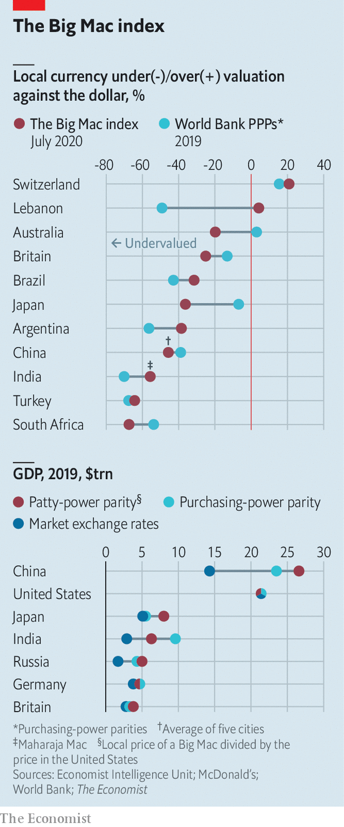

Every few years the World Bank embarks on a vastly more systematic effort to gauge purchasing power by comparing thousands of prices across the world. The results can be startling. Its survey of prices in 2011, released six years ago, showed that China was cheaper than previously thought and its economy was therefore much larger. Based on these estimates, the IMF calculated that its GDP overtook America’s in 2014 and was 27% bigger in 2019.

Many observers, however, greeted these estimates with scepticism. In 2010 an informal survey by a reporter at Caixin, a financial magazine, noted that a number of items were dearer in Hangzhou than in its sister city Boston. (It compared apples to apples, and found that the Golden Delicious variety was 37% pricier in the Chinese city.)

The sceptics won some vindication in May when the World Bank released its latest price-comparison exercise. It discovered that things were about 17% more expensive in China, relative to America, than previously thought. At a stroke, China’s GDP fell by over $3.2trn. The estimates suggest China did not overtake America’s economy until 2016.

But are these new estimates any more robust than earlier efforts? Comparing prices across the world is fraught with difficulties. An item may be a staple in one place and a delicacy in another. The World Bank must also decide how much weight to give each item. That depends on shopping habits, which differ—partly because prices differ. It is easy to go around in circles.

So it might help to check the World Bank’s results against a cruder yardstick—like the price of a Big Mac. Our index suggests that the bank now, if anything, underestimates the buying power of China’s currency, and therefore its economic size. McDonald’s was once a symbol of America’s economic might. Now the Big Mac shows how its might is being surpassed. ■

This article was downloaded by calibre from <https://www.economist.com/finance-and-economics/2020/07/18/how-big-is-chinas-economy-let-the-big-mac-decide>

|  |  |  |  |
| --- | --- | --- | --- |
| Previous | Articles | Sections | Next |

|  |  |  |  |
| --- | --- | --- | --- |
| Previous | Articles | Sections | Next |

#### Digital divide

# The row over taxing tech firms heats up

America plans tariffs in retaliation for France’s digital-services tax

Jul 18th 2020 | WASHINGTON, DC



WHEN G20 FINANCE ministers meet on July 18th and 19th, avoiding a new trade war will be high on the agenda. Cash-strapped governments around the world are planning to whack taxes on online services. But America regards these as a grab for its companies’ profits, and is considering retaliation against ten digital-tax proposals. On July 10th it said it would respond to France’s tax by hitting French handbags, lipstick and soap with tariffs of 25%. Unless a truce is struck, the tariffs will go into effect in January.

The root cause of the dispute is a flaw in the international tax system. In order to avoid taxing businesses twice, governments typically apply the corporate tax to firms that are legally domiciled on their shores or have a local physical base, and link the amount due to the location of their assets and production. But now many companies provide online services and can shift intellectual property to low-tax regimes with the click of a button. A system intended to stop profits being taxed too much allows them to be taxed too little.

In 2017 40% of profits made by multinational firms outside their home country were shifted to tax havens, reckon Thomas Torslov, now at the Danish Ministry of Taxation, and Ludvig Wier and Gabriel Zucman of the University of California, Berkeley. That meant more than $200bn in forgone tax revenue, equivalent to 10% of global corporate-tax receipts. This is a relatively small amount: by comparison, governments worldwide have unleashed stimulus of $5.4trn in response to covid-19. But it is symbolically important and rightly irks taxpayers, who must fill the hole.

For several years now, the OECD, a club of rich countries, has convened governments in the hope of plugging the tax leaks. The idea is that the G20 meeting lays the groundwork so that the OECD’s summit, planned for October, yields results.

The talks cover two proposals, or “pillars”, in OECD-speak. The first is meant to direct more of the global-tax take towards places where the customers of digital firms live. Corporate-tax liability will depend not on whether companies are physically present in a country, but on whether they have a “sustained and significant involvement” there. Pillar two establishes a global minimum tax. The OECD reckons that the two proposals could together raise corporate-tax revenue by up to 4%.

Pillar two has the greater chance of being agreed—and would raise more revenue. The idea of a global minimum is to blunt companies’ incentives to shift profits to low-tax jurisdictions. There is still some haggling to be done. But some sort of agreement should be possible, if only because governments can go it alone. The Americans, for example, enacted a version in 2017, with a tax on global intangible low-taxed income (GILTI). Havens can offer all the perks they want, but American companies still face a rate of at least 10.5% on GILTI associated with their foreign affiliates.

That might explain why Steven Mnuchin, America’s treasury secretary, was reasonably positive about the second pillar last month. But he wants to put talks on the first on hold. In December he proposed that the new system should be optional for American firms. The suggestion, which would in effect neuter any new rules, was badly received by other countries. But as it stands, the OECD’s plan is unbalanced: it asks America to hand over the right to tax its companies to other countries, without getting much in return.

Without an agreement on pillar one that divvies up tax rights, a proliferation of digital-tax schemes seems likely. (The European Union’s resolve to implement one may have been stiffened by its loss on July 15th of a big tax case against Apple.) These taxes are a much cruder fix than a pillar-one solution. Companies could face a stack of competing tax bills. The levies also mostly apply to revenues rather than profits, and often try to exempt domestic champions. To top it all off, they are a recipe for trade conflict. ■

This article was downloaded by calibre from <https://www.economist.com/finance-and-economics/2020/07/18/the-row-over-taxing-tech-firms-heats-up>

|  |  |  |  |
| --- | --- | --- | --- |
| Previous | Articles | Sections | Next |

|  |  |  |  |
| --- | --- | --- | --- |
| Previous | Articles | Sections | Next |

#### A premium on change

# The threat of irrelevance spurs insurers to consider new ideas

Insurers are rethinking their approach to systemic risks

Jul 18th 2020 |

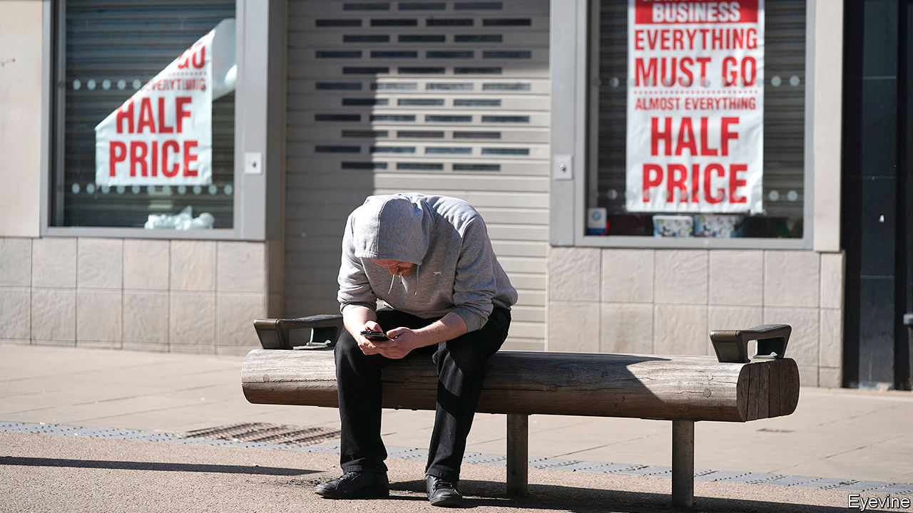

IN 2018 MARSH, an insurance broker, teamed up with Munich Re, a reinsurer, and Metabiota, a modelling firm, to launch a policy protecting businesses against losses linked to epidemics. The timing seemed right: the Ebola and Zika viruses had recently crossed entire continents. But many potential clients found the policy too niche and too dear. Plenty, having lost months of earnings to covid-induced lockdowns, will be kicking themselves.

Insurers have long been aware of the threat that pandemics pose to their businesses and have sought to minimise potential losses from them. Though they will not escape the covid-19 downturn unscathed, many may feel they have dodged a bullet. Instead the biggest risk the industry faces is that of irrelevance, as companies seeking protection from big new risks no longer see the point of insurance. The industry is scrambling to find ways to be helpful ahead of the next shock.

Make no mistake, the pandemic will hit insurers’ balance-sheets. Part of the shock is direct. Claims for aborted trips, unpaid trade invoices or cancelled events, such as music festivals or the Olympics, have picked up. But most of these have been assessed and their impact is limited. So far only $7bn in payouts has been announced.

Bigger losses will come from less direct sources. One area of worry is claims linked to litigation. Insurers themselves are party to some cases, as holders of policies covering business interruptions seek payouts for shutdowns. As of early July Cooley, a law firm, counted 677 motions against insurers related to these contracts in America. The bar for claimants to win seems high: most interruption policies require proof of physical damage. But courts could well force firms to pay up, as those in France and Germany have already done.

Insurers could also be on the hook for clients’ legal costs and payouts, adding up to tens of billions of dollars of losses. Staff might sue employers if they fall ill at work; customers could bring class actions against shops or entertainment venues. Lawyers already report a surge in cases.

Insurers’ assets have also taken a knock. At least half of the investments they hold to cover payouts and earn extra profit comprise bond holdings. Falling credit ratings have caused some asset values to decline, and raised the amount of capital insurers need to hold. It is very rare for one event to hit both sides of the balance-sheet, and so many lines and countries, points out John Neal, the boss of Lloyd’s, the world’s largest insurance marketplace. All told, property and casualty (P&C) insurers could suffer $203bn in losses worldwide in 2020.

Yet the industry, which writes P&C premiums worth $1.6trn globally, is escaping lightly compared with other sectors. It helped that insurers knew well the risk that pandemics posed to their business models, says George Netherton of Oliver Wyman, a consultancy. Typhoons and earthquakes do not happen everywhere at once; pandemics, by definition, do. Spooked by near-misses, like the SARS outbreak in 2003, insurers modelled the spread of viruses and excluded pandemics from most standard P&C contracts. Other lines have even benefited: people who stay home are less likely to crash cars or be burgled, resulting in record profits in personal insurance.

Solvency ratios, or insurers’ capital relative to their written premiums, remain healthy. Those of insurers have fallen from 200% at the start of the year to 150-190% globally, still well above the regulatory minimum of 100%. Despite falling in the first quarter, reinsurers’ capital buffers remain over 200%. The industry has also raised tens of billions in public and private equity and $70bn in debt since March, according to S&P Global, a rating agency.

Yet the mood is hardly upbeat. Insurers face a customer backlash on an unprecedented scale. Clients and brokers are unhappy that business-interruption policies have been of little use in tough times. More generally, customers feel insurers do a poor job of insulating them against intangible risks, like those of supply-chain disruptions and cyber attacks. John Doyle, who runs Marsh, says clients want to protect themselves against rare but damaging events. But many are losing faith that insurers can help them—or at least asking why they are not bearing more of the cost.

It would be ridiculous to expect insurers to underwrite all of the losses resulting from big systemic shocks. The sums injected by governments to support economies during the pandemic, for instance, exceed $5trn, more than the entire market value of listed insurers. But covid-19 has led insurers to consider public-private partnerships to cover such risks.

Various schemes are being floated. One idea, being discussed by American lawmakers, is for the government to cover some losses. Another, backed by Lloyd’s, is for insurers to pay into a kitty, and for states to bear losses when the pot is exhausted. As the kitty grows, the threshold for public action rises. An additional proposal would encourage companies to sign insurance contracts lasting 10-15 years, instead of the usual one year, with states guaranteeing premium payments if businesses go bust. This would help insurers amass firepower to cover big events over the period, knowing that customers will not leave in between. The solutions could help the industry insure against other systemic risks, such as climate change.

Plenty of thorny questions remain—whom to cover, and how much; how to encourage firms to buy insurance, rather than to expect bail-outs. But if they can answer these, insurers could be a bigger part of the solution to the world’s next crisis. ■

This article was downloaded by calibre from <https://www.economist.com/finance-and-economics/2020/07/18/the-threat-of-irrelevance-spurs-insurers-to-consider-new-ideas>

|  |  |  |  |
| --- | --- | --- | --- |
| Previous | Articles | Sections | Next |

|  |  |  |  |
| --- | --- | --- | --- |
| Previous | Articles | Sections | Next |

#### Buttonwood

# Why globalists and frontier-market investors love Vietnam

It is cheap, and a refuge from the Sino-American trade-and-technology war

Jul 18th 2020 |

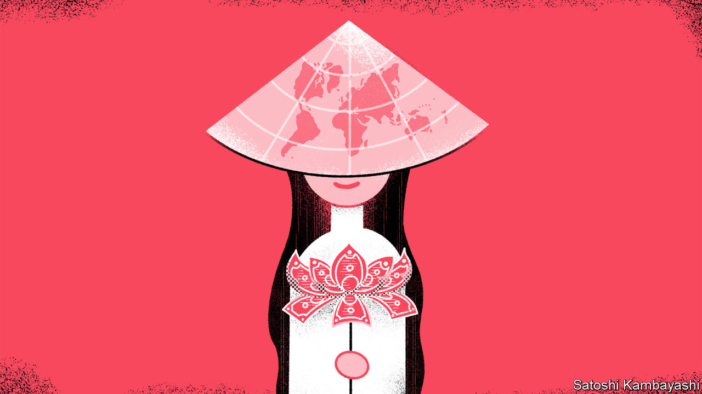

AT THE START of February, as the spread of a deadly virus in China became more threatening, Vietnam closed the border. Truckers could no longer ferry components and raw materials from China to local factories. This was a problem for Samsung, a South Korean hardware giant, which manufactures most of its handsets in Vietnam. It had just unveiled two new smartphones in America. It did not want to delay production. So it began to airlift vital parts from China.

The story is telling on two counts. Vietnam was swift in containing the spread of covid-19, with a fairly intrusive track-and-isolate strategy—the kind that only a one-party state may be able to implement. Its economy suffered, but has bounced back more sharply than most. It is one of just a few dozen countries where GDP is likely to grow this year. The story also underscores Vietnam’s status as a favoured venue for foreign direct investment (FDI). It is an established place for clothesmakers to set up. More recently it has become a key link in technology supply chains.

Vietnam is not just a darling of multinational firms. It is also beloved of investors in “frontier markets”, at the farthest edge of the equity universe. Such investors have few rags-to-riches economic stories to buy into. Vietnam looks like one of the more reliable ones. Indeed it is proving to be something of an each-way bet on globalisation. A big winner from the growth of world trade in recent decades, it is now a beneficiary from the geopolitical fallout from that growth.

Not so long ago Vietnam was one of the world’s poorest countries. In 1986 it launched its doi moi (“renovation”) reforms, which allowed for a greater role for market forces and the private ownership of enterprises. The economy was opened up to foreign trade and capital. Its low wage costs were an advantage, but hardly a unique one. So Vietnam also offered generous tax breaks to foreign companies that went there.

More recently a stable economy has added to its appeal, says Luong Hoang of Viet Capital Securities in Hanoi. The central bank has kept the dong fairly steady against the dollar. Stricter limits have been imposed on bank credit. Inflation has settled in the low single digits. Vietnam has further opened up to trade. It joined the World Trade Organisation in 2007. It has since signed deals with Japan and South Korea, two of the bigger investors in Vietnam. Last month it ratified one with the EU. And the FDI keeps rolling in. There have been biggish investments from China, Hong Kong and Singapore this year. It is the go-to place for the sort of production that has become too costly in China. It is also a refuge for companies that want to limit their entanglement in the Sino-American trade-and-tech battle.

There is an irony here. Vietnam’s economic strategy looks much as China’s once did: a lot of FDI; export-led growth; a steady climb up the value chain from textiles to tech. It is also prone to some of China’s vices, including a nexus of corruption, real-estate deals and bad debts. Still, Vietnam has attributes that once made investing in emerging markets so enticing and globalisation such a persuasive creed: a fast-growing economy, rapid urbanisation, improving infrastructure and an expanding middle class. Its array of listed companies—from banks and logistics firms to retailers and steelmakers—allows investors to gain exposure to these trends.

All this sounds lovely. But there is a catch. Vietnam imposes foreign-ownership limits on many home-grown companies. This is in large part why it is classed by MSCI, an index provider, as a “frontier” market, not an “emerging” one. A foreign investor who wants a stock that has reached the limit must buy from another foreigner. These off-exchange trades can take weeks to be arranged and approved, says Andrew Brudenell of Ashmore, a fund manager. A handful of stocks attract hefty price premiums. Shares in Mobile World, an electronics-cum-grocery retailer, recently changed hands among foreigners at a 51% premium to the on-exchange price, according to Viet Capital Securities.

The trade-oriented nature of Vietnam’s model means it is at the mercy of events elsewhere. However well it has handled the pandemic, there will be nerves about rising infections in America, its biggest export market. The government has dusted off infrastructure plans and relaxed land-use rules. Last month it approved a new $9.3bn tourist resort. Foreign investors, naturally, have a piece of that. ■

This article was downloaded by calibre from <https://www.economist.com/finance-and-economics/2020/07/18/why-globalists-and-frontier-market-investors-love-vietnam>

|  |  |  |  |
| --- | --- | --- | --- |
| Previous | Articles | Sections | Next |

|  |  |  |  |
| --- | --- | --- | --- |
| Previous | Articles | Sections | Next |

#### Free exchange

# Housing was the business cycle

Residential investment is not the macroeconomic force it used to be

Jul 18th 2020 |

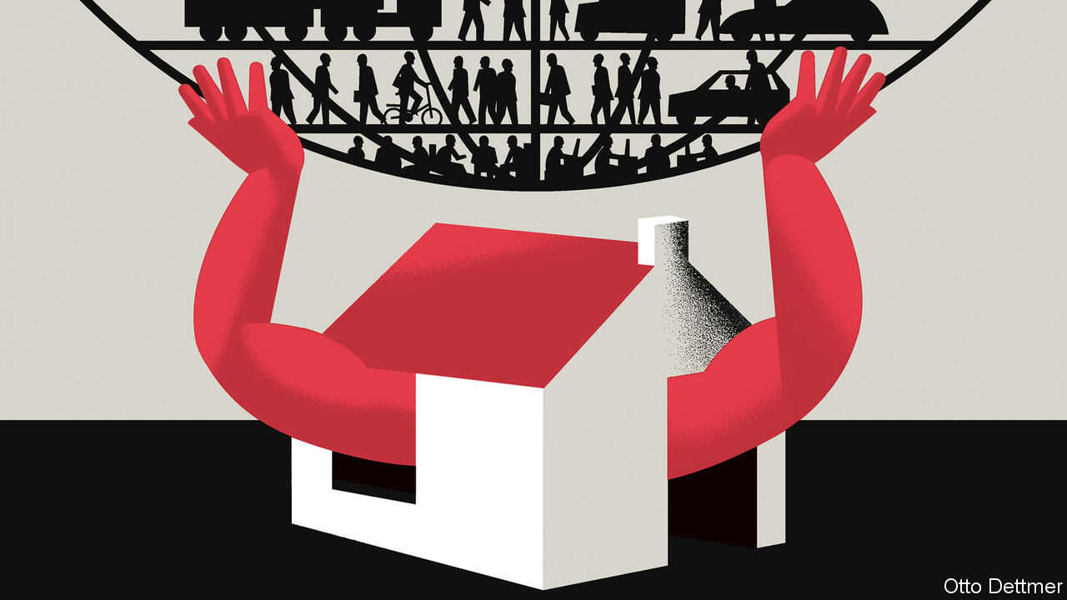

AMERICANS HAVE long understood the link between the state of the housing market and the health of the wider economy. When Paul Volcker, then the chairman of the Federal Reserve, raised interest rates to eye-watering levels in the early 1980s, furious builders sent him lumber in protest, and the unemployment rate soon rose to nearly 11%. In 2007 Edward Leamer of the University of California, Los Angeles, wrote that “housing IS the business cycle.” The Great Recession soon seemed to prove his point. The trauma of the global financial crisis has left Americans overly sensitive to wobbles in the housing sector. But in fact its role as the engine of economic fluctuations has diminished. Though the covid-19 recession will bring pain for many renters and homeowners, it may also demonstrate that housing woes are not the harbinger of doom that they once were.

Mr Leamer’s description of the importance of housing for past economic ups and downs is no exaggeration. Residential investment represents a small slice of GDP—about 4.6%, on average, over the post-war era. But it has typically varied more wildly, and consequentially, than other sectors. Between 2007 and 2009, for example, real output in America shrank by about 2.5%. Over the same period, however, residential investment tumbled by 41%. In his study of America’s post-war recessions, Mr Leamer finds that GDP starts to deviate from its trend even before a recession begins in earnest and output starts to fall. Slumping residential investment typically acts as an early-warning indicator, accounting for about a quarter of output shortfalls on the eve of a recession, on average. By contrast, the consumption of durable goods is responsible for about a fifth, and the consumption of services contributes only a tenth or so to economic weakness. The housing market has generally been both a reliable predictor of downturns and, frequently, a proximate cause. Serious housing troubles preceded nine of the 11 recessions between the end of the second world war and the start of 2020. One exception is the dotcom bust, which was preceded by only a modest housing slump. The other is the recession of 1953, which was triggered by demobilisation after the Korean war. Here housing was a completely innocent bystander.

Still, over the period housing’s economic role has gradually weakened. Residential investment (ie, spending on new housing capacity) as a share of GDP, which peaked at 6.9% in 1950, has since drifted downwards (see chart). The surge in construction in the early 2000s broke with that trend, only for the downward slide to resume thereafter. Investment in housing as a share of GDP was just 3.9% in 2017, the lowest cyclical peak since 1945. As the share of residential investment in GDP has fallen, its contribution to recession-inducing economic weakness has also declined: from 32% before the downturn in 1980, to 21% ahead of that in 1991, to only 12% by the eve of that in 2001.

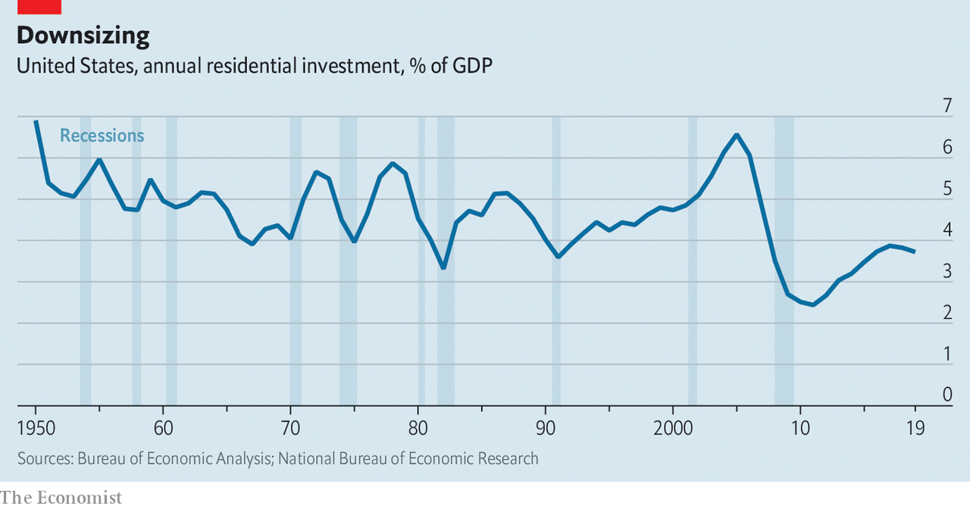

The Great Recession might seem a staggering exception. In fact, it proves the rule. A massive 22% decline in residential investment in 2009 subtracted 0.74 percentage points from real GDP growth that year, which is nothing to sneeze at. A comparable drop in 1980, though, cut growth by much more—1.2 percentage points. The role of housing in the Great Recession is less straightforward than commonly understood. Its contribution to growth began to fall in the fourth quarter of 2005—fully two years before the recession began, and three before the steepest falls in output. The large declines in GDP in late 2008 and early 2009, furthermore, were the result of the financial-sector knock-on effects of the house-price collapse, not the contraction in investment itself.

The property boom and bust of the 2000s were also products of economic circumstances that are unlikely to recur in the near future. Residential investment is highly sensitive to changes in interest rates and house prices. Prices themselves are strongly influenced by interest rates. Research published by the Bank for International Settlements, a club of central banks, in 2017 found that a one percentage-point decline in short-term interest rates in America in 1970-2015 was associated with a 5% rise in house prices over the subsequent three years. From 2000 to 2002, the Fed cut interest rates by more than five percentage points, stoking a surge in prices and construction, and helping revive the economy.

## A dull house

Fed officials will not find that trick easy to repeat. Interest rates at all durations have collapsed over the past decade, giving central bankers far less room to influence the timing of housing investment by adjusting policy rates. When the covid-19 crisis began, the Fed could cut its policy rate by only 1.5 percentage points before it hit the zero lower bound. Meanwhile, other factors are depressing the demand for homes. Net migration to America has historically had a profound influence on residential investment, but fell by more than 40% between 2016 and 2019. Indeed, in 2019 America’s population grew at its slowest pace in a century. Lower immigration and birth rates associated with the pandemic could reinforce the trend, leading to a secular decline in housebuilding.

Housing’s shrunken stature as a business-cycle villain does not mean its effects can be ignored entirely. New home sales in April were 13% below their level in April 2019; new residential construction fell by 26% over that period. When the figures are eventually published, they may show that the drop in residential investment in the first half of 2020 was the largest on record (though its contribution to the fall in GDP will almost certainly be swamped by contraction in other sectors). If generous aid to unemployed workers and relief programmes for struggling renters and borrowers are allowed to lapse, then the woes of the housing market could worsen.

The sector’s diminished share of GDP, though, limits its ability to amplify contractionary forces. And post-crisis changes in lending standards have reduced the threat that mortgage defaults trigger financial contagion. The biggest reason to worry about housing troubles now is the suffering that evictions and foreclosures stand to inflict on households and neighbourhoods. Time, then, for policy to treat housing less like an abstract macroeconomic football, and more like the essential service that it is. ■

This article was downloaded by calibre from <https://www.economist.com/finance-and-economics/2020/07/18/housing-was-the-business-cycle>

|  |  |  |  |
| --- | --- | --- | --- |
| Previous | Articles | Sections | Next |

|  |  |  |
| --- | --- | --- |
| Finance & economics | Sections | Books & arts |

Science & technology

Chipmaking: The incredible shrinking machine

.

Environmental science: Pining for water

.

A new comet: Comet NEOWISE lights up northern skies

.

Navigation: Crystal clear

.

The socioeconomics of sewage: Class acts

.

The theory of relativity: Cycling tricks

.

|  |  |  |
| --- | --- | --- |
| Finance & economics | Sections | Books & arts |

|  |  |  |  |
| --- | --- | --- | --- |
|  | Articles | Sections | Next |

#### The incredible shrinking machine

# A new material helps transistors become vanishingly small

And more transistors mean more computing power

Jul 18th 2020 |



THERE IS AN old joke in the semiconductor business that the number of people predicting the death of Moore’s law doubles every two years. This refers to another prediction, made in the 1970s by Gordon Moore, one of the founders of Intel, a giant chipmaker, that the number of transistors which can be crammed onto a silicon chip doubles every two years. When that number exceeded 1m in the mid-1980s, some said the rate of progress had to slow down. By 2005 the number of transistors on a chip rose above 1bn, which many thought was unsustainable. But there are now around 50bn transistors jostling for space on some chips and producers are gunning for more.

In the current state of the art, the smallest components (transistors and diodes) made on a silicon chip are about seven nanometres (billionths of a metre) across. That is a thousandth of the diameter of a red blood cell. But problems are mounting. As components shrink, electrons start to leak from the connections between them, causing interference and unreliability. The prophets of doom have therefore returned. Once again, however, they look like being wrong. The answer to the electron-leakage problem is better insulation between chip components. And a group of researchers in South Korea and Britain think they have the insulator required. It is called thin-film amorphous boron nitride (a-BN).

## The wonder that waits

The backstory of this material is intriguing. Boron and nitrogen lie on either side of carbon in the periodic table, one consequence of which is that materials composed of equal numbers of boron and nitrogen atoms crystallise in the same ways that carbon does. There are, in other words, boron nitride equivalents of diamonds and graphite. There are also boron nitride versions of the tiny arrangements of carbon atoms known as fullerenes and nanotubes. So it was no surprise, after the creation in 2004 of yet another allotrope of carbon, graphene, which consists of single layers of atoms arranged in a hexagonal grid like a honeycomb, that it had a boron-nitride analogue. This has come to be known colloquially as white graphene.

To start with, white graphene was an also-ran in the new field of two-dimensional materials, as these sheets of atoms are often called. Real graphene, being incredibly strong and able to conduct heat and electricity extremely efficiently, was toted as a wonder material that might one day be used to make transistors much smaller and faster than the silicon-based variety, and thus keep Moore’s law ticking over. But for this purpose real graphene has a problem that is the obverse of its wonderfulness: it has no band gap.

A material’s band gap is a measure of the energy required for an electron to flow through it. A narrow band gap means that material is a conductor. A wide band gap makes it an insulator. Graphene’s band gap of zero, which is most unusual, makes it a very good conductor indeed. But to be a semiconductor, the type of material from which transistors are fabricated, requires a “Goldilocks” band gap that lies between the two extremes—neither too narrow nor too wide. Various methods of tinkering have produced versions of graphene which possess this fairy-tale property, but transistors made with them are, so far, confined to the laboratory.

Studying graphene and its analogues has, though, given technologists a huge amount of experience in the field of two-dimensional materials. And that is where boron nitride comes in. Though no use as a semiconductor it has a band gap wide enough to make it an extremely good insulator. It thus looks a suitable material, at least in principle, to deal with the problem of electron leakage.

Among the firms attempting to develop graphene transistors is Samsung, a giant South Korean electronics group. Its researchers have not, however, neglected boron nitride. One of them, Hyeon-Jin Shin, working in collaboration with Hyeon Suk Shin (no relation) of the Ulsan National Institute of Science and Technology in South Korea and Manish Chhowalla of the University of Cambridge, in Britain, has come up with a form of thin-film boron nitride that lacks the regular hexagonal structure of standard white graphene—hence the description “amorphous”. Crucially, the way this substance is made may permit the integration of boron nitride into the standard chipmaking process.

## A fab outcome

Thin-film materials are usually created by a process called chemical vapour deposition (CVD), and a-BN is no exception. The technique, as its name suggests, involves vaporising the material in question, or chemicals that will react together to make it, and then depositing the result on a substrate. In the case of microelectronics, this substrate is usually a wafer of silicon.

In general, for two-dimensional materials such as graphene and white graphene, CVD has to be done at above 700°C. This is too hot for existing fabs. But with thin-film a-BN, Hyeon-Jin Shin says, the temperature can be turned down as low as 400°C. That lower temperature should allow the material to be deposited directly onto silicon wafers and other substrates without having to retool the multi-billion-dollar factories, known as fabs, in which computer chips are made. This, she believes, means thin-film a-BN could be commercialised for chipmaking much faster than other two-dimensional materials.

The new, amorphous films are thicker than standard white graphene, but only slightly so. At three nanometres, they are well within the size-range needed to form part of the next sceptic-busting generation of components. They are also thermally, mechanically and electrically stable. And they preserve white graphene’s wide band gap, and thus its insulating properties. Add their fab-friendliness into the calculation and their future looks bright. With luck, then, the Moore’s-law naysayers have been outmanoeuvred again.■

This article was downloaded by calibre from <https://www.economist.com/science-and-technology/2020/07/18/a-new-material-helps-transistors-become-vanishingly-small>

|  |  |  |  |
| --- | --- | --- | --- |
|  | Articles | Sections | Next |

|  |  |  |  |
| --- | --- | --- | --- |
| Previous | Articles | Sections | Next |

#### Environmental science

# Stopping pollution with pine needles

A pair of problems may be made to cancel each other out

Jul 18th 2020 |

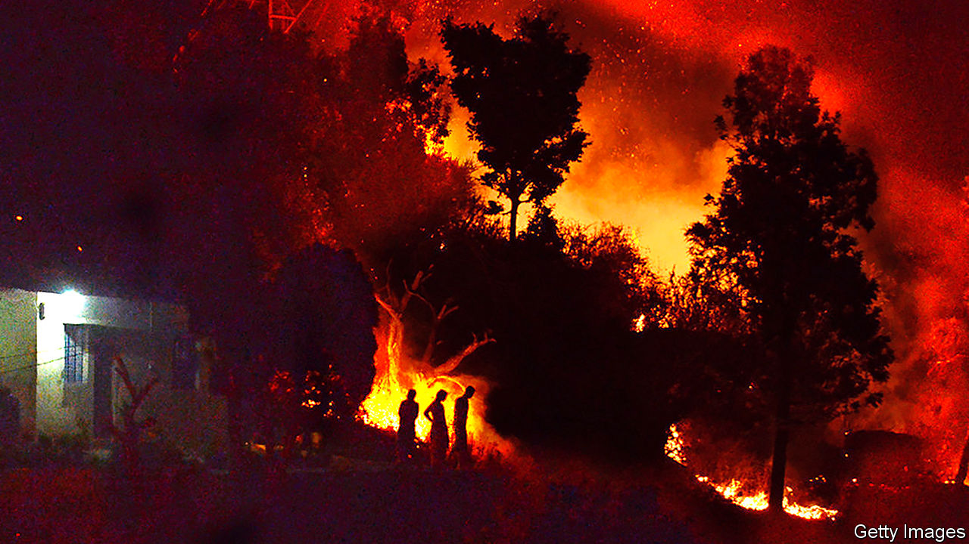

KILLING TWO birds with one stone is a desirable objective, but rarely an achievable one. However, Dinesh Mohan of Nehru University, in Delhi, thinks he may have worked out how to do it in the case of a pair of local environmental problems. One is the risk of fire in the pine forests cloaking the foothills of the Himalaya. The other is pollution by heavy metals, particularly lead, of some of the country’s water supply.

The fire risk comes from pines’ needle-like leaves. These decay only slowly once shed, and thus build up on the ground into thick, inflammable layers. Nor are they just a fire hazard. They also slow down the replenishment of groundwater and make the soil more acidic than it otherwise would be, discouraging the growth of grass and other non-arboreal plants.

The pollution risk comes from lead derived from fuels, old water pipes and paint. Heavy-metal pollution is by no means the only water-quality problem facing India, but it is one of the most pernicious. Like many other countries, India has adopted the maximum level in drinking water for lead set by the World Health Organisation (WHO). This is ten micrograms per litre. In 2014 (the most recent year for which data are available) the country’s Central Water Commission reported concentrations above this threshold at 47 of its 387 river-water-quality monitoring stations.

The simultaneous solution of the two problems, proposed by Dr Mohan in a paper in ACS Omega, is simple and elegant. It is to use the needles to clean up the water.

One way to extract heavy metals like lead from polluted water is to pass that water through charcoal filters. Charcoal, or “biochar” as it is now fashionably known in environmental circles, is a porous, amorphous material, which thereby folds a large surface area into a small volume. It is composed partly of elemental carbon, but this is accompanied by lots of organic molecules such as fatty acids, phenols and quinones, and also by salts of potassium, magnesium and calcium, all left behind from its previous existence as plant matter.

Many heavy-metal ions react enthusiastically with certain oxygen-containing groups of atoms that form parts of the organic molecules, and thus stick to them. They also, through a process called ion exchange, swap places with potassium, magnesium and calcium ions. The upshot is that biochar is good at pulling pollutants like lead out of water. And once a filter was saturated with the stuff, it would be a simple matter to replace it, strip out the accumulated lead using nitric acid, and then burn or dump the exhausted biochar.

Dr Mohan already knew, from previous work, that pine-wood biochar is an effective agent for stripping lead from water. But pine wood is a valuable commodity, so he wondered if he could pull off a similar trick using another forest product—one that currently has no value, namely pine needles. To test this idea he and his colleagues went foraging for needles in the forests of Uttarakhand state, north-east of Delhi. They returned their spoils to the laboratory, divided the needles into batches, and charred the batches in an electric furnace at temperatures ranging from 350-750°C.

Experiments suggested that material charred at 550°C extracted lead most efficiently, and examination showed that this material had the largest internal surface area per gram (determined by a technique that measures a substance’s ability to adsorb gases), and the optimal level of carbonisation needed to preserve the metal-capturing organic compounds. The best temperature for the process, they discovered, was 35°C—just under body heat, and also ambient, at least in the summer, in the wide plain south of the Himalaya through which the Ganges, one of the most polluted rivers on the planet, flows.

Whether these laboratory observations can be turned into a practical process is hard to say. Special filtration-beds would have to be built in water-treatment plants—facilities of which India is in any case woefully short. But it is not short of material to make the biochar.

An average hectare of Himalayan conifer forest produces over six tonnes of needles a year. The process of charring would reduce this to two tonnes, but that is still a fair yield. How much of this fallen foliage would need to be removed to reduce the fire risk and gain the other potential benefits, and what further effects this might have on the local ecology, remain to be determined. But Dr Mohan’s work does show how the cost of this removal might be turned into a benefit enjoyed by all.■

This article was downloaded by calibre from <https://www.economist.com/science-and-technology/2020/07/18/stopping-pollution-with-pine-needles>

|  |  |  |  |
| --- | --- | --- | --- |
| Previous | Articles | Sections | Next |

|  |  |  |  |
| --- | --- | --- | --- |
| Previous | Articles | Sections | Next |

#### A new comet

# Comet NEOWISE lights up northern skies

It was discovered by a satellite that monitors threats to Earth

Jul 18th 2020 |

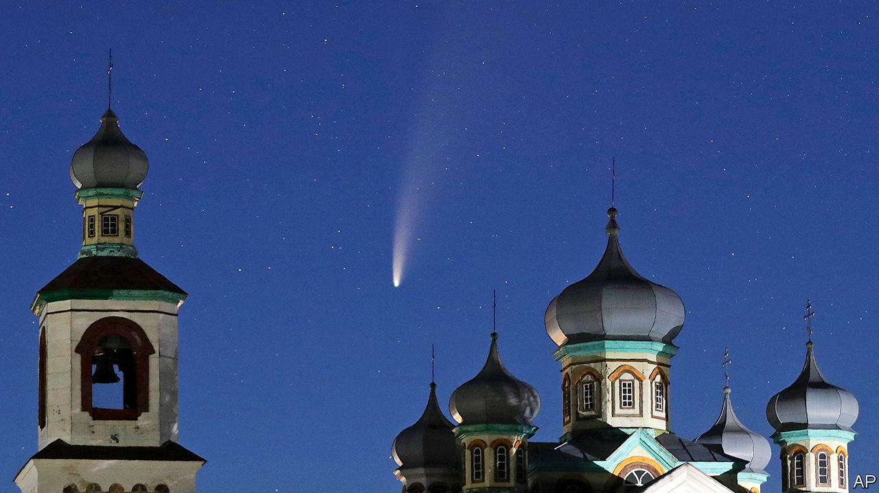

A VISITOR IS hanging in the night skies of the northern hemisphere. Comet neowise was discovered on March 27th by the eponymous Near-Earth Object Wide-field Infrared Survey Explorer, an orbiting telescope belonging to nasa, America’s space agency. neowise was originally just “wise”, an instrument launched in 2009 to map the entire sky at infrared frequencies. It was repurposed and renamed in 2013, and now searches for asteroids and comets. Comet neowise rounded the Sun on July 3rd and will make its closest approach to Earth (103.5m kilometres, about two-thirds of the distance between Earth and the Sun) on July 22nd. It is unlikely to outshine Hale-Bopp, the last bright northern-hemisphere comet, which appeared in 1997. But it is still well worth a look.

This article was downloaded by calibre from <https://www.economist.com/science-and-technology/2020/07/18/comet-neowise-lights-up-northern-skies>

|  |  |  |  |
| --- | --- | --- | --- |
| Previous | Articles | Sections | Next |

|  |  |  |  |
| --- | --- | --- | --- |
| Previous | Articles | Sections | Next |

#### Aircraft navigation

# Magnetometers based on diamonds will make navigation easier

Unlike GPS, they cannot be jammed by enemy action

Jul 18th 2020 |



MAGNETIC COMPASSES have guided sailors for centuries, but a compass tells you only in which direction you are pointing, not whereabouts you are. A new form of magnetic navigation being developed by the United States Air Force Research Laboratory (AFRL) can do better. It employs magnetometers made from tiny diamonds to indicate an aircraft’s precise location over Earth’s surface. It is so accurate that it might supersede GPS for aerial navigation.

A conventional compass aligns with the magnetic field generated by convection currents within Earth’s liquid-iron core. This field is, itself, approximately aligned with the planet’s axis of spin, and thus with the geographical poles. But there are fainter terrestrial magnetic fields around as well. These are embedded in the rocks of Earth’s crust and have a pattern sufficiently elaborate and distinctive as to be unique from place to place. In principle, therefore, they can tell you where you are. The trick is to reduce that principle to practice.

Until recently, the only magnetometers sensitive enough to be useful for this task have been costly and bulky. Some also require cooling with either liquid helium or liquid nitrogen. None of these things is true of a diamond magnetometer.

The diamond in question has an atomic lattice containing anomalous places called nitrogen-vacancy defects. Diamonds are crystals of carbon and these vacancies are places where a carbon atom in the crystal lattice has been replaced by a nitrogen atom, and an adjacent carbon is missing. When exposed to green laser light such vacancies fluoresce. The pattern of fluorescence changes in a magnetic field in a way which allows that field’s strength and alignment to be determined.

Diamond magnetometers are not, in truth, as sensitive as the alternatives. But in addition to their cheapness, lack of bulk and ability to function at room temperature they also have one further advantage. As Michael Slocum, a researcher at AFRL who is working on the project, observes, other sorts of magnetometers need careful calibration—and any system that depends on calibration is likely to suffer from measurement drift over the course of time. Since the nitrogen defects in a diamond do not move around, no calibration is needed.

Magnetometer-based navigation does require accurate maps of Earth’s surface magnetic fields. The best such are made by flying an aircraft over the area in question, but if that is not possible then (as the picture shows) a satellite can do a reasonable job. Tests suggest that navigation of this sort can locate an aircraft’s position to within 13 metres. And, crucially for military applications (and unlike GPS-based systems), it is unjammable by the enemy.■

This article was downloaded by calibre from <https://www.economist.com/science-and-technology/2020/07/18/magnetometers-based-on-diamonds-will-make-navigation-easier>

|  |  |  |  |
| --- | --- | --- | --- |
| Previous | Articles | Sections | Next |

|  |  |  |  |
| --- | --- | --- | --- |
| Previous | Articles | Sections | Next |

#### The socioeconomics of sewage

# Analysing waste water may assist census takers

Chemistry and demography are intertwined

Jul 18th 2020 |



YOU ARE what you eat, the saying goes. It therefore follows that what you excrete gives away a lot about you. Writ large, that information might yield useful demographic clues about particular neighbourhoods. This, at least, is the thinking behind a study by Saer Samanipour of the University of Amsterdam, in the Netherlands. Dr Samanipour has been analysing sewage, and has shown that it gives a pretty good profile of an area’s population.

To make sure that his analysis reflected the most up to date demographic information Dr Samanipour timed it to coincide with a census. The one he chose was that conducted in Australia, in 2016, so he called on the assistance of a group of colleagues from the University of Queensland.

As they describe in a paper in Environmental Science and Technology Letters, team members collected samples from more than 100 sewage-treatment plants for five to seven consecutive days around the time of the census. They analysed these for 40 chemicals that past research has suggested have socioeconomic significance. Nicotine, for example, is associated more with rural populations than urban ones, because people living in the countryside are more likely to smoke. Caffeine consumption correlates with education levels. Amphetamine use tracks levels of crime.

In total, the team looked at the concentrations of six legal recreational drugs, caffeine and nicotine among them, two illegal recreational drugs (amphetamine and methamphetamine), seven opioids (the legality of which depends on the circumstances), eight antidepressants and antipsychotics, nine other pharmaceuticals, two artificial sweeteners and six markers of diet, such as enterolactone, a substance that shows how much fibre people are consuming. All of the chemical information collected from each treatment plant was paired with data from the census to create a model of what the wastewater chemistry of populations with particular socioeconomic characteristics looks like. Among many correlations detected, the researchers found that high levels of B vitamins (abundant in red meat, whole grains and dark leafy greens), alcohol and caffeine were associated with high-rent districts, generally in the middle of cities, while opioids and antidepressants went hand in hand with an abundance of people with low-skilled occupations.

These general correlations are not, perhaps, that surprising (though another, between a lack of internet connection and an antihypertensive medication called atenolol, is intriguing—possibly being mediated through people’s age). But Dr Samanipour found that in combination they could predict quite accurately the demographic make-up of a sewage plant’s catchment area. He did this by taking the model he and his colleagues had devised, based on their 100 initial plants, and applying it to nine others. For each of these they forecasted the socioeconomics of the surrounding area and then tested those forecasts against reality, as revealed by the census.

These forecasts were quite specific: how many people in an area had finished secondary school; how many had cars; how many were single parents; and so on. Of the 37 questions asked by the census about education, occupation, income, social life and housing, the model was able to predict the pattern of answers to 30 of them with 25% or less deviation from the values calculated by the census.

Based on these results the researchers argue that, considering the relative ease, low cost and high frequency with which wastewater samples can be collected and analysed, their model could profitably be used, if not as a replacement for censuses, then at least as a way of keeping track of changes in the characteristics of populations more or less continuously, as they happen, rather than in a punctuated manner every five or ten years.■

This article was downloaded by calibre from <https://www.economist.com/science-and-technology/2020/07/18/analysing-waste-water-may-assist-census-takers>

|  |  |  |  |
| --- | --- | --- | --- |
| Previous | Articles | Sections | Next |

|  |  |  |  |
| --- | --- | --- | --- |
| Previous | Articles | Sections | Next |

#### The theory of relativity

# What if the speed of light were that of a cyclist?

A new paper revives a hero from physics’s past

Jul 18th 2020 |



ALBERT EINSTEIN was well known for his Gedankenexperimente, or “thought experiments”, conducted in imaginary versions of the real world. He used them to test ideas that observation could not confirm. But it is also possible to do imaginary experiments in worlds which are themselves imaginary, and thus to illuminate reality in a novel way. This was a particular skill of another 20th-century physicist, George Gamow, who explained his subject to the laity via a Mr Tompkins and his adventures in alternative wonderlands.

In the first of these tales Mr Tompkins dreams of a place where the speed of light is about that of a bicycle. How would a cyclist in such a world look to a watching pedestrian? Gamow’s answer was that the cyclist would shrink from back to front, and the faster he travelled the more slowly his pedalling feet would revolve. Gamow’s cyclist is compressed by an effect called the Lorentz contraction and his pedalling is affected by a slowing of the clock known as time dilation. These things are both consequences of the speed of light being constant no matter how rapidly its source is approaching or receding—an observation that was the starting point for Einstein’s own Gedankenexperimente.

This, though, turns out to be only part of the story. A paper published in the Proceedings of the Royal Society by Evan Cryer-Jenkins and Paul Stevenson, of the University of Surrey, in Britain, suggests that the full answer is even weirder than Gamow’s imaginings.

The first modification to Mr Tompkin’s dream came in 1959, two decades after his debut. A British mathematician called Roger Penrose calculated that he would actually have seen approaching cyclists as being elongated along their direction of motion, contracting only as they receded. Yet more peculiarly, as they drew abreast of him they would appear rotated, as if somehow cycling sideways with their backs turned to him. Mr Cryer-Jenkins and Dr Stevenson observe that, in addition to all this, the light from Gamow’s cyclists would, from Mr Tompkins’s point of view, be Doppler shifted. They also take on board a fact which Gamow and Sir Roger (as he now is) did not. Mr Tompkins, because he is a human being, has binocular vision.

The Doppler effect is a velocity-dependent change in frequency which makes light from an approaching object appear bluer than it would were its source stationary, and that from a receding object redder. So, not only will a cyclist approaching our hero be unfeasibly elongated, he will also be blueshifted so far as to be invisibly ultraviolet. He will thus appear as a black silhouette looming out of the landscape. His apparent distance, however, will fluctuate because, at these near-light speeds, the elongated images seen by each eye will warp at slightly different moments. Cycling abreast of Mr Tompkins when passing him, the rider will suddenly erupt into a pulsating, psychedelic rainbow of colour as he moves from blueshift to redshift. Amid this light show he will seem to rotate and contract, before vanishing into the profound blackness of the infrared—a strange, squashed shadow receding into the distance.

This article was downloaded by calibre from <https://www.economist.com/science-and-technology/2020/07/18/what-if-the-speed-of-light-were-that-of-a-cyclist>

|  |  |  |  |
| --- | --- | --- | --- |
| Previous | Articles | Sections | Next |

|  |  |  |
| --- | --- | --- |
| Science & ... | Sections | Economic & ... |

Books & arts

The future of journalism: Invisible men

.

Craft and commerce: Shifting plates

.

Science and politics: Trial and error

.

Musical high jinks: Played for laughs

.

|  |  |  |
| --- | --- | --- |
| Science & ... | Sections | Economic & ... |

|  |  |  |  |
| --- | --- | --- | --- |
|  | Articles | Sections | Next |

#### Invisible men

# How objectivity in journalism became a matter of opinion

In America, political and commercial strains have led to questions about its value and meaning

Jul 16th 2020 |

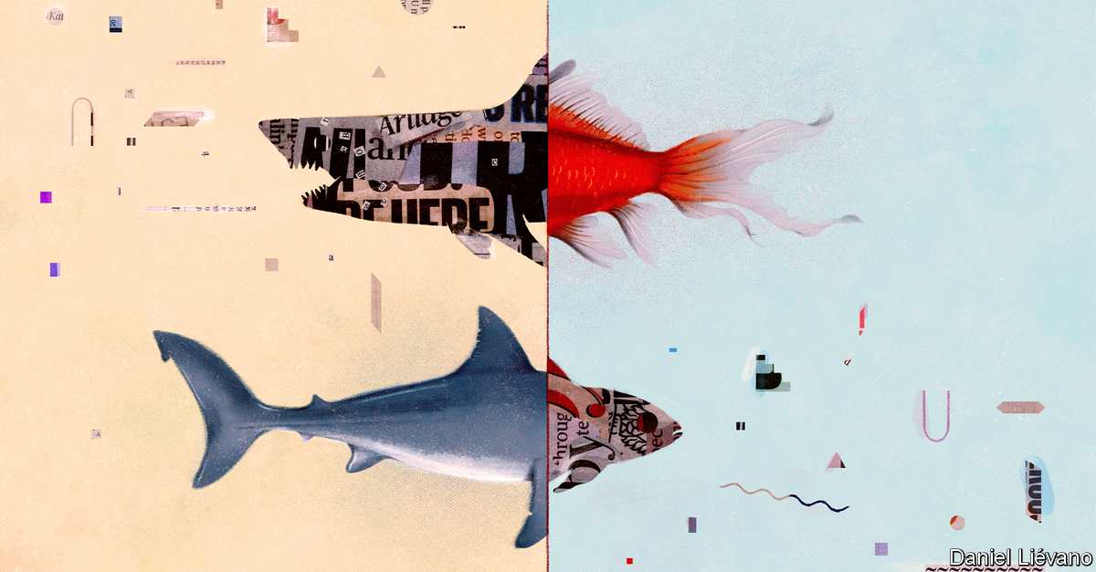

HAVE YOU heard the news? It’s about the news. As correspondents covered the widespread protests on the streets of America in recent months, many were engaged in a parallel protest of their own—against their employers. On private Slack channels, public Twitter feeds and in op-ed columns, journalists revolted. Editors apologised, promised change and in some cases were sacked, their downfall promptly written up in their own papers.

The immediate cause of this rebellion is race: how it is reported and how it is represented among staff. More than 150 Wall Street Journal employees signed a letter saying that they “find the way we cover race to be problematic”. Over 500 at the Washington Post endorsed demands for “combating racism and discrimination” at the paper. Journalists at the New York Times tweeted that a senator’s op-ed advocating a show of military force to restore order “puts black @nytimes staff in danger”.

But at the heart of many of these arguments is another disagreement, about the nature and purpose of journalism. As a Bloomberg employee is said to have remarked at a recent meeting, reporters are meant to be objective, but to many the distinction between right and wrong now seems obvious. A new generation of journalists is questioning whether, in a hyper-partisan, digital world, objectivity is even desirable. “American view-from-nowhere, ‘objectivity’-obsessed, both-sides journalism is a failed experiment,” tweeted Wesley Lowery, a Pulitzer-winning 30-year-old now at CBS News. The dean of Columbia Journalism School described objectivity as an “inherited shibboleth” in a message to students. The Columbia Journalism Review pondered: “What comes after we get rid of objectivity in journalism?”

Objectivity hasn’t always been a journalistic ideal. Early American newspapers read a bit like today’s blogs, says Tom Rosenstiel of the American Press Institute (API), an industry group. Benjamin Franklin’s Pennsylvania Gazette and Alexander Hamilton’s Gazette of the United States were unashamedly partisan. As they sought wider audiences in the 19th century, newspapers became more concerned with what they called “realism”. Some of this was provided by the Associated Press (AP), founded in 1846, which supplied stories to papers of diverse political leanings and so stuck to the facts. As the news pages became more even-handed, publishers established editorial pages, on which they could continue to back their favoured politicians.

## Hot takes and alternative facts

Only in the 1920s did objectivity truly gain currency. “A Test of the News”, by Walter Lippmann and Charles Merz, found that the New York Times’ coverage of the Russian revolution was rife with what today might be called unconscious bias. “In the large, the news about Russia is a case of seeing not what was, but what men wished to see,” they wrote. At the same time, as communism advanced, Joseph Pulitzer’s view of the centrality of journalism to democracy—“Our Republic and its press will rise or fall together”—gained adherents. These lofty aims overlapped with commercial ones. Advertisers wanted less partisan coverage to sit alongside their messages.

And so objectivity became journalism’s new lodestar. As Lippmann put it, the journalist should “remain clear and free of his irrational, his unexamined, his unacknowledged prejudgments in observing, understanding and presenting the news.”

A century later, four trends have put this principle under strain. (The Economist, a British publication, has grappled with most of them.) One is Donald Trump’s rise and the challenges it has posed to traditional reporting. Some of his statements can be accurately described as lies, or as racist. But such words are so seldom used of sitting presidents—except by partisans—that writers and editors have reached for euphemisms. After Mr Trump told four non-white congresswomen to “go back” to the “crime-infested places from which they came”, the Wall Street Journal called his words “racially charged”; the Times plumped for “racially infused”.

The Trump era has also exposed problems with journalistic notions of balance. Giving equal weight to both sides of an argument is an easy shortcut to appearing objective. Yet this “bothsidesism” has sometimes come to seem misleading. At an impeachment hearing in December, “the lawmakers from the two parties could not even agree on a basic set of facts in front of them,” reported the Times. Which facts were real? Readers were left to guess.



A second cause of doubts about objectivity is the changing make-up of the American newsroom. Amid more diverse recruitment, the share of the Times’ editorial staff who are white is falling; the proportion who are women is rising. Not only has this sharpened sensitivity to odd phrases like “racially infused”; it has also made some wonder if the “objective” viewpoint is in fact a white, male one. The “view from nowhere” is just the view of “a white guy who doesn’t even exist”, Dan Froomkin, an outspoken media critic, has argued.

Concerns like these might in the past have remained on the shop floor. But a third factor—the rise of social media—has given dissenters a megaphone. It has also highlighted the contrast between the detached style journalists are meant to adopt in print and the personal approach many employ online—something bosses seem unsure whether to encourage or deter. Readers, for their part, are bathed on the web in highly partisan content that whets their appetite for more opinionated news. The division between news and comment, clear on paper in American journalism, dissolves on the internet. A study for the API in 2018 found that 75% of Americans could easily tell news from opinion in their favoured outlet, but only 43% could on Twitter or Facebook.

## Keeping up appearances

The final reason for the turn against objectivity is commercial. The shift away from partisanship a century ago was driven partly by advertisers. Today, as ad revenues leak away to search engines and social networks, newspapers have come to rely more on paying readers. Unlike advertisers, readers love opinion. Moreover, digital publication means American papers no longer compete regionally, but nationally. “The local business model was predicated on dominating coverage of a certain place; the national business model is about securing the loyalties of a certain kind of person,” wrote Ezra Klein of Vox. Left-leaning New Yorkers may switch to the Washington Post if the Times upsets them. The incentive to keep readers happy—and the penalty for failing—are greater than ever.

These pressures are changing the way newspapers report. Last year AP’s style book declared: “Do not use racially charged or similar terms as euphemisms for racist or racism when the latter terms are truly applicable.” Some organisations have embraced, even emblazoned taboo words: “A Fascist Trump Rally In Greenville” ran a headline last year in the Huffington Post. Others are inserting more value judgments into their copy. A front-page news piece in the Times this month began:

President Trump used the spotlight of the Fourth of July weekend to sow division during a national crisis, denying his failings in containing the worsening coronavirus pandemic while delivering a harsh diatribe against what he branded the “new far-left fascism”.

Disenchanted with objectivity, some journalists have alighted on a new ideal: “moral clarity”. The phrase, initially popularised on the right, has been adopted by those who want newspapers to make clearer calls on matters such as racism. Mr Lowery repeatedly used the phrase in a recent Times op-ed, in which he called for the industry “to abandon the appearance of objectivity as the aspirational journalistic standard, and for reporters instead to focus on being fair and telling the truth, as best as one can, based on the given context and available facts.” The editor of the Times, Dean Baquet, called Mr Lowery’s column “terrific” in an interview with the “Longform” podcast. Objectivity has been “turned into a cartoon”, he said. Better to aim for values such as fairness, independence and empathy.

Back in the 1920s, Lippmann might have agreed with much of this. He saw objectivity not as a magical state of mind or a view from nowhere, but as a practical process. Journalism should aim for “a common intellectual method and a common area of valid fact”, he wrote. That does not mean using euphemisms in place of plain language, or parroting both sides of an argument without testing them. Indeed, when journalism has erred in recent years, it has often done so by misinterpreting objectivity, rather than upholding it. The most persuasive calls for moral clarity today articulate something close to Lippmann’s original conception of objectivity.

The danger is that advocates of moral clarity slide self-righteously towards crude subjectivity. This week Bari Weiss, a Times editor, resigned, criticising what she said was the new consensus at the paper: “that truth isn’t a process of collective discovery, but an orthodoxy already known to an enlightened few whose job is to inform everyone else.” Earlier Mr Rosenstiel warned, in a largely supportive response to Mr Lowery’s column, that “if journalists replace a flawed understanding of objectivity by taking refuge in subjectivity and think their opinions have more moral integrity than genuine inquiry, journalism will be lost.”

As reporters learn more about a subject, he adds, the truth tends to become less clear, not more so. Recognising and embracing the uncertainty means being humble—but not timid. ■

This article was downloaded by calibre from <https://www.economist.com/books-and-arts/2020/07/16/how-objectivity-in-journalism-became-a-matter-of-opinion>

|  |  |  |  |
| --- | --- | --- | --- |
|  | Articles | Sections | Next |

|  |  |  |  |
| --- | --- | --- | --- |
| Previous | Articles | Sections | Next |

#### Shifting plates

# An enlightening history of German porcelain

It is both a precious industry and a fragile one

Jul 16th 2020 |



Porcelain: A History from the Heart of Europe. By Suzanne Marchand. Princeton University Press; 544 pages; $35 and £30.

IT SOUNDS LIKE a fairy-tale. A visionary alchemist, arrested by a tyrannical ruler, is put to work turning scraps into riches. Yet for a few years in the early 18th century Johann Friedrich Böttger was a genuine Rumpelstiltskin. Seized by Augustus the Strong, elector of Saxony, after he crossed Prussia’s frontier, Böttger was imprisoned and ordered to conjure up treasure—and, in a sense, he did. He didn’t make gold, but Böttger was the first European to create something almost as precious: porcelain.

As Suzanne Marchand shows in her meticulous new book, porcelain has been integral to German life since its reinvention in Saxony in 1708 (the Chinese perfected the craft centuries earlier). It was initially a plaything for princes, as Böttger’s incarceration suggests; Augustus and his rivals sponsored state-run factories for what one called the “splendour and prestige” of their realms. From that beginning, Ms Marchand traces porcelain’s role in German history, examining its uses from Romantic busts of Goethe to Nazi egg cups.

“Porcelain” is about more than culture. Because the commodity was prized and produced over centuries, the author uses it to explore wider economic changes. Ultimately it became thoroughly industrialised—porcelain’s use in false teeth and telegraph insulator tubes leads Ms Marchand to call it the plastic of its day—but the path to modernity meandered. Several early factories, including the famous one at Meissen, were just converted palaces or monasteries, run by courtiers in powdered wigs. Some idiosyncrasies survived into the 20th century: though they hated all things aristocratic, East German officials brought back classic rococo figurines after Marxist alternatives proved unsellable.

Despite its winding economic narrative (and piles of manufacturing statistics), “Porcelain” is rarely a grind. Ms Marchand writes wittily about subjects from bourgeois views on tableware to Weimar advertising, veering away from tea sets and vases when she spies an interesting vignette. “Fox tossing”, she relates, was a popular pastime for 18th-century courtiers (the animals were hurled into the air until they died). King Frederick the Great of Prussia recruited hundreds of invalids from a state hospital literally to sniff out illegal coffee-roasters in Berlin and Potsdam.

The porcelain-makers themselves were often as fascinating as Böttger. After running away from home to become a cowboy, for instance, Philipp Rosenthal made a fortune in porcelain—before being ruined by the Nazis. Ordinary workers led colourful lives too. One report of 1796 describes how employees at a firm in Fürstenberg drank schnapps at work or skived off to go hunting. Their successors in the 1940s spent their time dodging Allied bombs and repairing shattered windows.

Today German porcelain-makers face different threats. Chinese imports are undercutting them. Tastes have evolved: polystyrene cups have long replaced elegant coffee sets in many situations. Between 2006 and 2014 alone 190 German porcelain firms closed. Soon, writes Ms Marchand, production may return entirely to East Asia, where porcelain was first invented. The story that began with Böttger could become just another fairy-tale. ■

This article was downloaded by calibre from <https://www.economist.com/books-and-arts/2020/07/16/an-enlightening-history-of-german-porcelain>

|  |  |  |  |
| --- | --- | --- | --- |
| Previous | Articles | Sections | Next |

|  |  |  |  |
| --- | --- | --- | --- |
| Previous | Articles | Sections | Next |

#### Trial and error

# The flawed brilliance of J.B.S. Haldane

The biologist knew that science and politics could never be separated

Jul 18th 2020 |

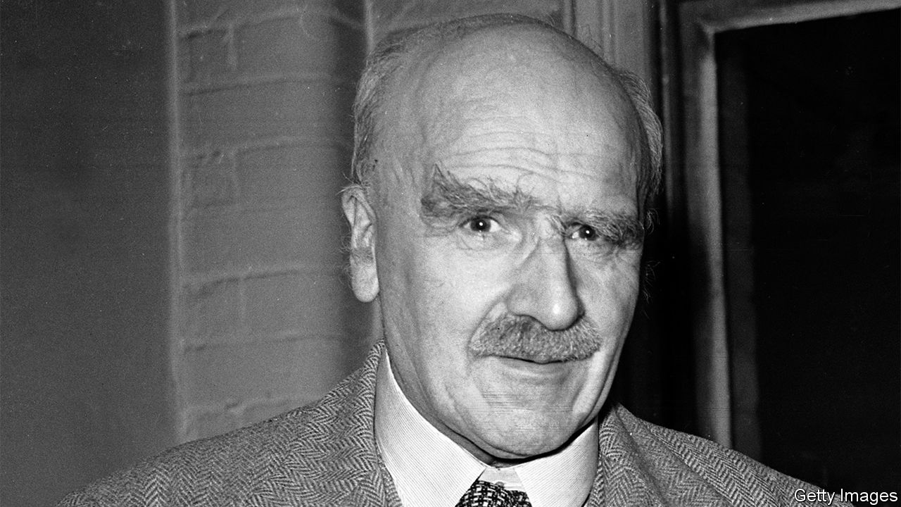

A Dominant Character: The Radical Science and Restless Politics of J.B.S. Haldane. By Samanth Subramanian. W.W. Norton; 400 pages; $40. Atlantic Books; £20.

TOWARDS THE end of his life, J.B.S. Haldane was inseparable from a pebble that had been found in the Valley of Elah in Israel, where David felled Goliath with a similar projectile. A king-size man who towered over British biology for several decades in the middle of the 20th century, Jack Haldane—the “half-Dane”—was a more obvious Goliath, but he always took the side of the underdog.

That is the contradiction at the heart of Samanth Subramanian’s astute and sympathetic biography. An Eton- and Oxford-educated communist, who with a handful of others fleshed out Darwin’s theory of natural selection by marrying it to genetics and grounding it in maths, Haldane was born into privilege but came to identify himself with the masses. And if his unconscious sense of entitlement can sometimes be grating, it is more than offset by his humour, facility for language, intellectual generosity and—the product of all this—his giant contribution to the popularisation of science.

Science was his first and most enduring love. Aged three, studying blood trickling from a cut, he is supposed to have asked, “Is it oxyhaemoglobin or carboxyhaemoglobin?” Thus began a life of inquiry in which he was always either being experimented on—notably by his father, the physiologist J.S. Haldane—or experimenting on himself or others. Bertrand Russell thought that science could rarely be beautiful, but for Haldane beauty came through understanding. “Until I took to scientific plant-breeding”, he wrote, “I did not appreciate the beauty of flowers.”

Haldane wrote a great deal, in learned journals but also in the popular press and in response to letters from the scientifically curious, and on a breathtaking range of subjects. “Please send me no more caterpillars,” he pleaded on one of the many occasions that his mailbag threatened to overwhelm him. As he coped with his own and other people’s inquisitiveness, world events intruded. He wrote parts of a paper on genetic linkage—whereby two genes that sit close to each other on a chromosome are more likely to be inherited together—while serving in the trenches during the first world war.

It was in the trenches, too, that Haldane’s rejection of his birthright crystallised. As disappointed by the officer class as he was by army chaplains, he wrote to his mother that, when the revolution came, the people would “strangle the last Duke in the guts of the last parson”. But he was attracted to Marxism for more than just its egalitarian ideals; it struck him as practical, transparent—in short, scientific. Though he kept his distance from the Communist Party of Great Britain (CPGB) until 1942, MI5 had him down as a subversive from the time of his only visit to the Soviet Union, in 1928.

Haldane’s politics and his science clashed mightily in 1948, when as the CPGB’s foremost intellectual—and, by then, one of the most influential geneticists in the world—he refused to publicly condemn the pseudoscience of Trofim Lysenko. Stalin’s favourite agronomist claimed that he could drum desirable traits into wheat by altering its environment, just as Jean-Baptiste Lamarck had once believed giraffes had stretched their necks through practice. In the Soviet Union scientists who disagreed with Lysenko vanished. One of them, Nikolai Vavilov, had hosted Haldane in Moscow. Haldane’s own science contradicted Lysenkoism. Nobody who knew him could fathom his stance.

## Bioengineers of the soul

Mr Subramanian doesn’t defend it either. He makes it clear that Haldane ignored overwhelming evidence of Vavilov’s internment and death in the gulag. But he uses the episode to illustrate a wider truth, which is that science cannot be extricated from politics. Today many scientists describe their research as apolitical, but Haldane knew that was impossible: “I began to realise that even if the professors leave politics alone, politics won’t leave the professors alone.”

It meant that he was prepared to change his mind. Eugenics was a mainstream theory when he entered biology, and he partially embraced it. But he also warned that genetics was too young a science to be applied successfully. His ideas evolved until they fell into line with those of the scientists now wielding genetic-engineering tools to improve humanity (though they would reject the eugenics label).

Haldane changed his mind too slowly about the Soviet Union, but having done so he found new hope in India, where he moved in 1957. Its bureaucracy maddened him and he said so loudly and often—flashing his white male privilege like a peacock’s tail—but its tropical profusion provided him with a natural laboratory, and the climate was kinder to a body damaged by decades of self-experiment. When he died there in 1964, still holding the stone from Elah, it was no surprise to anyone that he donated his body to science. ■

This article was downloaded by calibre from <https://www.economist.com/books-and-arts/2020/07/18/the-flawed-brilliance-of-jbs-haldane>

|  |  |  |  |
| --- | --- | --- | --- |
| Previous | Articles | Sections | Next |

|  |  |  |  |
| --- | --- | --- | --- |
| Previous | Articles | Sections | Next |

#### Home Entertainment

# Ylvis and the inspiration of banality

A Norwegian comedy duo make music out of the very ordinary

Jul 18th 2020 |



THE SONG begins in typical power-ballad fashion, with plaintive piano chords and rumbling strings. Soon, though, the lyrics go awry. The lead singer reflects on his good fortune—a successful career on television, a passionate marriage, a “thousand-dollar haircut”—but laments that he is tormented day and night by a single question. Such soft-rock numbers usually dwell on a former lover or missed opportunity; what preoccupies this man is a prehistoric monument in south-west England. “What’s the deal with Stonehenge?” he cries, his white shirt billowing in the wind. Is it “a giant granite birthday cake, or a prison far too easy to escape”?

There are few more enjoyable ways to while away an evening in lockdown than discovering the work of Ylvis, a Norwegian comedy duo. Made up of brothers Vegard and Bard Ylvisaker, the band produces delightfully absurd pastiches of various kinds of music. Many of the songs were written in English for their variety TV show, “Tonight With Ylvis”, and are best consumed on YouTube with the zany accompanying videos. This is music designed to be appreciated at home, where the lyrics can be easily digested and the videos paused or repeated when laughter ensues.

Much of Ylvis’s comic appeal lies in the way they treat everyday, even banal, themes with deadpan gravity. They wrote a song about animal noises, asking “What does the fox say?” and parodying European electronic pop, because they “wanted to make a very good production about something very stupid,” Vegard explains. It is an irresistible earworm, topping the charts in Norway and reaching number six on the Billboard chart in America. The video has been watched nearly 1bn times online.

“Jan Egeland”, a rock track with thundering electric guitars and falsetto vocals, pays tribute to a Norwegian diplomat involved in the Oslo accords. The country-inflected “Massachusetts” is a tongue-in-cheek ode to America’s 15th-most-populous state (it angered some Bay Staters by suggesting that they were homophobic). “Russian Government Process”, in the style of a traditional folk song, pokes fun at that country’s opaque bureaucracy—as the music increases in tempo, the list of instructions becomes harder to understand.

Bard says the pair have “an appetite for all sorts of genres”. They have also written lampoons of sultry R’n’B (“The Cabin”), misogynistic hip-hop (“Work It”) and dubstep (“Someone Like Me”). Besides their sheer range, what sets Ylvis apart from other comedy groups is the catchiness of the melodies and the brothers’ versatile and prodigious talents. You will try—and fail—to hit their high notes in the shower. In these dull, repetitive days, their work is a heartening reminder that even anodyne things can be a source of inspiration. ■

This article was downloaded by calibre from <https://www.economist.com/books-and-arts/2020/07/18/ylvis-and-the-inspiration-of-banality>

|  |  |  |  |
| --- | --- | --- | --- |
| Previous | Articles | Sections | Next |

|  |  |  |
| --- | --- | --- |
| Books & arts | Sections | Graphic detail |

Economic & financial indicators

Economic data, commodities and markets

.

|  |  |  |
| --- | --- | --- |
| Books & arts | Sections | Graphic detail |

|  |  |  |  |
| --- | --- | --- | --- |
|  | Articles | Sections | Next |

# Economic data, commodities and markets

Jul 18th 2020 |

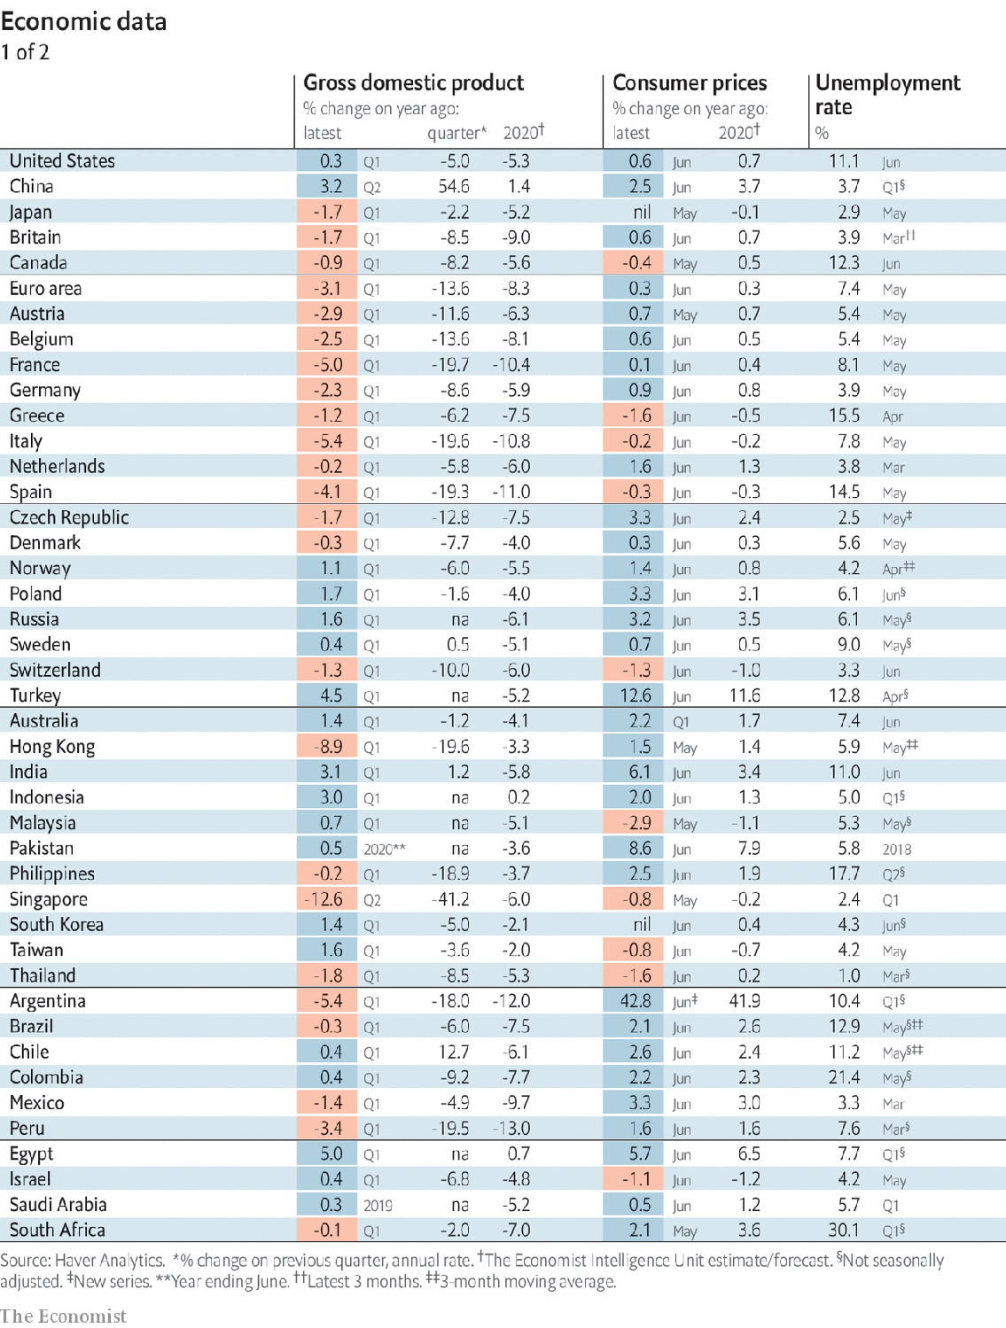

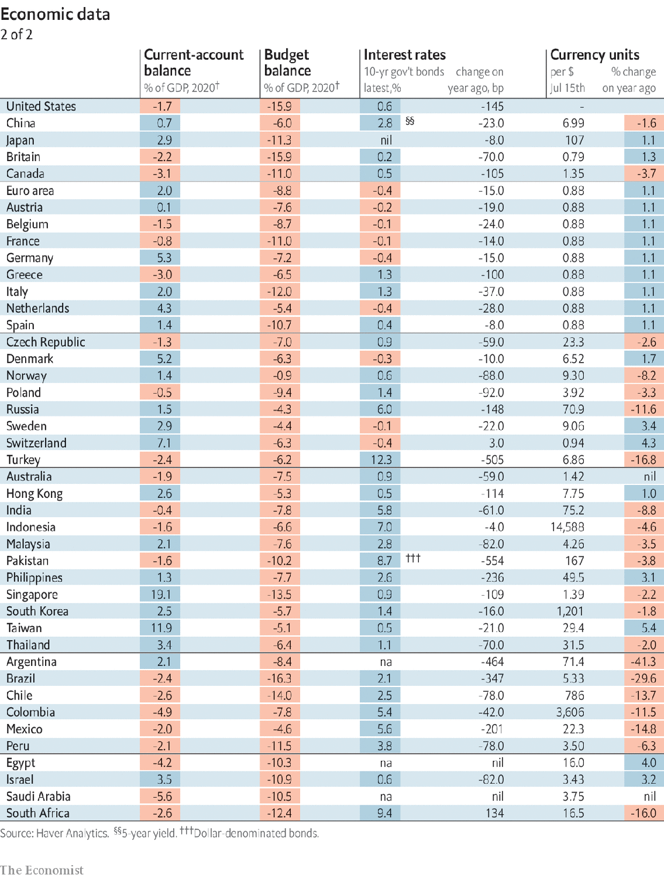

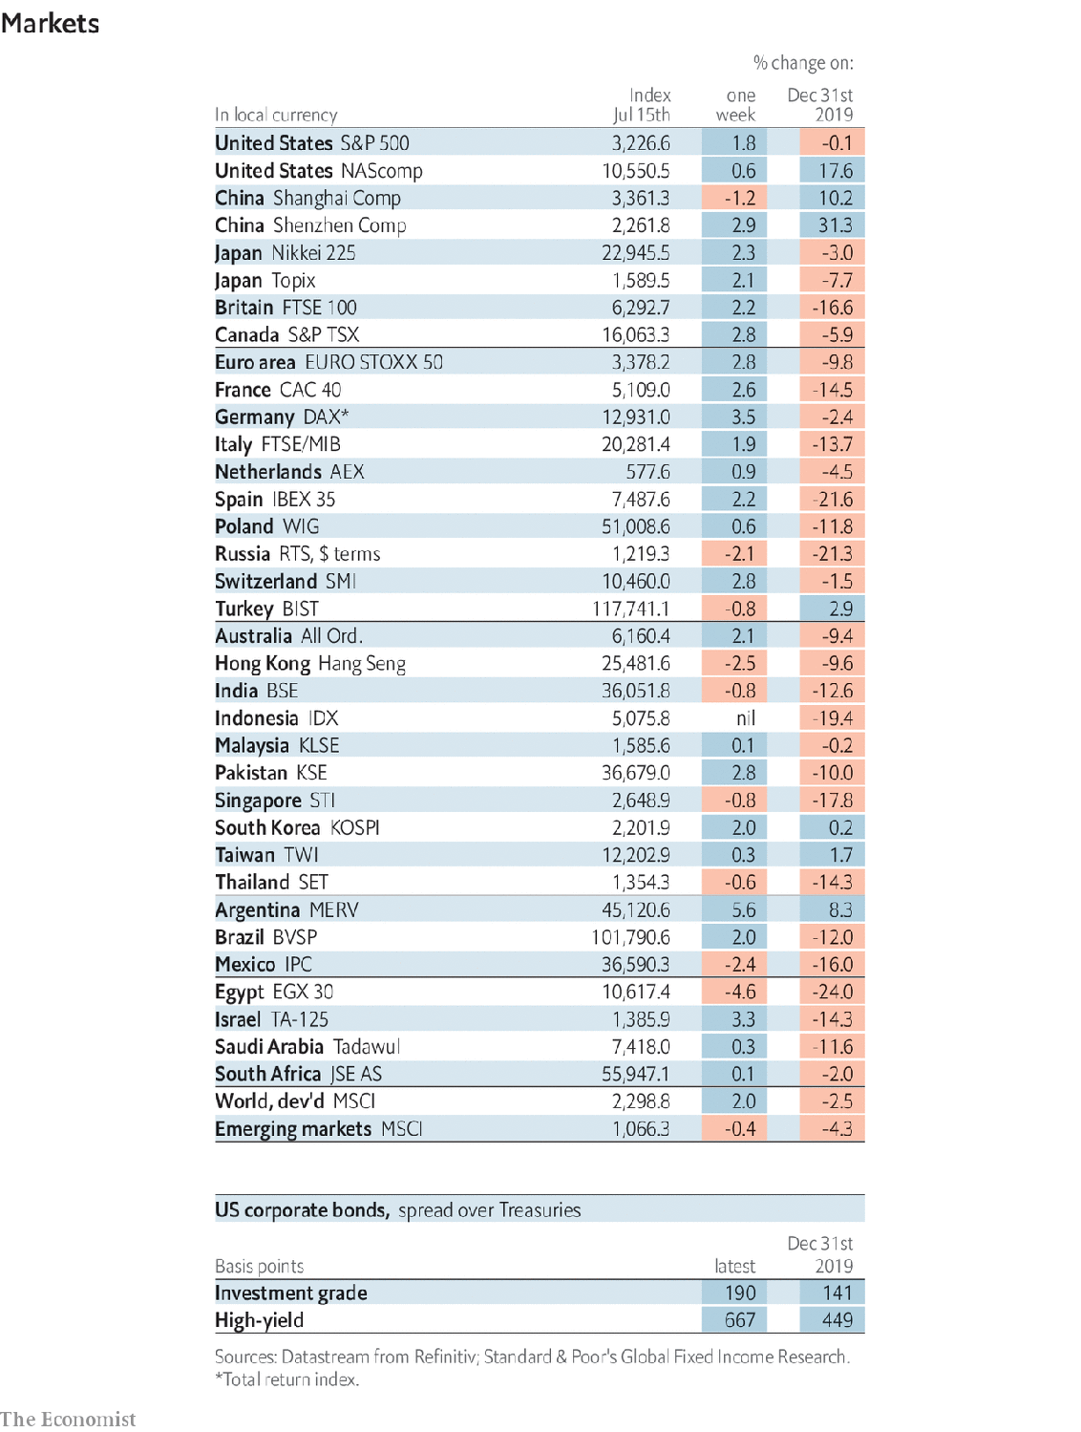

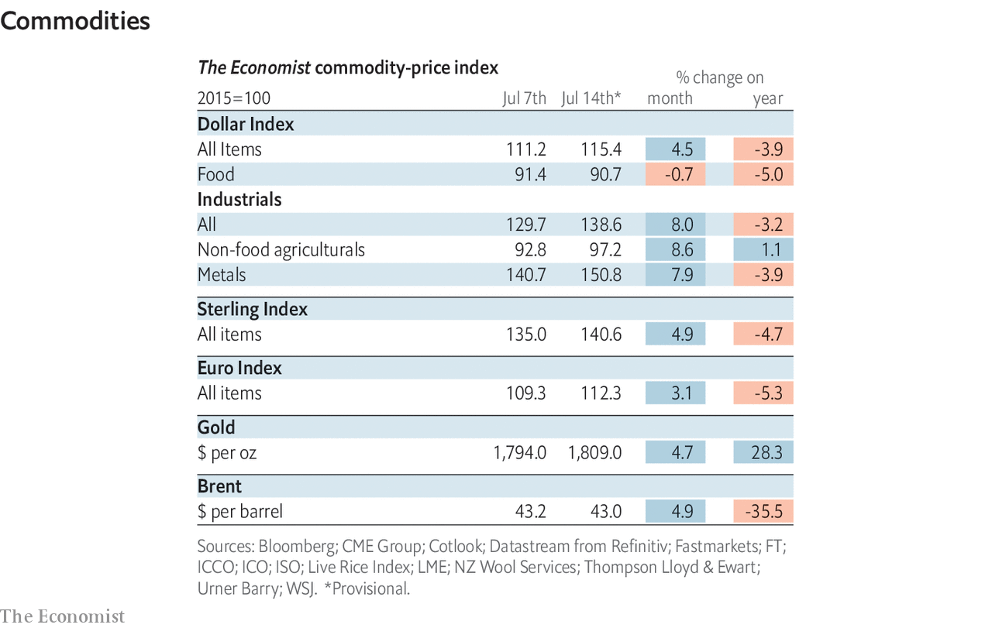

This article was downloaded by calibre from <https://www.economist.com/economic-and-financial-indicators/2020/07/18/economic-data-commodities-and-markets>

|  |  |  |  |
| --- | --- | --- | --- |
|  | Articles | Sections | Next |

|  |  |  |
| --- | --- | --- |
| Economic & ... | Sections | Obituary |

Graphic detail

Resource economics: Capital pains

.

|  |  |  |
| --- | --- | --- |
| Economic & ... | Sections | Obituary |

|  |  |  |  |
| --- | --- | --- | --- |
|  | Articles | Sections | Next |

#### Nature depreciation

# The world’s wealth is looking increasingly unnatural

As natural wealth is used up, economies will rely more on human capital

Jul 18th 2020 |

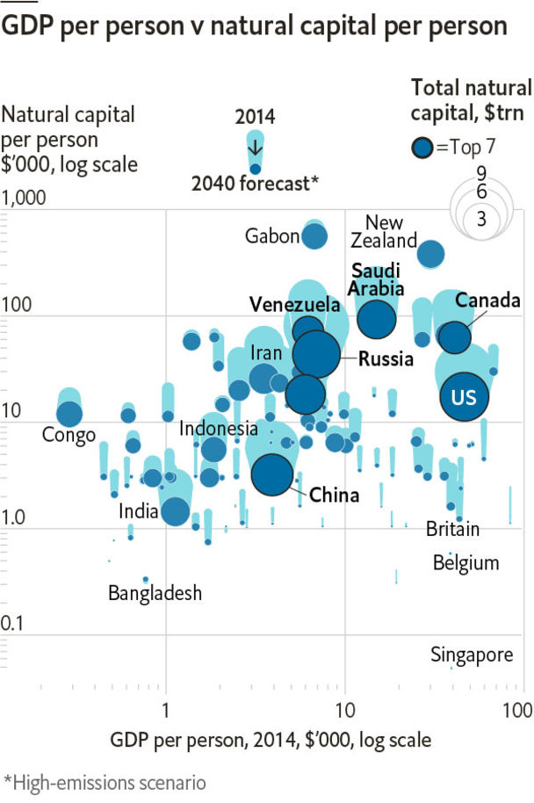

NATURE’S BOUNTY is not easy to count, partly because she was kind enough not to bill us for it. Some economists, however, have attempted to put a dollar figure on the value of the world’s land, forests, fisheries, minerals and fossil fuels—or what is left of them. Their work has fed into the Inclusive Wealth project, initiated by the United Nations, directed by Managi Shunsuke of Kyushu University and advised by Sir Partha Dasgupta of Cambridge. They estimate the world’s natural capital amounted to over $91trn in 2014, or over $13,000 per person. (The estimates use 2005 exchange rates and prices.) New Zealand has more natural capital per person ($380,000) than oil-rich Kuwait ($362,000) or Saudi Arabia ($180,000). Gabon has more than anywhere else.

Many researchers now think of natural resources as a “curse” that erodes competitiveness and breeds corruption—economies which are heavily dependent on exporting raw materials are often dominated by small, rapacious elites. For example, Congo, which relies on mining, has about 25% more natural capital per person than the global average, but remains desperately poor. Conversely, countries like Singapore enjoy a high GDP per person despite an utter lack of God-given resources. About two-thirds of Singapore’s wealth consists instead of traditional capital: infrastructure, buildings, plant and equipment. The rest is the “human capital” reflected in its people and their skills.

On average, however, countries with more natural capital also tend to have a higher GDP per person. So is it a curse or a blessing? Some economists argue that natural bounty raises the level of GDP but slows its growth rate: it provides an additional, steady stream of income that grows less quickly than the rest of the economy.

One reason may be that resources become harder to extract as they are depleted. According to the Inclusive Wealth Report, 47% of the world’s natural capital comprises fossil fuels (oil, natural gas and coal) and minerals (copper, gold, iron and so on) that took an eternity to form and will not be replaced. From 1990 to 2014, the stock of natural capital per person fell in 128 out of the 140 countries in the report.

Will that trend continue? Together with Yogi Sugiawan, formerly of Kyushu University, and Robi Kurniawan of Tohoku University, Mr Managi has calculated the future trajectory of natural capital under a variety of scenarios. In a future of continued high energy demand, carbon emissions can be expected to grow by 7% in high-income countries and by 44% in the rest of the world over the next two decades.

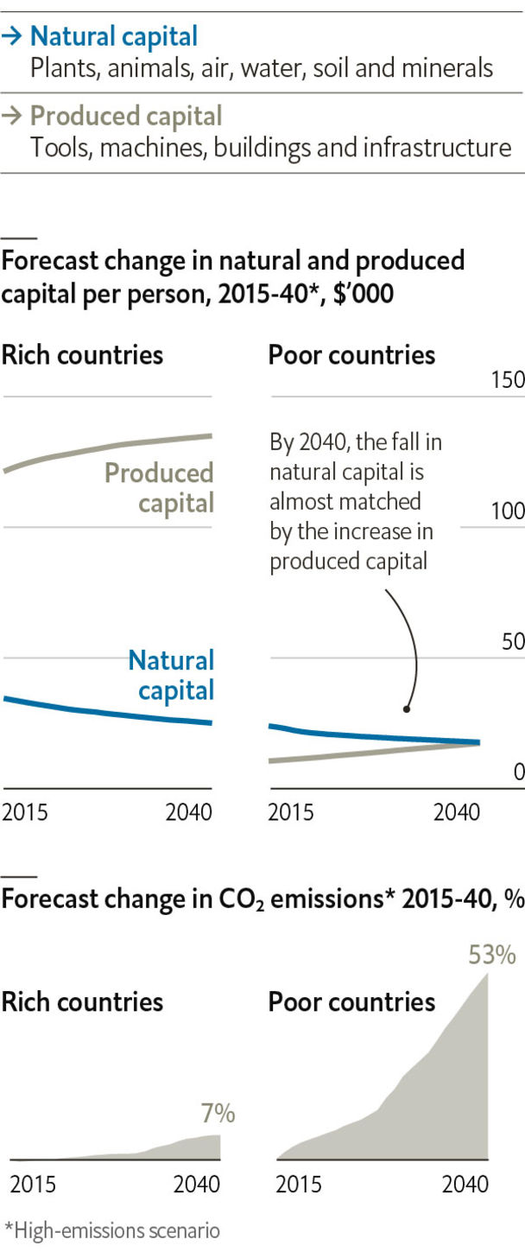

In such a scenario, the world will continue to grow wealthier, but natural assets will diminish rapidly as a share of its portfolio. A typical person in one of today’s high-income countries will have 21% less natural capital at their disposal in 2040 than they do today. In other, poorer countries they will have 17% less.

According to these projections, only 12 countries will increase their stock of natural capital per person over the next two decades. And in 39 countries, including resource superpowers like Brazil, Russia and Saudi Arabia, the stock will fall by over 30%. Financial capital tends to accumulate. Natural capital seems destined to do the opposite. ■

Sources: Yogi Sugiawan, Robi Kurniawan, Managi Shunsuke; Inclusive Wealth Report 2018; The International Institute for Applied Systems Analysis; World Bank; UN; The Economist

This article was downloaded by calibre from <https://www.economist.com/graphic-detail/2020/07/18/the-worlds-wealth-is-looking-increasingly-unnatural>

|  |  |  |  |
| --- | --- | --- | --- |
|  | Articles | Sections | Next |

|  |  |  |
| --- | --- | --- |
| Graphic detail | Sections |  |

Obituary

Ennio Morricone: Man on a mission

.

|  |  |  |
| --- | --- | --- |
| Graphic detail | Sections |  |

|  |  |  |  |
| --- | --- | --- | --- |
|  | Articles | Sections | Next |

#### Writing music

# Ennio Morricone died on July 6th

The Italian composer, who made his name writing music for the cinema, was 91

Jul 18th 2020 |



THE THEME may have been written well over half a century ago, but in less than three minutes you hear everything that came to matter most to him in a lifetime of composing. There is the two-note howl at the Moon—once heard, never forgotten. Musically, it is that rare fusion of heart and mind and as recognisable, in its way, as the opening notes of Beethoven’s 5th Symphony. Then there are the classic musical motifs, like those Richard Wagner scattered through the “Ring” cycle, that mark out the good man, the bad and the ugly. And then there is the freewheeling range of sounds with which he chose to make that music: the whistling, the yodelling, the gunfire and the squeaky ocarina, an ancient Italian wind instrument that looks like a sweet potato and is better known to a younger generation as the soundtrack of a Nintendo video game.

The range and audacity of his music surprised those who might have assumed that a working-class Catholic upbringing, not a mile from the Vatican, would have produced someone conventional rather than creative. But the Roman enclave of Trastevere, where he was born just after Benito Mussolini came to power, was an unusual place. A historical outsider-land on the far side of the Tiber, it has tall spindly houses that, for centuries, have been home to artisanal guilds, small businesses, ancient synagogues and enterprising Jewish and Catholic families. Above the winding cobbled streets, with their medieval shopfronts and wooden shutters, the Roman light shines through the pine trees in the hills with cinematic luminosity. His friend, Sergio Leone, who directed “The Good, the Bad and the Ugly” and many of the other films that made him famous, lived just a few minutes away. Both boys attended a private Catholic school nearby, and for a while were even in the same year.

His father, a professional musician, and his mother, who ran a small textile business, brought up four siblings: Ennio, Franco, Adriana and Maria. A fifth child, Aldo, the youngest, died at three when he was fed cherries by a nanny who did not know he was allergic to them. For a while, understandably perhaps, the ten-year-old would-be composer thought he might become a doctor.

But two other passions also exerted their pull. He took up chess after finding a small chess manual in a secondhand shop, and for a while played it obsessively with three friends who lived in the same block of flats in Via delle Fratte. At the same time he was drawn to music and wrote his first composition at six, having watched his father practise the trumpet at home every day and heard him perform with his light-music orchestra on the radio.

Chess was silent music, he liked to say, and playing it was a bit like composing. But whereas he was a conventional chess player, leading always with a queen and pursuing the logic of calculation rather than playing by instinct, music set him free. He composed for the stage and the radio, but quit the national radio broadcaster, RAI, when they wouldn’t let him freelance on the side.

Branching out on his own, he refused to let himself be distracted, one reason why he continued living in Trastevere, travelled little and never bothered to learn to speak English. Hollywood, when it decided it wanted him, had to come to Rome. When his music came to him, it was fully formed. He would rise before dawn to write, composing at his desk on 12-staff paper with a pencil rather than experimentally at the piano. His wife, Maria Travia, occasionally wrote the lyrics to his songs. He would play her his work, and only if she approved did he then show it to anyone else.

A daily routine allowed him to experiment, first with Il Gruppo, an avant-garde free-improvisation collective in Rome for which he played the trumpet and the flute. But it was the soaring landscape of the cinema that allowed his composing to take flight. He liked using all the orchestra’s resources in his arrangements; his musicians would often find themselves playing instruments that they had never played before—the military snare drum, the jaw harp and, increasingly, the Fender Rhodes electronic piano. He wasn’t showing off; every note had a job to do. Changing one thing changed everything.

In time he came to realise that his approach to composing was like his favourite grandmaster, Bobby Fischer’s approach to playing chess: a series of sudden and surprising moves. Cinema-goers sensed how he melded thinking and feeling, that he played with sounds that spoke to his romantic nature and was able to conjure up, in music, heroic figures who resonated with audiences around the world, however different they might be.

It was the music he wrote for “A Fistful of Dollars” that turned the unknown Clint Eastwood from a faux-western cowboy into a hero worthy of Homer—honourable, fearless and with a kind hidden heart—and the opening chords of Johann Sebastian Bach’s first song of St Matthew’s Passion, “Come, ye daughters, share my mourning” just before the rat-a-tat-tat drumbeat of French soldiers pouring out of their trucks, that helped transform Gillo Pontecorvo’s “Battle of Algiers” from a story about a nasty colonial spat into a tragic historical epic. As with the ghostly harmonica in “Once Upon a Time in the West” and the soaring theme the Jesuit Father Gabriel plays on the oboe as he tries to bring God to the Amazon in Roland Joffé’s “The Mission”, many of his compositions outlived the films they were written for.

## Music to remember them by

Visiting journalists sometimes failed to realise he was having them on when he gently insisted that people go to the cinema to watch films, not to hear them. Deep down he knew that music could make a film unforgettable. That was why Sergio Leone so often had him compose the music before shooting started, rather than the reverse, which is the way films are usually made, or even insisted the actors listen to the soundtrack to get them into character. He had just one piece of advice when approached by John Zorn, then a budding cinema composer: “Forget the film. Think of the record.” Millions would agree.■

This article was downloaded by calibre from <https://www.economist.com/obituary/2020/07/18/ennio-morricone-died-on-july-6th>

|  |  |  |  |
| --- | --- | --- | --- |
|  | Articles | Sections | Next |